**SOFTWARE ENGINEERING PROJECT**

**TEAM - D**

**B.Sc. Hons Computing**

**Woodlands University College**

# ASSIGNMENT COVER SHEET

|  |  |  |  |  |  |  |  |  |
| --- | --- | --- | --- | --- | --- | --- | --- | --- |
| **Course: BSc Computing (SE)** | | | | **Year: 2** | | **CSY2027** | | |
| Group Project | | **Title: The Design and Development of a Course Management Software System** | | | | | | |
| Date due out: | Date due in: | | Extension date: | | | | | Extension agreed by: |
| **Student Names (List each member of the group)**  **Rojen Tamang (Leader): 18413711**  **Ayush Sherpa : 18406507**  **Roshan Giri : 18406492**  **Prabin Shrestha : 18417133**  **Prazwol Simkhada : 18406512**  **Sandesh Bindukar : 18406550**  **Shangbu Tamang : 18418323**  **Pragyan Karki : 18408450**  **Sushant Adhikari : 18413691** | | | | | | | **Tutor:** | |
| Student comment, specific request for feedback etc. | | | | | Marker’s General View of the work | | | |

**ASSESSMENT FEEDBACK:**

|  |  |  |  |  |  |  |  |  |
| --- | --- | --- | --- | --- | --- | --- | --- | --- |
| **RATING SCALE** | **Excellent** | | **Good** | | **Satisfactory** | **Needs some more work** | | **Needs much more work** |
| Elicitation Plan/ Interview(s)/Findings (10%) |  | |  | |  |  | |  |
| Requirement Specifications Documentation  (10%) |  | |  | |  |  | |  |
| System Design Documentation  (25%) |  | |  | |  |  | |  |
| Prototype Functionality and Quality of Application Code (35%) |  | |  | |  |  | |  |
| Test/Evaluation Strategy  (10%) |  | |  | |  |  | |  |
| Group Cohesion, Teamwork and Project Management/ System Presentation (10%) |  | |  | |  |  | |  |
| Specific aspects of your assignment that the marker likes: | | | | Specific aspects of your assignment that need more work: | | | | |
| Tutor’s Signature: | | Date: | | | | | Grade: | |

**Table of Contents**

**ASSIGNMENT COVER SHEET 1**

*Group Project 1*

**1. Introduction 1**

1.1 Project Background 1

*1.2.1 Project Aims 1*

*1.2.2 Project Objectives 1*

1.2 Project Aims and Objectives 1

1.3 Project Development Methodology 2

*1.3.1 Problem Domain: 2*

*1.3.2 System specification Phase: 2*

*1.3.3 System design and testing Phase: 2*

**2. Requirements Engineering 3**

2.1 Elicitation Activities 3

*2.1.1 Interview plans 3*

*2.1.2 Interview findings 3*

*2.1.3 Other problem domain research 16*

*2.1.3.1 Comparable Software System Review 16*

**2.2 Requirements Specification 30**

2.2.1 Problem Domain Description 30

2.2.2 Functional Requirements 35

*2.2.3 Performance Requirements 48*

*2.2.4 Design Constraints 49*

*2.2.5 Commercial Constraints 50*

*2.2.6 Acceptance Tests 51*

**3 System Analysis & Design 52**

3.1 Preliminary Design Stages 52

*3.1.1 Textual Analysis 52*

*3.1.2Significant Event Analysis 53*

*3.1.3Commands Queries and Constraints. 55*

3.2 Detailed Static System Designs 58

*3.2.1 First Draft BON System Architecture Diagram 58*

*3.2.2 BON System Chart 58*

*3.2.3 BON Cluster Charts 59*

3.3 Detailed Dynamic System Designs 62

*3.3.1 Events Charts 62*

*3.3.1.2 Internal (Outgoing Event Chart) 62*

*3.3.2 Object Creation Charts 63*

*3.3.3 System Scenario Charts 64*

*3.3.4 Dynamic Diagrams 66*

3.4 System Database Design 67

*3.4.1 E-R Model 67*

*3.4.2 Attribute Listings 67*

**4. System Interface Designs 67**

4.1 Draft Interface Designs 67

*4.1.1 Wireframes 67*

*4.1.2 System Navigation Diagram 104*

*4.1.3 System Screen mock-ups 106*

*4.1.4 System Activity Event Diagrams 131*

4.2 Design Revisions 139

4.3 Heuristic Evaluation 139

**5 System Build and Technical Notes 141**

5.1 Technically Difficult Code Sections 141

5.2 On-going Testing Methodology 142

**6 Test Strategy 143**

6.1 Overview of Test Strategy 143

6.2 Sample Test Results 143

**7 System Evaluation 151**

7.1 Usability Evaluation Strategy 151

7.2 System Pilot Trials 151

**8.Project Conclusions 152**

**9. Project Management 1**

9.1 Project Gantt Chat/WBDS/Activity List 1

9.2Project Meeting Minutes and Quality Plan/Strategy 4

9.3 Project Work Log 6

**10. References 9**

**11. Appendix 10**

# 1. Introduction

This project was given to our company from the Woodlands University College. The college wants our team to prepare them an efficient software (web based application) which can clear all their difficulties resulting in easing their tasks and better productivity than the existing clerical system which runs the overall function of this college. Basically, the software should be designed to computerize all the university records and make the lectures, grades, notes, modules, projects, assignments and other academic materials available to all the students and staffs with all the user information.

## 1.1 Project Background

According to the research and findings, Woodlands University College’s whole system is clerical based and is less efficient to all their staffs and students. Recording of data is usually being done in handwritten format. The management was not well organized by the system and the productivity of the system was very low. In the beginning, we interviewed four different members of the college. As a result, we found many difficulties and the need to update the system with the current system of the college. After listing the difficulties, analyzation of all the aims and objectives were done to create the best systematic solution for the college. Finally, the creation of the application was started. Mockups and wireframes were designed first and then the functional requirements were researched.

### 1.2.1 Project Aims

* To create a software for university (modification of clerical system) instead

of the existing clerical system which is outdated.

* To Store data in proper order (Attendances and Grades) so that users can

access the data and materials easily.

* For the management of Courses and modules according to the university for the better productivity and efficiency of the academics.
* To make Whole system computerized as the necessity of present time for the proper functioning of any organization.
* To avoid duplicity in records and safeguard the important and confidential information.
* To make every job more efficient, reliable, and fast as opposed to slow and unreliable system at present.
* To create an easy communicating system for all the people connected with the university college.
* To make the system user friendly, secure and attractive for the ease of the users.

### 1.2.2 Project Objectives

## 1.2 Project Aims and Objectives

* Interview related problems and solutions with Administrator, tutors and

student.

* A proper analyzation of those problems and their best solutions.
* Comparison and idea retrieving from other similar applications.
* Researching and exploring about other main problems and solutions related

with the system.

* Discussion and listing of the functional requirements that are need to be

introduced in the system.

## 1.3 Project Development Methodology

### 1.3.1 Problem Domain:

The main problem with woodlands university college is the system was clerical based. All the records were kept in writing form, which made difficult for updating and deleting the data. Many duplicity of data were seen. Thus, to overcome these problems our company wants to create a software which helps the user of the college to use more easier and better than previous system.

### 1.3.2 System specification Phase:

After the analyzation and research of the problems faced by the university members, a good web application is designing by our company. In the application administrator, module tutors and students can login to their account. Functions of the account are different for administrator, tutors and students. 100000 is the maximum number of students that can be registered. New students can register by their own, but the user id will be provided by the administrator.

### 1.3.3 System design and testing Phase:

After completion of the research and findings, system designing was started. Wireframes and mockups were designed first for the better view of the application. Different images, signs, panels, buttons etc. were used and placed to the right order which would make user to run the task easily. Wireframes were made completely for every slides of the application. Then, mockups for each page were designed. User friendly colors were kept for the attractive view. Proper images were placed in right order. According to the wireframes and mockups the application was created, then comes the testing part. In testing part every buttons, bars, items were tested weather it works or not.

# 2. Requirements Engineering

Requirement Engineering is the iterative process of defining, documenting, and maintaining the requirements of what the services should be provided by the system. In this phase, the service provided by the system is gathered and defined. It consists of the requirement elicitation activities and requirement specification which is described below.

## 2.1 Elicitation Activities

### 2.1.1 Interview plans

The group consists of nine team mates so we decided to make key questions to Dr. Simon White (computing course leader), Mr. Adam Blake (course administrator), Dr. Raj Singh (module lecturer, senior lecturer and personal tutor), and Mr. Mark Williams (current existing student on computing course). We planned to record the interview so that it would be better to evaluate their answers and to fulfill their requirements. We then took the interview date and took the interview in their convenient time.

### 2.1.2 Interview findings

The followings are the interview findings with Dr. Simon White (Course leader), Mr. Adam Blake (course administrator), Dr. Raj Singh (module lecturer, senior lecturer and personal tutor), and Mr. Mark Williams (current existing student on computing course). These findings helped us to move forward and provided enough information for to carry out the project.

|  |  |  |  |
| --- | --- | --- | --- |
| **TOPIC AREA** | **INTERVIEWEE** | **QUESTION NUMBER** | **QUESTIONS** |
|  | **Dr. Simon White** |  | What made you to change from your old framework to the enhanced one? What were the loop holes in your previous system so that we can improve it in the new system?  **Answer:** The course leader said that the previous system was totally paper-based. Due to this reason they couldn’t access the data that they wanted in the desired time. Furthermore, the system covered a lot of space which created other problems as well. There was risk of losing data by tearing of paper, rats and pests. So, in order to overcome such problems Mr. White wants to switch from the paper-based system to the digital system. |
|  |  |  | How were the records managed in the clerical based system and what did you like about it?  **Answer:** Dr. White managed the records in the paper system. All student records, exam notices, assessment were managed in the papers. It took a lot of time for him to manage all those records in papers. The paper-based system is time consuming, not effective so Dr. White did not like anything about the clerical based system. |
|  |  |  | As a course leader what problems do you face in regards to managing the computing faculty?  **Answer:** As a course leader, the problems that Mr. Simon White faced was that he couldn’t provide necessary content materials directly to students. If he provided information to a single student and tell them to share, some might not get the content. If some student is absent, they may not get the content as well. He said that he was getting a lot of problems managing the student records, attendance, grades. |
|  |  |  | Would it be possible to list out some of your roles and responsibility (things that you oversee as a course leader)?  **Answer:** The major roles and responsibilities of Dr. Simon White as a Computing Course leader is to keep track of each students’ attendances, to grade students academically and to manage the course contents for Computing faculty. |
|  |  |  | What level of accessibility to the data should be provided to the module leaders and the students?  **Answer:** The course leader suggested that data of all the staffs and students must be protected. The data mustn’t be viewable by unauthorized personnel’s as the data could be confidential and could contain private information’s about the person. He said that module leaders could make changes to their specific modules and to the assignments of that particular module and could also view the records of the students in their module. And as for the students they could only view their own records on assignments, address and their grades.  **Recommendation:** Each category of user is provided with a set of username and password to allow proper user authentication that would differentiate them from one another and based on their usernames (type) the level of accessibility is determined. |
|  |  |  | How do you check to see if the course is running according to the university’s specification? (Which topics have been cleared for each module?)  **Answer:** As a course leader Dr. white wants a web-based application in which students can login their own account and view it. Teachers could also login their account and view student's account of their module also. So, as a course leader Dr. white wants to view all the records of students and tutors to check whether the system is running according to the universities specification or not. |
|  |  |  | Do you want any feature where you get to know the student’s academic status?  **Answer:** Yes, I would be glad the feature where I get to know student’s academic status. |
|  |  |  | If incase this software could accomplish just a single goal, what might it be?  **Answer:** As a faculty (course leader), this software should accomplish different goal and they are the student records, attendance and grades. This software should also have the features of uploading the modules content. |
|  |  |  | What may be your expectation from us? Any extra feature you would like us to append?  **Answer:**  As being the course leader since I am facing the problems about the students record like attendance, grading and problems related to module content. I expect to have the information about the student attendance and the grading. Also, I expect to have to have the access in uploading and changing the module content. Extra feature I would like to have is the social media. It will be easier for me and the students to directly deals with the problems and any other necessary talks. |
|  |  |  | Are there things that you would never want us to include in this software?  **Answer:** Mr. White thinks the privilege to be able to change, upload, or modify the contents of the course would be marvelous. Regarding the latter, Information about all of the results and marks should be only visible to the module leader and not everyone must have access to do so. He also thinks personal tutors must be able to access the grade status because they need to know their tutee’s weaknesses |
|  |  |  | By what way will you measure accomplishment/success of the software?  **Answer:** The system should able to manage students record, their attendance, grading and to upload the modules content. Besides these, if the system could handle security measures and backup data properly, this would be the major accomplishment of the software for Dr. Simon White. |

|  |  |  |  |
| --- | --- | --- | --- |
| **TOPIC AREA** | **INTERVIEWEE** | **QUESTION NUMBER** | **QUESTIONS** |
|  | **Mr. Adam Blake** |  | How does your present system work? Will it be feasible for us to see some example list of your present strategy/plans?  **Answer:** Mr. Blake said that the present system is based on all paper work. All the records such as student information, exam paper and other activities are managed over paper which are stored in a warehouse. All the required documents were provided by Mr. Blake to us. He also said that he would clarify the documents if we find difficulty understanding it. |
|  |  |  | Would it be possible to list out some of your roles and responsibility?  **Answer:** Mr. Adam Blake is supposed to look only after the administration part. His major role is to look after the whole application process and to manage student and staffs record. Taking about the application process, the student application sent to the administrator through UCAS (a UK body). Then administrator role is to prepare provisional case papers. After viewing the eligibility of a student, they send two kinds of offers, conditional offer or unconditional offer. Then 8-digit unique ID number is assigned for each student along with their name and status (dormant or active) to create case papers. Each year they have to handle 20,000 to 30,000 case papers but only 10,000 case papers are accepted. If the students don’t show up after the enrollment the papers are stored as dormant. These papers are kept approximately for about 10 years. Besides these application process, they have to look after the students and staff records. |
|  |  |  | As an administrator what was the most difficult task for you to do with the clerical based system?  **Answer:** The most difficult task for him to do was to manage all those records systematically and to find the required documents when needed. To find the needed documents the old system took a lot of time so it was time consuming. He had to maintain the records of thousands of students so there was change of files being misplaced and miscarried. There was chance of losing the documents and storing the documents multiple times. All the data were reductant. So, it was very hard to maintain the documents. |
|  |  |  | How were the records of all students and staffs managed in the clerical based system?  **Answer:** The previous system was a paper-based system that would store all the records of staffs as well as students in a paper record. All the admission information’s were provided by the UCAS and would contain well over 100,000 records of students and they would have to select the eligible students out of all of them. Then later provisional case papers would be made for the eligible students. There would also be Applications of students that applied for the college but did not completely meet the requirements and would be placed on conditional offers. The selected students would then be provided with an 8-digit unique id. There would also be case papers of those students containing information about their name and statuses. |
|  |  |  | Is this project an application or a website?  **Answer:** This project is a web-based application. |
|  |  |  | What privileges would you like in this system for you?  **Answer:** In this system, I would like to have the privilege of managing the records for students and staffs like adding, editing, archiving, assigning, and deleting the data and maintaining the proper security for the users. I would also like to have a feature to communicate with the students regarding their attendances. |
|  |  |  | Who are the targeted audience for this system?  **Answer:** The targeted audience for this system is students, module leaders, administrator. So, basically these are the targeted audience for this system. |
|  |  |  | What is the information’s that an unauthorized user can view?  **Answer:** The unauthorized users are only able to view the landing page (Home Page). As the software is not a promotional website, the landing page should consist of a user login section and some of the vital information related to the university. |
|  |  |  | What is the minimum number of user that this system must accommodate overall?  **Answer:** Mr. Blake said that the system should accommodate one hundred thousand of users. The university enrolls ten thousand of student at a time and they also manage the records of the pass out students. |
|  |  |  | What items might you want to show on your landing page?  **Answer:** Mr. Blake said that the landing page should contain the basic information of the college and a login portal. The main features can only be used by the authorized user. |
|  |  |  | What would be the font type and color combination of this software?  **Answer:**  Readability and clarity should be the focal point. It should look appealing with good color combinations. We can give you the feedbacks once you walk through the design and show it to us. The color combination should be such that it is easier to read and it does not strain our eyes. Overall it should look impressive and appealing. You can provide a privilege where you can increase or decrease the font sizes on your own. |
|  |  |  | Would you like to separate some space for educational advertisement/ recommendation?  **Answer:** He said that he would not like to separate space for educational advertisement or recommendation. He said that it is not a promotional website and it is only used for internal purposes. |
|  |  |  | Should the software be responsive? What kind of devices are you targeting for this software to run on?  **Answer:** Mr. Blake said that the software should be responsive on all devices such as iPad, mobile phones, computers and so on. For staffs the software should be desktop friendly. As most of the student prefers to use mobile phones these days so Mr. Blake would like us to make the software responsive on all the mobile devices. |
|  |  |  | Do you have any pre- existing software solution and any legal requirements?  **Answer:** No, we don’t have any pre-existing software solution. Among the legal requirements he wants to protect their data and prefers privacy and security in the software. |
|  |  |  | What may be your expectation from us? Any extra feature you would like us to append?  **Answer:** Mr. Adam Blake expects from us to complete our project on time and to fulfill their basic requirements to solve their current problem. The extra features that can be added are to allocate personal tutors and notify the tutors and students. Mr. Blake also wants us to add a form from which the students can correct their home address and when the correction is made than the students are notified about the correction. |
|  |  |  | What is the time span to finish the project?  **Answer:** This project is to be finish by March 2019. |
|  |  |  | What is the budget range of this software? Do you have any in mind?  **Answer:** Mr. Blake first want to see the system and its usability before rating its value. It was all paper based before so budget is not much big deal while they were facing the real problem.so all the budget works will be determined after the system completion. |

|  |  |  |  |
| --- | --- | --- | --- |
| **TOPIC AREA** | **INTERVIEWEE** | **QUESTION NUMBER** | **QUESTIONS** |
|  | **Dr. Raj Singh** |  | How are you handling your job right now? Would it be possible to list out some of your roles and responsibility?  **Answer:**  The main job of the (senior lecturer, module leader, personal tutor) Dr. Raj Singh is to handle the attendance of all the students, conducting the exams and teaching students as a personal tutor. |
|  |  |  | What were the difficulties that you were facing in the clerical based system?  **Answer:** In the clerical based system, everything was done in paper, so it was very difficult. Specially, for making an announcement, conducting examinations, updating the grades, we are using paper-based system which is so much time consuming and need a lot of effort to finish it. |
|  |  |  | How did you manage the student records in your previous system?  **Answer:** Mr. Raj managed the students records in the papers. All the attendance is managed manually in the papers. All the announcements are made in the notices board. The results of the students are posted in the notice board. Everything was paper based so it was hard for Mr. Raj to manage the students records. |
|  |  |  | How are the students informed about assignments, activities, changes in modules and so on?  **Answer:** The assignments would be pasted on a notice boards along with any other announcements or events taking place in the college. This would prove to be extremely inefficient as not all the students would be well informed about any such thing.  **Recommendation:**  The software could have a section where the all the students would be sent information about any upcoming events and other notification directly to their homepages. |
|  |  |  | Would you like any chat feature to take time for personal teaching between you and students? We could make a profile system where students could visit your profile and get to know your active hours.  **Ans:** Yes, Dr. Raj Singh would like to have chat feature between teachers and students. Previously, they had to take permission with the administration to make any kinds of announcement. All the announcement was done orally. So, he always wants to have some kinds of direct messaging tools between teachers and students. |
|  |  |  | Would you like any feedback feature from students that are having problems with the modules?  **Answer:** He would like to have this feature where the student can send feedback if they are having problems with the modules. This would help him and his student to discuss directly the module and his style of teaching. He said that it would be more easier for him to deliver his knowledge to his students. |
|  |  |  | If incase this software could accomplish just a single goal, what might it be?  **Answer:**  Since, now it is a clerical based system it must be total go into the clerical based system. Being the module leader, I need the basic things to be there. Basic things like login credential, module which I am handling should be visible and able to upload  the necessary materials by me. It would be better if I am able to take the TCA examination and submission of the assessment. As examination is conducted grading must be done so, I must be able to grade them and the grading should be come to the grade center. |
|  |  |  | What may be your expectation from us? Any extra feature you would like us to append?  **Answer:** Beside other basic requirements, module tutor wants to have the authority to change the course materials and wants to have safety in the system from other module so that no other tutor could make changes in other modules. Besides this he also wants the system to give authority to module tutor to conduct enrolled exams. |
|  |  |  | Are there things that you would never want us to include in this software?  **Answer:** The security must be very high. There is a high chance of being plagiarized which is a serious issue. Availability of information should only be accessed once you are a privileged authorized user. Only some of us should have the access to such information. A particular tutor must be able to view the modules grades and other module tutors cannot. |

|  |  |  |  |
| --- | --- | --- | --- |
| **TOPIC AREA** | **INTERVIEWEE** | **QUESTION NUMBER** | **QUESTIONS** |
|  | **Mr. Mark Williams** |  | What experience do the students have of the institution?  **Answer:** Since, we have a clerical based system we are facing a lot of problems. Problems like changes in address, email, phone number. Once they are changes they need to change form, once changes it is not updated properly then while informing about some announcement it will be a problem. In the case of the grades as well as in the attendance, we have to do manually and while having the grades there may be mistakes in the entry and same grades and attendance comes to the finalization. |
|  |  |  | What are the things that you admire the most in the current clerical system?  **Answer:** Mr. Mark said that there is not a one thing that he admires the most in this clerical system. He had to go through a lot of process if there is mistakes in his attendance, test results or the address of his house. |
|  |  |  | What are the things that you find difficult in the current system?  **Answer:** Due to the clerical based system, the students are facing many problems. Whenever students have to change their address, phone number, etc. they have to write letters to the administrator. They don’t even know whether the letter has been reached or their problems has been addressed. Results and attendance, are all performed manually, due to which some students are not able to visualize what has been happening at the moment. So, these were the difficulties addressed by Mr. Mark Williams. |
|  |  |  | How are your module activities and assignments, assessment, test results managed in the current system? Do you want messages or notification in this new system?  **Answer:** Mr. Mark said that all the activities, assignments, test results are managed over the papers. He said that all the announcements, test results, activities are posted in the notice board. Mr. Mark said that sometimes there is mistakes in the attendances, test results and so on. He said that he had to go through a lot of process to correct those mistakes and it was irritating. He also said that if someone address is changed than the university would send the announcement to the old address. Mr. Mark would be very happy if he would get message or notification if there is any activity going on over his modules. |
|  |  |  | Are there any resource activities such as Linda, oracle, student hub to make your studies better, if not would you like to add such activities?  **Answer:** No, there isn’t any resource activities because it is clerical based system. As a student, I would like you to add such features in new system as it helps to make our studies better but I don’t have the authority to make an approval. But, I would love to have such features in the new system. |
|  |  |  | If incase this software could accomplish just a single goal, what might it be?  **Answer:** The single goal would be to make the system more effective by doing all the necessary requirements so that there would be no more problem in the future. |
|  |  |  | What may be your expectation from us? Any extra feature you would like us to append?  **Answer:** Since there used to be paper base system in the institution, there would be difficulties in making notes of all those subjects. So, it would be better if we could find slides or any other files in the system which will benefit all the students even if we get absent in some classes by some reason. |

### 2.1.3 Other problem domain research

### 2.1.3.1 Comparable Software System Review

1. **Nile: University of Northampton (**<https://nile.northampton.ac.uk/webapps/portal/execute/tabs/tabAction?tab_tab_group_id=_1_1>**)**

Nile stands for Northampton Integrated Learning Environment. It is the portal for the members of the university of northampton.

1. **The Landing page:**

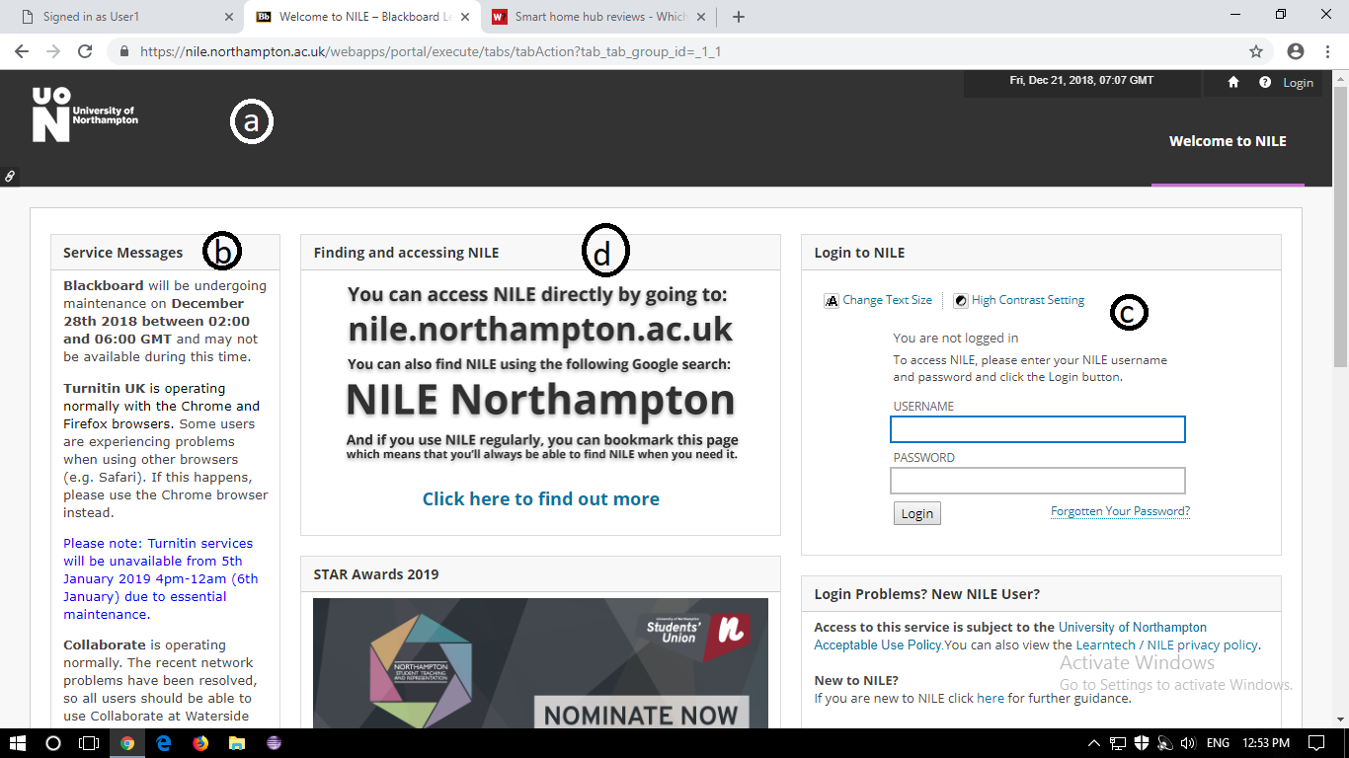

*Fig: Landing page*

1. **Header:**

The header of the page consists of the name of the organization and some info about the profile of the user. There is a section showing the date and current time at the London. There is a login icon for logging out of this session.

1. **System Notification Section:**

There is a section allocated for the notifications for the change in the webpage. The dates of the updates and the changes made during the last update are shown in this section.

1. **Login Portal:**

The login portal lies in the left side of the webpage**.** There are two dialogue boxes which ask the user about the information like the login id or username and password. The user can only proceed into deeper portion of the page only after logging in.

1. **Guide Section:**

The middle part of the website has the guide section. It helps the user to easily access the website and its necessity in the digital learning system.

1. **The homepage:**

This page is only accessible after the login.

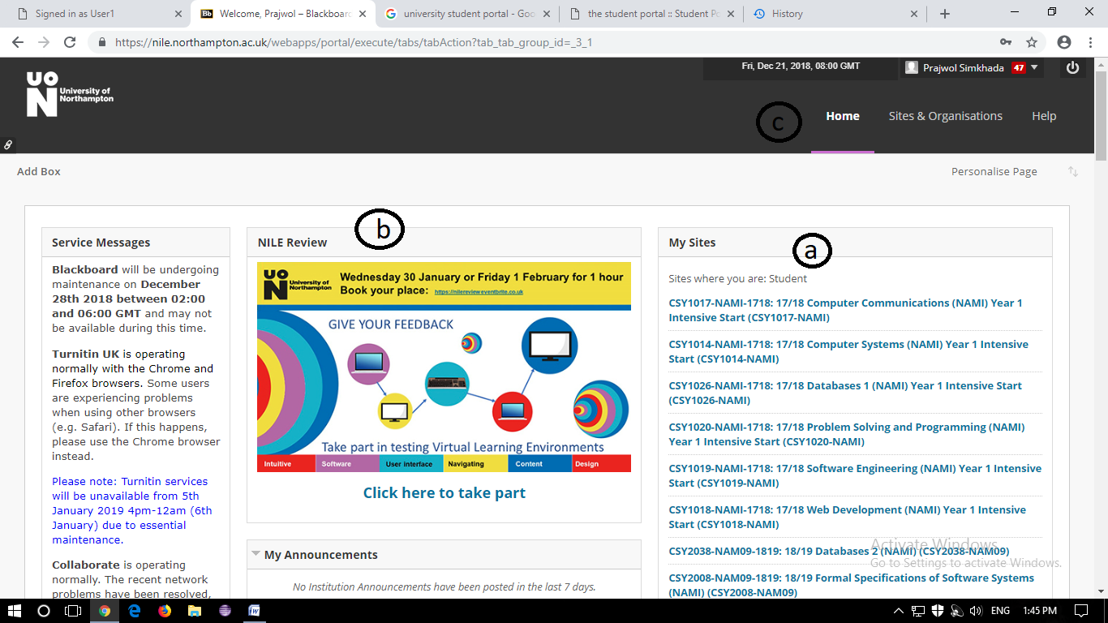

*Fig: Homepage*

1. **My sites:**

This is the area which shows about the modules and courses that the student has enrolled has selected. All the reading materials are kept separately inside the specific sites of the modules.

1. **Nile review section:**

This portion consits of the all the important announcements that are made by the organizations c)like the examination and result publication, the changes in the modules and so on. Furthermore this section has the links to the eesntial reading resources for helping the students improve their studies.

1. **Home and others:**

The header section has now three more sections. The home is the landing page after login.There is also sites and organization tab and a help tab as well. On the top of that we can see the profile of the user.

1. **The Grade Viewing Page:**

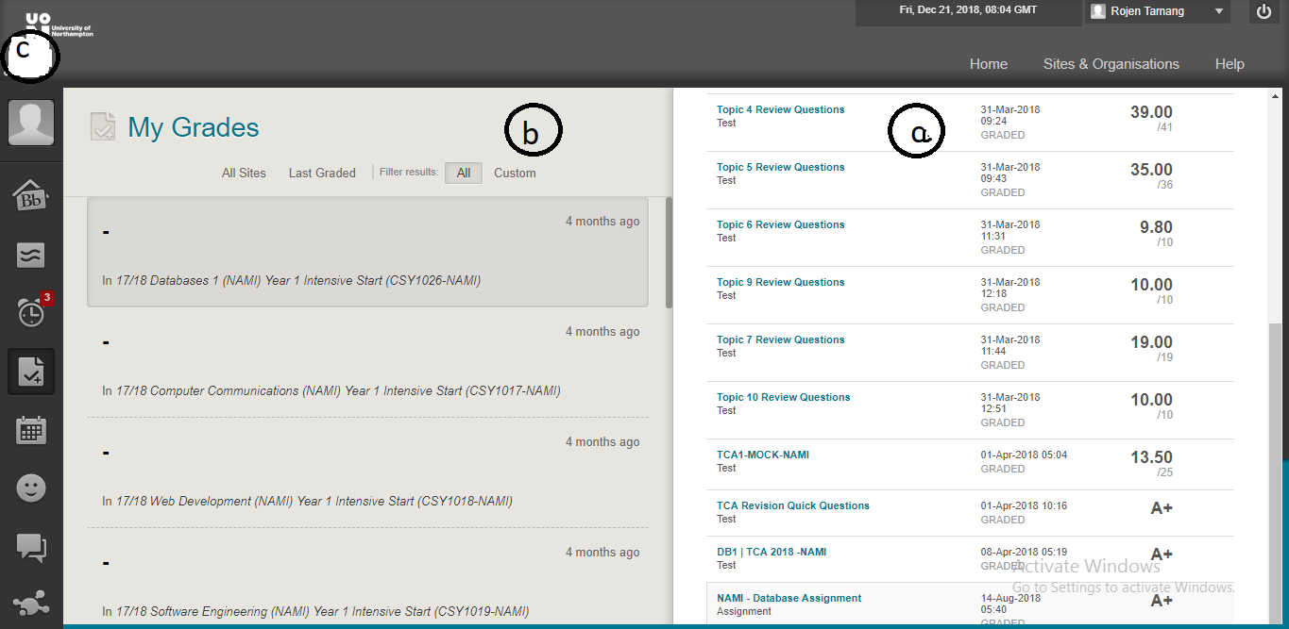

*Fig: Grade viewing Page*

1. **Grades:**

This area views the grades of the student in the selected subjects marked by the tutor. The tutor can write, alter and updates these grades while it is read only for the students. The net grade of the students is published accordingly.

1. **Subjects:**

It is the section which shows the name of the modules. The grades are listed inside this column.

1. **Icons:**

This area shows the icons of the profile of the user and all the other important tabs for the user to customize and review their activities and grades.

1. **Module Page:**

This page displays the contents of the module.

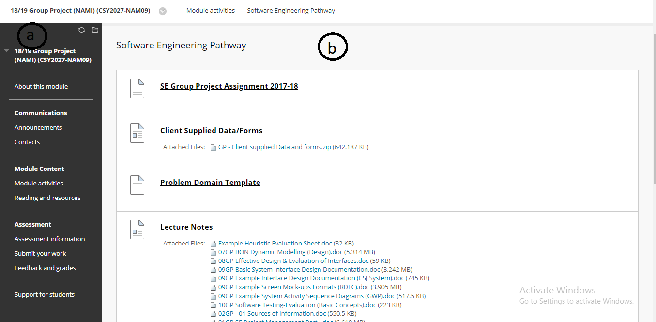

*Fig: Module page*

1. **About the module:**

This page has the all the essential reading and resources which is needed for the students in a model. Students can view the module details as well as submit their works through here.

1. **Module Pathway:**

This is the container of the weekly activities. The lecture and the tutorial materials are listed weekly wise here. The module tutor can control what do display in this page.

**Merits of NILE:**

* This is easy and user-friendly website.
* The sections and asides are well-managed.
* The image content in the website are of high quality.
* User can manage their account and view of the website accordingly.
* Non-user cannot access the files. So, the security is top knot.
* Announcements are given more priority.
* There is proper updating in the system performance and bugs.

**De-Merits of NILE:**

* The website is not responsive.
* There is no attendance section as our software demands.
* As the images are of high-quality, it takes more time on loading the content.
* Students cannot access the files which are not covered in regular classes. This might slow down the curiosity of the students in exploring new topics themselves.
* User profile is hard to manage.

1. **Newmis: Apex College (**<http://newmis.apexcollege.edu.np/>**)**

Newmis is the login portal for the members of the Apex College.

1. **The Landing Page:**



*Fig: Landing page*

The design of the landing page is very simple. It has a login portal for the staff or students in the middle of the page. The logo and the hyper-links to the different social media sites and the library of the college are pushed into the left-hand side. This means that the non-user can view other college related contents without accessing into the system.

1. **The Homepage:**

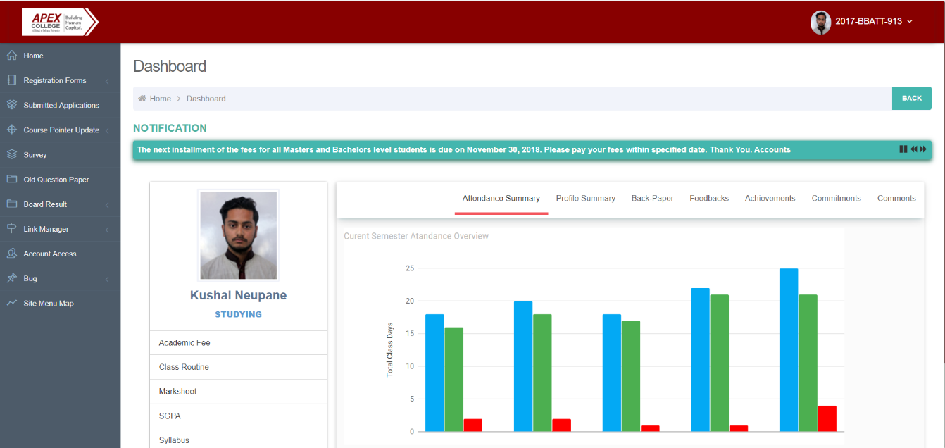

*Fig: Homepage*

The homepage opens with the student profile showing the attendance and other information about the users. The logo is present in the left top corner of the page and the menu are listed just below it. There is a notification panel which shows the announcements made by the college. The result must be downloaded manually (i.e. there is no automatic displaying of the result in this website).

1. **Course View:**

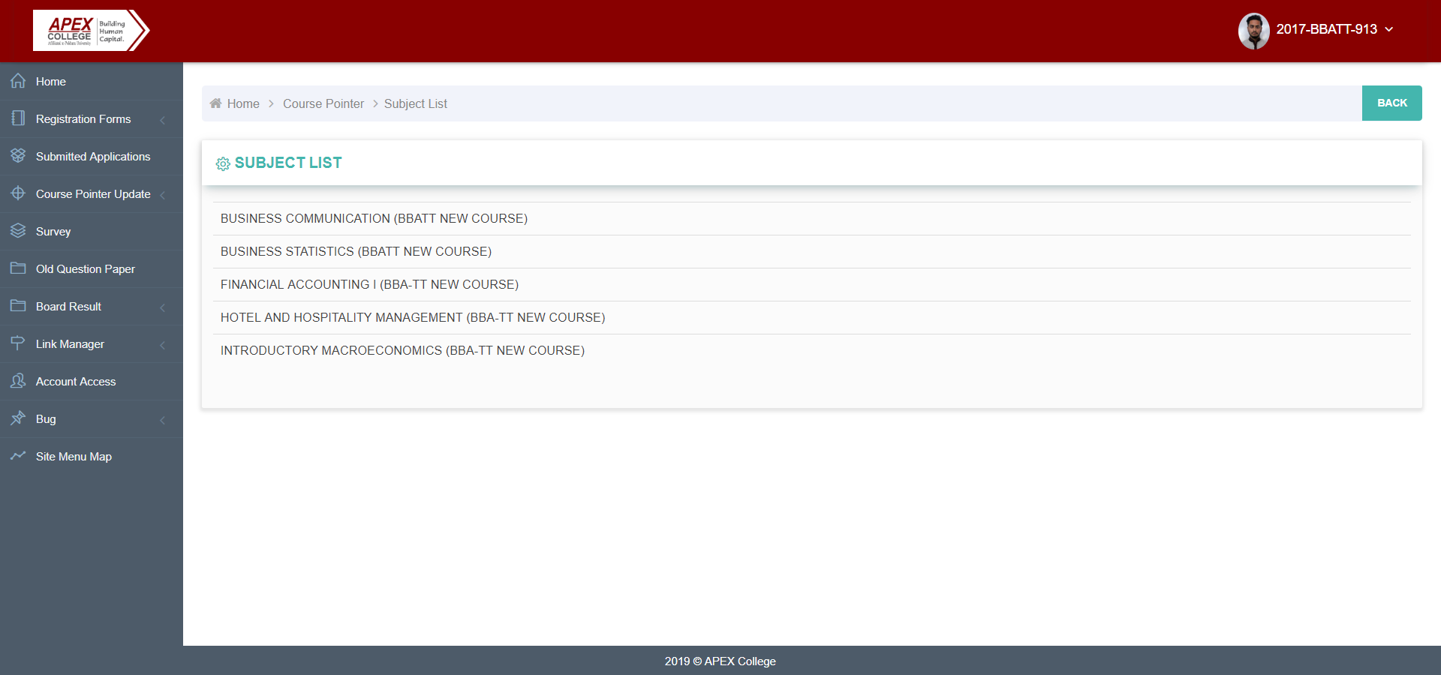

*Fig: Course view*

All the reading contents and assessments are enlisted inside the course update column. The list of the subject is seen while the option is clicked. Other links and functions remain in the left-hand side as in the homepage. Further when the course is expanded, we can see the list of topics we are going to cover in this module. The topics which have been completely are shown with blue mark and the rest are shown in white. This helps students to track their learning process and help prepare what they are going to learn in the coming days.

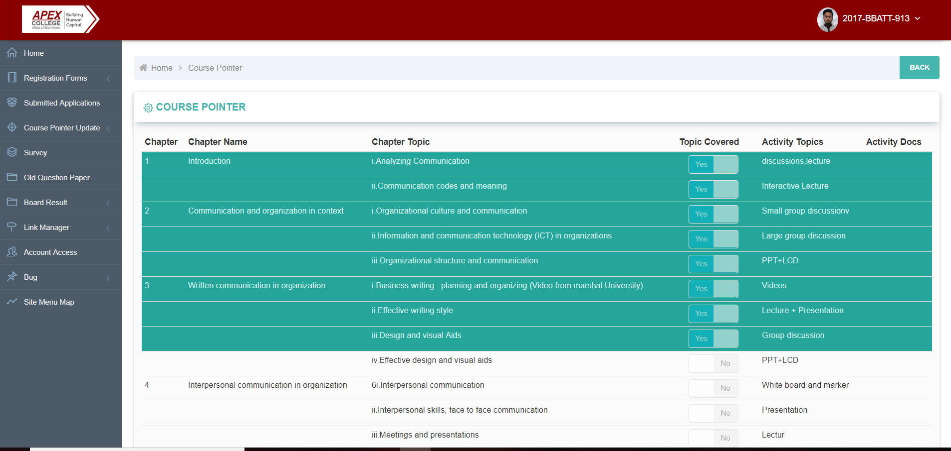

*Fig: Inner view of courses*

1. **Form Viewing Page:**

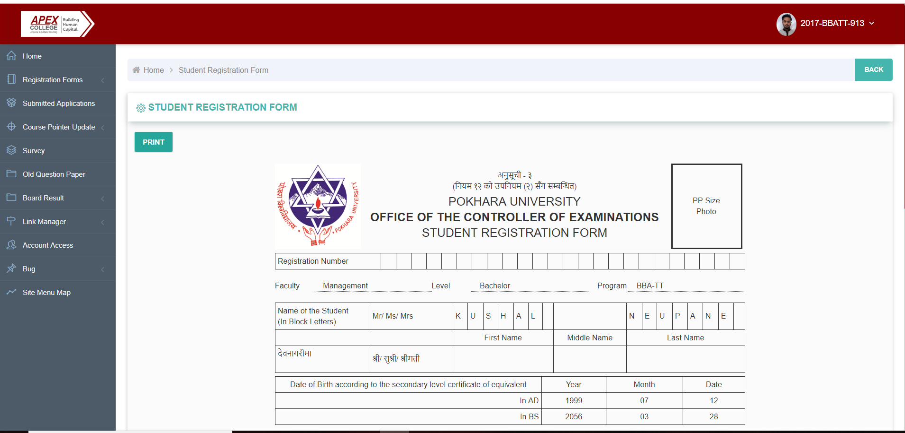

*Fig: Registration form*

This option shows the registration forms of the student which has been submitted to the affiliated university. There is also an option for course registration request form from which the students can write the list of the courses s/he wants to study. This show the legal alignment of student to the university.

**Merits of Newmis:**

* It shows the attendance of the students.
* The courses which will be covered in the coming days are also shown.
* Non-users can visit the social pages and get information about the college.
* It is simple and easy to use.
* It requires less data to load the contents.
* Legal proof of student’s alignment to university is shown as it shows the copy of registration form.
* There is proper updating in the system performance and bugs.

**De-Merits of Newmis:**

* The server cannot hold many users at a time.
* The images and graphics designs are of low quality.
* University announcements are not given more priority.
* Result is not displayed in the same webpage. It must be downloaded manually.

1. **Moodle mobile app (**[https://moodle.org](https://moodle.org/)s**)**

It is the open source learning app for all kinds of the users.

1. **The Login page:**

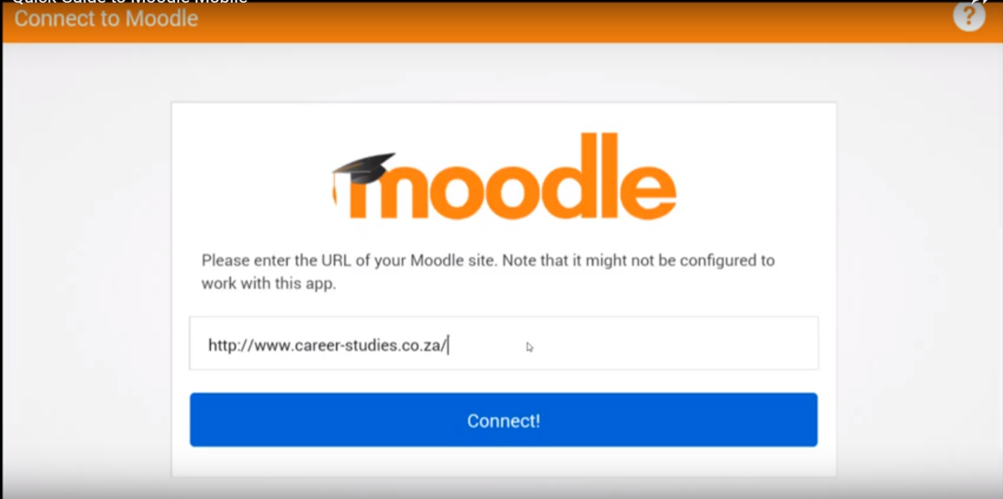

*Fig: URL for app*

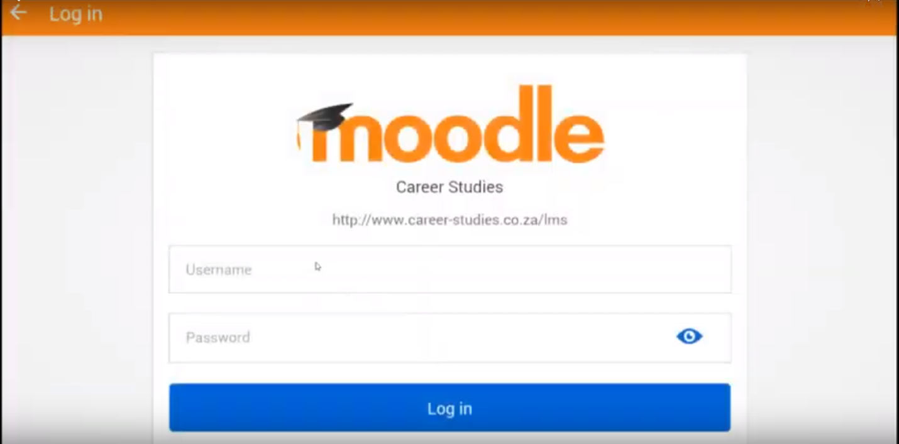

*Fig: user login portal*

The login page has two login portals. First the user has to input the URL for the Moodle app and it lands to another login page where the user has to input their login name and a password.

1. **Courses:**

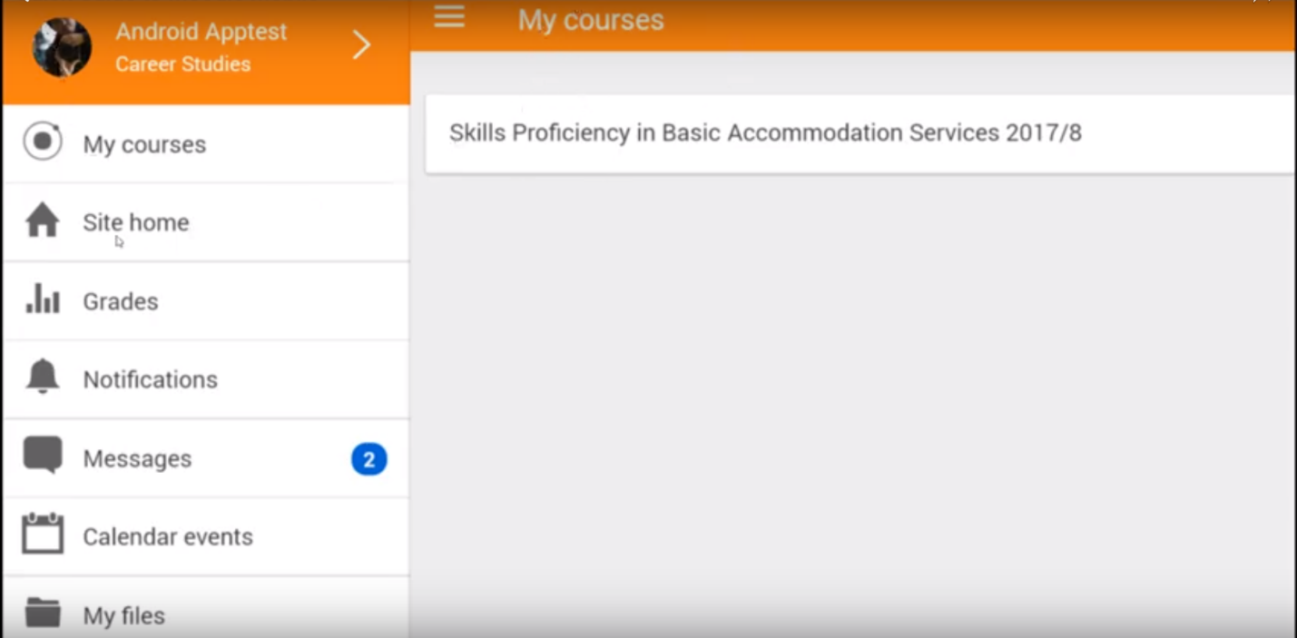

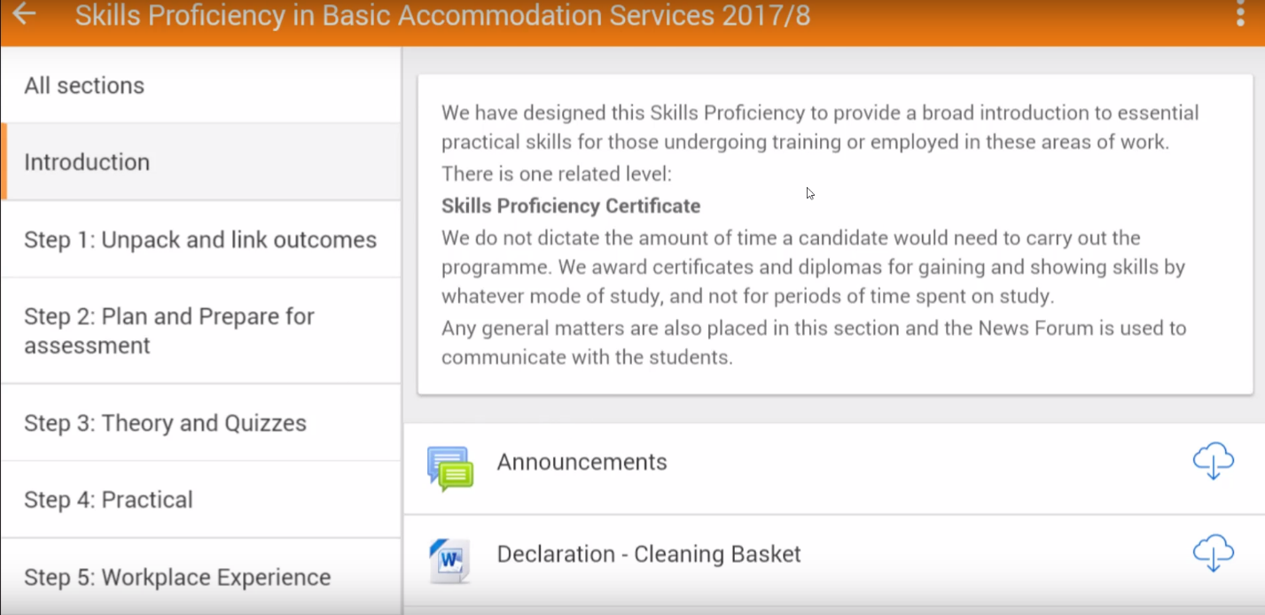

*Fig: courses*

After logging into the app, it lands into my courses. It shows the course in which the user is assigned into. On the left-hand side, there is a dropdown list which displays the homepage, grades, messages etc. options. Moving further into courses, we can see the materials of the courses. The announcements of the specific course is shown inside here.

1. **Grade:**

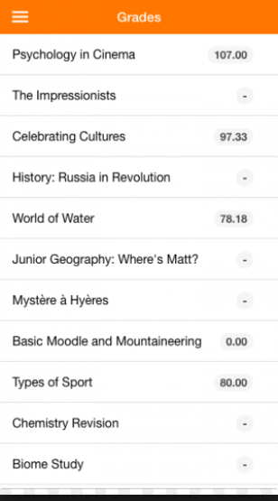

*Fig: Grade view*

This shows the grade of the student in the course. The tutor can update, grade and alter the grades of the student where as it is read only for the students.

**Merits of Moodle:**

* It is mobile friendly and easy to access.
* It requires less data to operate.
* As it is a global learning platform, so everyone can be a user of this app.
* It is configurable, highly-Flexible, and feature-Rich

**De-Merits of Moodle:**

* It cannot run larger project and files as the server is weak.
* The increase in number of users makes the system slower.
* It is difficult to customize the application.
* There are very less updates in this app which doesn’t cover most of the bugs.

Hence, from all the comparison of the different alike applications, our system must fulfill the following needs:

* It must be easy to use and mobile friendly.
* It should have proper section for viewing grades, announcements and attendances.
* It should be customizable, flexible and feature-rich.
* The number of users using the software should not hinder the performance of the system.
* There should be proper updates to fix the bugs.
* There should be provision for the backup server for the application.
* It should be associable in any internet condition.
* The graphics contains should be good.

#### 2.1.3.2Development Relevant Legislation

When making the web application for this university our team make sure to abide certain laws and acts. Some of the laws and acts that software companies should abide are listed as follow:

1. The Data Protection Act (1998),
2. The Computer Misuse Act (1990),
3. The Equality Act (2010)

Our team made sure to do our work within these laws and not breach them. These acts and laws are here to protect people’s privacy, to give everyone equal rights and to protect peoples work and ideas.

The Data Protection Act is an act in which people’s personal information is protected. The Data Protection Act states that:

*“Personal data shall be processed fairly and lawfully and, in particular, shall not be processed unless one of the conditions for ‘relevant for purposes of the data protection principles: processing of any person or processing of sensitive personal data’ is met.” [UK Government, 1998]*

*“Personal data shall be obtained only for one or more specified and lawful purposes, and shall not be further processed in any manner incompatible with those purposes.” [UK Government, 1998]*

So, for Woodland University college, they get information when the student signs up for the application process and once they are eligible, they are enrolled in the university. Once the students are enrolled in the university then they are eligible to use the services provided by the university. For those users who are not enrolled in the university they can only use the application but cannot use the service provided by the university.

*“Personal data shall be adequate, relevant and not excessive in relation to the purpose or purposes for which they are processed*.” *[UK Government, 1998]*

The data that the university gains will only be used where necessary. The records of the students should not be made public. The university should not provide the students records to anyone unless they have legal rights to access the information.

*“Personal data processed for any purpose or purposes shall not be kept for longer than is necessary for that purpose or those purposes.” [UK Government,1998]*

Suppose, when a staff/student leave the university then the university can only keep the information/records for certain period of time and then they have to remove the data under the act. This was the meaning of the above statement.

*“Personal data shall be accurate and, where necessary, kept up to date.” [UK Government,1998]*

The student/user should inform the university if they change their details such as address and so on. They are responsible to inform the university if their details are changed.

*“Appropriate technical and organizational measures shall be taken against unauthorized or unlawful processing of personal data and against accidental loss or destruction of, or damage to, personal data.” [UK Government,1998]*

The staff/member of the university should have to sign up to the Data Protection Act. If the staff/member is using the data of the student/user then the university have to take legal action to the staff/member. The staff/member should follow the terms and conditions of the university for the protection of their student/user right.

The Computer Misuse Act (1990) is an act that protects user from accessing files from computer without permission. This act protects the personal data from inappropriate manners. The Computer Misuse Act states:

*“Unauthorised access to computer material.” “A person most not cause a computer to perform any function with intent to secure access to any program or data held on any computer”. [UK Government, 1990]*

The staff/member/user of the university should not violate this act. They should follow the university protocols. All the users log in from the application with their unique id and password to access their data. They should not give the password to any other users so that their data is safe.

*“The person is guilty of an offence if he accesses the unauthorised data or information with intent to commit or facilitate commission of further offences.” [UK Government, 1990]*

The user/student should not allow their data to be used by other users. If the user/student allow their data to be used by others than they would be held responsible for their act and can be suspended from the university.

*“Unauthorised modification of computer material.” [UK Government, 1990]*

The above statement implies that the user/student cannot modify the data or information of another user and present it as if the work is done by them. The university will take strict action in such condition.

*The Equality Act (2010) protects people from any kind of discrimination based on age, color, sex, race and so on. These acts help people to respect each other and to take legal action in case of unfair treatment.*

#### 2.1.3.3Academic Literature Review

In research of different ideas of School management methods, the researcher has carried out some of research on journals to support the ideas of better management of school and colleges.

|  |  |  |
| --- | --- | --- |
| Title | Author/date | Subject relevant topics |
| A Study on School Management System. | Baginwar Akash/2013 | * The powerpoint presentation represents all the aspects of the research on the school called ISTR. * The document stated usage of SAS(Statistical analysis System) to define a sequence of operations. * The provision of payment of fees and examination online was available. |
| A Complete School Management System | E-tech School Online/2014 | * Notifications and messages could be set according to the preferences, also includes private chatting between users. * Offline services for the courses and contents. (Files could be downloaded and later be accessed without help of internet) * Forums section for discussions. * The students can have shared contact numbers |

# 2.2 Requirements Specification

## 2.2.1 Problem Domain Description

Current course management system is based on the clerical system. This is the paper based system where the module leader, course leader, students works on basis of paper. Required documents, reports and other requirements are fulfilled through clerical system.

#### 2.2.1.1 Existing Business Operation

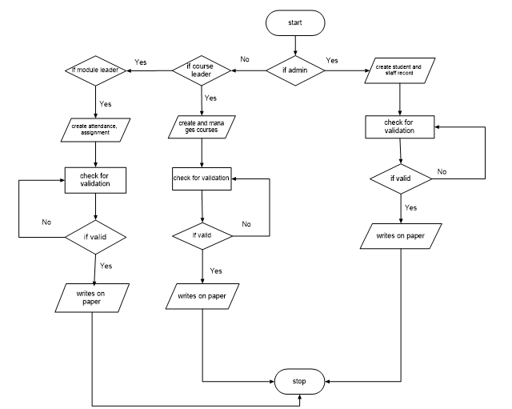

*Figure: 2.1 Create Records*

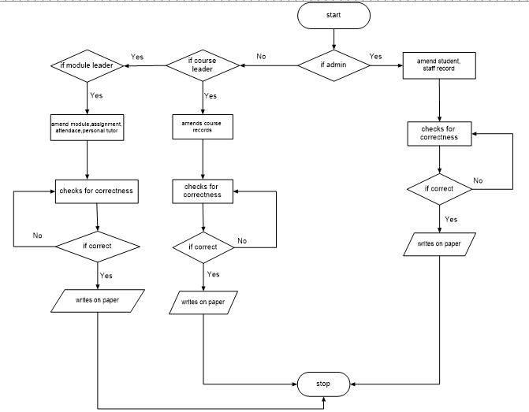

*Figure: 2.1 Amend Records*

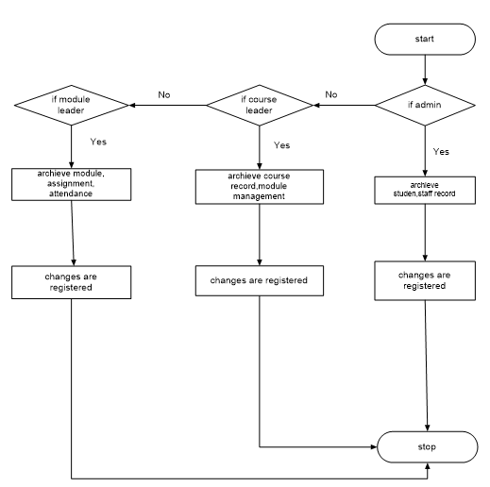

*Figure: 2.1 Archive Records*

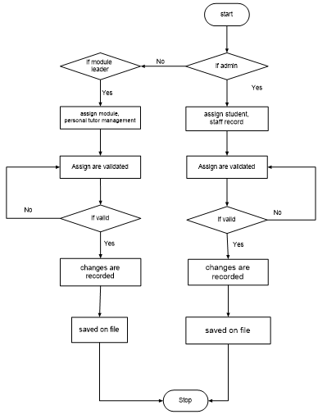

*Figure: 2.1 Assign Records*

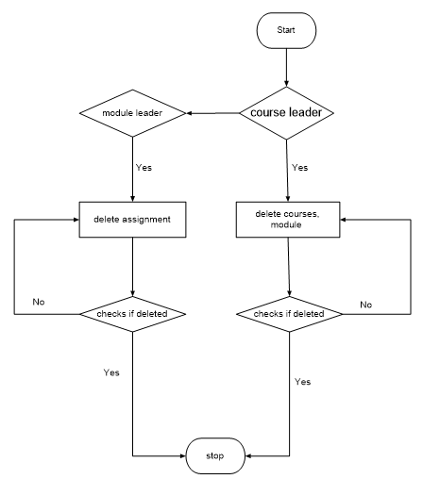

*Figure: 2.1 Delete Records*

#### 2.2.1.2 Summary of existing business limitations requiring resolution

Clerical based system is one of the oldest practices in today’s world. It is totally a

paper based system. In this system all the activities of recording like records of staff, student attendance and other essential things are done on basis of the paper. Management of assignment, timetable is also done on paper. Once they are done either they are posted on the notice board or either they are given to the students personally. All the data are recorded on the paper, data’s of newly joined students, newly joined staffs. Topics related to module are also recorded on paper. And once they are prepared they are provided to the students through paper.

In terms of the limitation many topics rises, topics like security, reliability, efficiency and others. As, the records are on the paper, there will be lot of paper and becomes difficulty to manage. In case of security papers may get lost, even rats may torn the papers to pieces and once the data are wiped out it is the beginning of the more trouble. While filling the data also one can make a mistake and even the same data may be recorded over and over. To get the certain data on certain person it is seems to be more time consuming. Since, it is the large institution there will be thousands of papers and it is obvious that to get the data on certain person from those it would be time consuming although it is managed in their systematic way.

## 2.2.2 Functional Requirements

#### 2.2.2.1 Basic Functionality Item Listing

The students record, staff records, course records, attendance records, etc. holds many information and functions to be retrieved, create, edit, assign, maintain, archive, delete and many more.

Here are the records operation lists:

Table: 2.1 Basic Functionality Item Listing

|  |  |  |  |  |
| --- | --- | --- | --- | --- |
| **Area** | **Admin** | **Course Leader** | **Module Leader/Personal tutor** | **Student** |
| **Student Records** | - Create records of new student  - Edit records of new student  - Archive records of new student  - Display the updated records. | - Assign the added students to their related platform. | No access | - View their own updated records |
| **Staff Records** | - Create records of new staff  - Edit records of new staff  - Archive records of new staff  - Display the updated records. | - View their own updated records. | - View their own updated records | No access |
| **Course Records** | No access | - Create the structure of the new course related to its module  - Edit the course contents  - Display the contents of the courses  - Delete the courses - Archive any courses that are displayed. | No access | No access |
| **Module Management** | No access | - Create a new module  - Edit the displayed module  - Delete the module  - Archive the module  - View all the updated modules | - Create a new module - View all the modules | -View all the updated modules |
| **Assignment Management** | No access | - Mark and display the grade records of student of any courses related to their own module. | - Create the assignment  - Edit the assignment  - Delete the assignment  - Archive the assignment  - Calculate the scored grades of the student. | No access |
| **Attendance Records** | - Assign any actions or punishment to the student who have low attendance. | - Create the attendance of the student and monitor them. | - Create the attendance of the students  - Edit the attendance of students  - Archive the attendance of students - Monitor and display the updated records. | - View their own attendance. |
| **Personal Tutor management** | No access | No access | - Create a new module - Edit the module  - Assign the module to their respective courses - Display the updated records. | No access |
| **Time Table Management** | - | - | - | - |
| **Diary management** | - | - | - | - |
| **Report Generation/ Management** | No access | - Create the report of any related course  - Display the report – Print the report | No access | No access |

Here is more clarified entity list for Student record:

Table: 2.2 Students Record

|  |
| --- |
| students |
| Name of entity | **Type/Format** | **Notes** |
| student_record_status | CHAR(Provisional, Live, Dormant) | Students current status |
| dormant | CHAR(Graduated, Withdrawal, Terminated) or NULL | Reason for dormancy. If not dormant it should be null |
| firstname | String (Limited to 25 characters) | First name of the student |
| middlename | String (Limited to 25 characters) | Middle name of the student |
| surname | String (Limited to 25 characters) | Last name of the student |
| address_term_time | String (Limited to 50 characters) | Term time address |
| address_non_term_time | String (Limited to 50 characters) | Non-term time if different |
| id | Integer (8 digits, no decimal place) Format (99999999) | student assigned ID number |
| password | Encrypted String (Limited to 32 characters to allow encryption) | Students password |
| phone_no | String (Limited to 25 characters) | Students telephone or mobile number |
| email | String (Limited to 50 characters) | Email address of student |
| course_code | String (Limited to 5 characters) | Current course code student is enrolled into |
| entry_qualification | String (Limited to 50 characters) | Qualification of the student |
| exit year | Date (DD-MM-YY) | Time duration for student to day in University |

Here is more clarified entity list for Administrator record:

Table: 2.3 Admin Record

|  |
| --- |
| admin |
| Name of entity | **Type/Format** | **Notes** |
| admin_record_status | CHAR(Live or Dormant) | admin current status |
| dormant | CHAR(Retired, Resigned, Misconduct) or NULL | Reason for dormancy. If not dormant it should be null |
| firstname | String (Limited to 25 characters) | First name of the administrator |
| middlename | String (Limited to 25 characters) | Middle name of the administrator |
| surname | String (Limited to 25 characters) | Last name of the administrator |
| address | String (Limited to 25 characters) | Address of administrator |
| id | Integer (8 digits, no decimal place) Format (99999999) | administrator assigned ID number |
| password | Encrypted String (Limited to 32 characters to allow encryption) | administrator password |
| phone_no | String (Limited to 25 characters) | administrator telephone or mobile number |
| email | String (Limited to 50 characters) | Email address of administrator |

Here is more clarified entity list for Module Leader record:

Table: 2.4 Module Leader Record

|  |
| --- |
| module_leader |
| Name of entity | **Type/Format** | **Notes** |
| module_leader_record_status | CHAR(Live or Dormant) | module leader current status |
| dormant | CHAR(Retired, Resigned, Misconduct) or NULL | Reason for dormancy. If not dormant it should be null |
| firstname | String (Limited to 25 characters) | First name of the module leader |
| middlename | String (Limited to 25 characters) | Middle name of the module leader |
| surname | String (Limited to 25 characters) | Last name of the module leader |
| address | String (Limited to 25 characters) | Address of module leader |
| id | Integer (8 digits, no decimal place) Format (99999999) | module leader assigned ID number |
| password | Encrypted String (Limited to 32 characters to allow encryption) | module leader password |
| phone_no | String (Limited to 25 characters) | Module leader telephone or mobile number |
| email | String (Limited to 50 characters) | Email address of module leader |
| role | String (Limited to 25 characters) | Eg: module tutor for XXXX, personal tutor, course leader |

Here is more clarified entity list for Course Leader record:

Table: 2.5 Course Leader Record

|  |
| --- |
| course_leader |
| Name of entity | **Type/Format** | **Notes** |
| course_leader_record_status | CHAR(Live or Dormant) | course leader current status |
| dormant | CHAR(Retired, Resigned, Misconduct) or NULL | Reason for dormancy. If not dormant it should be null |
| firstname | String (Limited to 25 characters) | First name of the course leader |
| middlename | String (Limited to 25 characters) | Middle name of the course leader |
| surname | String (Limited to 25 characters) | Last name of the course leader |
| address | String (Limited to 25 characters) | Address of course leader |
| Id | Integer (8 digits, no decimal place) Format (99999999) | course leader assigned ID number |
| password | Encrypted String (Limited to 32 characters to allow encryption) | course leader password |
| phone_no | String (Limited to 25 characters) | course leader telephone or mobile number |
| Email | String (Limited to 50 characters) | Email address of course leader |
| Role | String (Limited to 25 characters) | Eg: module tutor for XXXX, personal tutor, course leader |
| specialist_subject | String (Limited to 50 characters) | Eg: Computing-Database Technology |

#### 2.2.2.2 Functionality Operational Logic

The following figures demonstrate how the new system will operate logically for key operations:

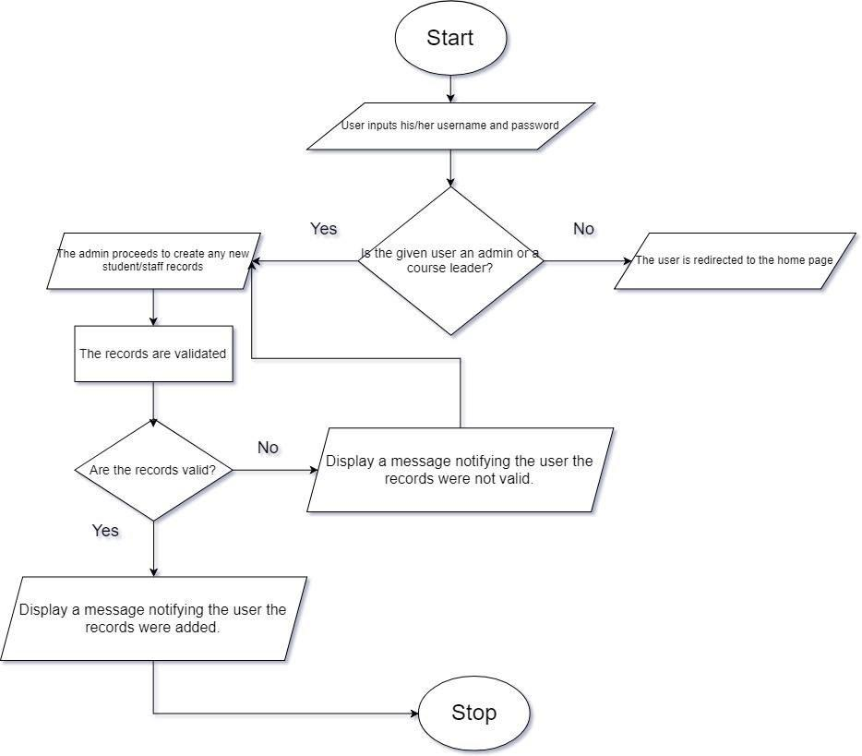

*Figure: 2.1 Create Records*

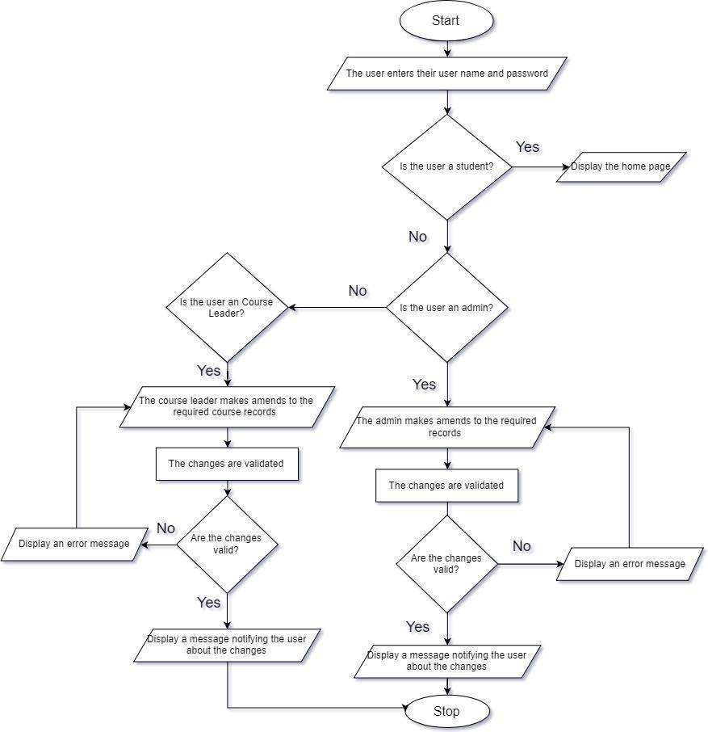

*Figure: 2.2 Amend Records*

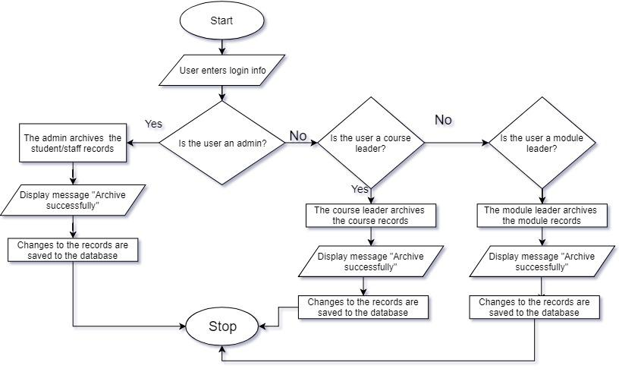

*Figure: 2.3 Archive Records*

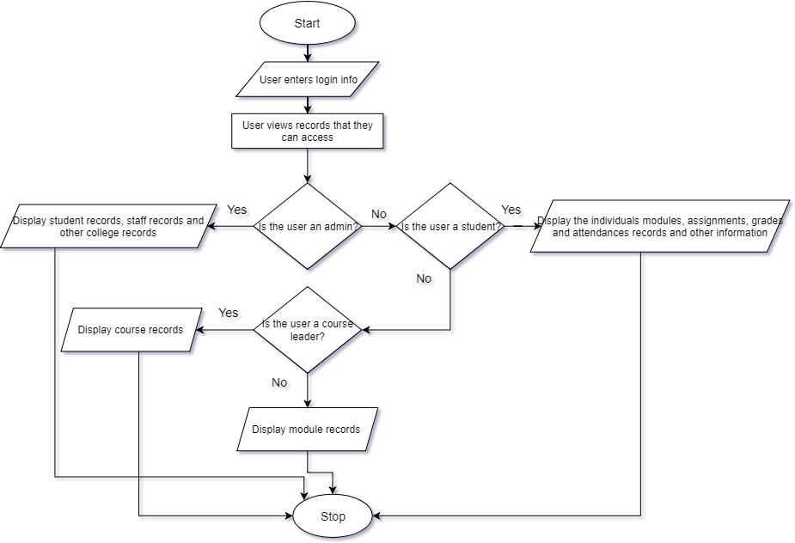

*Figure: 2.4 Display Records*

#### 2.2.2.3 Attribute Table and Associated Drop-Down (Sub-category listing) Selection Options

This table lists the important attributes along with their brief description. In some cases, drop down list (sub-categories) are also mentioned below:

|  |  |
| --- | --- |
| **Attribute** | **Notes/ Examples** |
| student_record_status | It’s the present status of a student.  The record status are either Provisional, Live or Dormant. |
| dormant (for student) | If a student is dormant, the reason should be specified. The reasons may be either Graduated, Withdrawal, Terminated.  If the reason is not specified, then dormant should be NULL. |
| firstname | Fitst name of a staff or a student |
| middlename | Middle name of a staff or a student |
| surname | Surname name of a staff or a student |
| address_term_time | Temoprary Address of student |
| address_non_term_time | Permanent Address of student |
| id | Students or Staff id number.  Once they are part of organization, each individual are assigned a unique Id number. |
| password | Password are assigned to each individual (staff or students), once they are enrolled. |
| phone_no | Phone number of staff or student |
| email | Email of staff or student |
| course_code | Code assigned to each courses, which are taught in the University |
| entry_qualification | Qualification of a students before being assigned to University.  Entry qualification can also be taken as pre-requisites. |
| exit_year | Once registered to University, Student are provided a exit year, the year which whey leave or graduate from the college. |
| admin_record_status | It’s the present status of an admin.  The record status are either Live or Dormant. |
| dormant (for admin) | If a admin is dormant, the reason should be specified. The reasons may be either Retired, Resigned, Misconduct.  If the reason is not specified, then dormant should be NULL. |
| module_leader_record_status | It’s the present status of a Module Leader.  The record status are either Live or Dormant. |
| dormant (for module leader) | If a module leader is dormant, the reason should be specified. The reasons may be either Retired, Resigned, Misconduct.  If the reason is not specified, then dormant should be NULL. |
| role | Each Module leader has a specific role in the University.  For e.g. module tutor for XXXX, personal tutor, course leader, etc. |
| course_leader_record_status | It’s the present status of a Course Leader.  The record status are either Live or Dormant. |
| dormant (for course leader) | If a module leader is dormant, the reason should be specified. The reasons may be either Retired, Resigned, Misconduct.  If the reason is not specified, then dormant should be NULL. |
| specialist_subject | Each Course Leader are employed for certain subjects.  Subject Specialist specifies to which subject course leader is assigned to, For e.g. Computing-Database Technology |

#### 2.2.2.4 Example External Output Format (for use with e-mail/letters/SMS/reports)

1. **Failure to attend Personal Tutor Meeting**

|  |
| --- |
| DD/MM/YYYY  Dear Title First Name surname, (eg. XYZ)  Your name has been referred as a possible cause for concern by your module co-ordinator because you are recorded as: Not attending a personal tutorial meeting [ ]  It is essential that you see me as soon as possible. You must do this by Date(DD-MM-YY). The meeting will check and review your progress and find a means of resolving any difficulties you may be experiencing. The Student Code details the implications of 'failure to attend personal tutor meetings' and whilst there may be mitigating circumstances not known to us at this time, you should regard this letter as an informal warning that your continuation on the course may be at risk.  If for any reason you are experiencing difficulties which impact on your academic work, you should contact your personal tutor for advice. You must however see me as instructed by the -------------------.  Yours sincerely,  Module Co-Ordinater  To Students email-id  CC Student file / Course Leader |

1. **Poor Attendance Letter**

|  |
| --- |
| DD/MM/YYYY  Dear Title First Name surname, (eg. Mr XYZ)  Your name has been referred as a possible cause for concern by your module co-ordinator because you are recorded as: Having poor or no attendance at classes [ ]  It is essential that you see me as soon as possible. You must do this by Date(DD-MM-YY). You are reminded that all students enrolling on a course at UCN are expected to meet the academic requirements of their programme. The Student Code details the implications of 'failure to meet required attendance' and whilst there may be mitigating circumstances not known to us at this time, you should regard this letter as an informal warning that your continuation on the course may be at risk. Failure to make contact may result in us deeming you to be withdrawn from your course.  If for any reason you are experiencing difficulties which impact on your academic work, you should contact your personal tutor for advice. You must however see me as instructed by the -------------------.  Yours sincerely,  Module Co-Ordinater  To Students email-id  CC Student file / Course Leader |

1. **Failure to Submit Coursework**

|  |
| --- |
| DD/MM/YYYY  Dear Title First Name surname, (eg. Mr XYZ)  Your name has been referred as a possible cause for concern by your module co-ordinator because you are recorded as: Not submitting coursework [ ]  It is essential that you see me as soon as possible. You must do this by Date(DD-MM-YY). You are reminded that all students enrolling on a course at UCN are expected to meet the academic requirements of their programme. The Student Code details the implications of 'failure to meet academic, professional or vocational requirements' and whilst there may be mitigating circumstances not known to us at this time, you should regard this letter as an informal warning that your continuation on the course may be at risk. Failure to make contact may result in us deeming you to be withdrawn from your course.  If for any reason you are experiencing difficulties which impact on your academic work, you should contact your personal tutor for advice. You must however see me as instructed by the -------------------.  Yours sincerely,  Module Co-Ordinater  To Students email-id  CC Student file / Course Leader |

1. **Address Amendment Letter**

|  |
| --- |
| DD/MM/YYYY  Dear Sir or Madam,  This letter is to notify you about my change of residency. As I have recently moved into new location, I would like to amend on my previous address on my profile. My full details are provided below:-  Name:  Students name  Uni ID:  University ID  Previous Address:  Street name, City, Country  (Eg: 345 New Road, Kathmandu, Nepal)  Current Address:  Street name, City, Country  (Eg: 451 Jorpati, Kathmandu, Nepal )  I would be very grateful for your help.  Thanks and regards,  (name of student)  To: Administrator |

1. **Confirmation Letter**

|  |
| --- |
| DD/MM/YYYY  Dear Title First Name surname, (eg. Mr XYZ)  Your Amendment of Address from (previous address) to (new address) has been verified and confirmed.  Your Profile has been Updated successfully.  If you have any queries, please do contact, Student Service Office.  Yours sincerely,  Administrator  To Students email-id |

### 2.2.3 Performance Requirements

The performance of a software is one of the critical and important attribute of a system. With the rapid growth in online application usage, performance of any software, or system plays a vital role in the software’s success or failure so, proper planning and testing is done to confirm this prototype software. The following requirement are taken into consideration

#### 2.2.3.1 Speed

The speed of the system refers to the speed at which the data is loaded onto the main page. A good system requires fast access of data, so the system increases efficiency of the system. So, the main two factors for speed are:

1. **Response time:**

The response time of a system is faster. So, the new system is expected to response within less than 2-3 seconds if it meets all the criteria such as internet speed, device performance, etc. For this, different servers are deployed to test the pilot system.

1. **Throughput:**

If all the criteria are met, the pilot system can handle at most 1000 users at a time. The server can provide required records within a second with a Throughput = 100ms(micro seconds).

#### 2.2.3.2 Capacity

Since the system is a pilot the total capacity is unknown but would potentially support over a 1000 user. With over 1000 users using the system, the user’s data must be secured and stored properly so, different servers will be used to store data securely.

#### 2.2.3.3 Reliability

Reliability means how reliable the system is, how often the software crashes, and how secure the system is. The users should be able to access the website/ system for as long as possible and from any devices. Proper security of user’s data is maintained. The system will have a login system so that the authorized user’s data are protected and they can’t access other user’s data except theirs and protect from unauthorized users.

#### 2.2.3.4 Usability

The system must be user friendly so that everyone can learn and operate the system easily. If the software is not user friendly, complex to learn and use, the system will not be used for long which results in user’s will stop using the system. Since this is a college system, the loss of users is unacceptable as all the academic events are handled through the system. So, the system is simple, easy to understand, is made of user-friendly color combination, is responsive with proper security. By making the system easy to understand and use the information can easily be shared to all the user of the system which are usually the students and staffs.

### 2.2.4 Design Constraints

Well the client lacks the facility of the online base system and so currently using the paper base system where they are having trouble in working efficiently. The system is outdated and causes more problems in the university as well as for students also. Since every faculty are having a problem with the paper base system they are planning to have the online base system which over takes the facility of the paper base system and helps all the faculty member to work effectively and efficiently which will lead the students with a big help in having notes and other things such as checking attendance, having tests and exams.

As for the demand in the system, it should work with network in the laptop where every faculty has the different ability to do the work such as admin has the facility to maintain the records of both teachers and students where course leader has the ability to maintain the information regarding the courses. Admin can change the records of the students and tutors if there are errors. He can also manage the notice board with the functions and programs if there is any. Talking about module tutors, they should have the facility to work only in their specific modules where they can add slides and have mock exams with no interference of other module tutors.

Besides the faculty the system must be helpful for the students so that they don’t have problems in study. If any student is not able to attend the class, then the student could get the notes through the system and also can communicate with the tutors for the help. They can check their attendance and have all the slides of all the modules respectively.

All the properties that paper based system had must be in the online based system in précised form such as attendance entry, module slides and tests respectively, marks visible to the students. According to the information gathered from the interview, students are having trouble with the system. Once they loss the class with some reason they will be having trouble in the study for long term because of the lack of the notes availability. So putting the focus on the students, as they are former viewer and user of the system, they are given the facility to go through the module slide as well as library too where they can have extra books to study accordingly. Some may want to research on the books and there are very few sites which facilitates needy books. This could be a big help for them to have the authority to go through the library books available in the system.

As per the functionality of the system HTML, CSS could be the considerable programming language to be used to design the website. This is the easy language to use which helps in fulfilling the all functionality in the system. Since there are different functions and work to do in the system, it is demanded to be work in PC’s. As for the students, they are using mobile phone very frequently and so they are demanding the system to work on the mobile phones if possible which will help them get information any time they need.

Besides these, the layout of the website is the important part of the system so that it could help the users to use very easily without having any difficulties. Well the price depends upon the work.

### 2.2.5 Commercial Constraints

Since, the system is pilot trial, our group will be updating the following table after real implementation of the software:

|  |  |
| --- | --- |
| **Project Info** |  |
| Weeks Worked |  |
| Wage (per hour) |  |
| Number of workers |  |

|  |  |  |  |
| --- | --- | --- | --- |
| **Project Tasks** |  | | |
|  | **Weeks** | **Time weekly(in hrs)** | **Total wage** |
| Requirement Engineering |  |  |  |
| System analysis and design |  |  |  |
| System Interface designs |  |  |  |

|  |  |
| --- | --- |
| **Project Building** |  |
| **Total weeks worked** |  |
| **Activities** | **Work percent per week** | **Time weekly(in hrs)** | **Total wage** |
| Software |  |  |  |
| Testing |  |  |  |
| Analysis |  |  |  |

|  |  |
| --- | --- |
| **Total building cost** |  |

**Supplementary costs:**

|  |  |
| --- | --- |
| **Expenses on topics** | **Costs** |
| Hardware and Software |  |
| Official expenses |  |
| Further expenses (%) |  |
| Gain Border ( %) |  |

|  |  |
| --- | --- |
| **Total Cost** |  |

### 2.2.6 Acceptance Tests

|  |  |  |
| --- | --- | --- |
| ID NO. | Software performance test | Test Strategy |
| 1. | Accepts multiple users simultaneously | * Performance of the software depends upon the number of users using the software simultaneous * Testing is done on the software allowing the multiple users simultaneously |
| 2. | Throughput Speed | * Throughput speed is the speed through which the requested data is being provided from the server * Testing is done on surveying on various users * Through the good internet speed the average throughput is about 100ms(micro second) |
| 3. | Response Time | * response time is defined as the time taken from the time of the request made by the users until the user gets the response on requested one * survey is done on various users * average response time of about 2-3 seconds came as a result on good internet |
| 4. | Capacity | * on our project we define capacity as the capacity of number of users the system can hold at a time * as on testing we came with the result of supporting over 1000 users at a time |
| 5. | System Reliability | * system reliability is the smoothness on the system, how often the software crashes, and how secure the system is * for this testing the software is run for the longer time and no problem is found * in the case of the |

# 3 System Analysis & Design

## 3.1 Preliminary Design Stages

### 3.1.1 Textual Analysis

|  |  |
| --- | --- |
| Candidate | Candidate authority |
| Admin | Login  logout  Data entry  Database access  Upload notices  Add events  Search  Add user  Delete user  Edit user  View staff details  View student details |
| Course leader | Login  logout  Add course  edit course  delete course  append course |
| Module tutor | Login  Logout  Add slides  Edit slides  Add assignment  Grade assignment  Make marks visible  Create mock test |
| Students | Login  Logout  View modules  View slides  Submit assignment  View marks  Attend mock exams |
| Course Record |  |
| Module -management | Append module  Edit module  Update module |
| Assignment- management | Upload assignment  Delete assignment  Edit assignment |
| Attendance- management | Attendance entry  View attendance  Edit attendance  Delete attendance |
| Personal Tutor- management |  |
| Report generation | Upload grades  Update grades  Edit grades  Delete grades |

### 3.1.2Significant Event Analysis

|  |  |  |
| --- | --- | --- |
| **Event** | **Performers** | **Attributes** |
| Login | Admin  Student  Module tutor  Course leader | Username  password |

|  |  |  |
| --- | --- | --- |
| **Event** | **Performers** | **Attributes** |
| Change password | Student  Admin  Module leader  course leader | User id  Old password  New password |

|  |  |  |
| --- | --- | --- |
| **Event** | **Performers** | **Attributes** |
| View student details | Admin | Student name  Student id  student address  student phone  student email-id  Attendance  Grades  Submission  Gender  DOB |

|  |  |  |
| --- | --- | --- |
| **Event** | **Performers** | **Attributes** |
| View staff details | Admin | First name  Last name  Staff id  Staff address  Staff phone no.  Gender  DOB |

|  |  |  |
| --- | --- | --- |
| **Event** | **Performers** | **Attributes** |
| Add module slides | Module tutor | upload slides  add slides  delete slides |

|  |  |  |
| --- | --- | --- |
| **Event** | **Performers** | **Attributes** |
| Create event and program information | Admin | Create events  Delete events |

|  |  |  |
| --- | --- | --- |
| **Event** | **Performers** | **Attributes** |
| Reset website login | admin | Reset password |

|  |  |  |
| --- | --- | --- |
| **Event** | **Performers** | **Attributes** |
| Assignment submission | student | Upload assessment  Submit assessment |

|  |  |  |
| --- | --- | --- |
| **Event** | **Performers** | **Attributes** |
| View modules | Module tutor  students | View modules  View slides  Download slides |

|  |  |  |
| --- | --- | --- |
| **Event** | **Performers** | **Attributes** |
| Create mock exam | Module tutor | Create mock exam  Create time limit  Limit grade |

|  |  |  |
| --- | --- | --- |
| **Event** | **Performers** | **Attributes** |
| Attend mock exam | students | Open mock test  Give exam  Submit exam  View grades |

### 3.1.3Commands Queries and Constraints.

|  |  |  |
| --- | --- | --- |
| Class | Admin | Part:1/1 |
| Type Of Object: staff | | Indexing:  Cluster:  Created: |
| Queries | * Id * First name * Last name * E-mail address * Phone no. * Gender * DOB | |
| Commands | * Login * Logout * Update details * Edit details * Delete details * View * Search | |
| Constraints | * Must be a registered staff member of the university | |

|  |  |  |
| --- | --- | --- |
| Class | Course leader | Part:1/1 |
| Type Of Object :staff | | Indexing:  Cluster:  Created: |
| Queries | * Id * First name * Middle name * Last name * E-mail address * Phone no. * Gender * DOB * Address | |
| Commands | * Log-in * Log-out * View * Edit course * Delete course * Update course | |
| Constraints | * Must be a registered staff member of university | |

|  |  |  |
| --- | --- | --- |
| Class | Module leader | Part:1/1 |
| Type Of Object : staff | | Indexing:  Cluster:  Created: |
| Queries | * Id * First name * Middle name * Last name * E-mail address * Phone no. * Gender * DOB * Address | |
| Commands | * Log-in * Log-out * View * Edit module * Delete module * Update module | |
| Constraints | * Must be a registered staff member of university | |

|  |  |  |
| --- | --- | --- |
| Class | Student | Part:1/1 |
| Type Of Object : | | Indexing:  Cluster:  Created: |
| Queries | * Id * First name * Middle name * Last name * E-mail address * Phone no. * Gender * DOB * Address | |
| Commands | * Log-in * Log-out * View slides * View grades * Submit assignment * View notice | |
| Constraints |  | |

## 3.2 Detailed Static System Designs

### 3.2.1 First Draft BON System Architecture Diagram

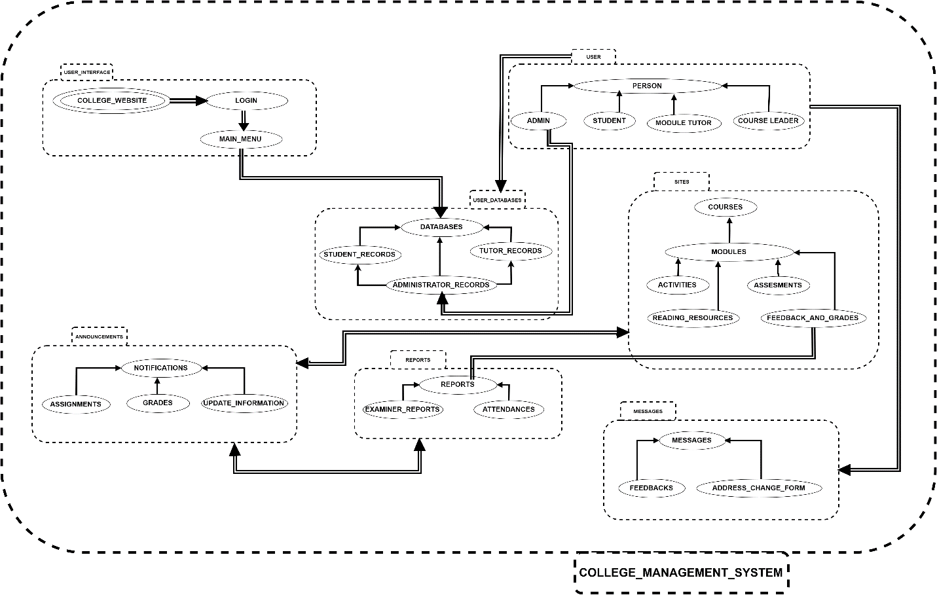

### 3.2.2 BON System Chart

|  |  |  |
| --- | --- | --- |
| **SYSTEM** | | **COLLEGE_MANAGEMENT_SYSTEM** |
| PURPOSE : System to manage and manipulate data of users in a college | | |
| **CLUSTER** | **DESCRIPTION** | |
| USER | Holds information about the main categories of people who interact with the system. | |
| USER_DATABASES | Holds the information of every record of every user in the database | |
| USER_INTERFACE | User Interface of the system(website) | |
| SITES | Areas of the User interface where users can navigate through study materials | |
| MESSAGES | A feedback form for inquiry | |
| REPORTS | Reports needed to be generated in the system | |
| ANNOUNCEMENTS | Every kind of notification in the system | |

### 3.2.3 BON Cluster Charts

|  |  |  |  |
| --- | --- | --- | --- |
| CLUSTER | User | | Part:1/1 |
| PURPOSE: interact with the system with the  Permission | | INDEXING:  Author: Prabin Shrestha | |
| Class/(Cluster) | | Description | |
| Students | | Main user of the academic system | |
| Admin | | Plays a role model in handling the academic behavior like adding modify essential material | |
| Module Tutor | | Performs all activities related to his/her module | |
| Course Leader | | Course related activities like adding, modify and other permissions are granted | |

|  |  |  |  |
| --- | --- | --- | --- |
| CLUSTER | User interface | | Part:1/1 |
| PURPOSE: like a main gate from where users  Log in into the system | | INDEXING  Author: Prabin Shrestha | |
| Class/(Cluster) | | Description | |
| College website | | Landing page where there is all information on college | |
| Login | | Place where users enters their details | |
| Main menu | | Menu bar where users after login can choose various options | |

|  |  |  |  |
| --- | --- | --- | --- |
| CLUSTER | User Database | | Part:1/1 |
| PURPOSE: to keep records of all people related to  academic | | INDEXING  Author: Prabin Shrestha | |
| Class/(Cluster) | | Description | |
| Student records | | Full details on college students | |
| Tutor records | | Full details about the tutors related to the college | |
| administrator records | | Full details on administrator | |

|  |  |  |  |
| --- | --- | --- | --- |
| CLUSTER | Sites | | Part:1/1 |
| PURPOSE: provides information related on their  respective courses and information  related to courses | | INDEXING  Author: Prabin Shrestha | |
| Class/(Cluster) | | Description | |
| Courses | | Path chosen by the students | |
| modules | | Related topics on the path chosen by the students | |
| activities | |  | |
| Assessment | | Works provided to student as a exam | |
| Reading resources | | All the materials provided by the institution to their students | |
| Feedback and grades | | Results gained after the work done by students on particular module | |
| CLUSTER | Announcement | | Part:1/1 |
| PURPOSE: to make announce on academic  topics to make student updated | | INDEXING:  Author: Prabin Shrestha | |
| Class/(Cluster) | | Description | |
| Assignment | | Work provided by module leaders | |
| Grades | | Place where we can see our results of our assignment and written exams | |
| Update information | | Any extra information that needs to be known by the students related on modules or other academic activities | |

|  |  |  |  |
| --- | --- | --- | --- |
| CLUSTER | Reports | | Part:1/1 |
| PURPOSE: provides whole records of students  enrolled in the college | | INDEXING:  Author: Prabin Shrestha | |
| Class/(Cluster) | | Description | |
| Examiner reports | | Reports of student who have given the exams | |
| attendances | | Attendances of the students on each modules | |

|  |  |  |  |
| --- | --- | --- | --- |
| CLUSTER | Messages | | Part:1/1 |
| PURPOSE: interaction between the student and  the concerned authority through this  medium | | INDEXING:  Author: Prabin Shrestha | |
| Class/(Cluster) | | Description | |
| Feedback | | Regarding the performance of the student | |
| Address change form | |  | |

## 3.3 Detailed Dynamic System Designs

### 3.3.1 Events Charts

#### 3.3.1.1 External (Incoming Event Chart)

|  |  |
| --- | --- |
| External (Incoming) | Involved object types |
| Tutor appeals to involve | REGISTER_FORM, TUTOR, ADMINISTRATOR,  COURSE, MODULE |
| Student request to register | REGISTER_FORM, STUDENT, ADMINISTRATOR,  COURSE |
| Tutor wants to login to their account | TUTOR_DETAILS, ADMINISTRATOR |
| Student wants to login to their account | STUDENT_DETAILS, ADMINISTRATOR |
| Tutor request to add content to the module | TUTOR, COURSE, MODULE, ADMINISTRATOR |
| Tutor request to view attendance of students | STUDENT, TUTOR, MODULE, ADMINISTRATOR |
| Tutor request to add, dele te and update a module | COURSE, MODULE, TUTOR, ADMINISTRATOR |
| Student request to update their account | STUDENT, COURSE_LEADER, ADMINISTRATOR |
| Tutor request to provide assignments of their module | TUTOR, COURSE, MODULE, ADMINISTRATOR, STUDENT |
| Student uploads assignment of related module | COURSE, MODULE, STUDENT, COURSE_LEADER |
| Tutor request to approve grades and display | COURSE_LEADER, COURSE, MODULE, STUDENT, TUTOR |

### 3.3.1.2 Internal (Outgoing Event Chart)

|  |  |
| --- | --- |
| Internal (Outgoing) | Involved object types |
| Course leader sends announcement to Tutors and students | COURSE_LEADER, TUTOR, STUDENT, ADMINISTRATOR |
| Course leader notifies tutors about updated course contents | COURSE_LEADER, TUTOR, STUDENT, ADMINISTRATOR, COURSES, MODULES |
| Administrator updates the calendar and displays it | COURSE_LEADER, TUTOR, STUDENT, ADMINISTRATOR, COURSES, MODULES |
| Course leader update any Programs, Exams and send it to the tutors and students | COURSE_LEADER, COURSES, MODULE, TUTOR, STUDENTS |
| Tutor send announcement to students | TUTORS, STUDENTS, ADMINISTRATOR |
| Tutor send mails via social media to students | TUTORS, STUDENTS |
| Course leader send assignment to tutor and student | COURSE_LEADER, TUTORS, STUDENTS, COURSES, MODULES |
| Tutor displays grades of students | TUTOR, STUDENTS, COURSES, MODULE, ADMINISTRATOR |
| Share information through chat system | TUTOR, COURSE_LEADER, STUDENTS, ADMINISTRATOR |

### 3.3.2 Object Creation Charts

|  |  |
| --- | --- |
| Class | Creates instance of |
| ADMISSION | STUDENT, REGISTER_PAPER, COURSE, TECHNICAL_PROGRAM, DATE, FEES |
| REGISTRATION | STUDENT, COURSE, FORM |
| ENROLL | STATUS, COURSE, STUDENT, PROGRAM_COMMITEE |
| ATTENDANCE | STUDENT, TUTOR, ATTENDANCE_PAPER, DATABASE, ADMINISTRATOR |
| ACCOUNT | STUDENT, TUTOR, COURSE, MODULE, EMAIL |
| MODULE | TUTOR, LECTURES, TUTORIALS, STUDENT |
| ASSIGNMENT | TUTOR, STUDENT, MODULE, PAPER, WEB-LINKS, ADMINISTRATOR |
| GRADES | TUTOR, UPDATES, STUDENT, COURSE, ASSIGNMENT, MODULE, ADMINISTRATOR |

### 3.3.3 System Scenario Charts

|  |  |  |  |
| --- | --- | --- | --- |
| **SCENARIOS** | *ADMIN_SUPPORT* | | **PART:** 1/5 |
| **COMMENT**  Set of representative scenarios to show important type of behavior for admin (adding students to the system). | | **INDEXING**  **created:** 2/22/2019 | |
| **Login:**  First open the login page and enter the admin id and password. | | | |
| **Students Management:**  Go to the student management tab in the admin homepage after logged in. | | | |
| **Add students:**  Go to the add student tab. Enter the first name, middle name, surname, address, phone number, email, course code, qualification, exit year, record status, dormant and save the details. | | | |
| **Display message:**  A message showing student added successfully is displayed. | | | |
| **Display student records:**  The student’s record table is updated with the new student details and the table is displayed. | | | |

|  |  |  |  |
| --- | --- | --- | --- |
| **SCENARIOS** | *ADMIN_SUPPORT* | | **PART:** 2/5 |
| **COMMENT**  Set of representative scenarios to show important type of behavior for admin (deleting students to the system). | | **INDEXING**  **created:** 2/22/2019 | |
| **Login:**  First open the login page and enter the admin id and password. | | | |
| **Students Management:**  Go to the student management tab in the admin homepage after logged in. | | | |
| **Delete students:**  Go to the student’s record tab. A delete button is pressed to delete the student’s record. | | | |
| **Display message:**  A message showing student deleted successfully is displayed. | | | |
| **Display student records:**  The student’s record table is updated and the table is displayed. | | | |

|  |  |  |  |
| --- | --- | --- | --- |
| **SCENARIOS** | *COURSE_LEADER_SUPPORT* | | **PART:** 3**/**5 |
| **COMMENT**  Set of representative scenarios to show important type of behavior for course leader (adding modules to the system). | | **INDEXING**  **created:** 2/22/2019 | |
| **Login:**  First open the login page and enter the id and password. | | | |
| **Opens module list:**  Go to the modules tab and view the modules list. | | | |
| **Add Modules:**  Go to the add modules tab. The modules details with the necessary content is selected and uploaded. | | | |
| **Display message:**  A message showing modules added successfully is displayed. | | | |
| **Display modules list:**  The updated modules list is displayed. | | | |

|  |  |  |  |
| --- | --- | --- | --- |
| **SCENARIOS** | *MODULE_LEADER_SUPPORT* | | **PART:** 4**/**5 |
| **COMMENT**  Set of representative scenarios to show important type of behavior for module leader (uploading module content to the system). | | **INDEXING**  **created:** 2/22/2019 | |
| **Login:**  First open the login page and enter the id and password. | | | |
| **Select Modules:**  Go to the modules tab and select the modules. | | | |
| **Upload Content:**  The files/content is inserted from the drive and is uploaded in the system. | | | |
| **Display message:**  A message showing content uploaded successfully is displayed. | | | |
| **Display modules content:**  The updated modules content is displayed. | | | |

|  |  |  |  |
| --- | --- | --- | --- |
| **SCENARIOS** | *STUDENT _SUPPORT* | | **PART:** 5**/**5 |
| **COMMENT**  Set of representative scenarios to show important type of behavior for student (submitting assignment to the system). | | **INDEXING**  **created:** 2/22/2019 | |
| **Login:**  First open the login page and enter the id and password. | | | |
| **Opens module list:**  Go to the modules tab and view the modules list. | | | |
| **Assessment Tab:**  Select the module from the list and go to the assessment tab. | | | |
| **Submit your work:**  Open the submit your work tab and uploads the necessary files. | | | |
| **Display message:**  A message showing the file is uploaded successfully is displayed. | | | |
| **Home tab:**  Go to the module home tab. | | | |

### 3.3.4 Dynamic Diagrams

|  |
| --- |
| **Scenario: Submit the work and get grades** |
| 1 Student enter the id and password in the login page.  2 Student go to assessment tab.  3 Student go to the submit your work tab and  upload the work.  4 Student go to the view grades and look their grades  once the grade is published.  5 Student press logout tab and gets logged out. |

## 3.4 System Database Design

### 3.4.1 E-R Model

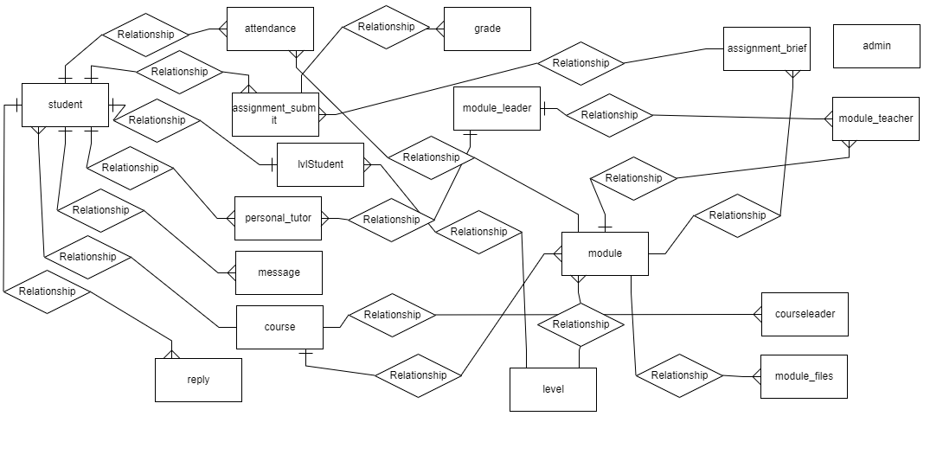

*Fig:* ERD

# 

# 4. System Interface Designs

The system interface design mainly includes two parts. The first part is to design the user interfaces and the other is to design the interfaces so that it can interact with other systems. The purpose of this designs is to carry out the process accurately and easily. In the system interface design the team made wireframes of the system. The wireframe is the first draft interface design.

After that the team made the system navigation diagram for admin, staff and students.

## 4.1 Draft Interface Designs

### 4.1.1 Wireframes

Wireframe is the first draft of the interface design. In this project the team made the wireframe using the pencil and paper. The team drafted the wireframe of the proposed system by consulting the client. The team design the wireframes of every screen of the system.

1. **Student Section Wireframe**

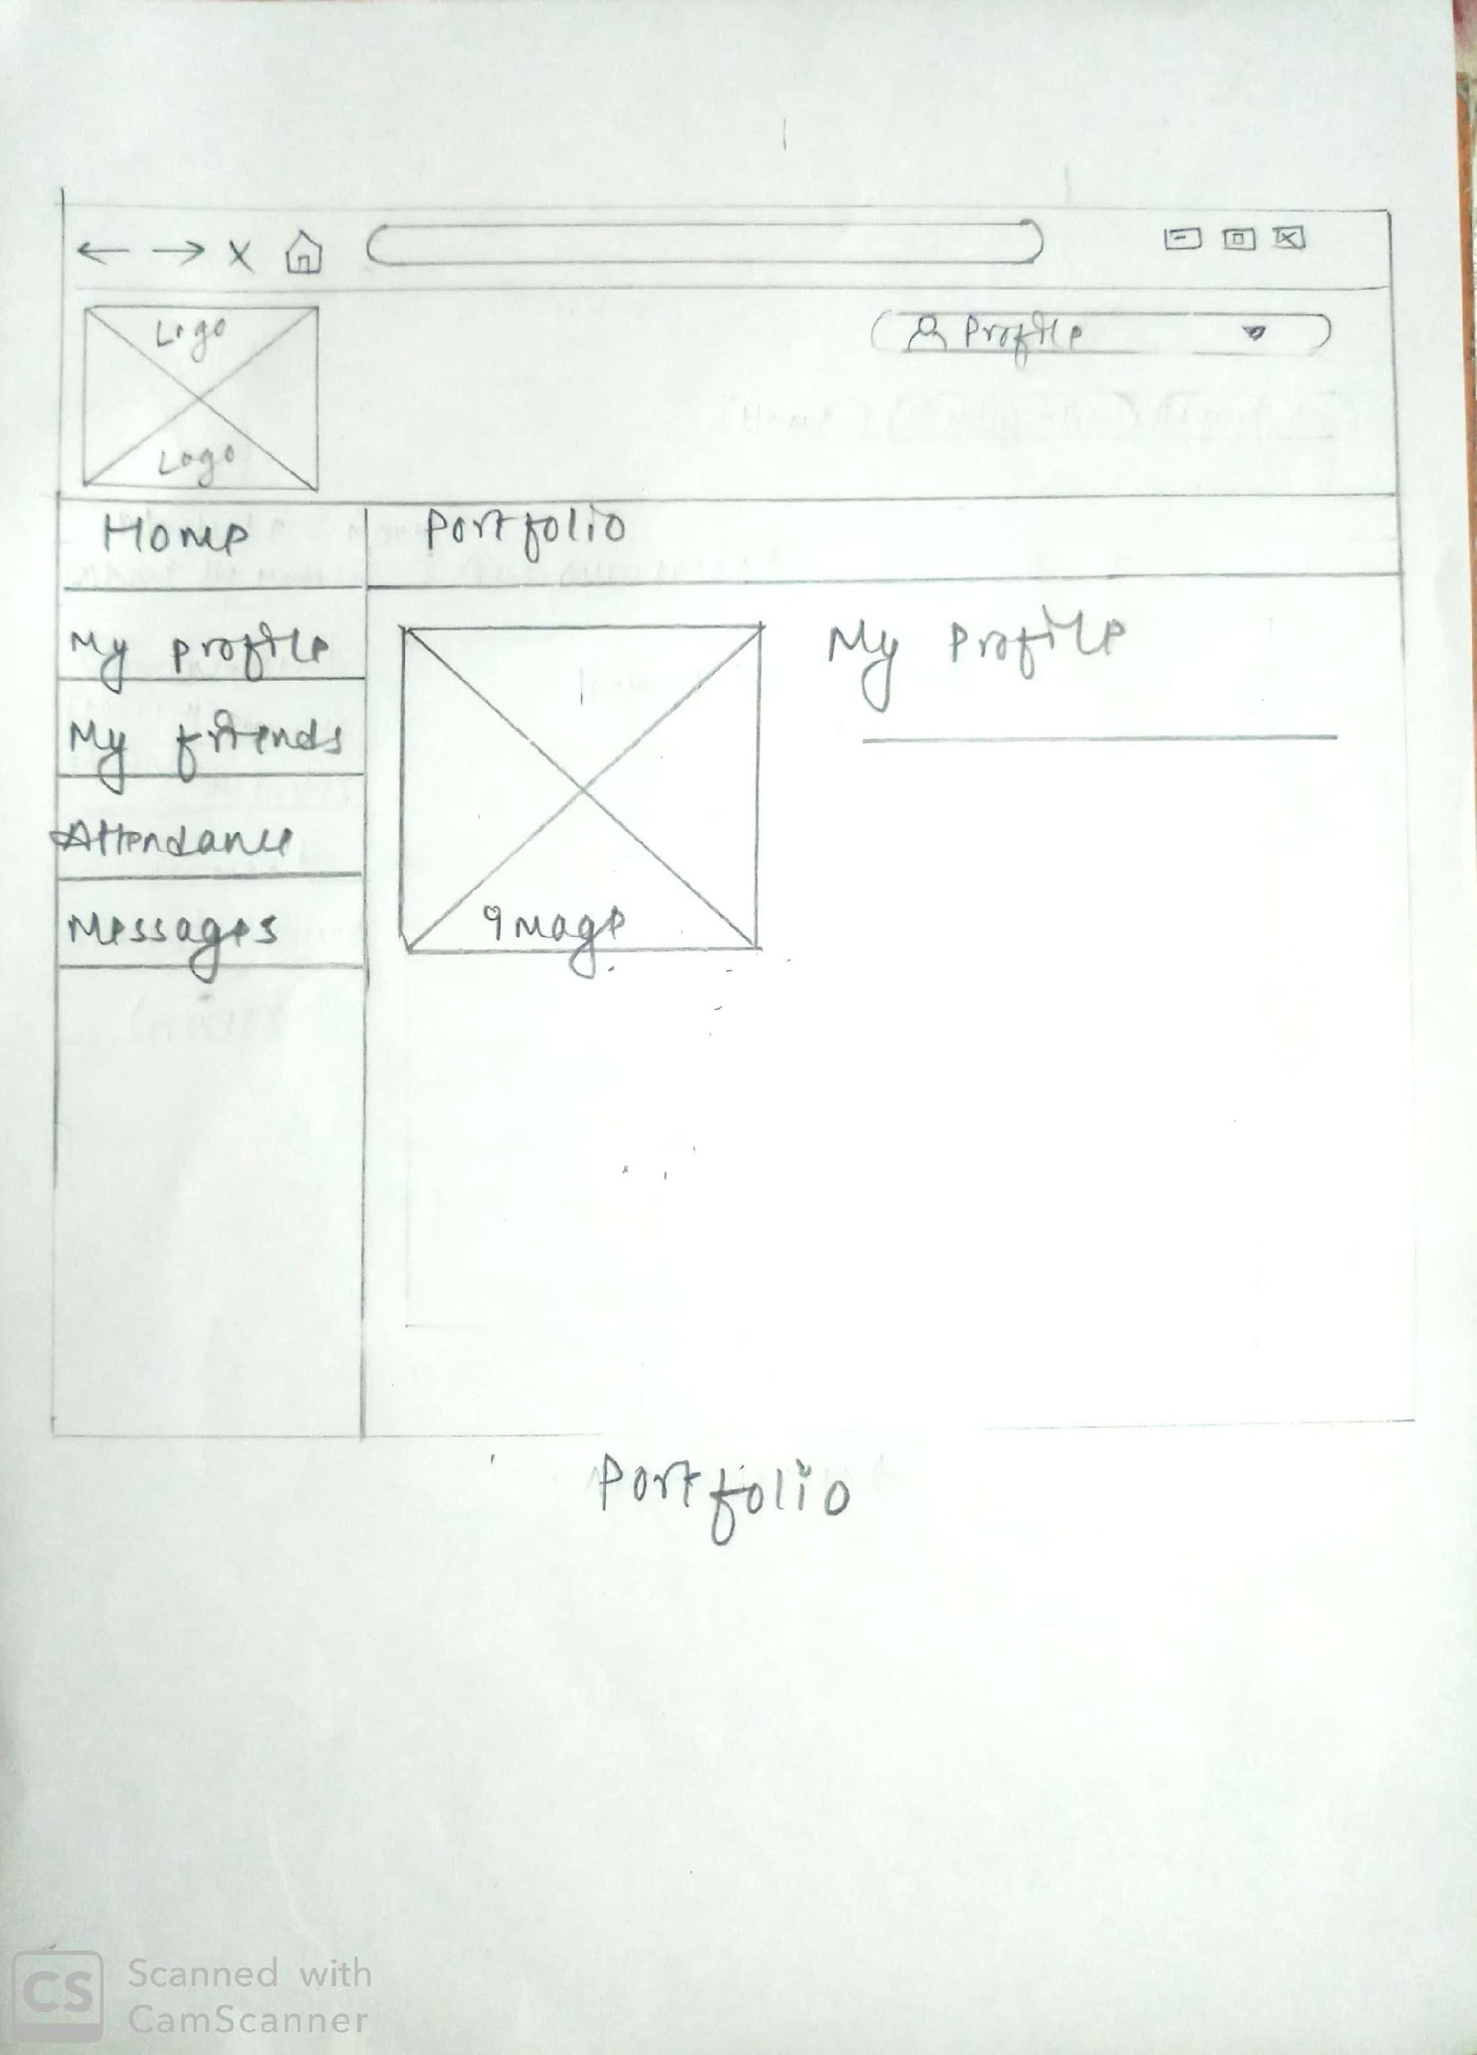

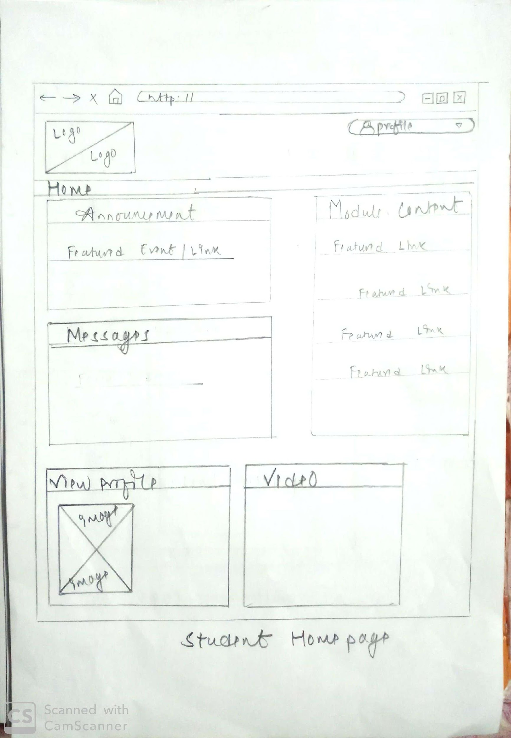

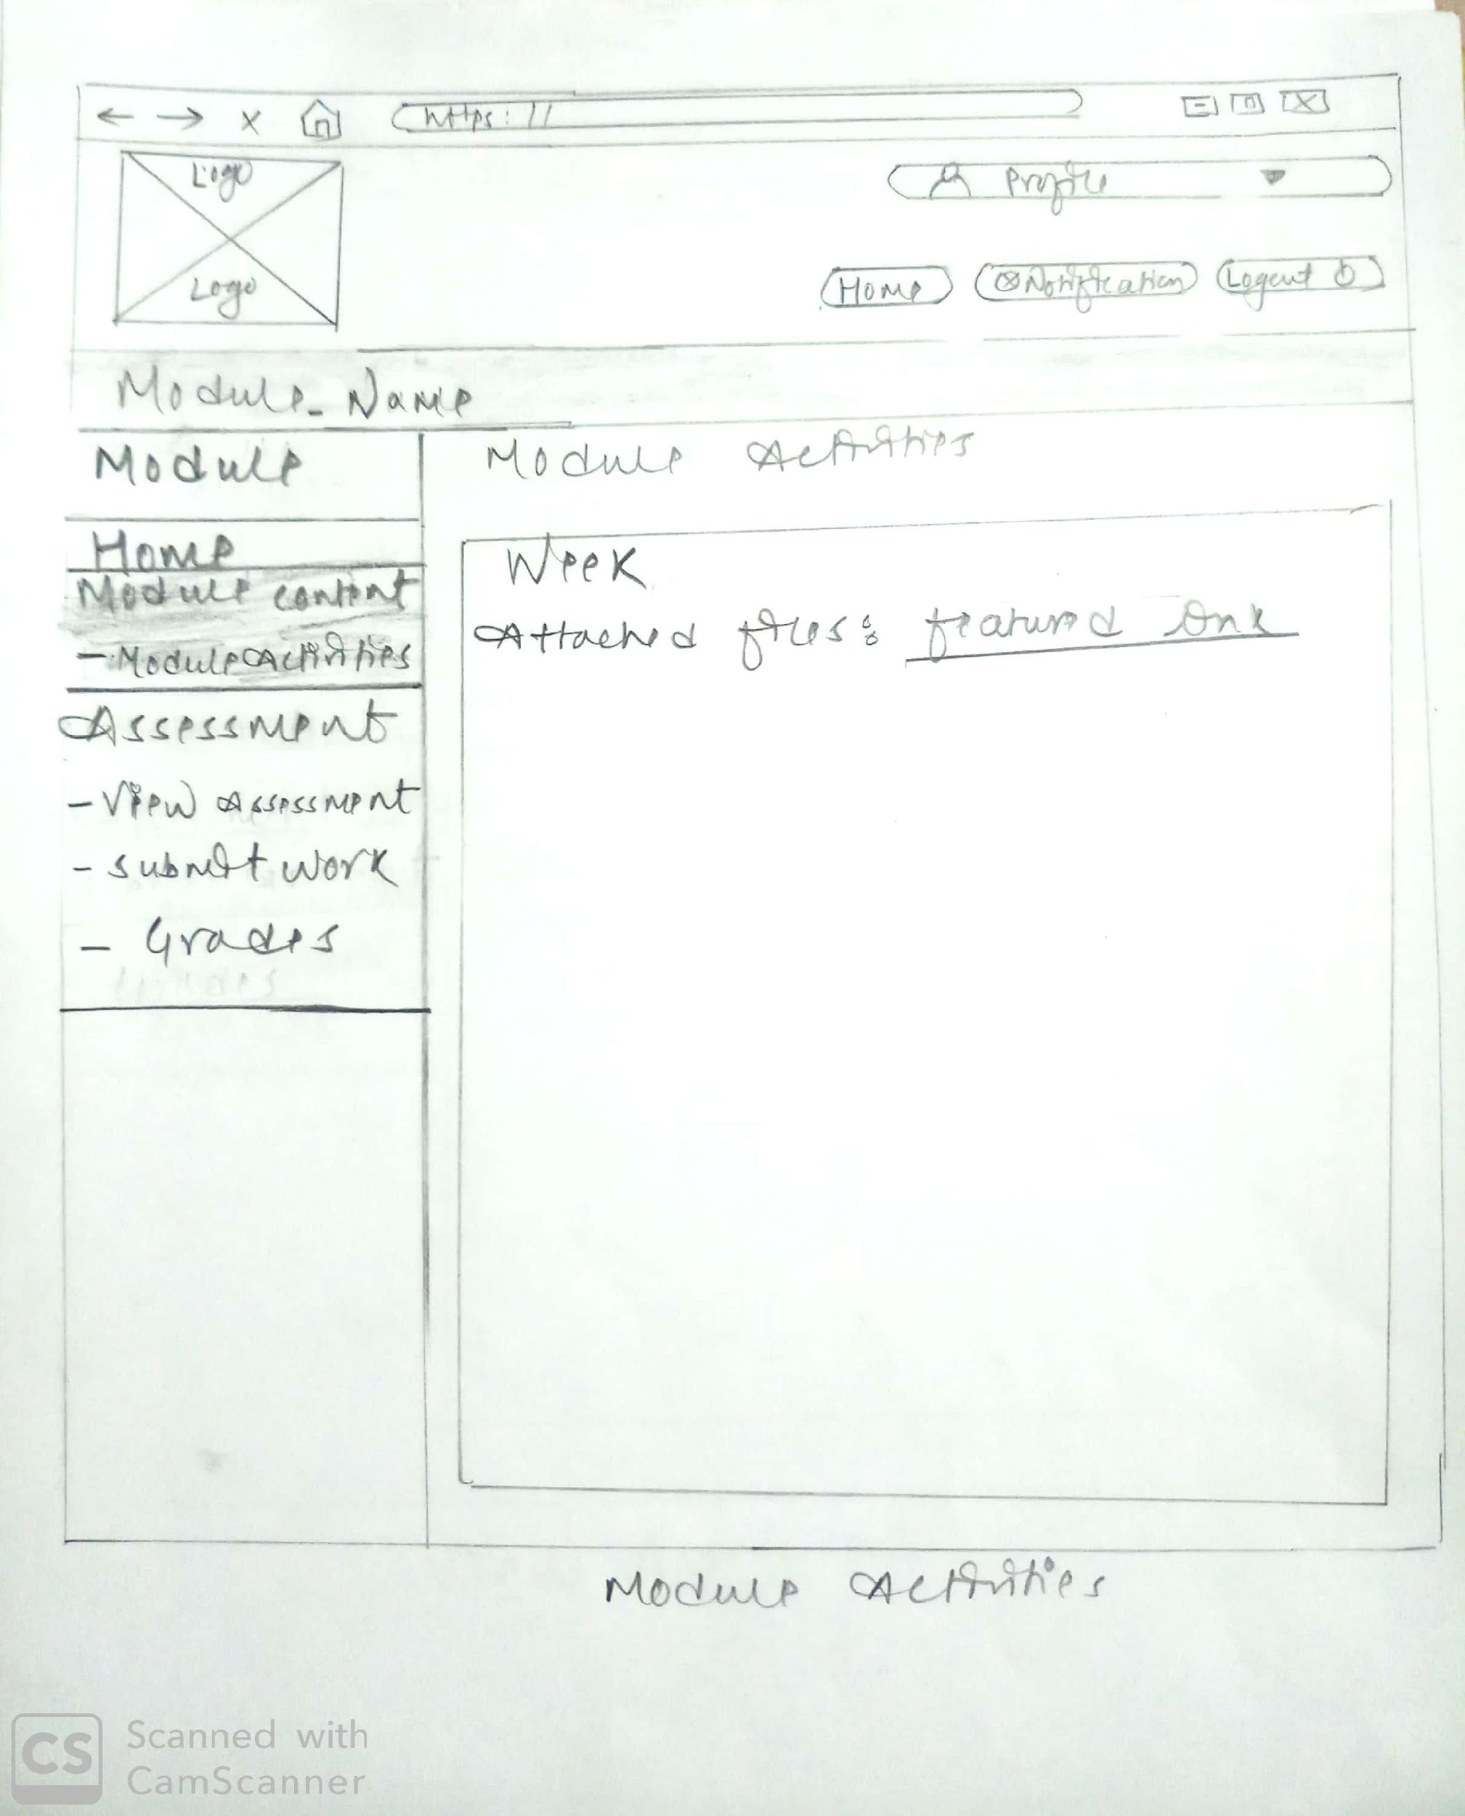

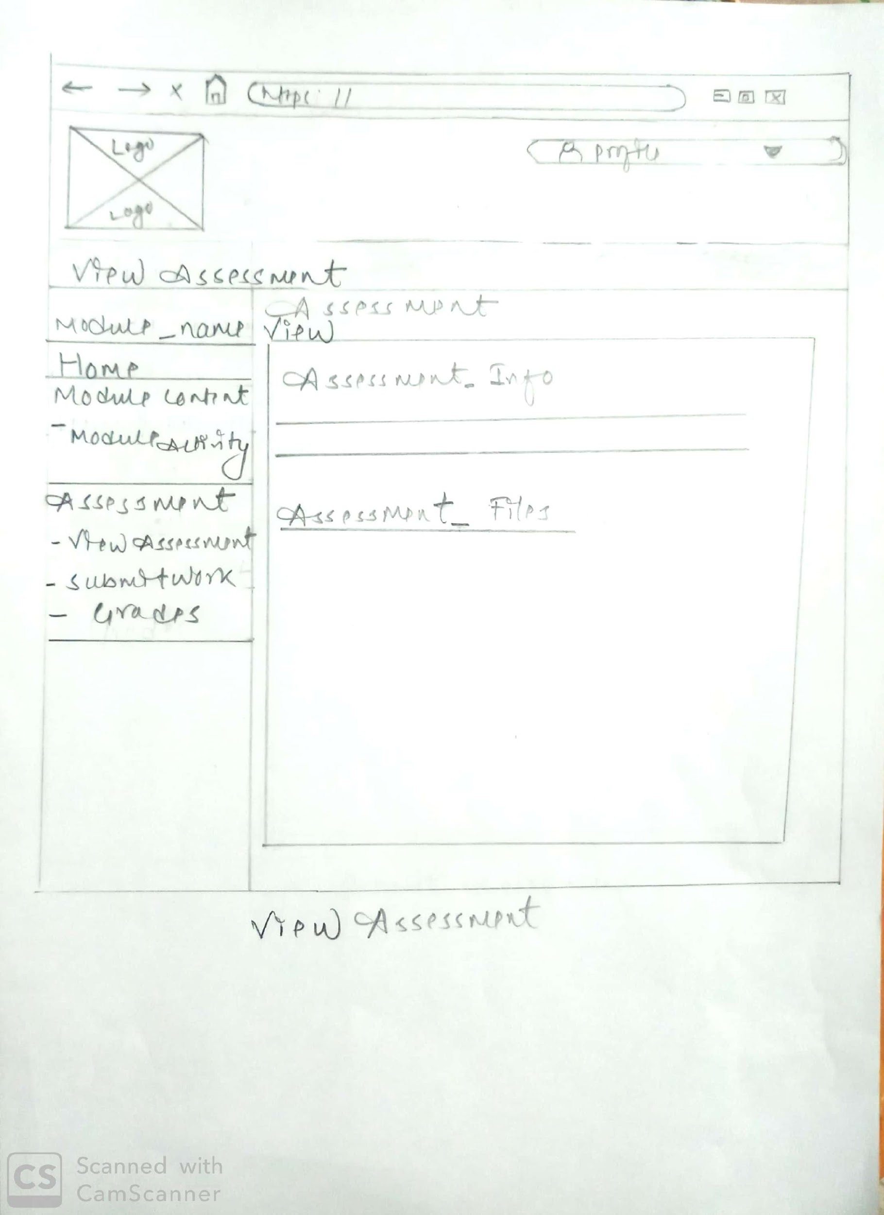

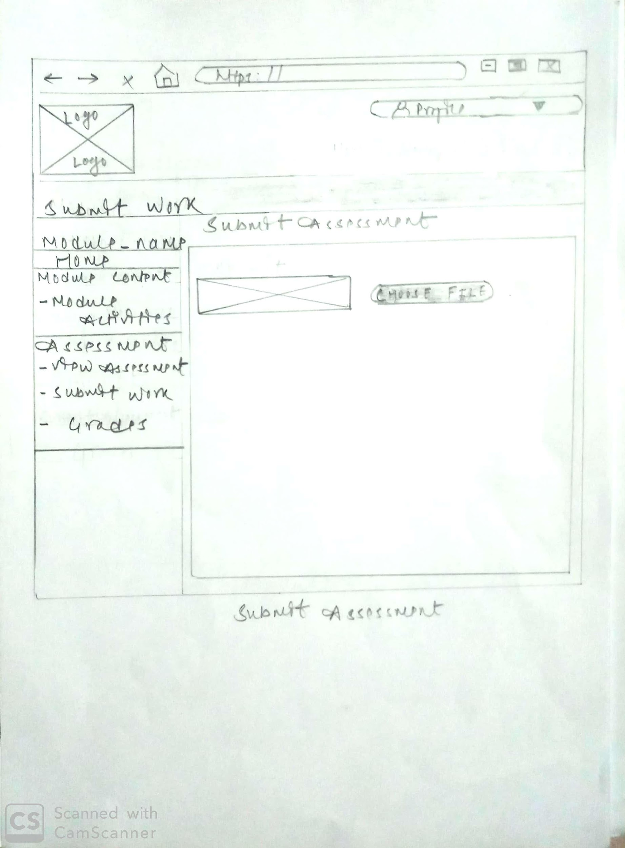

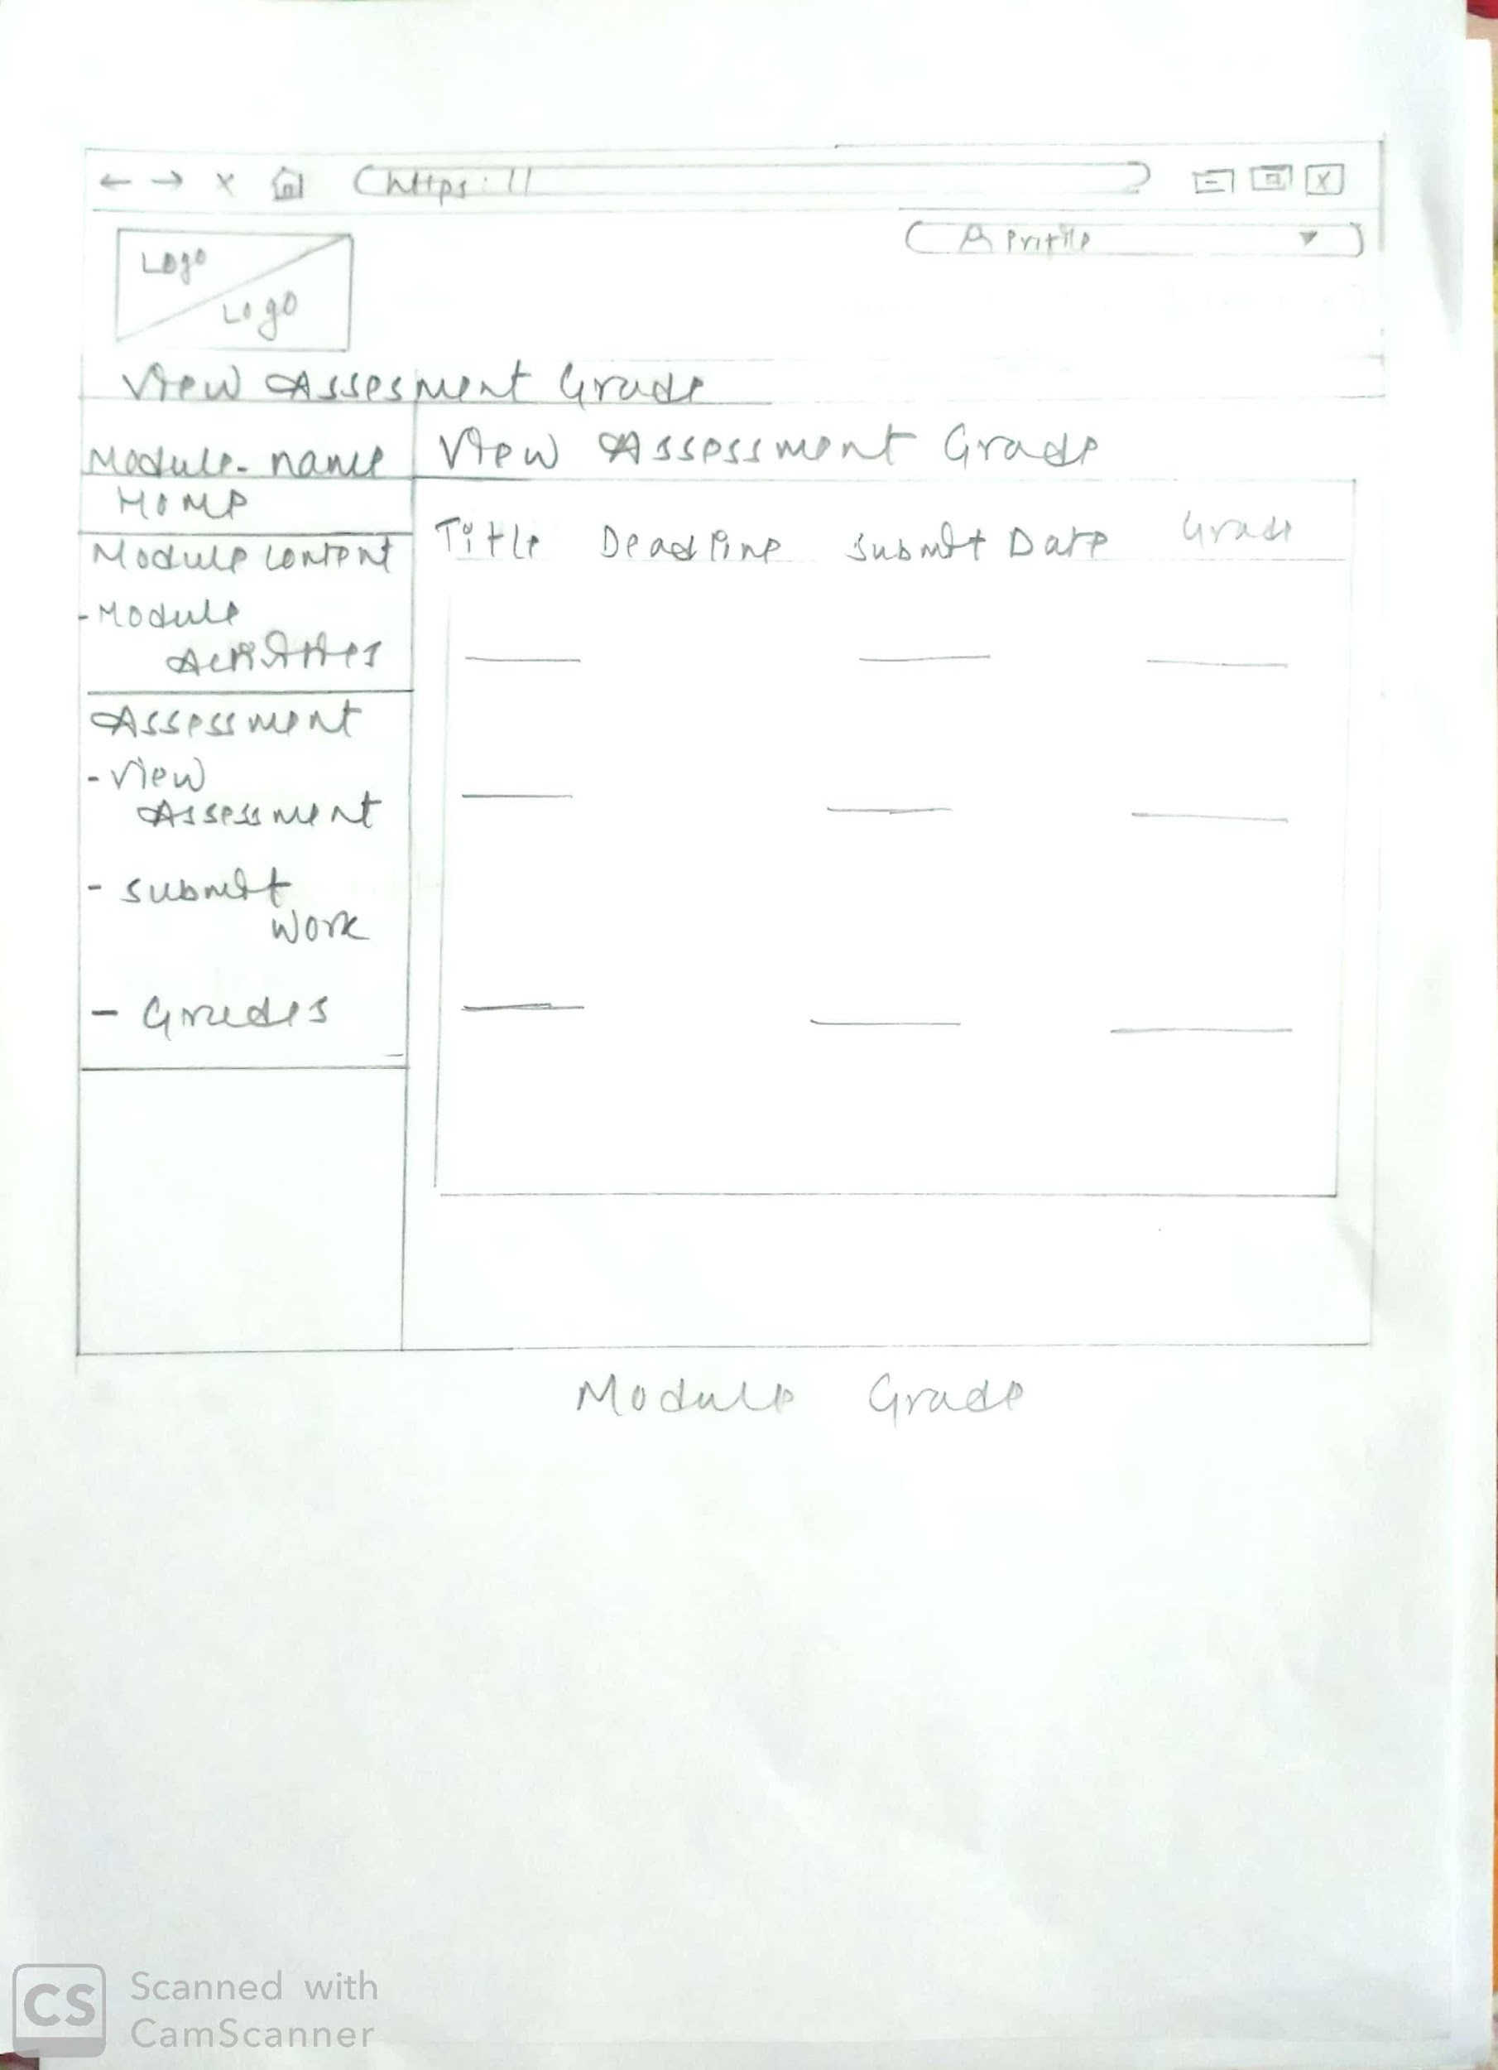

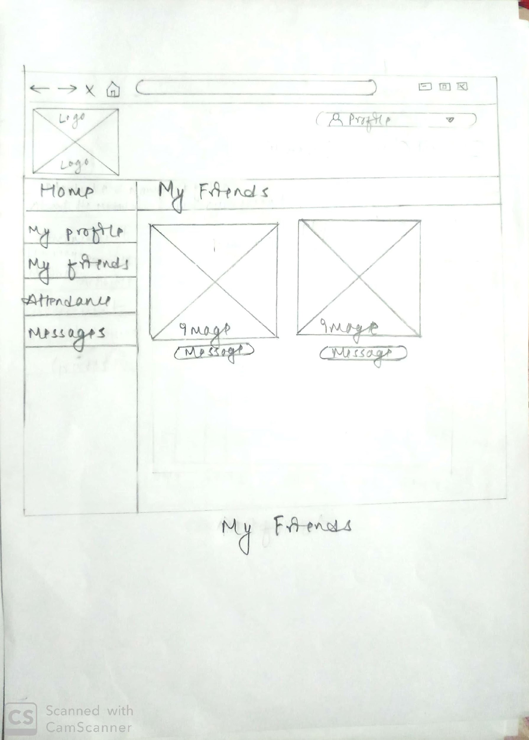

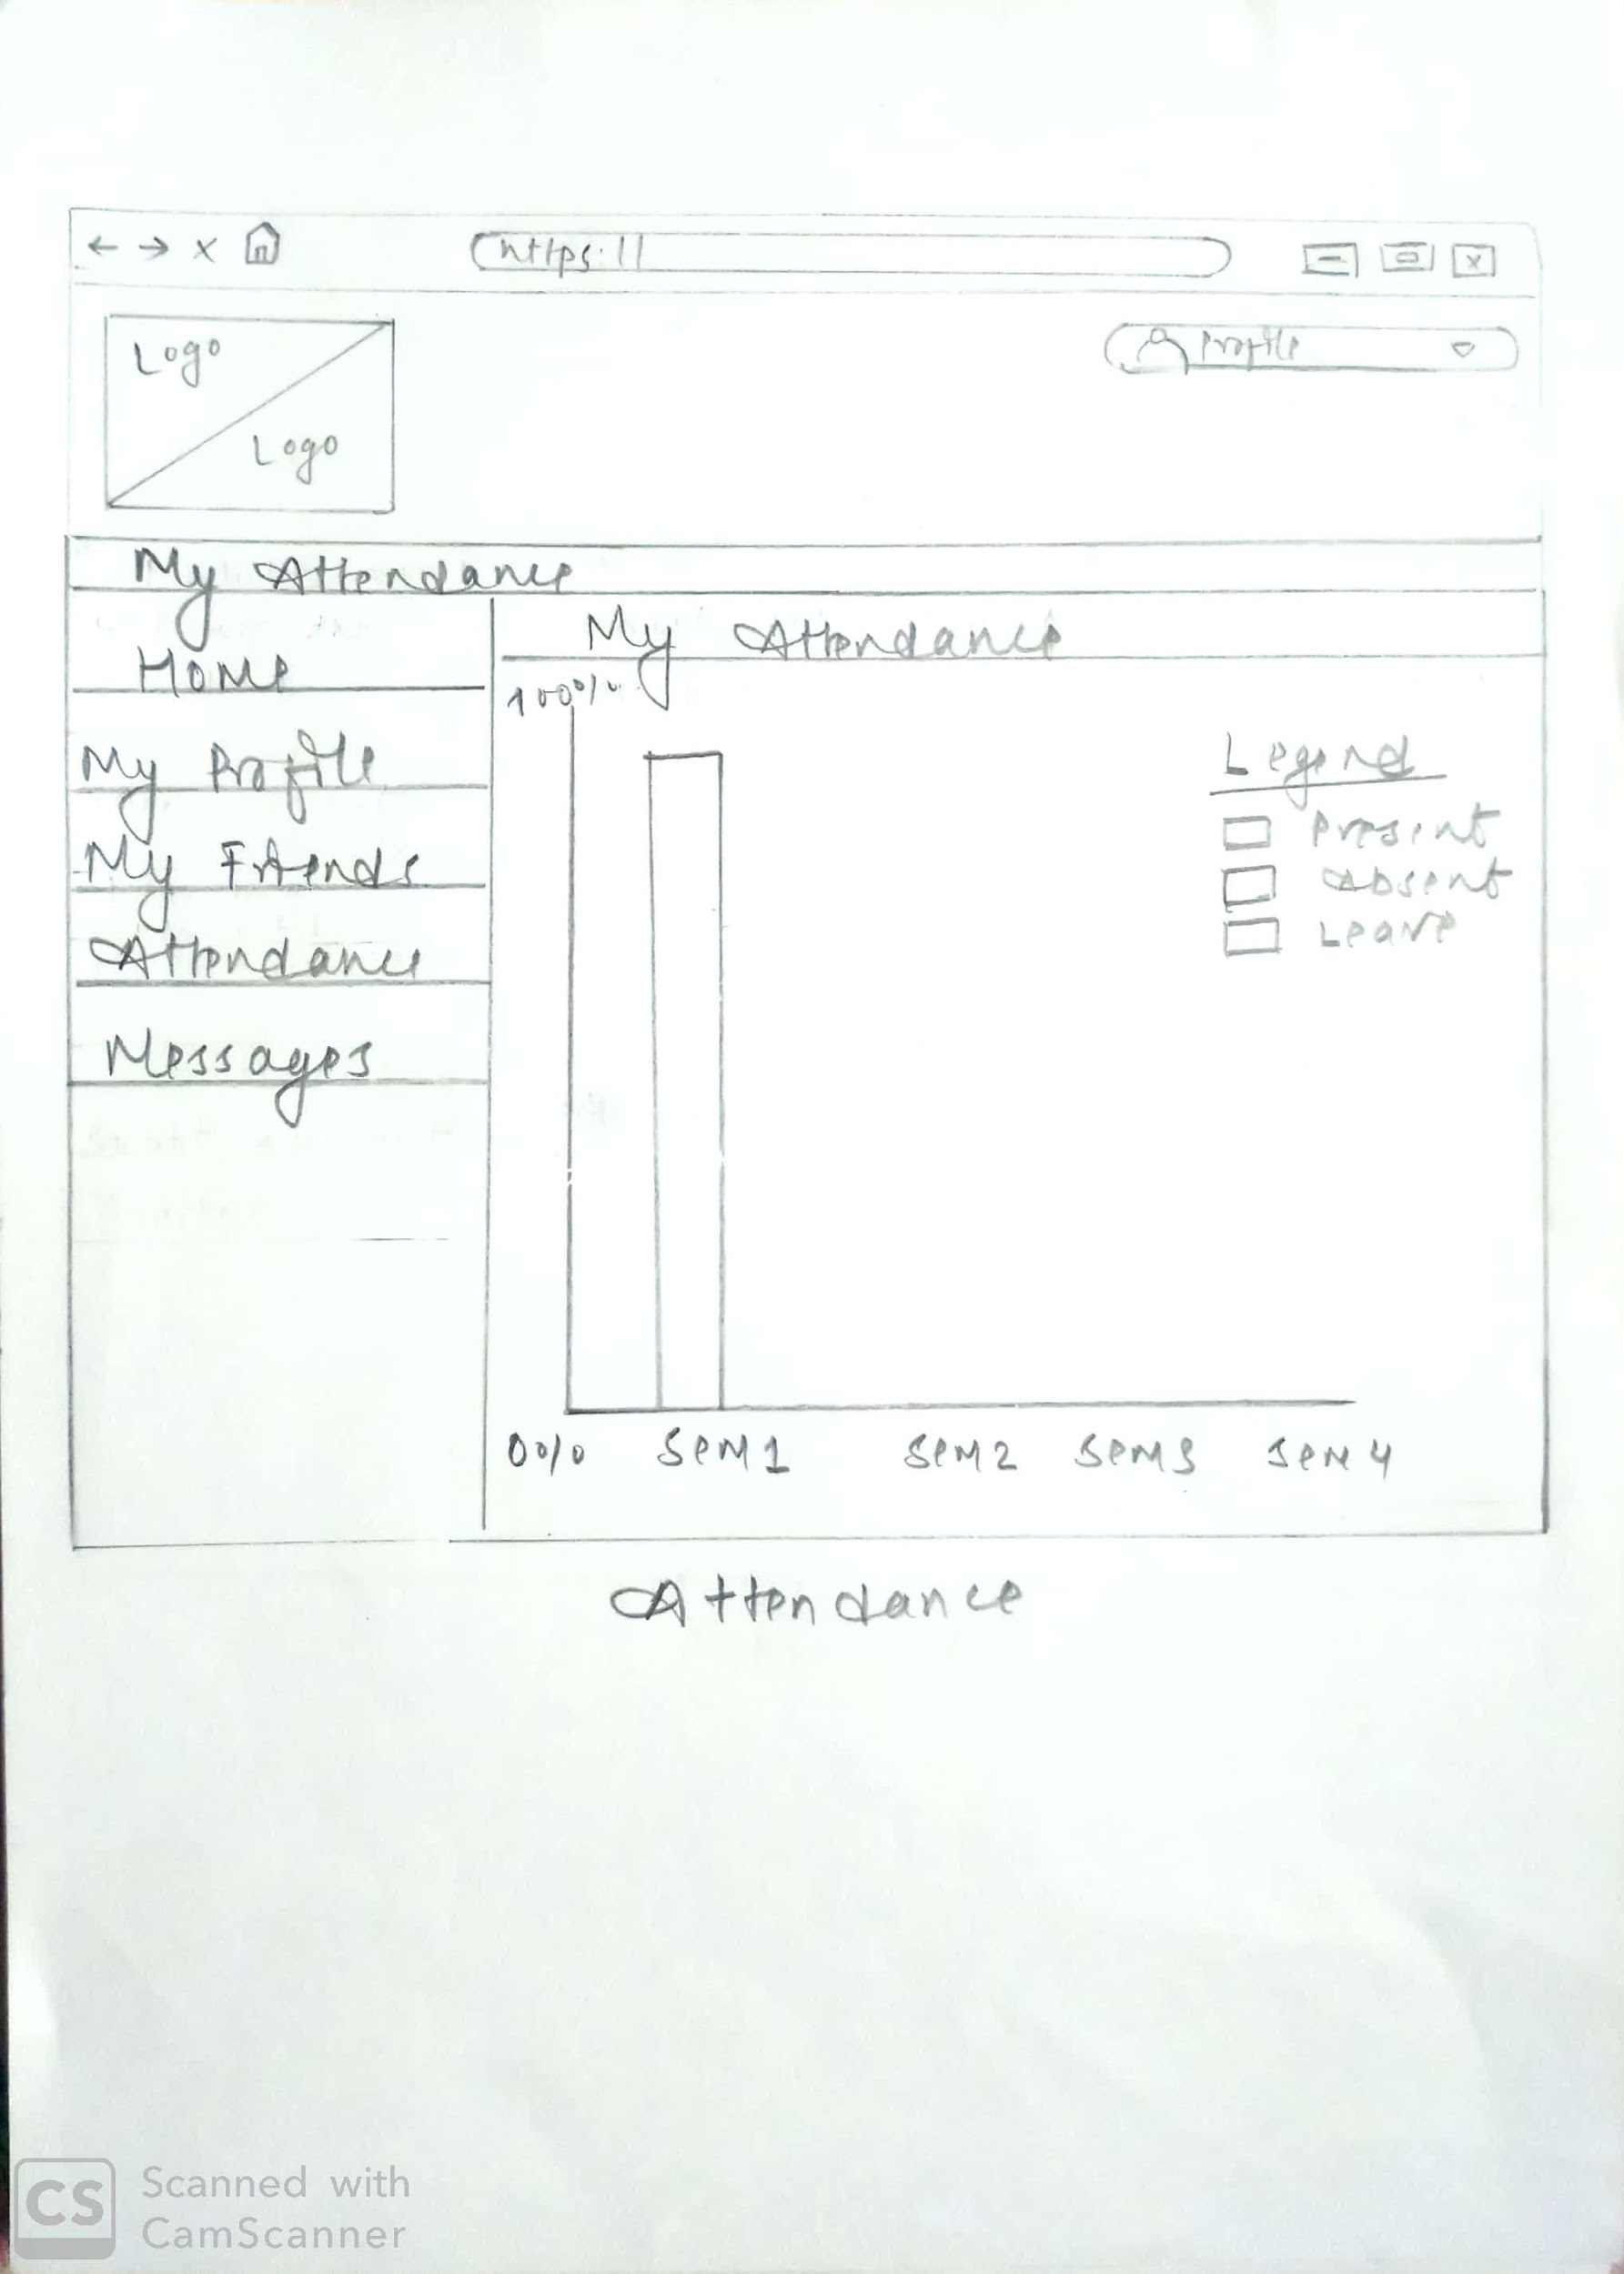

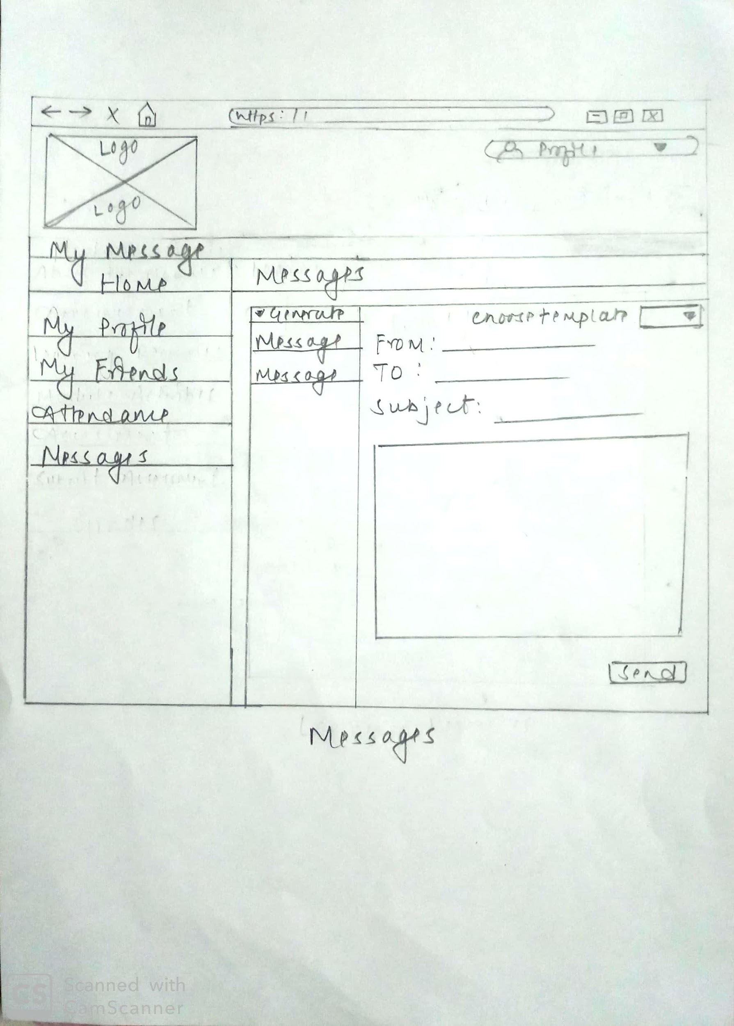

1. **Admin Section Wireframe**

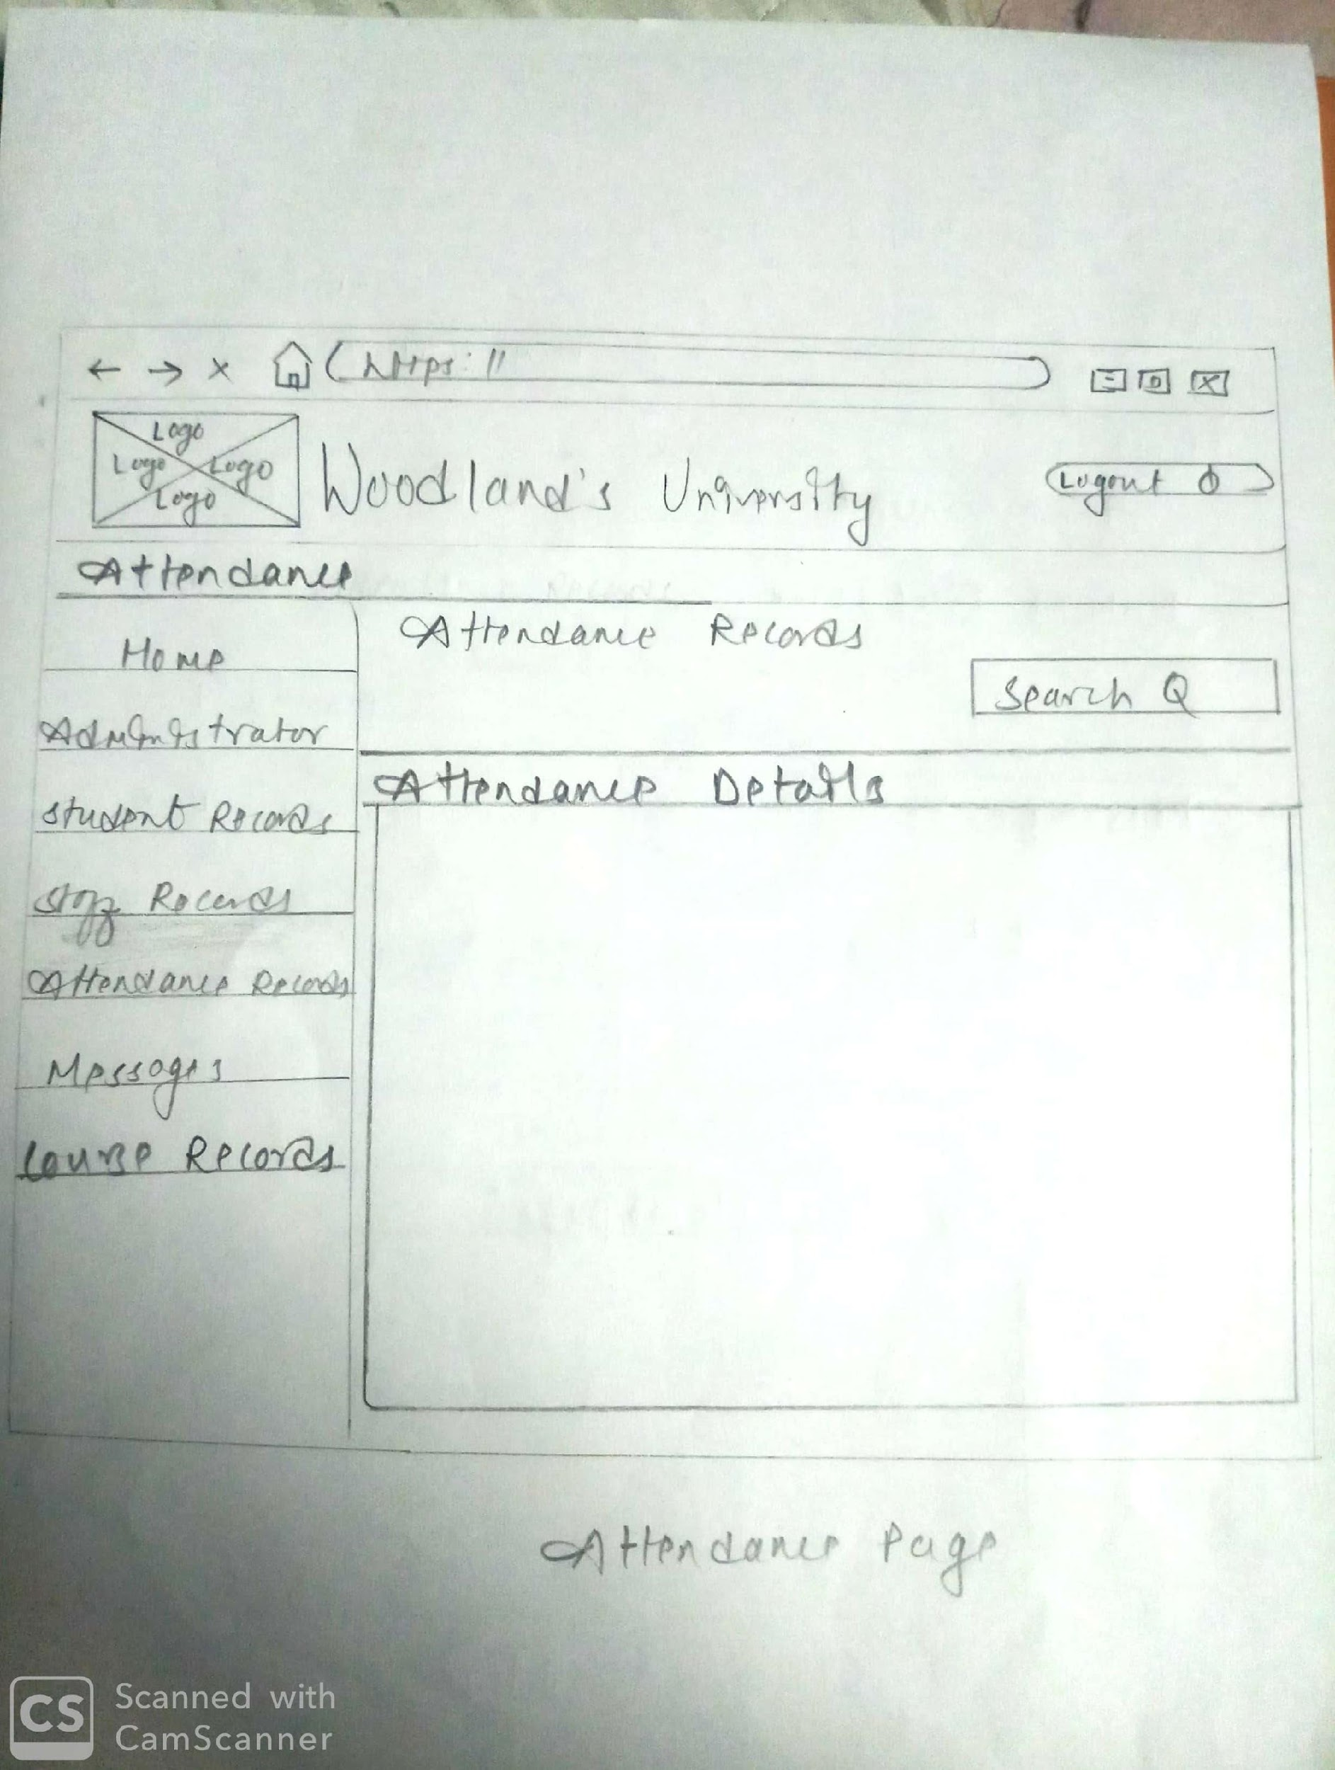

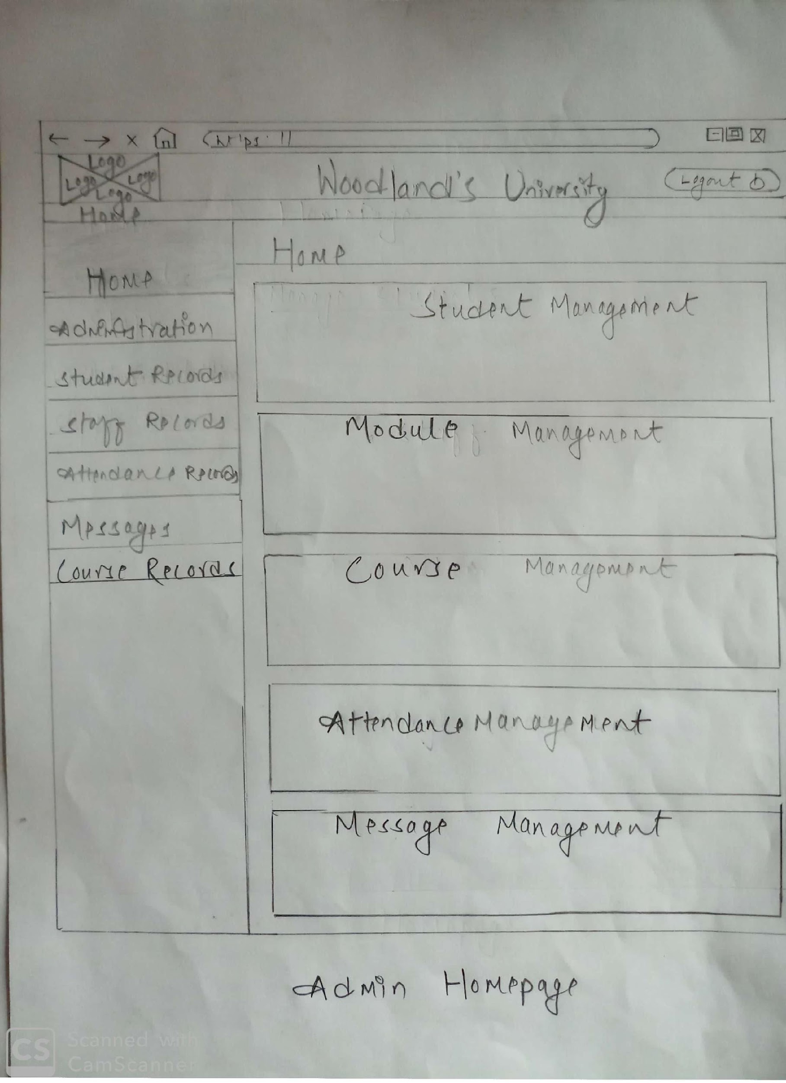

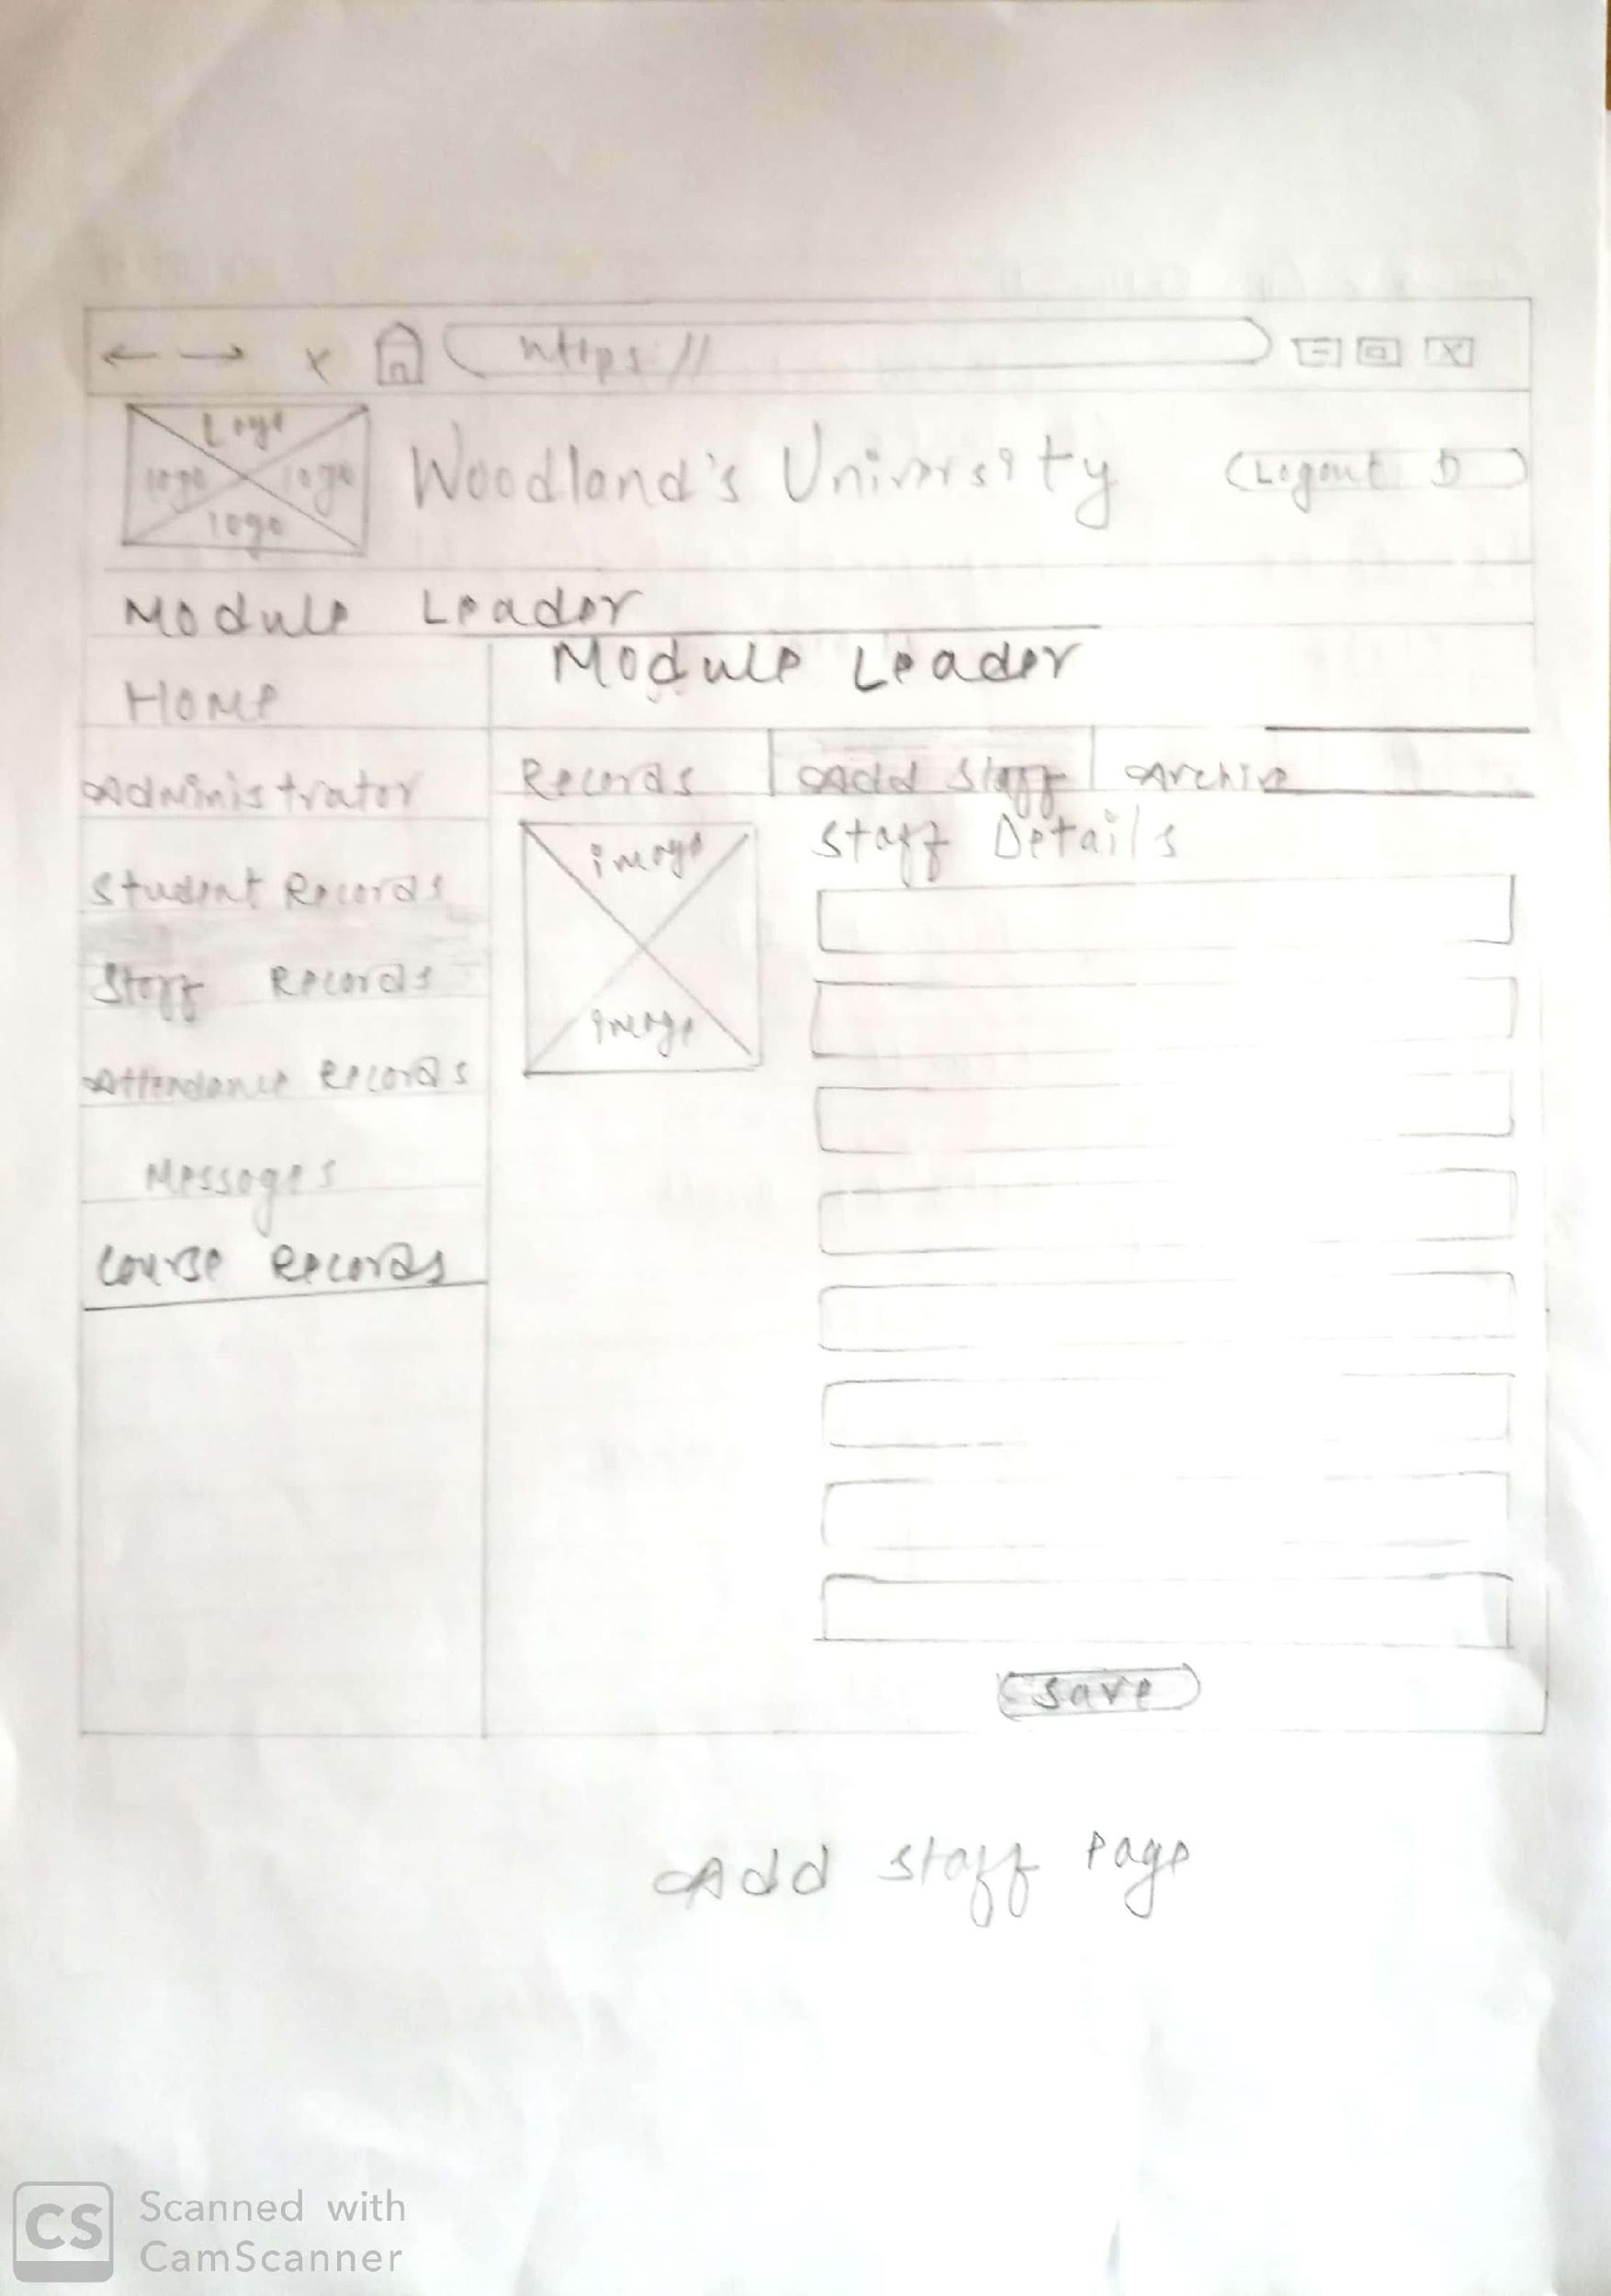

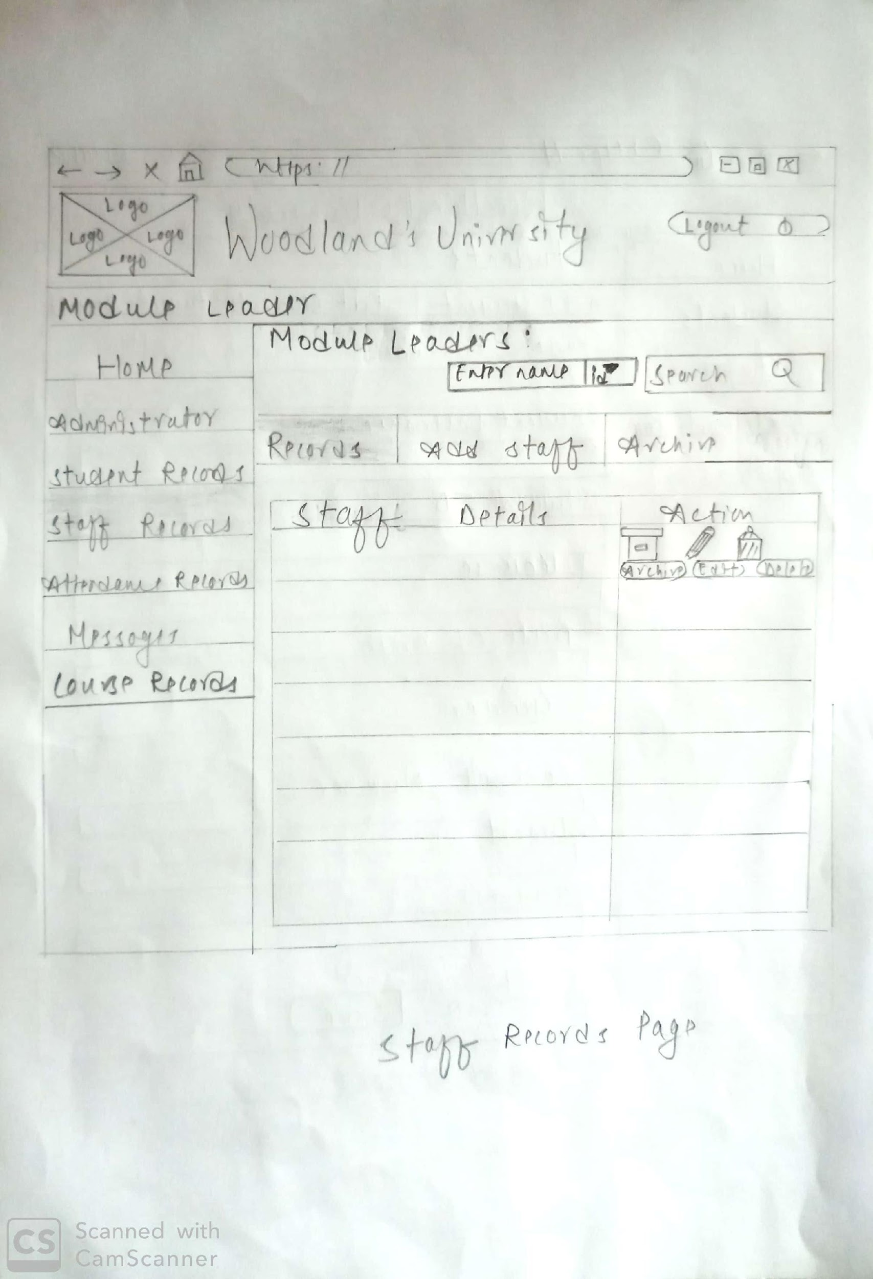

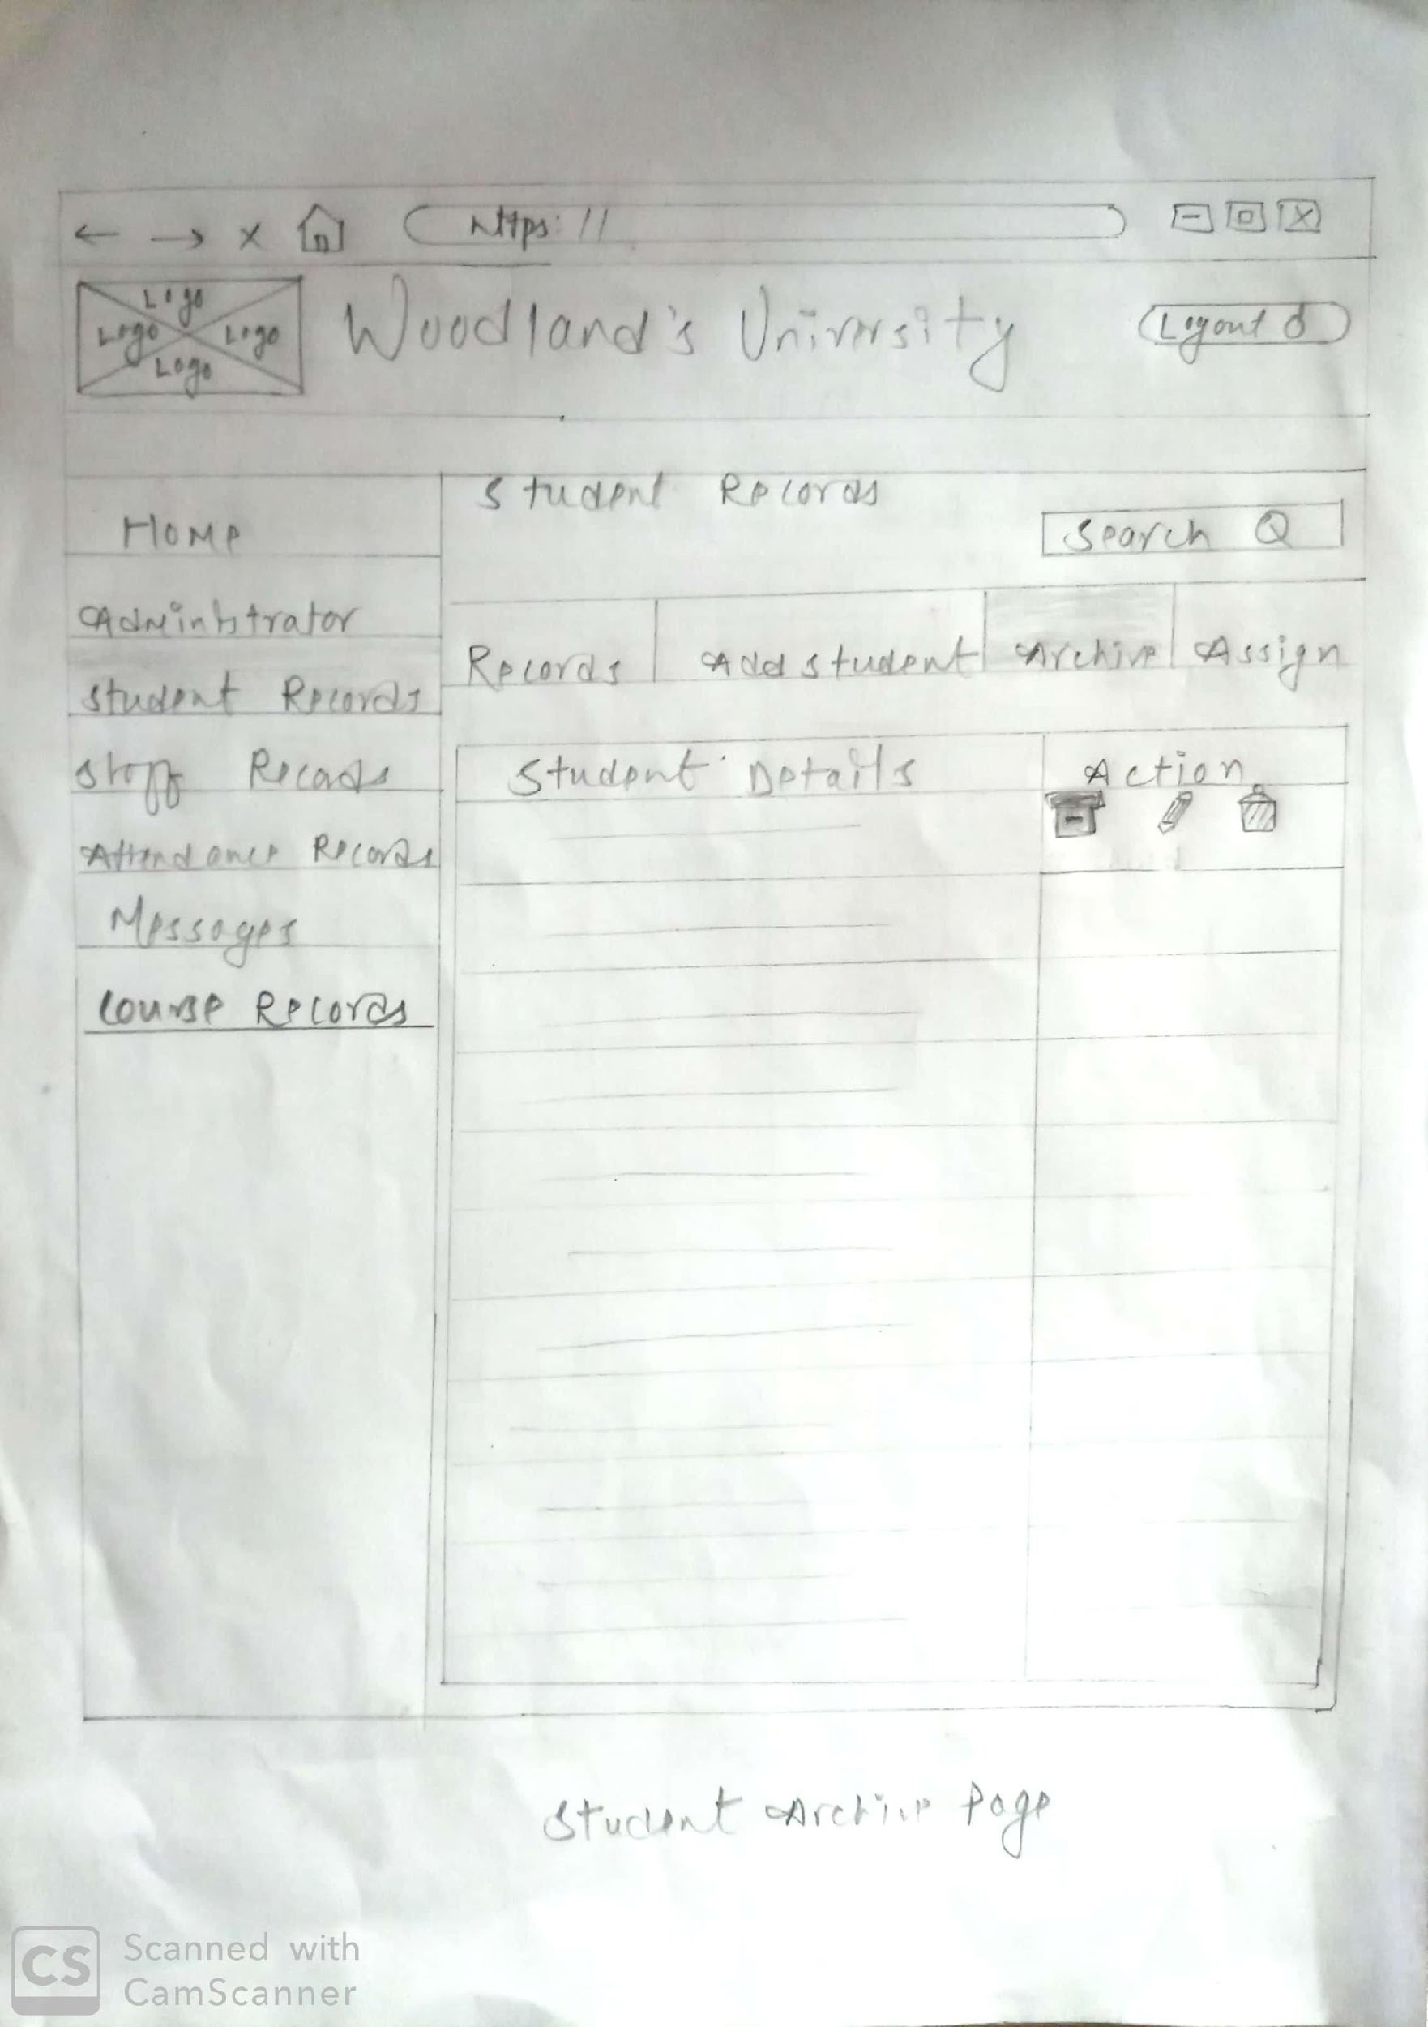

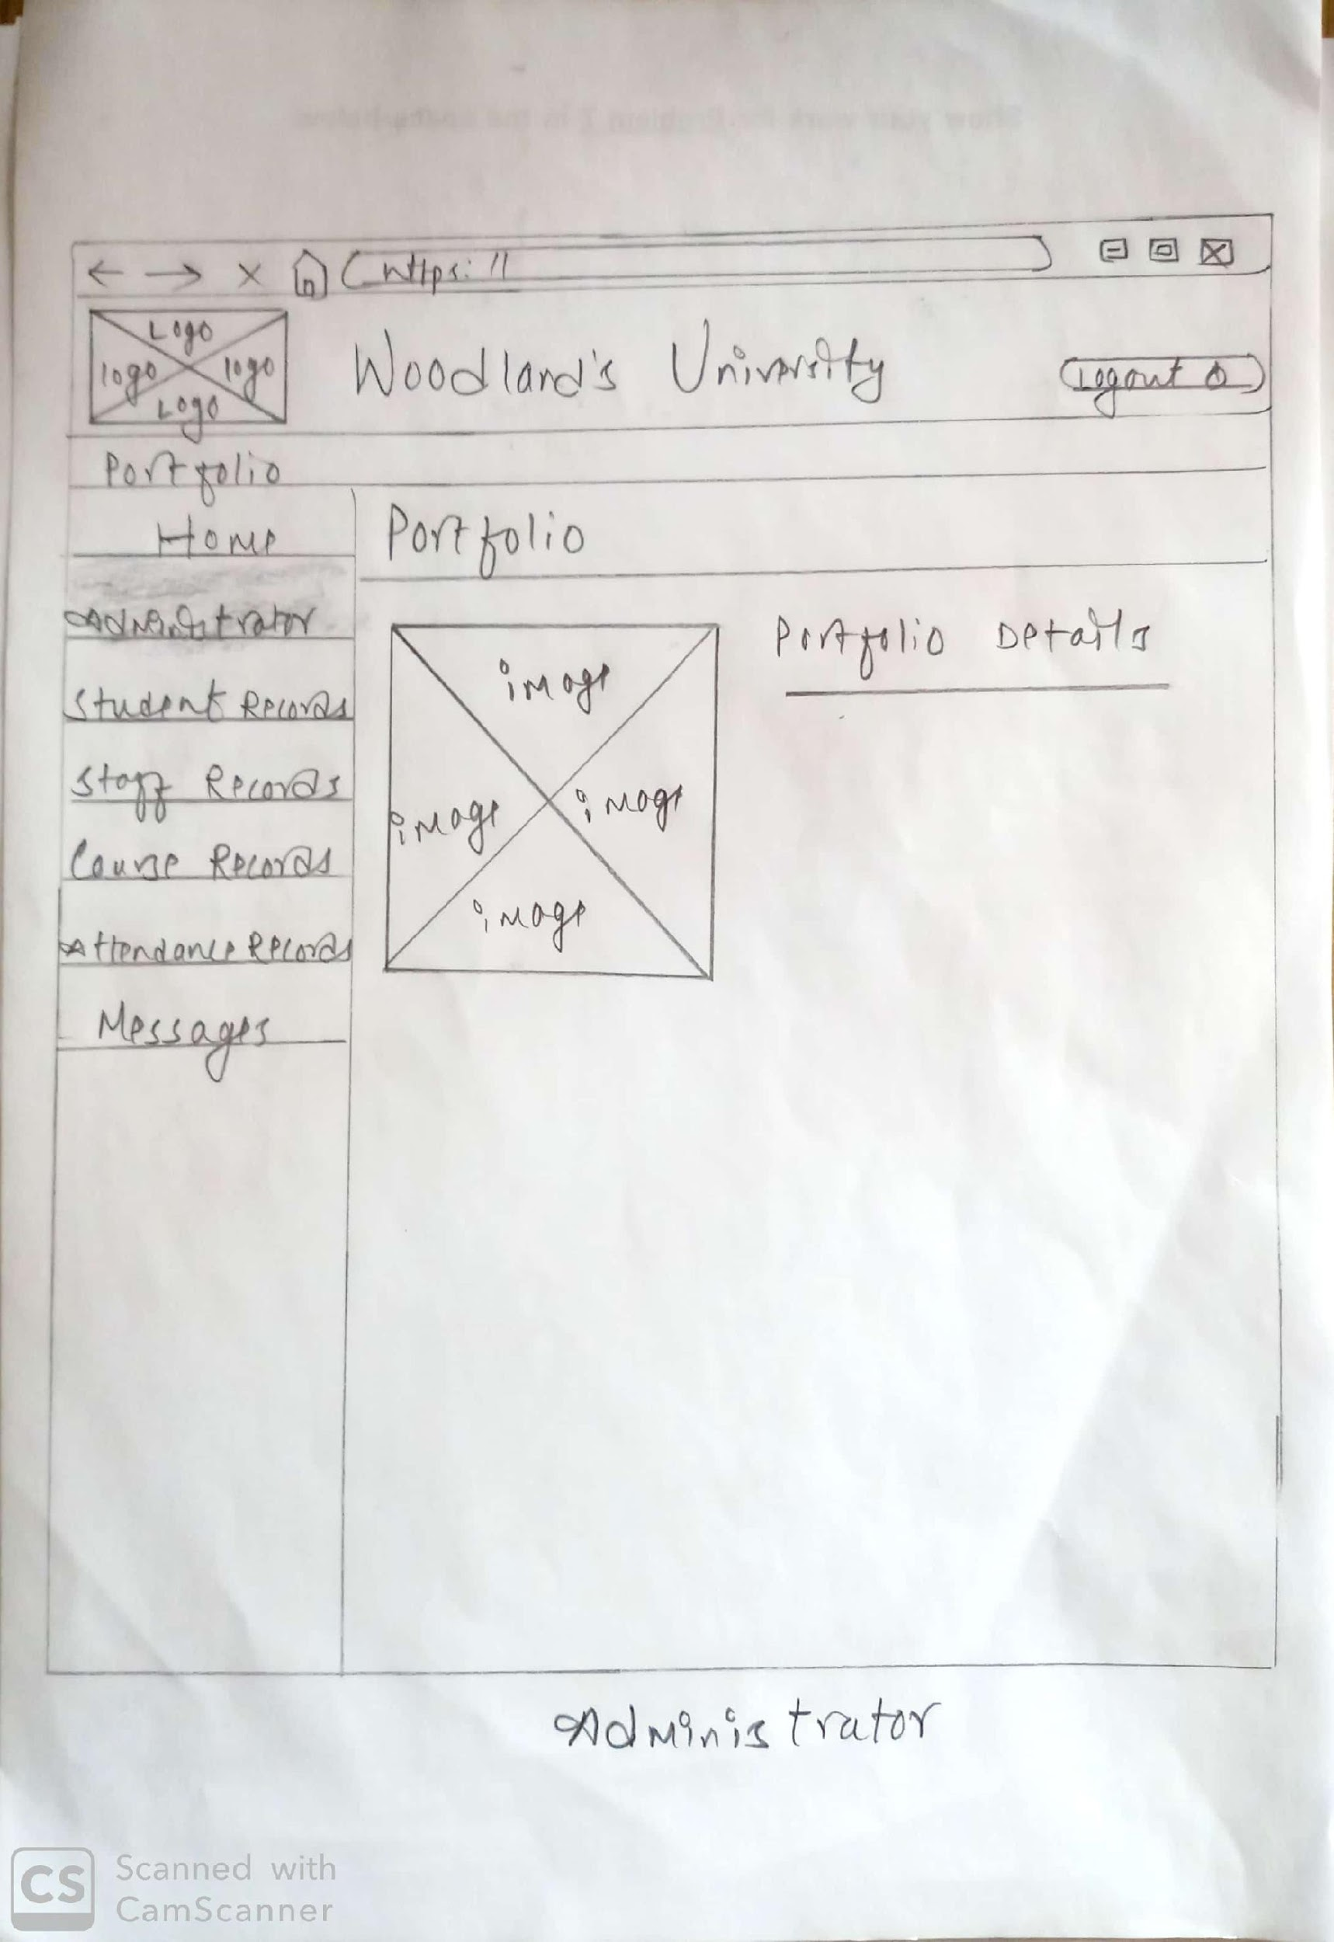

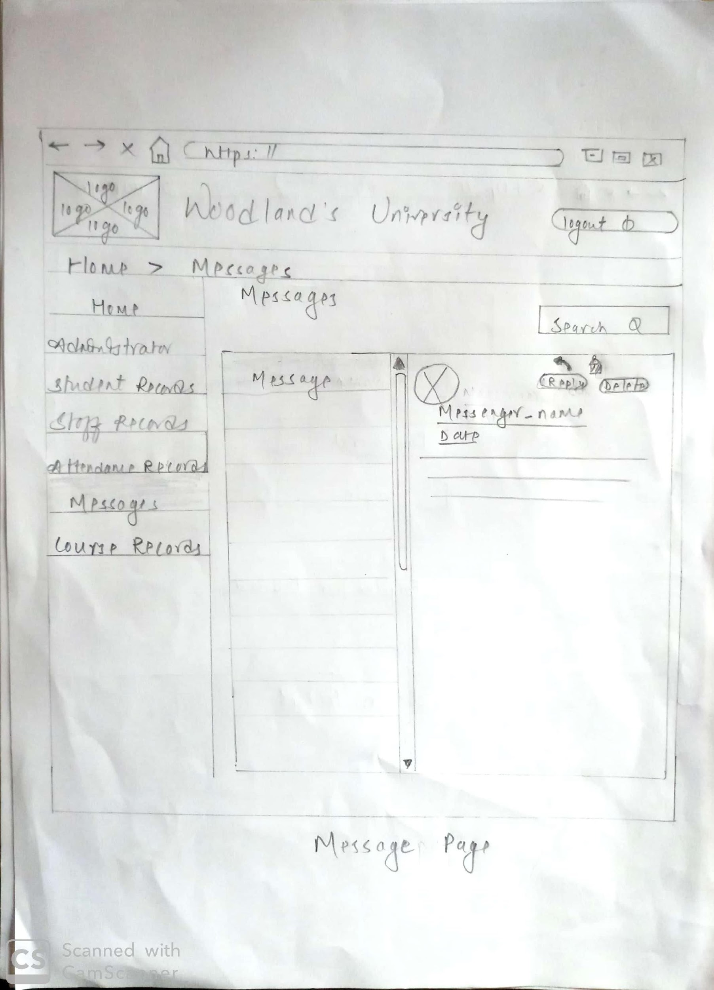

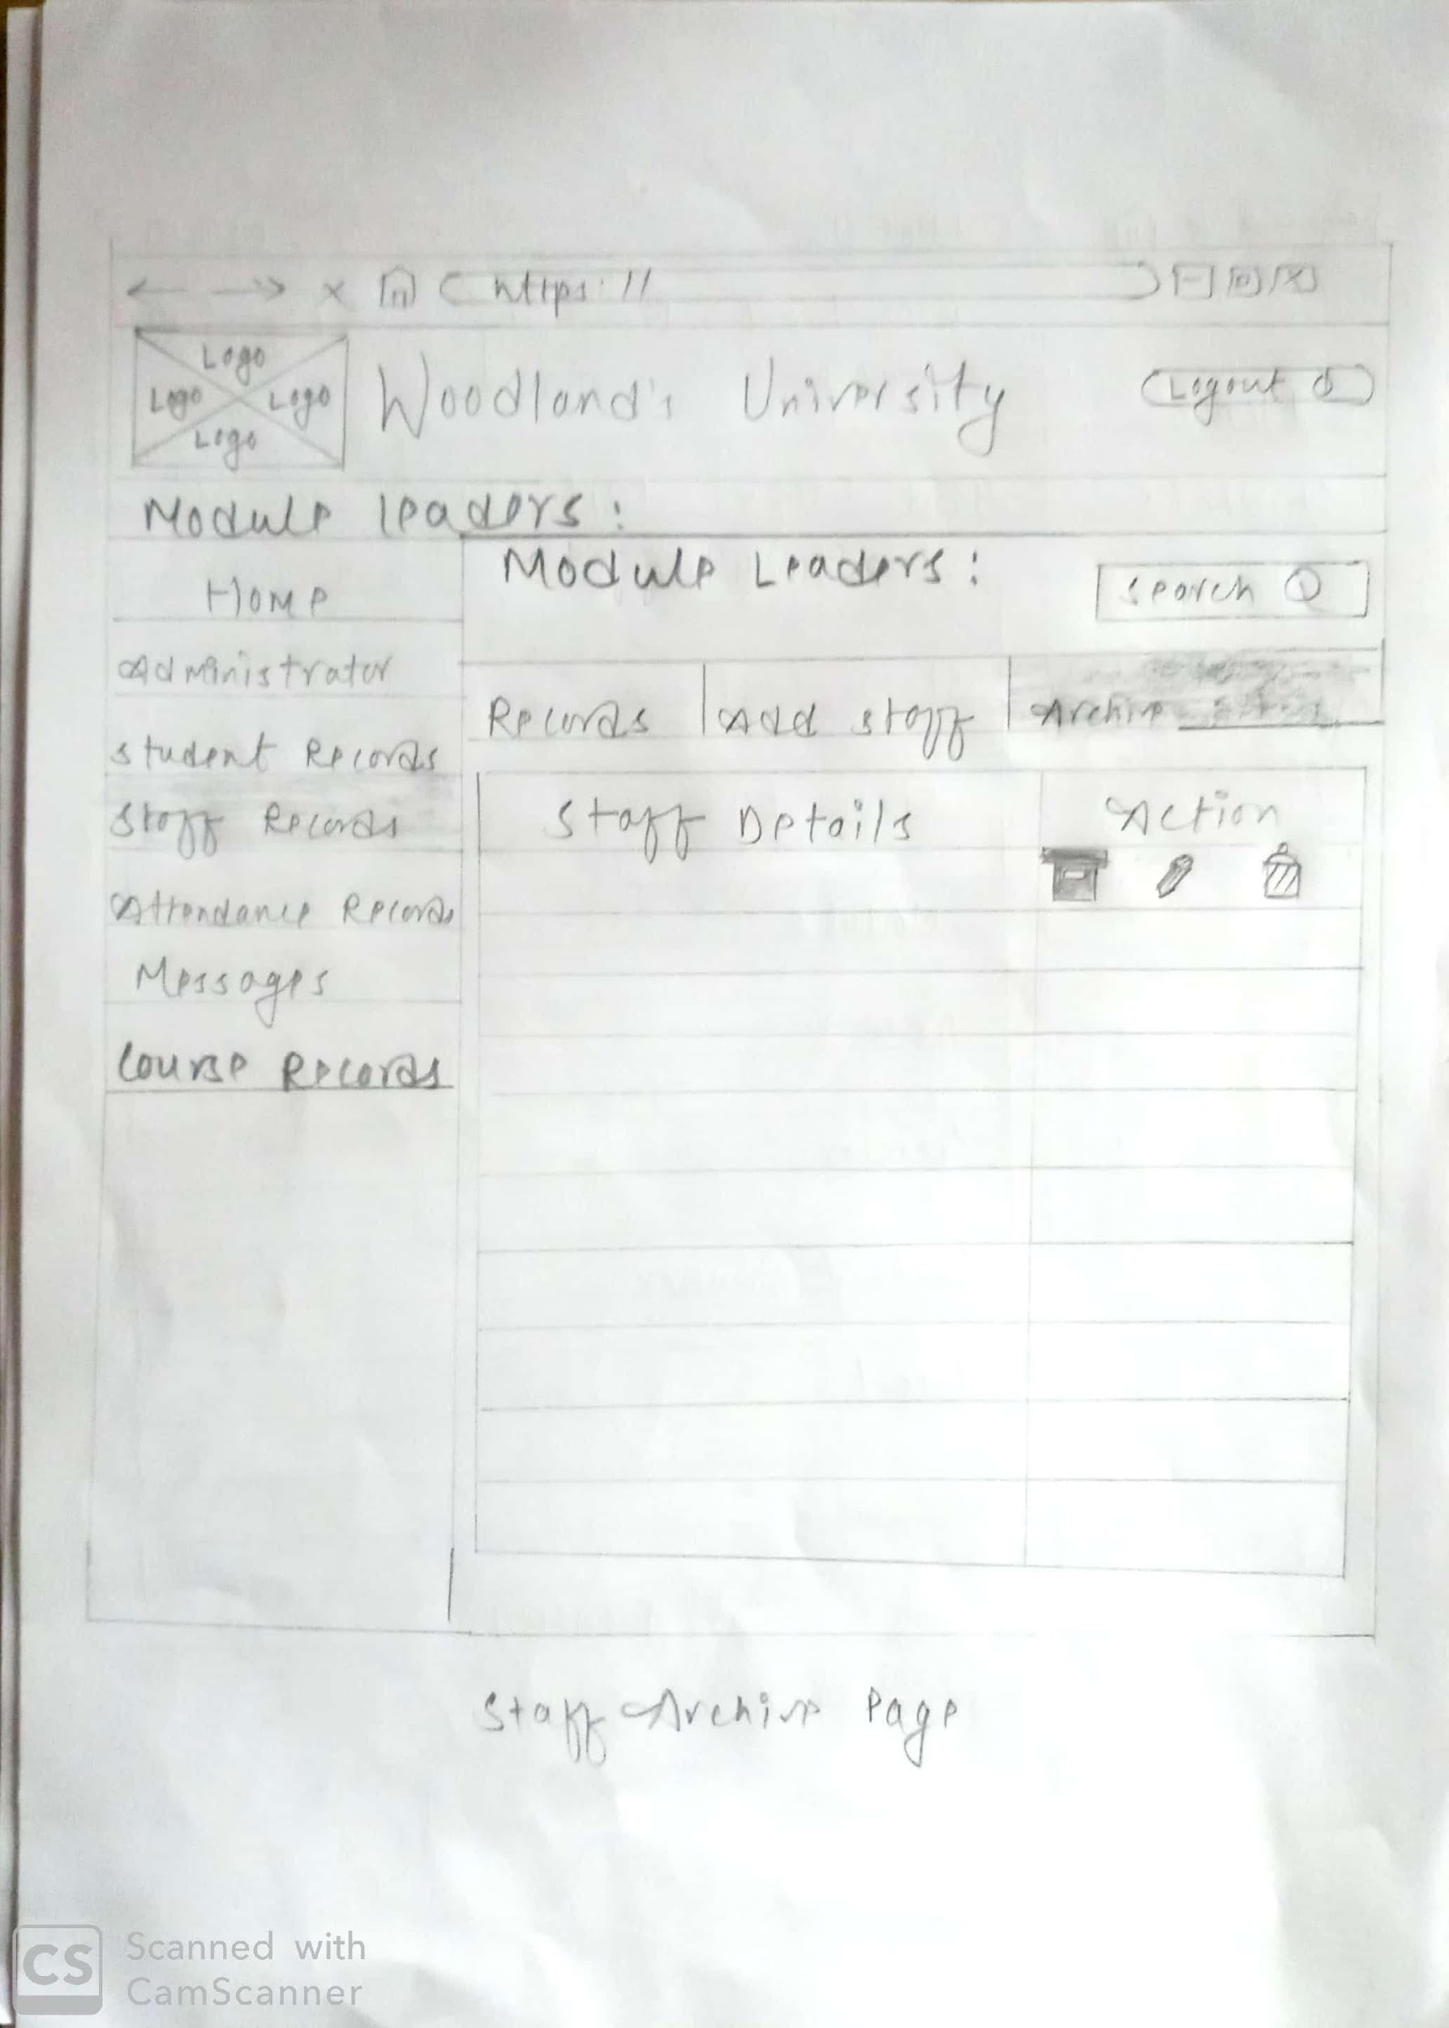

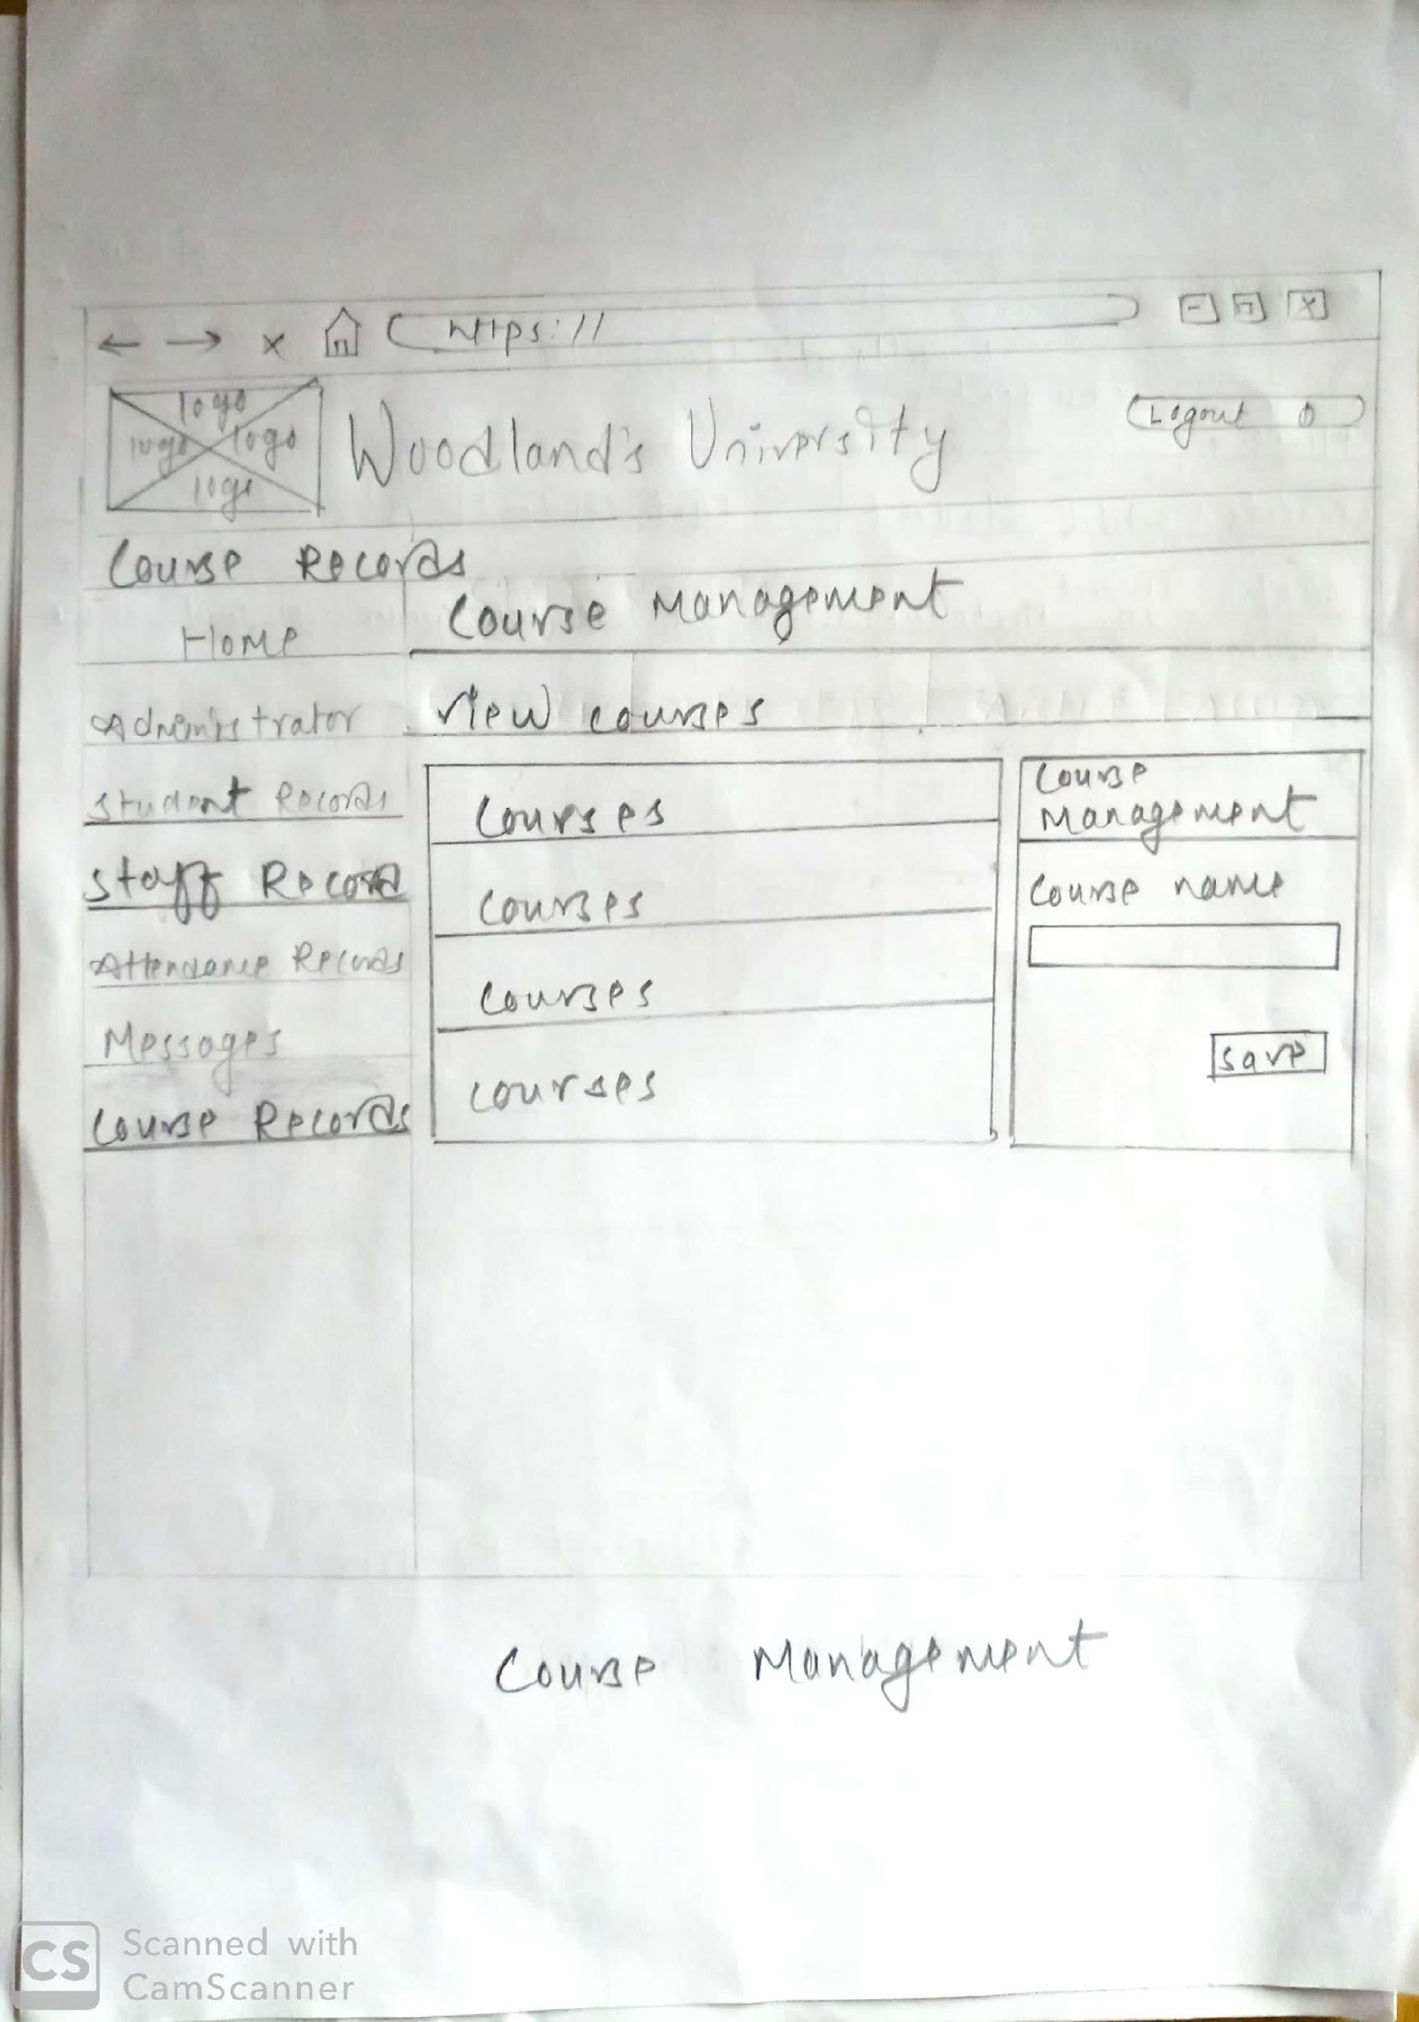

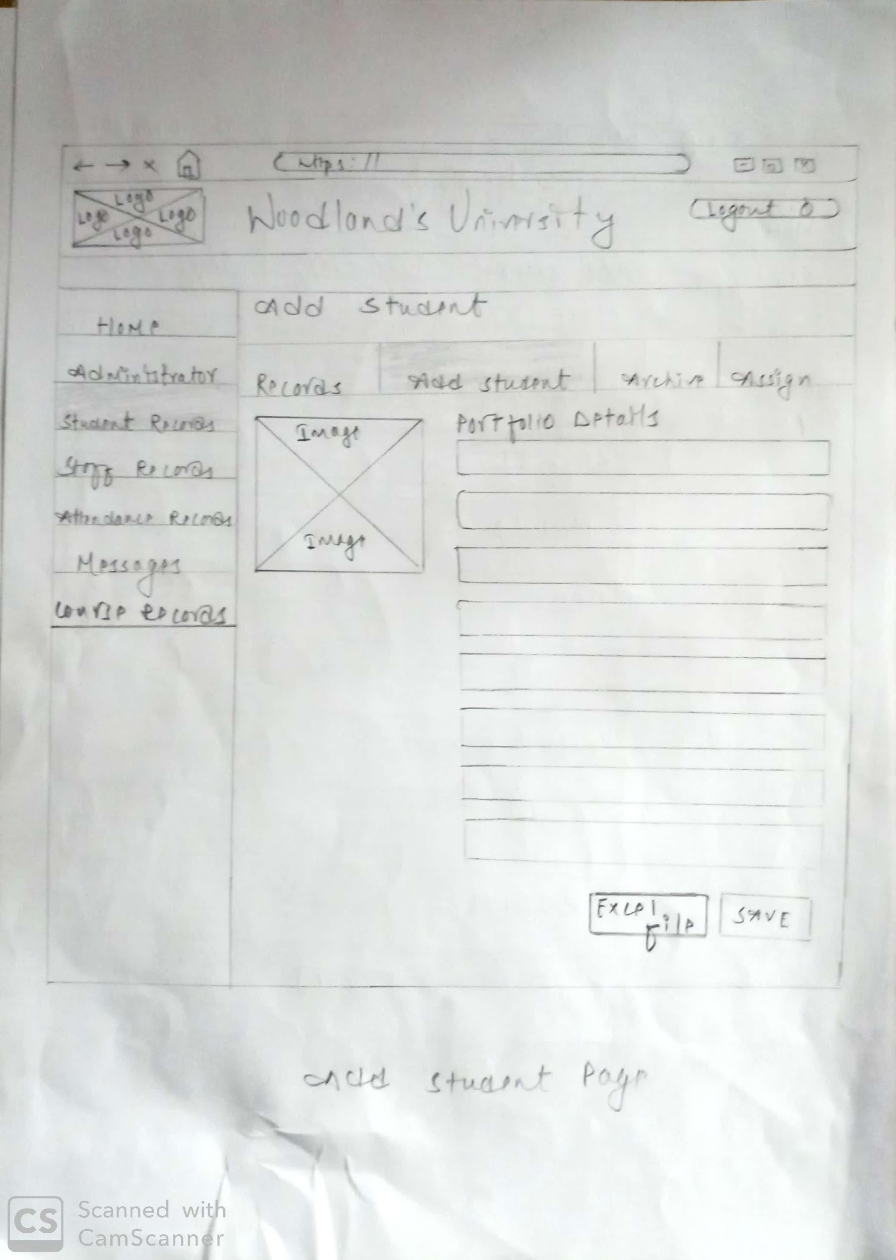

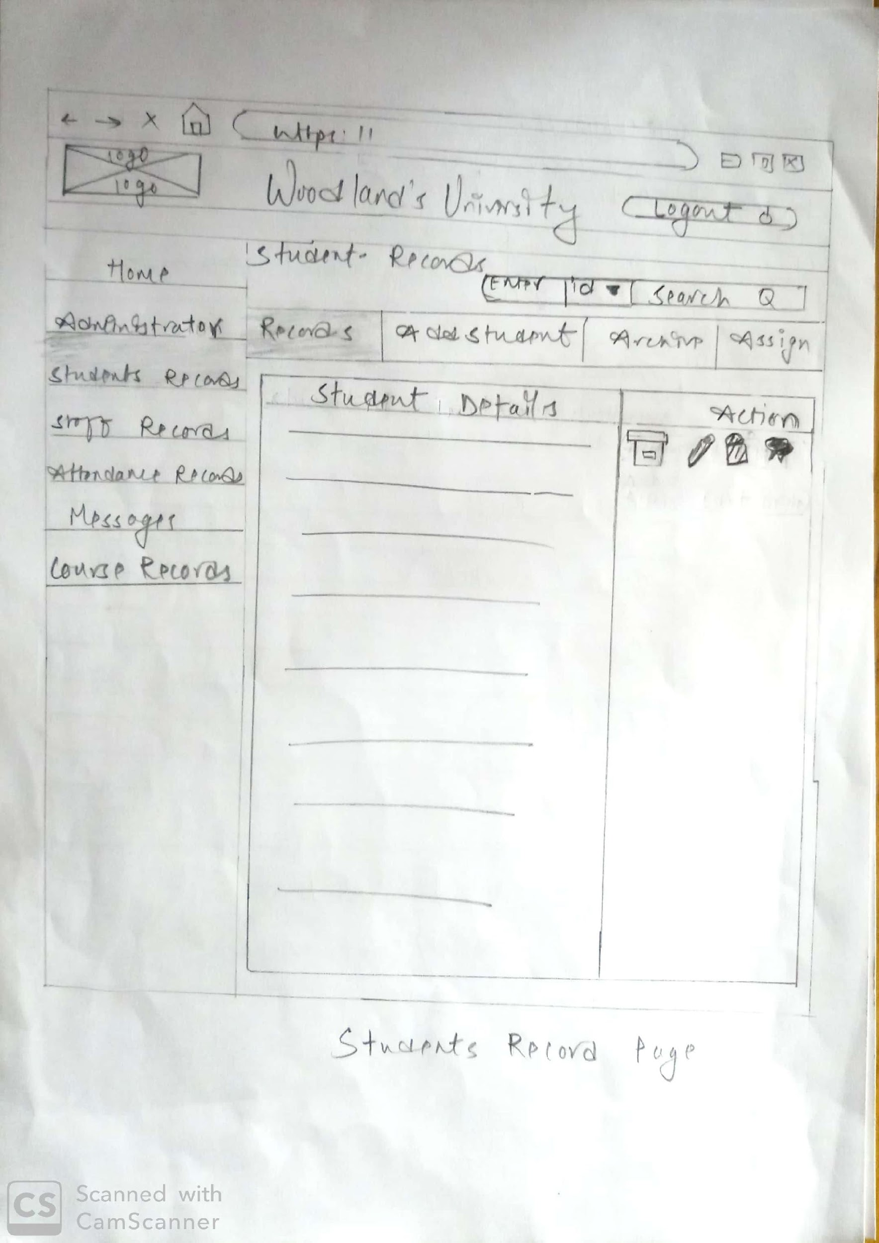

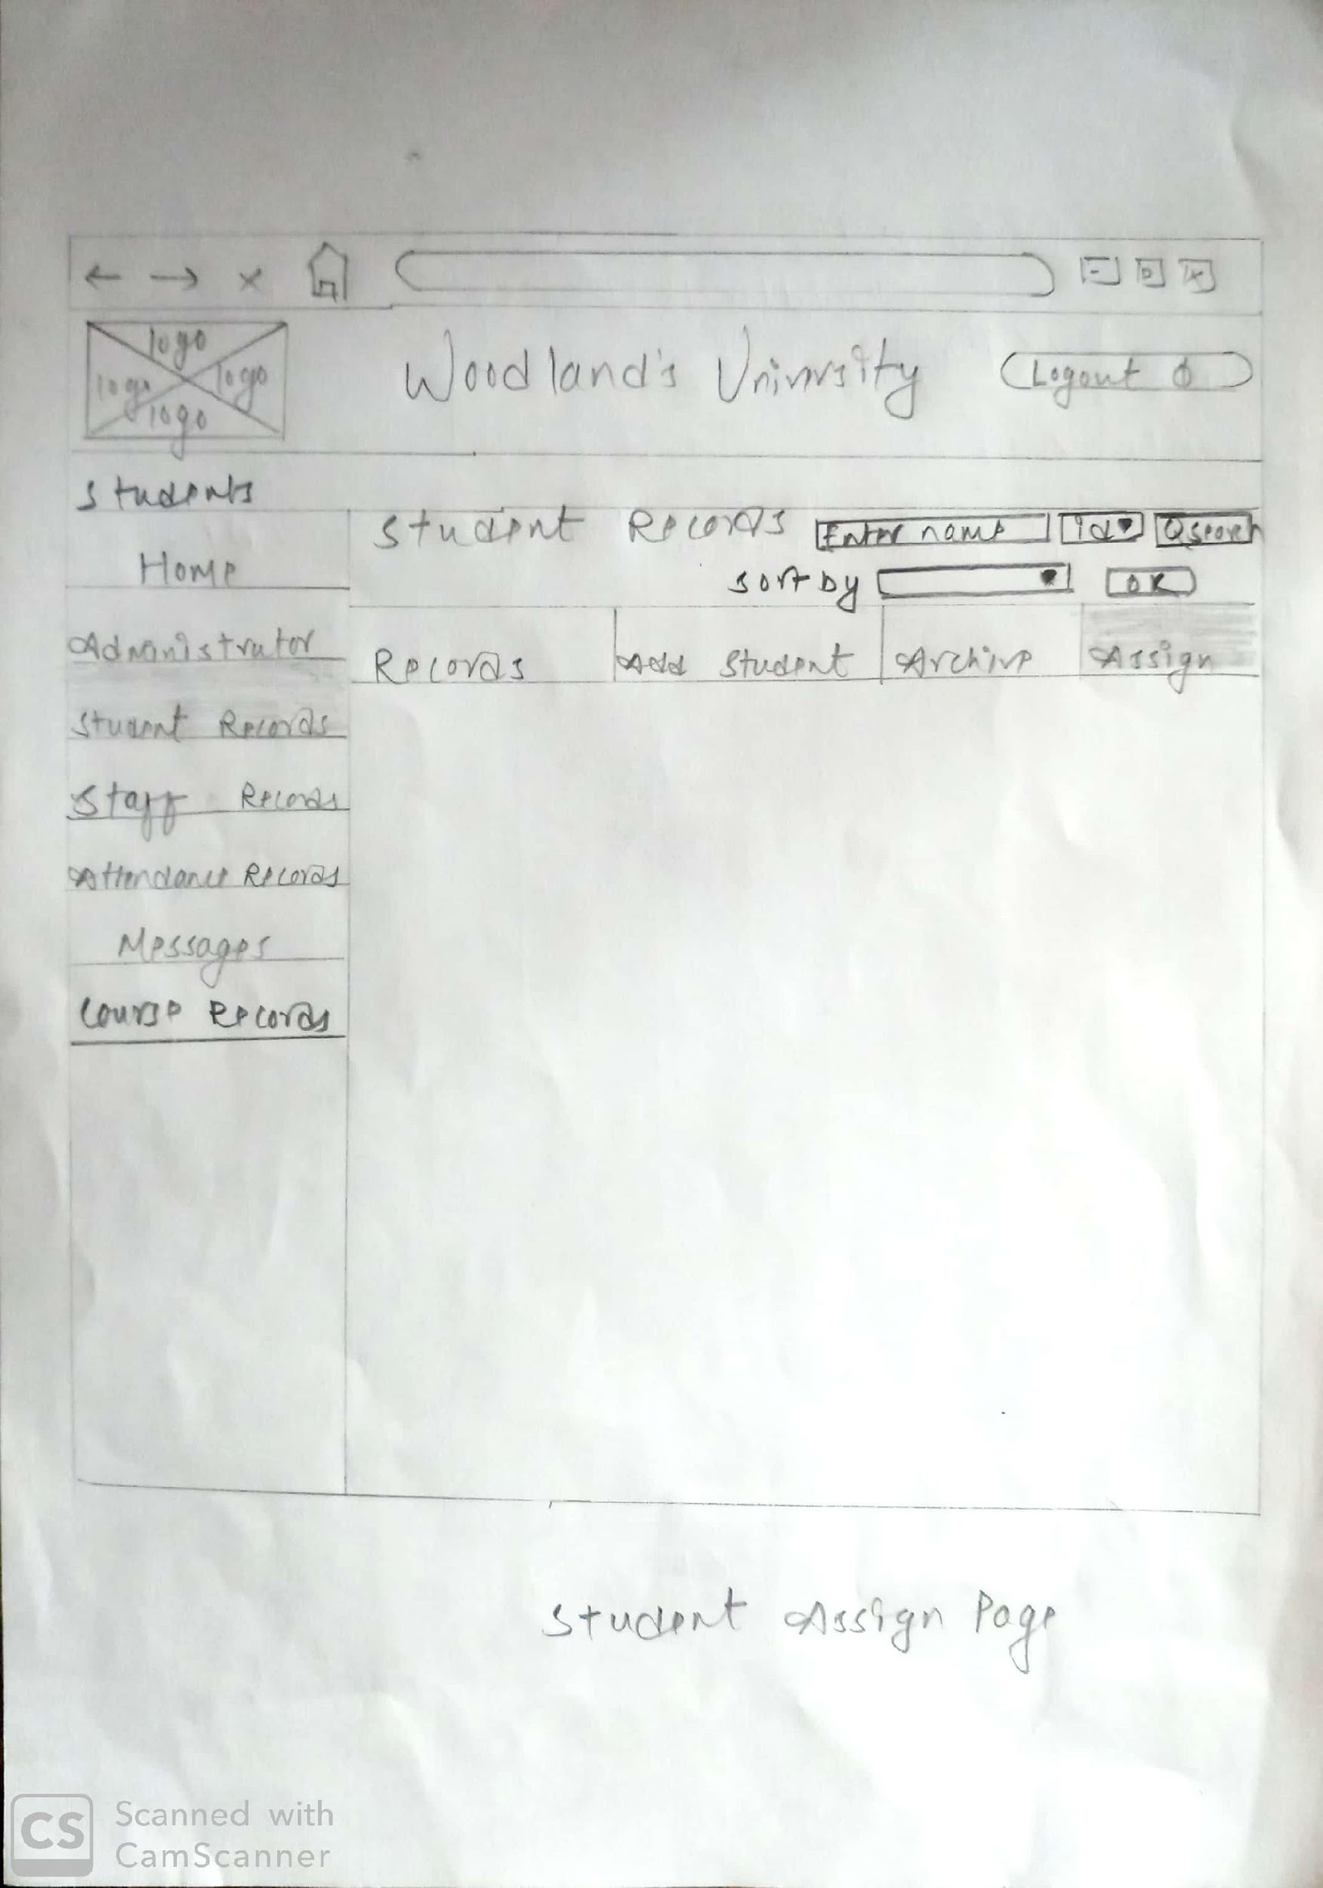 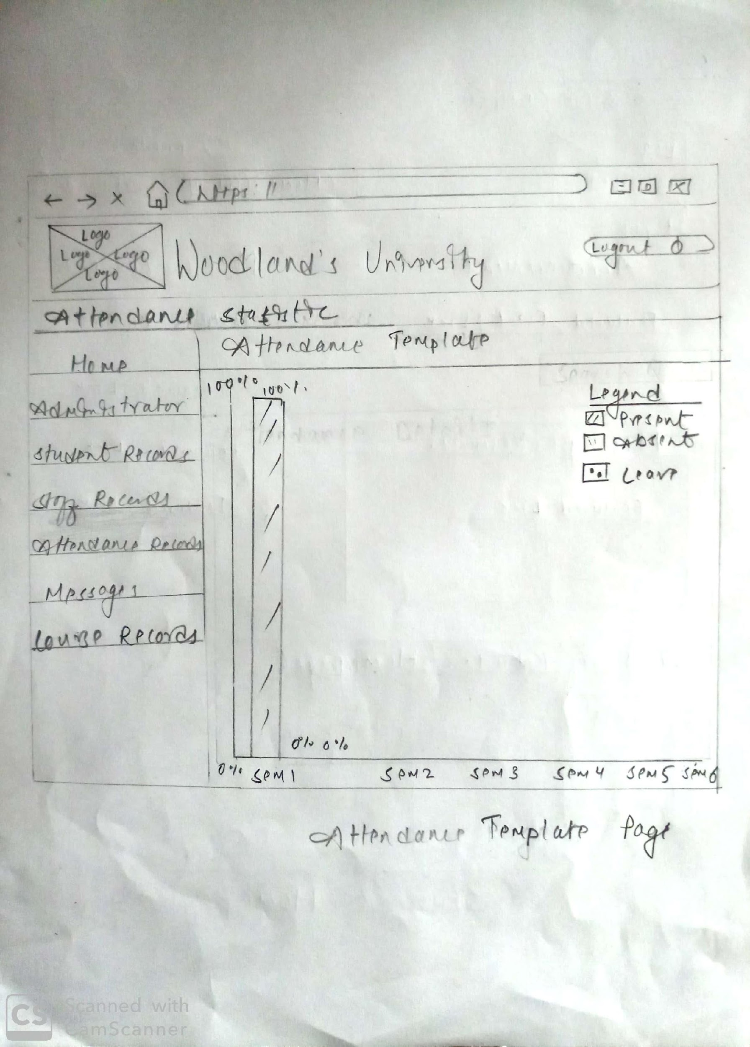

1. **Course Leader Website Wireframe**

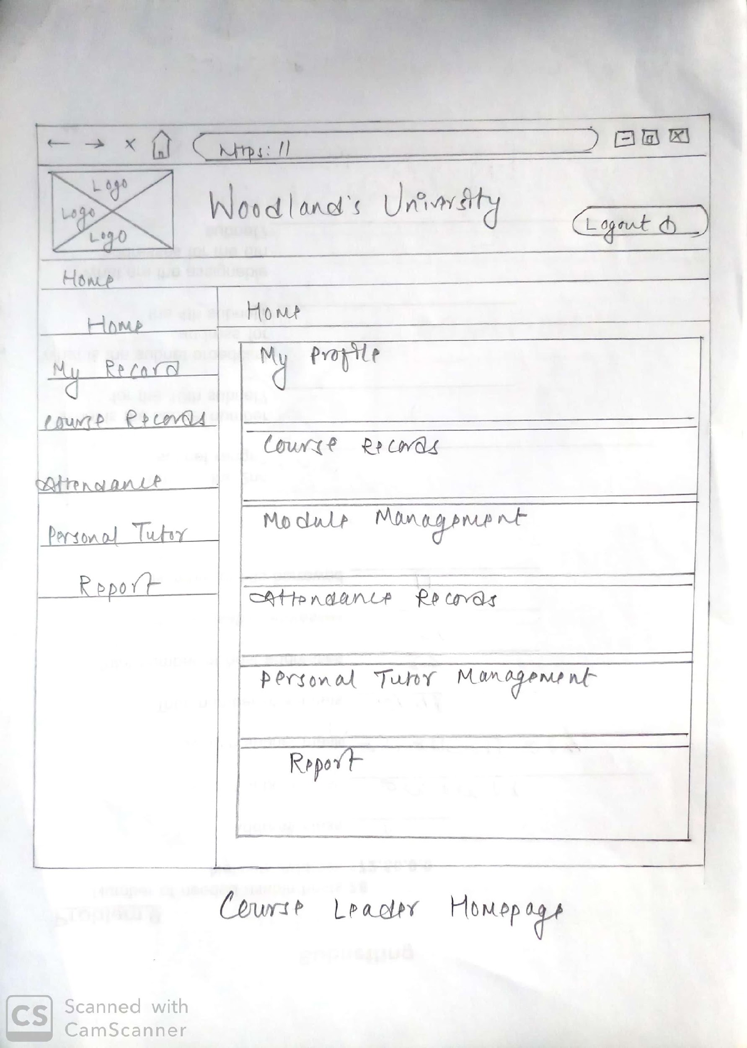

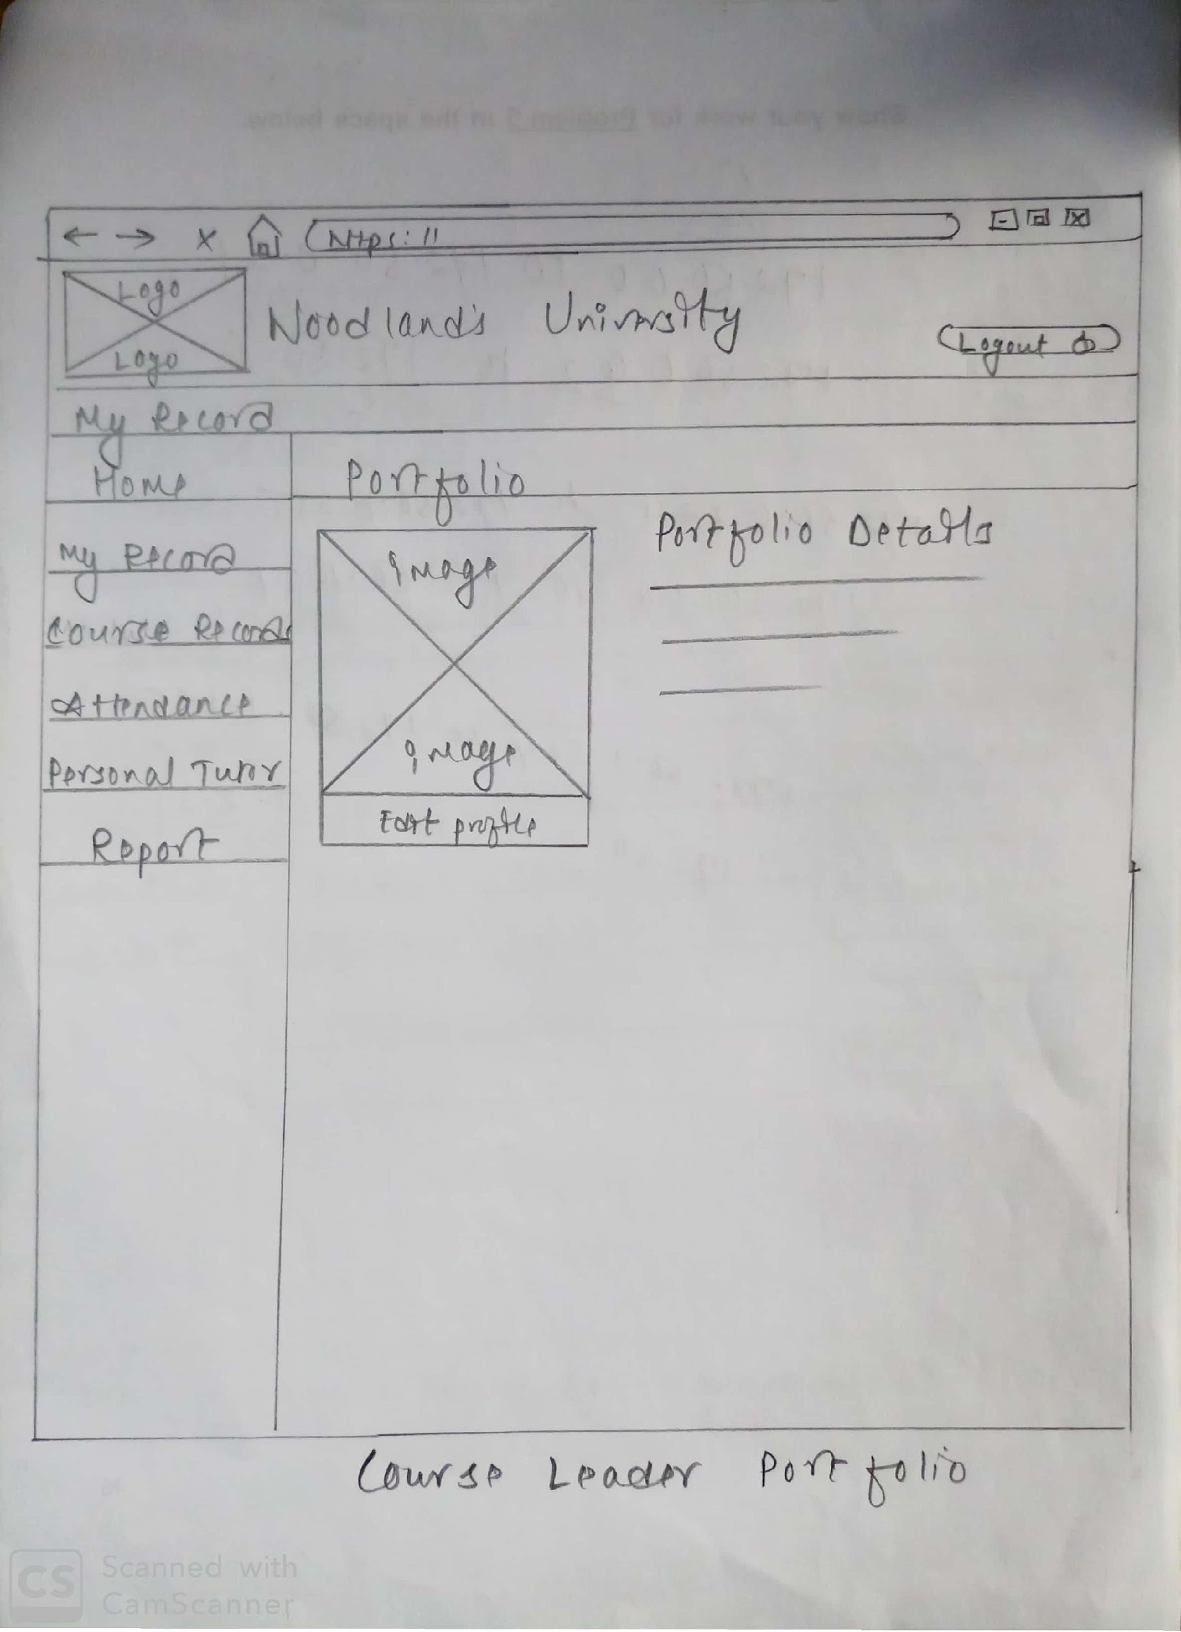

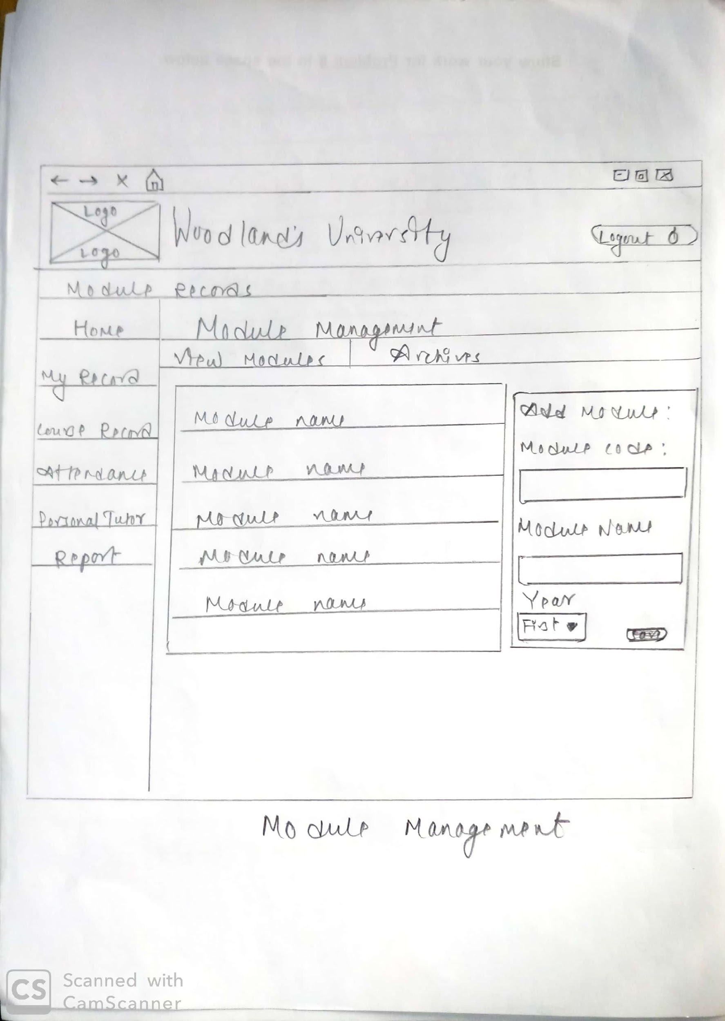

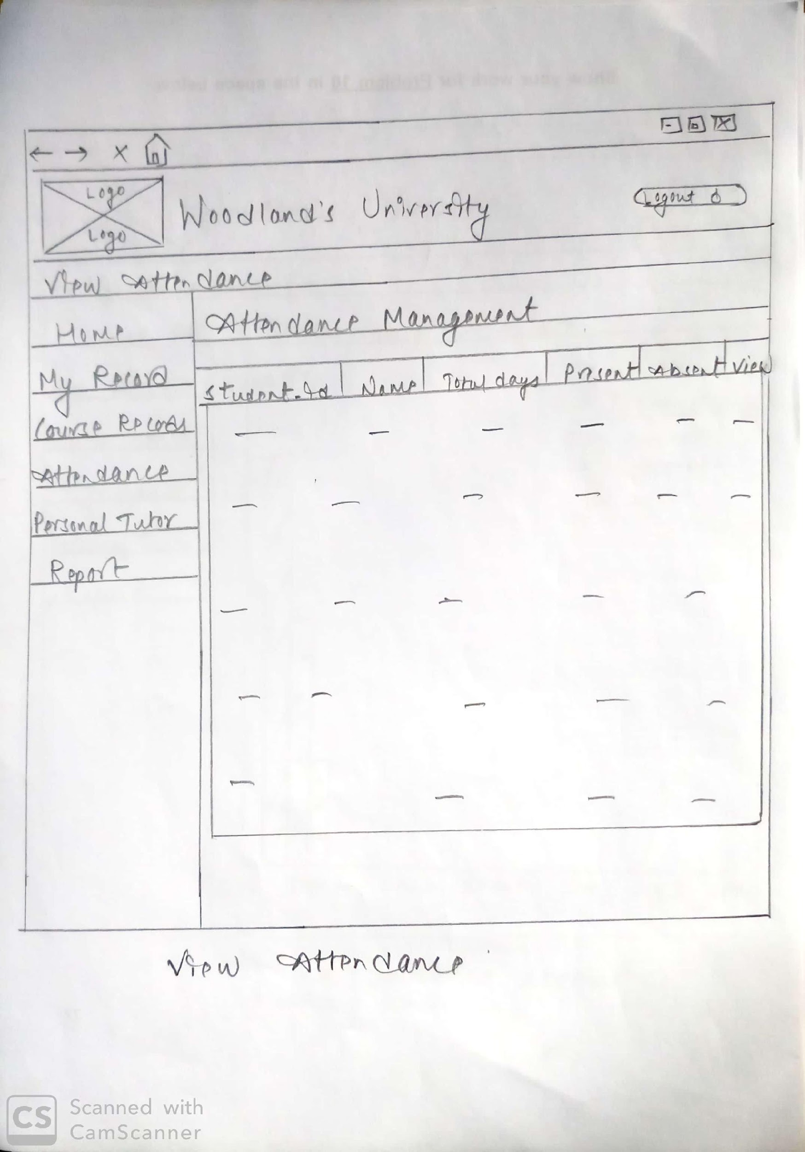

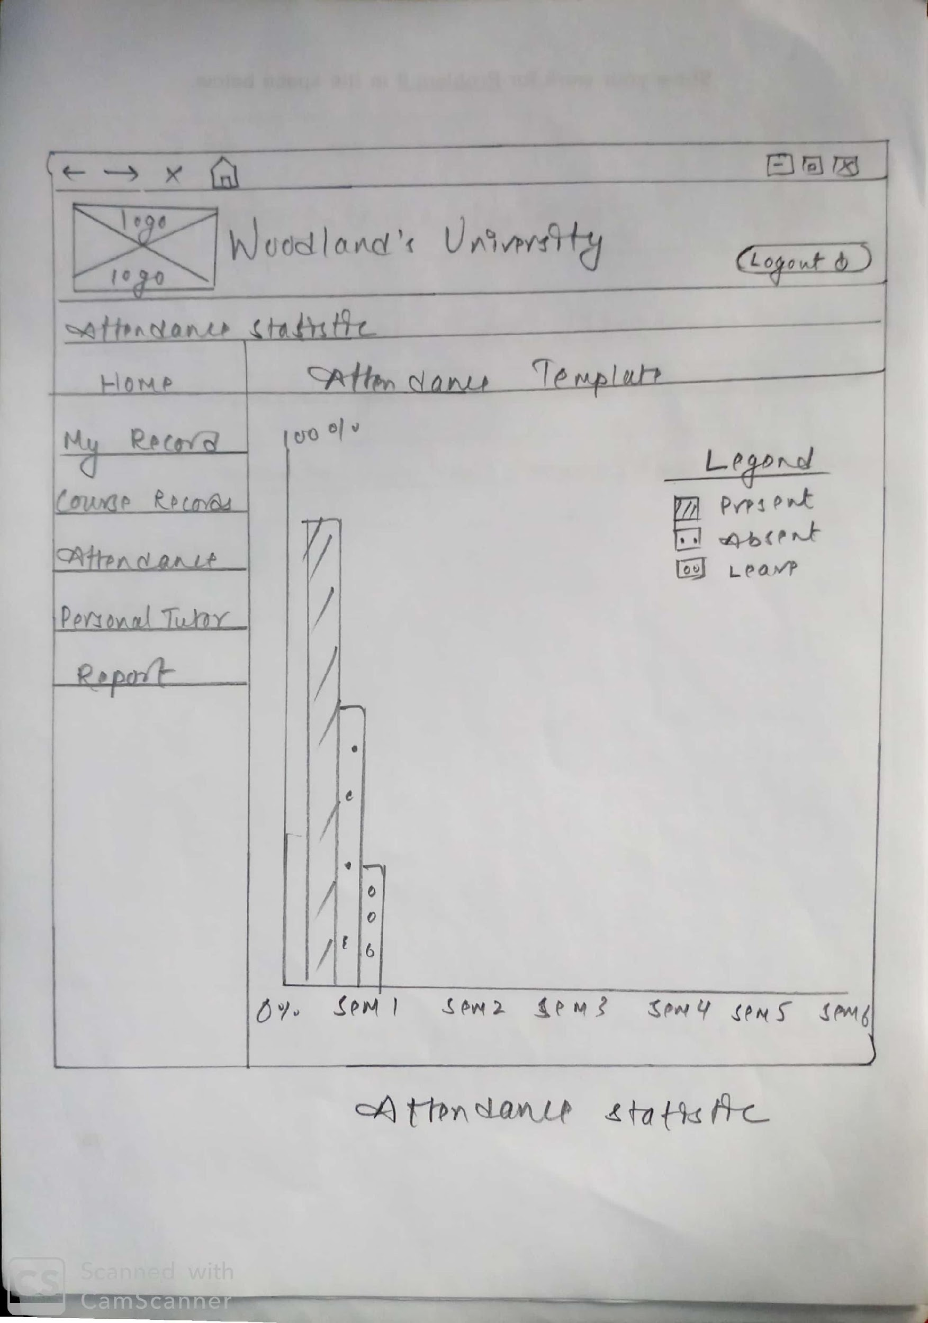

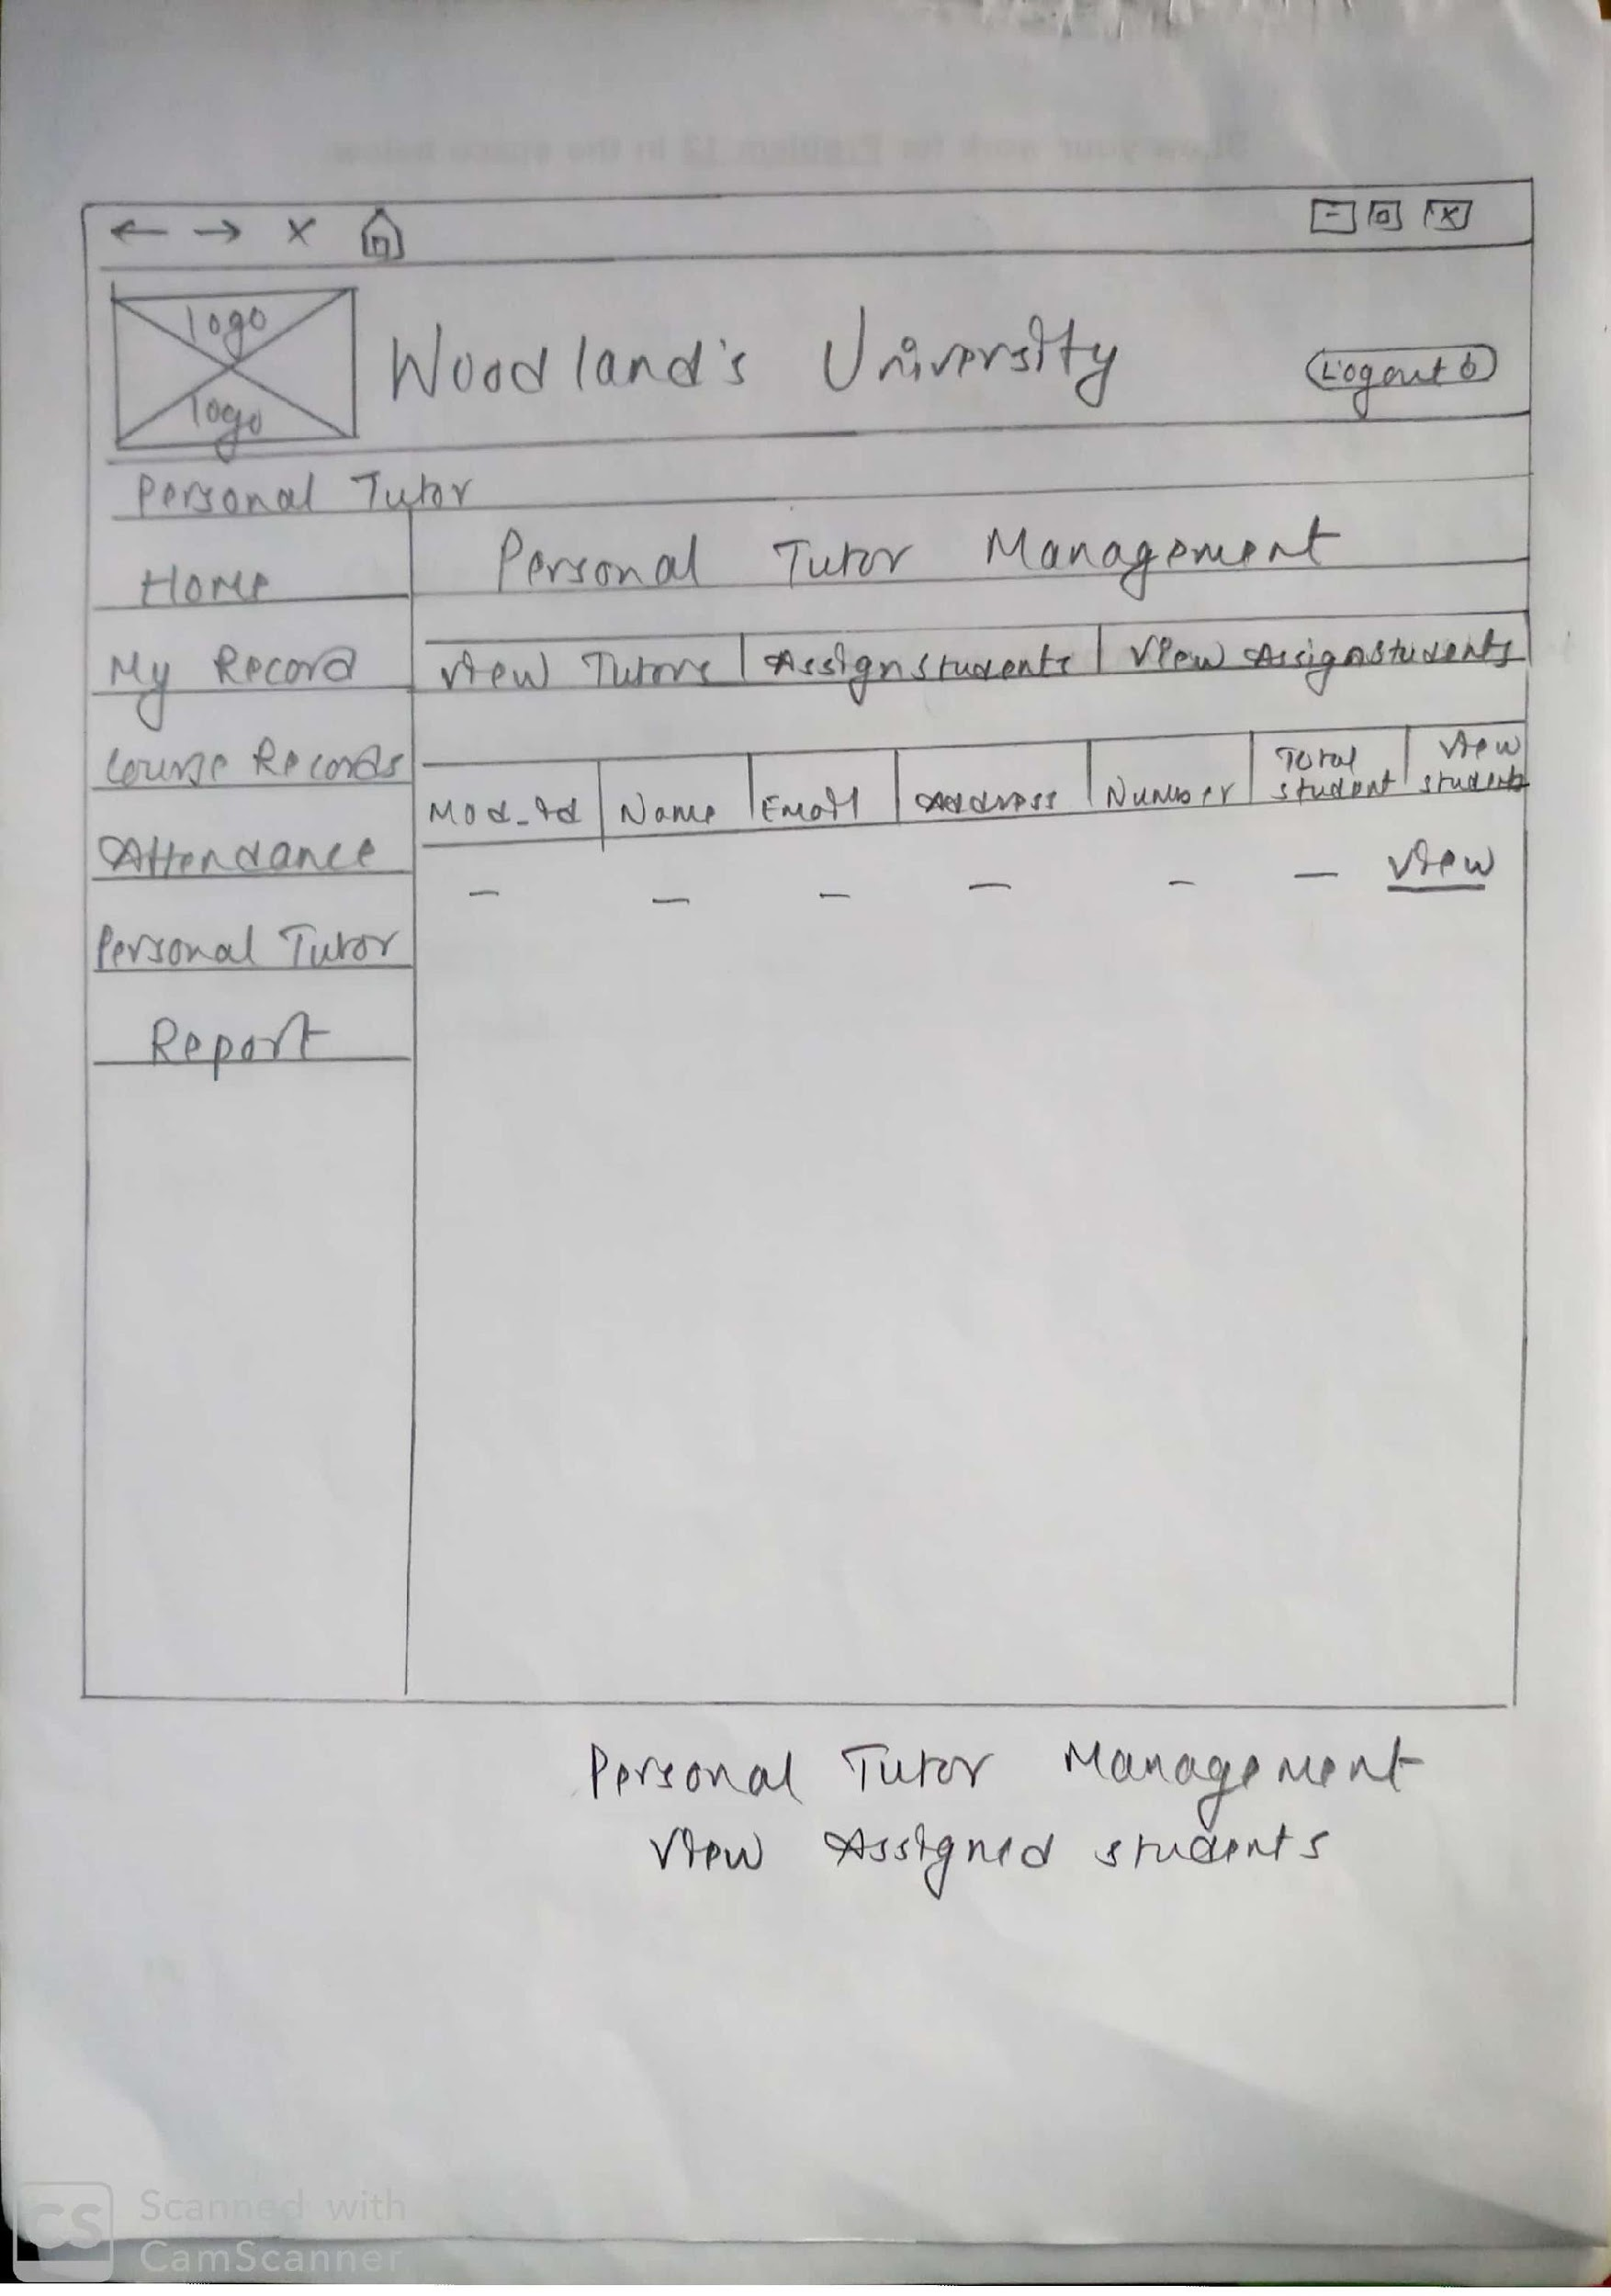

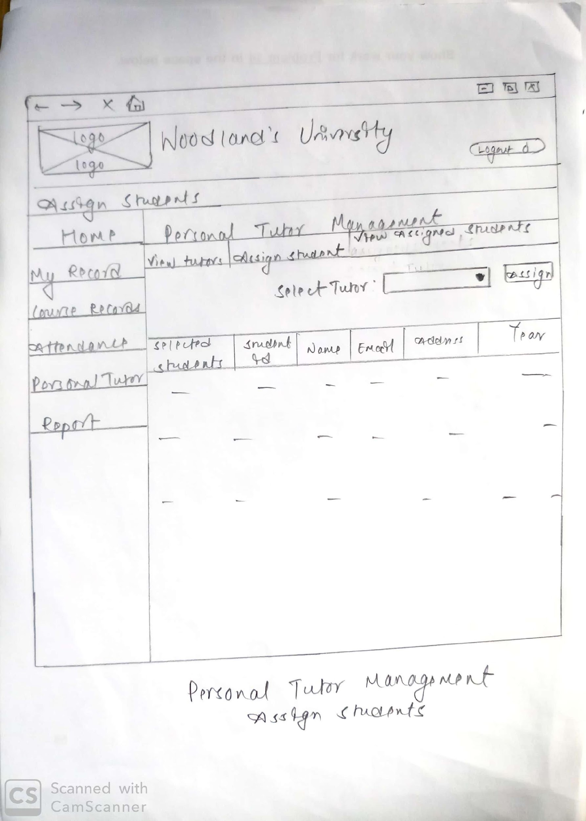

1. **Module Leader Website Wireframe**

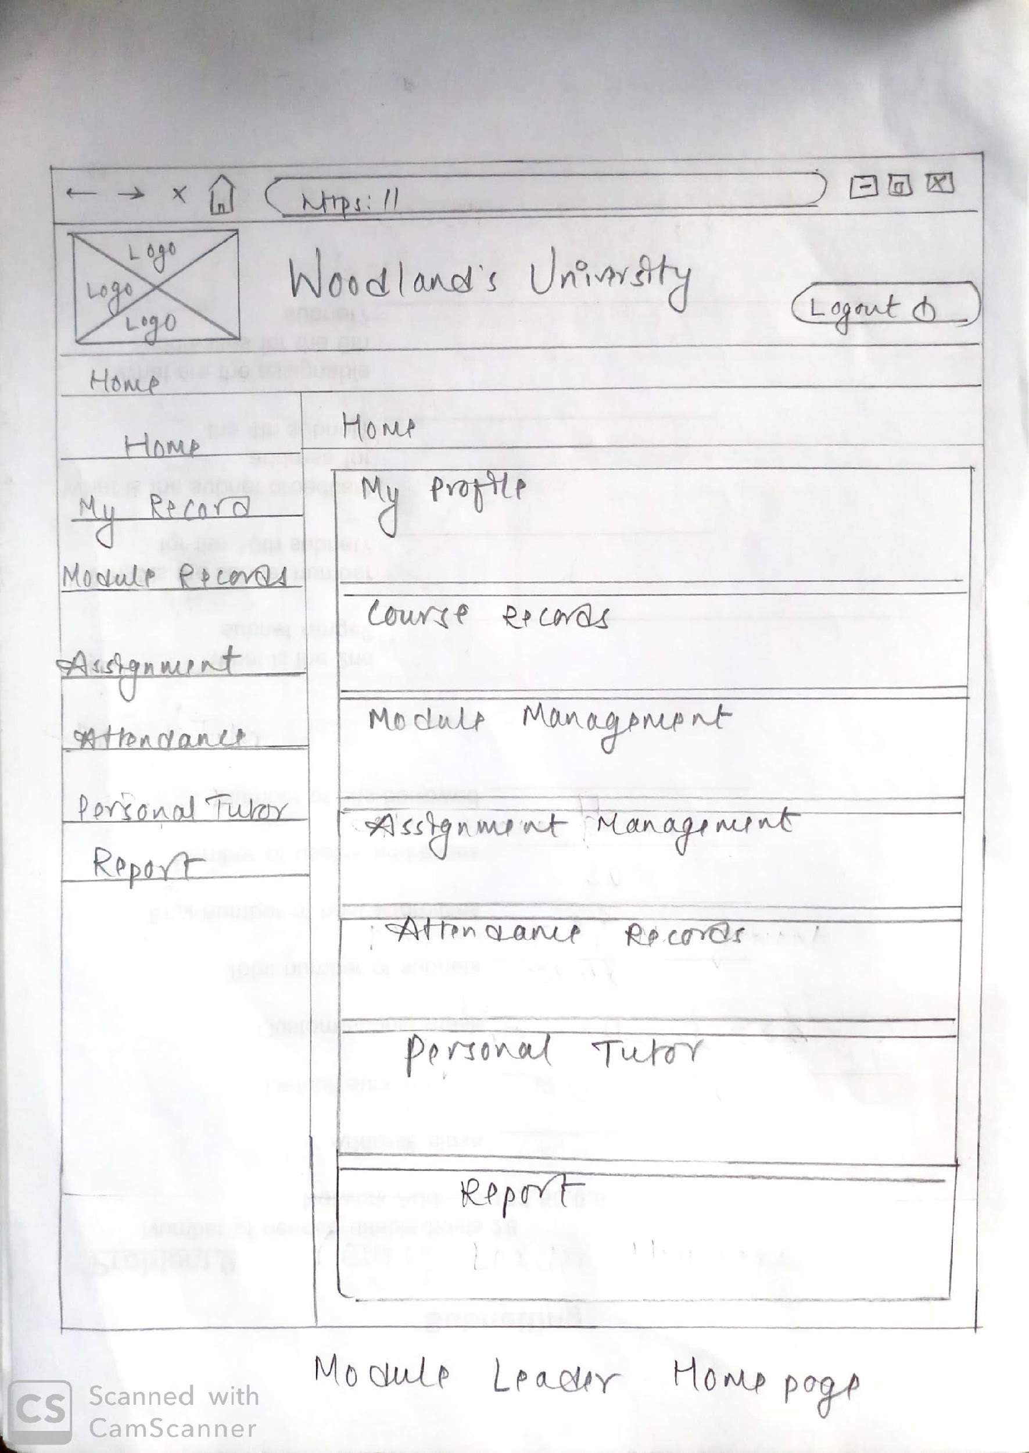

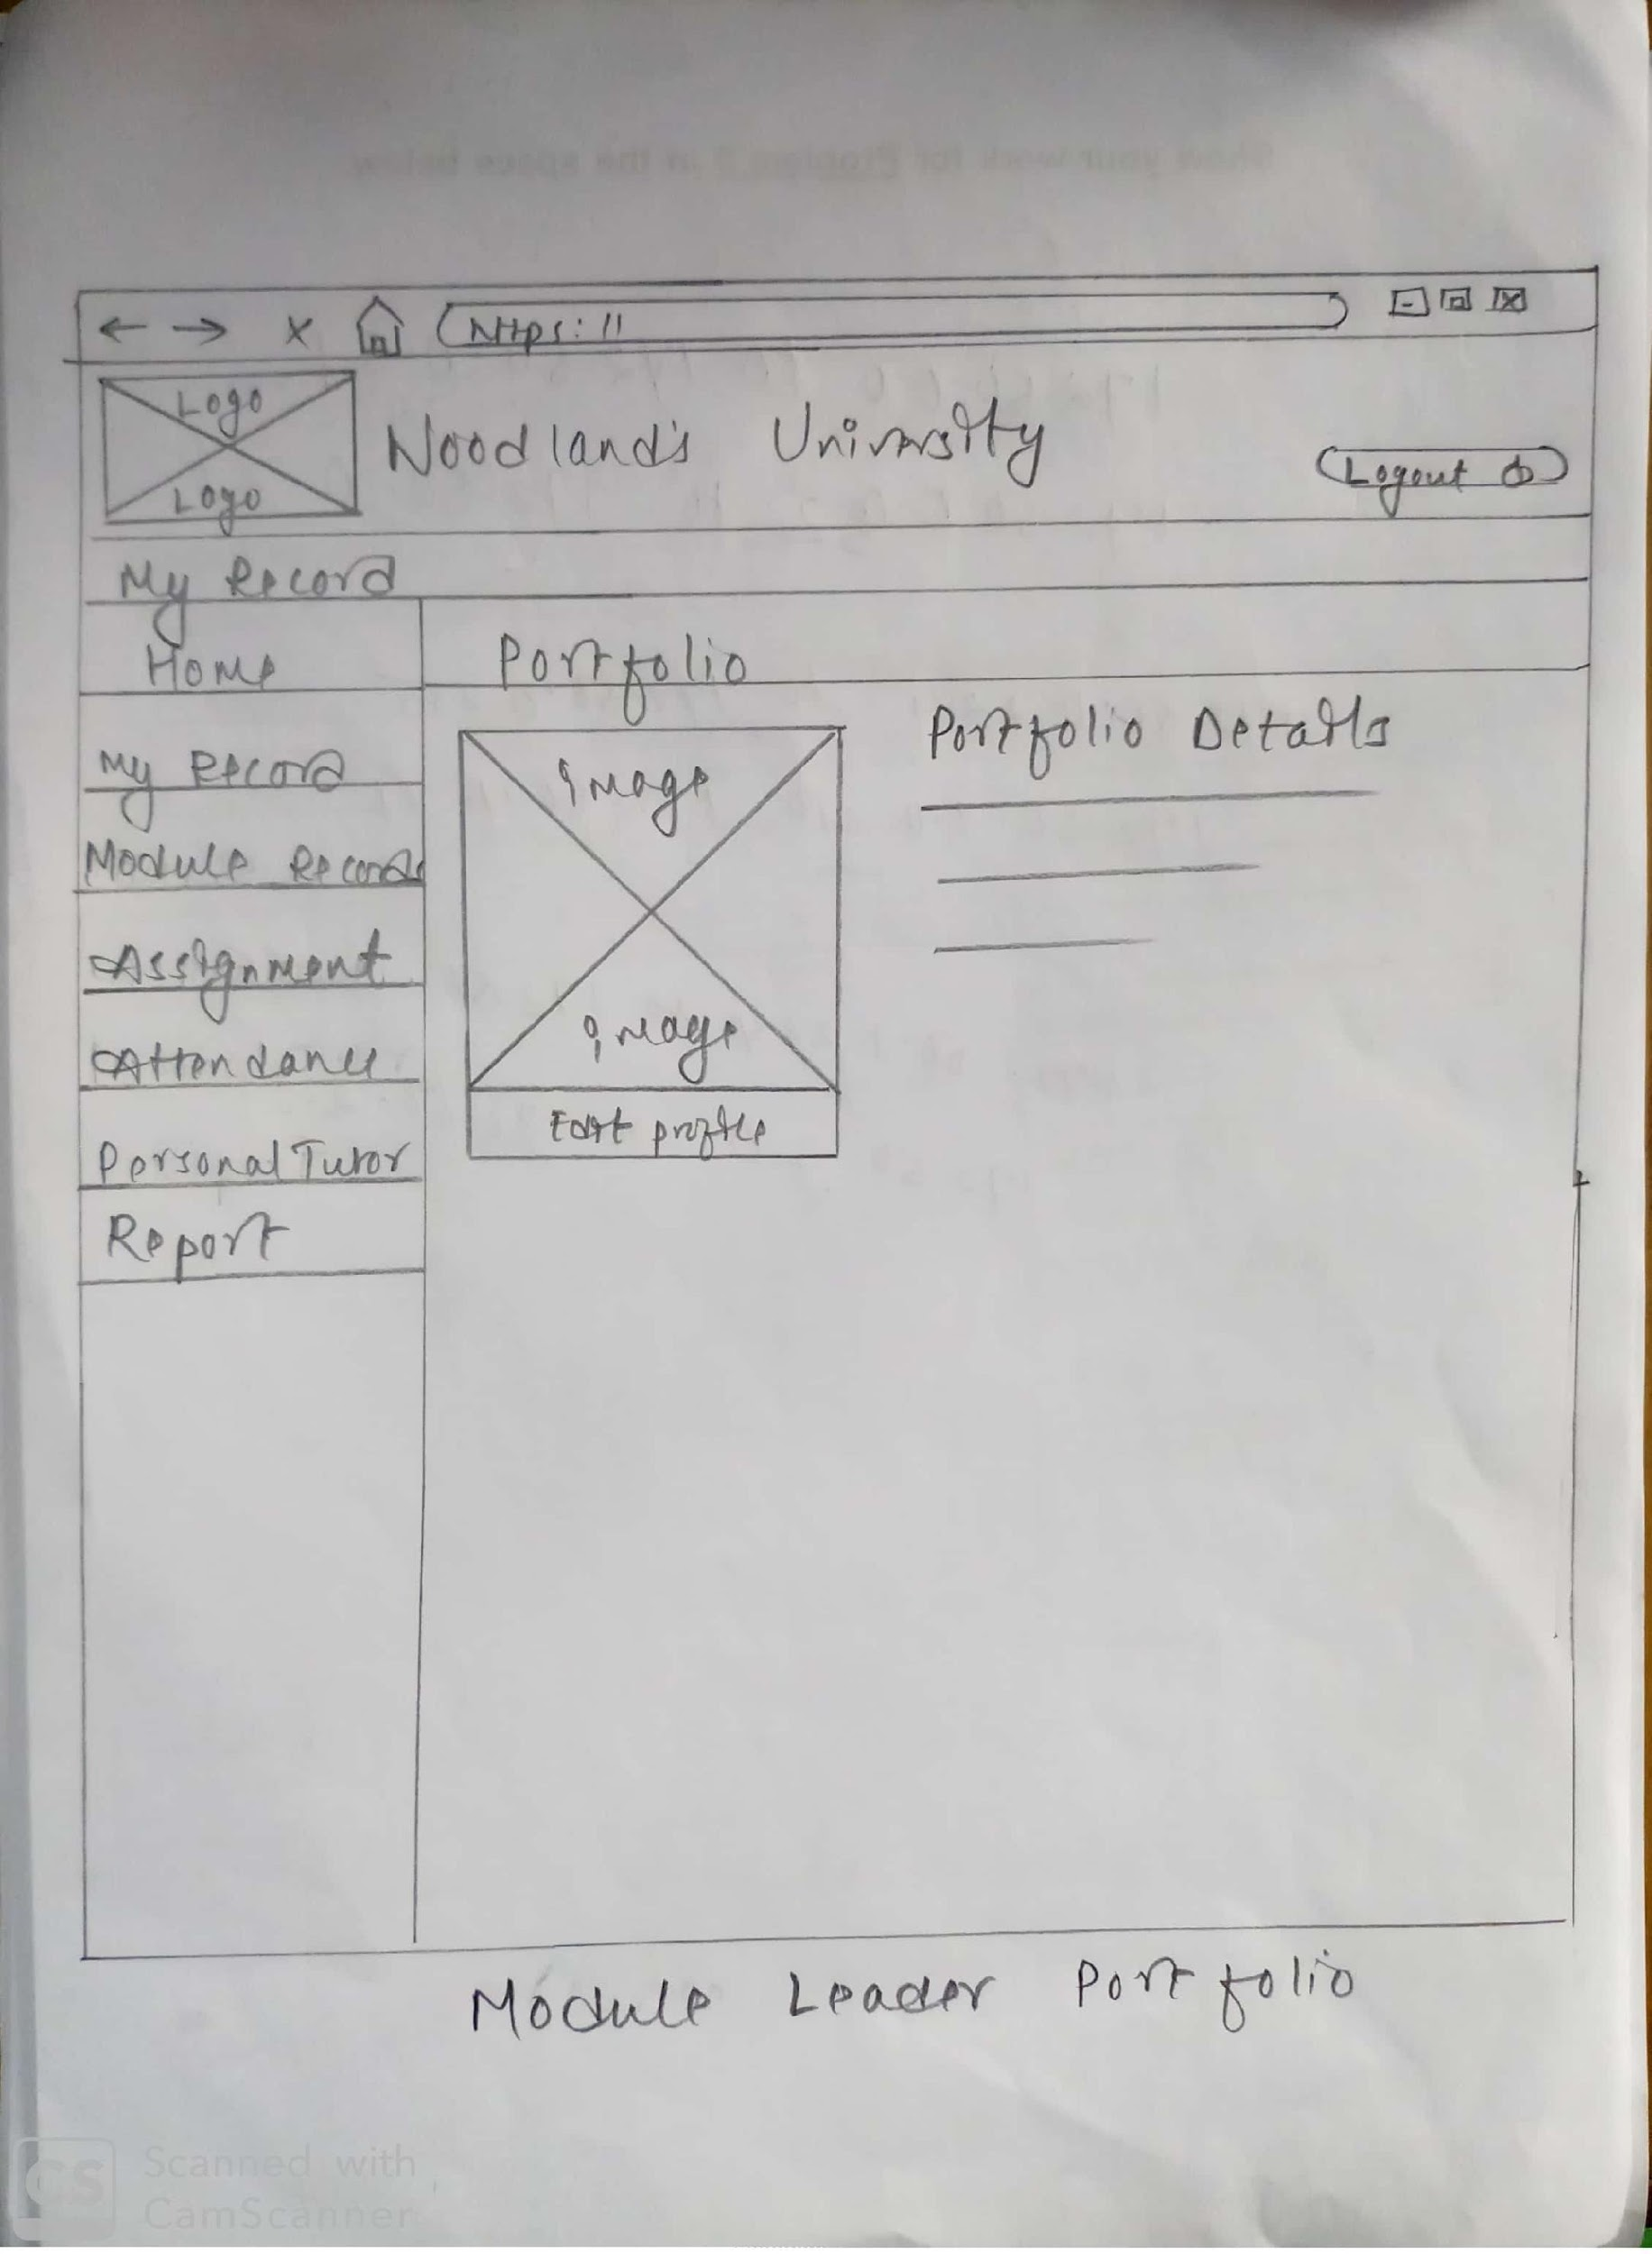

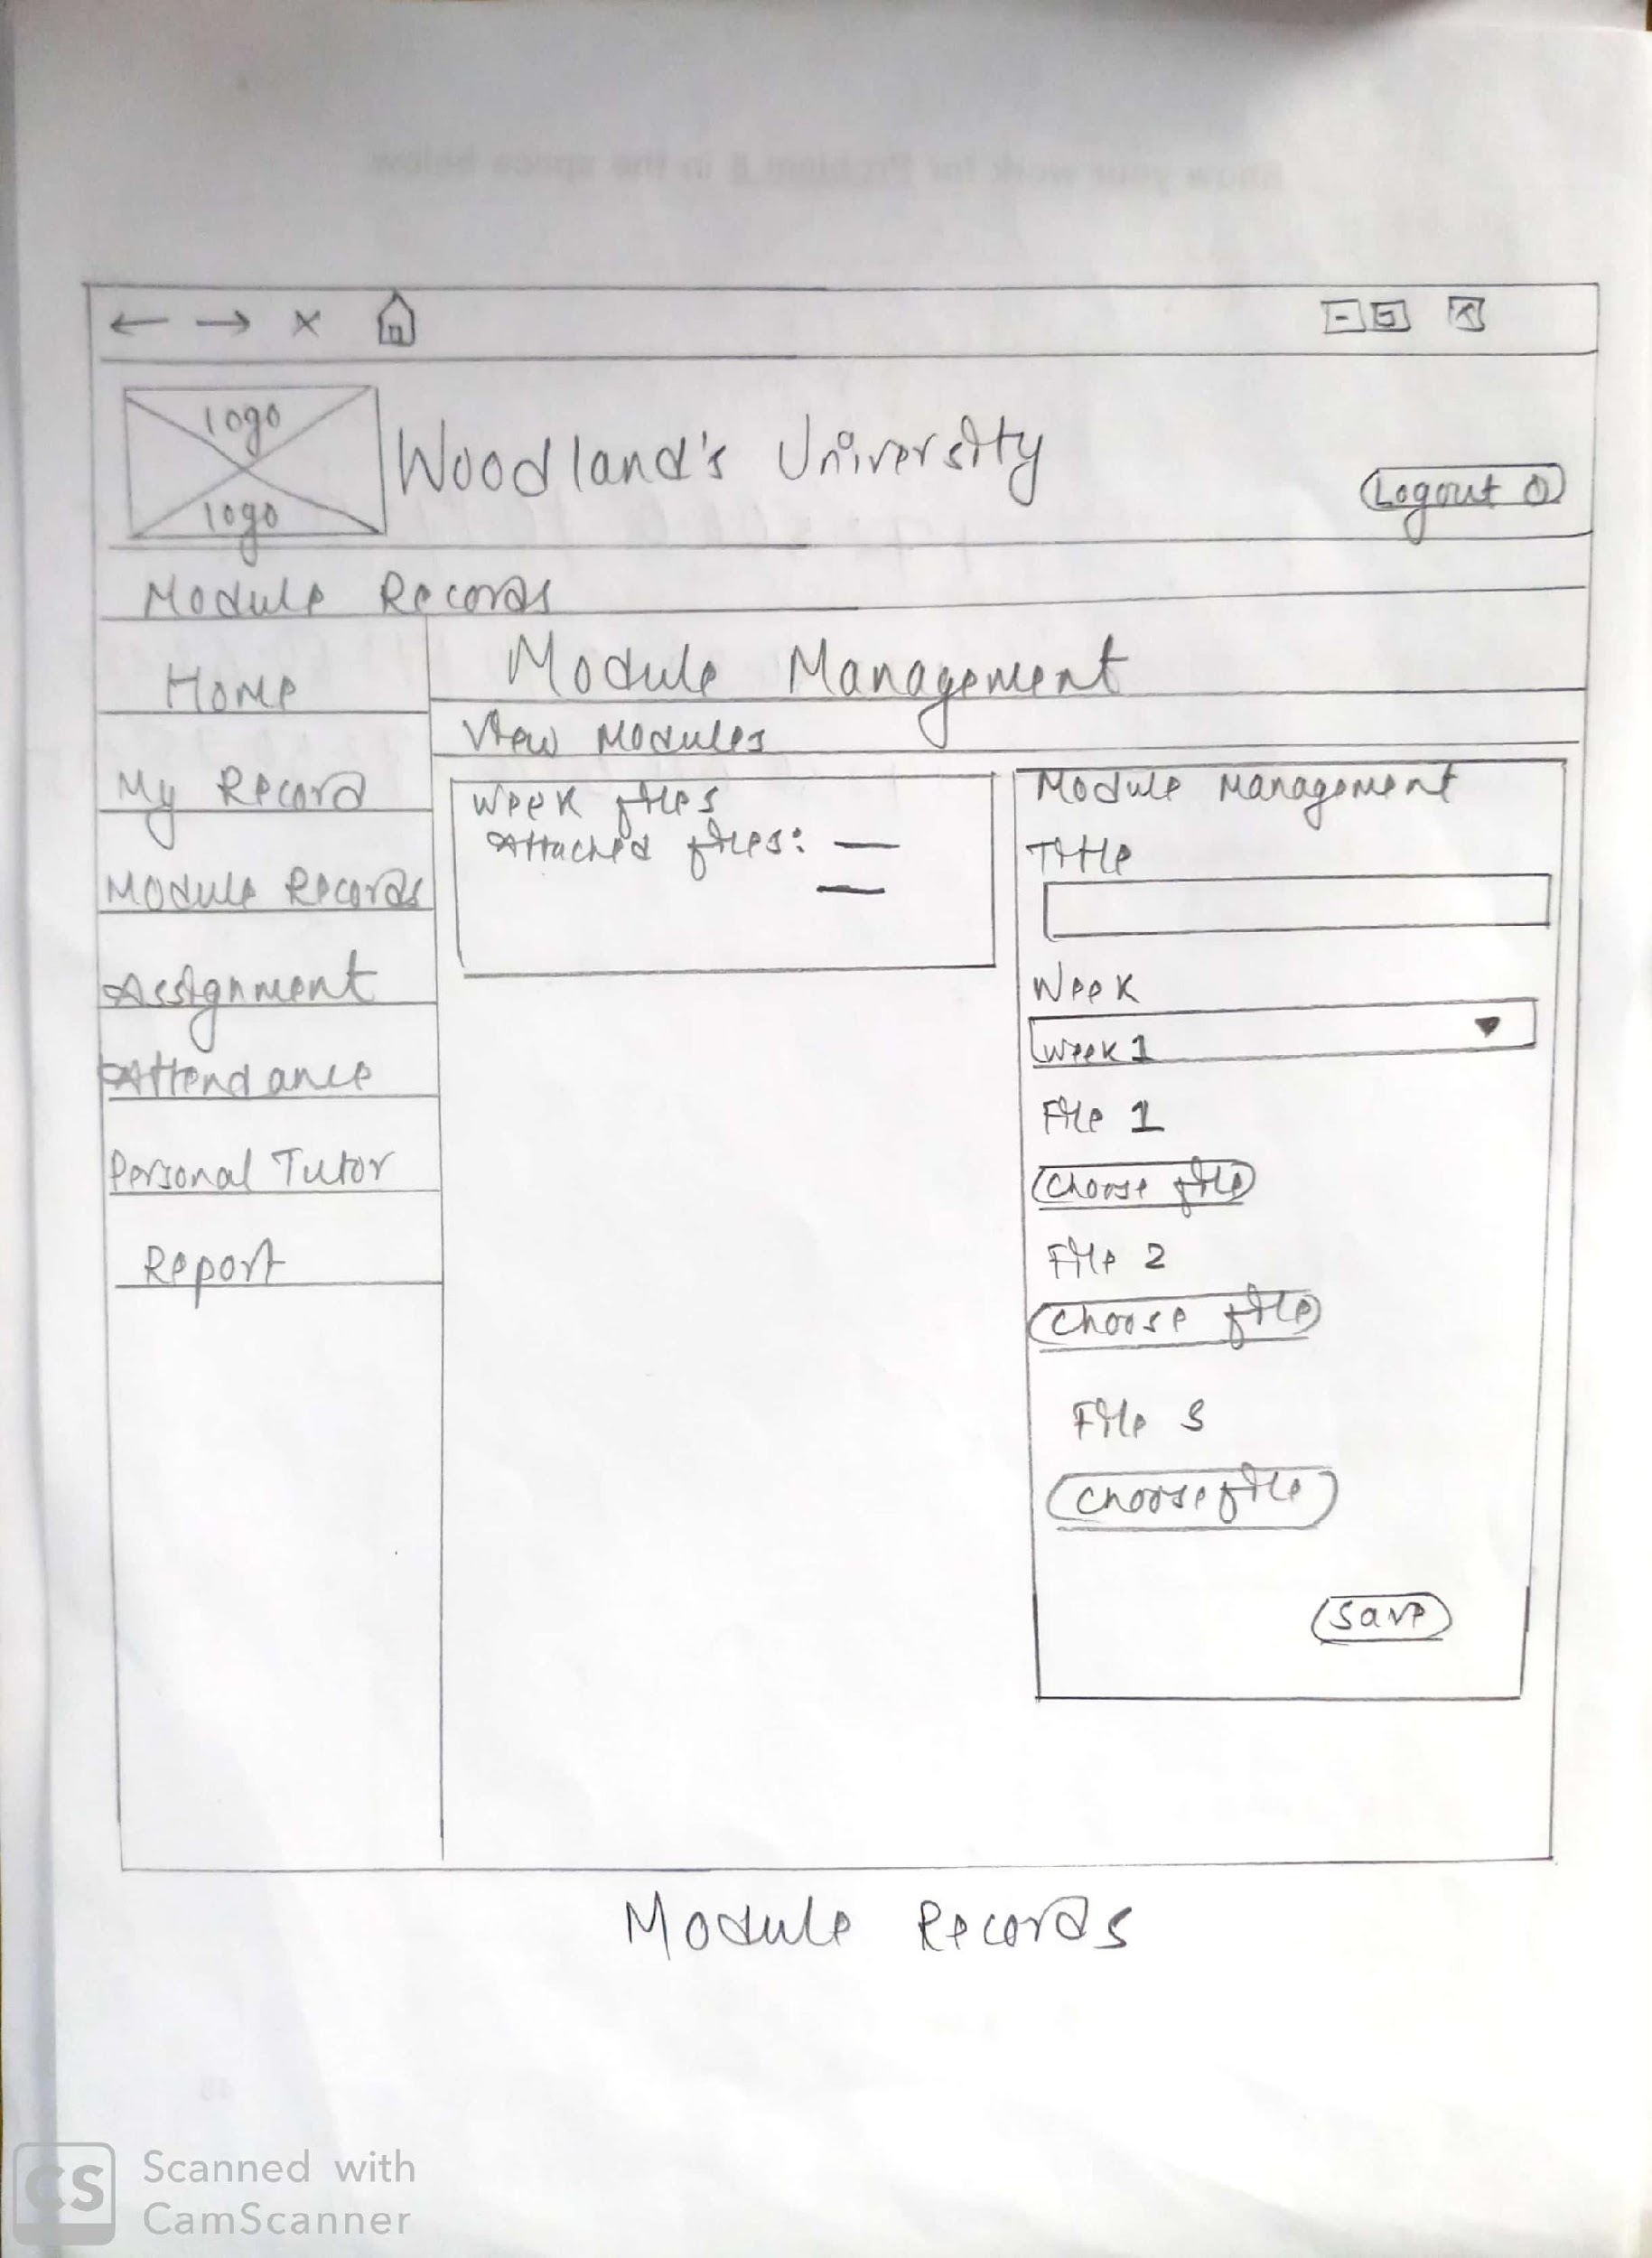 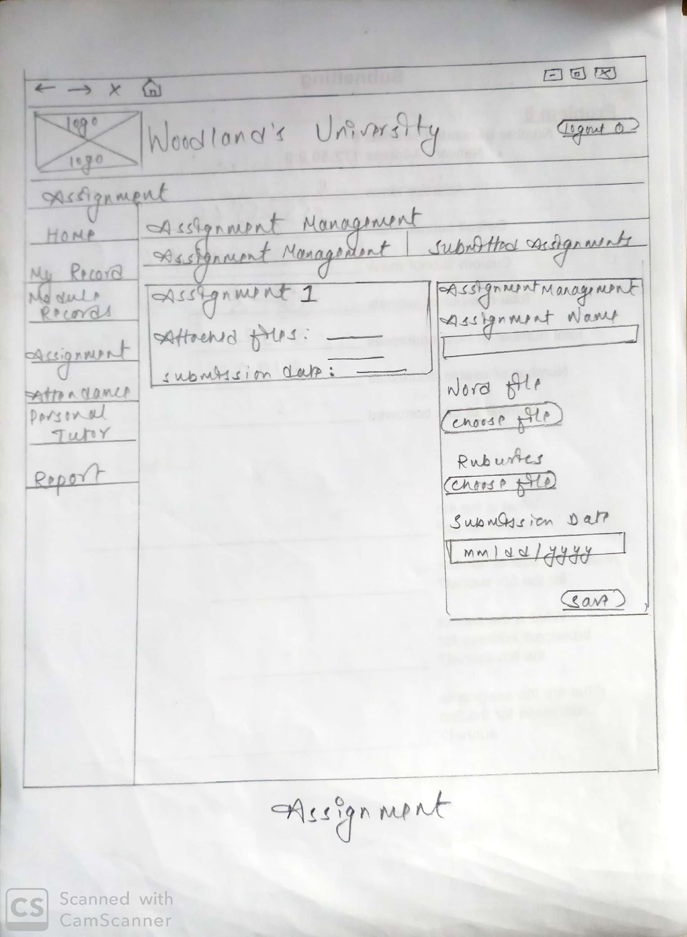

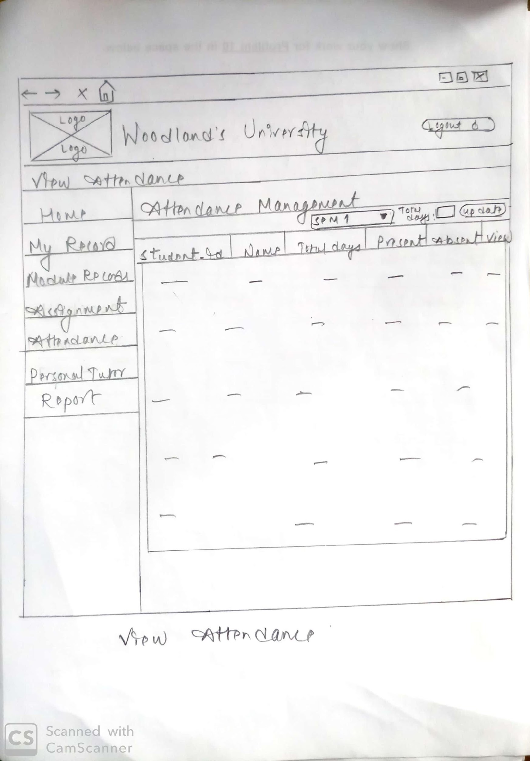

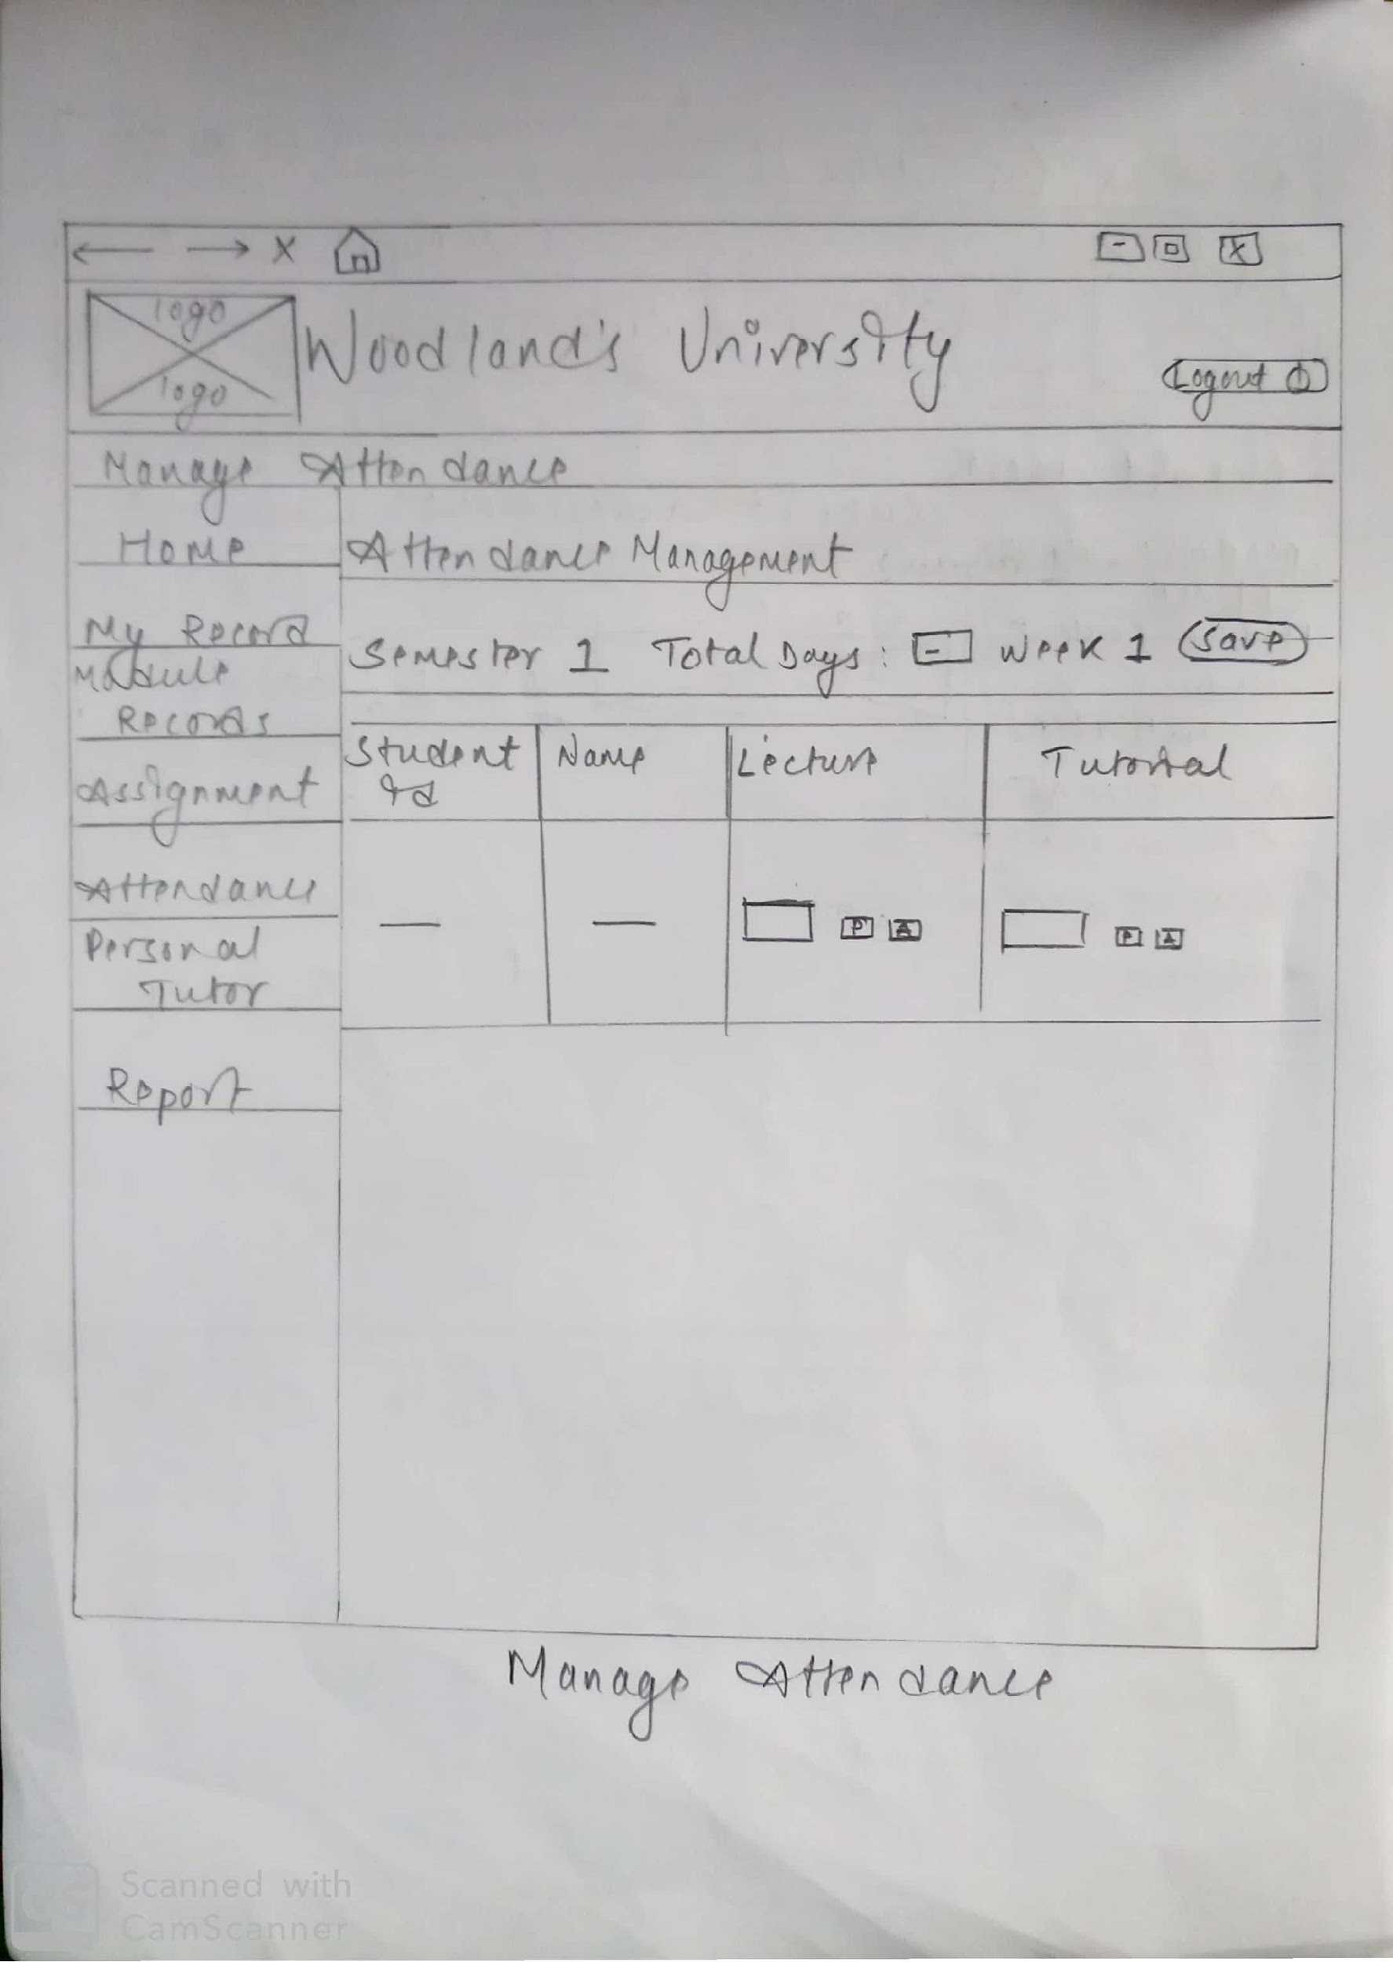

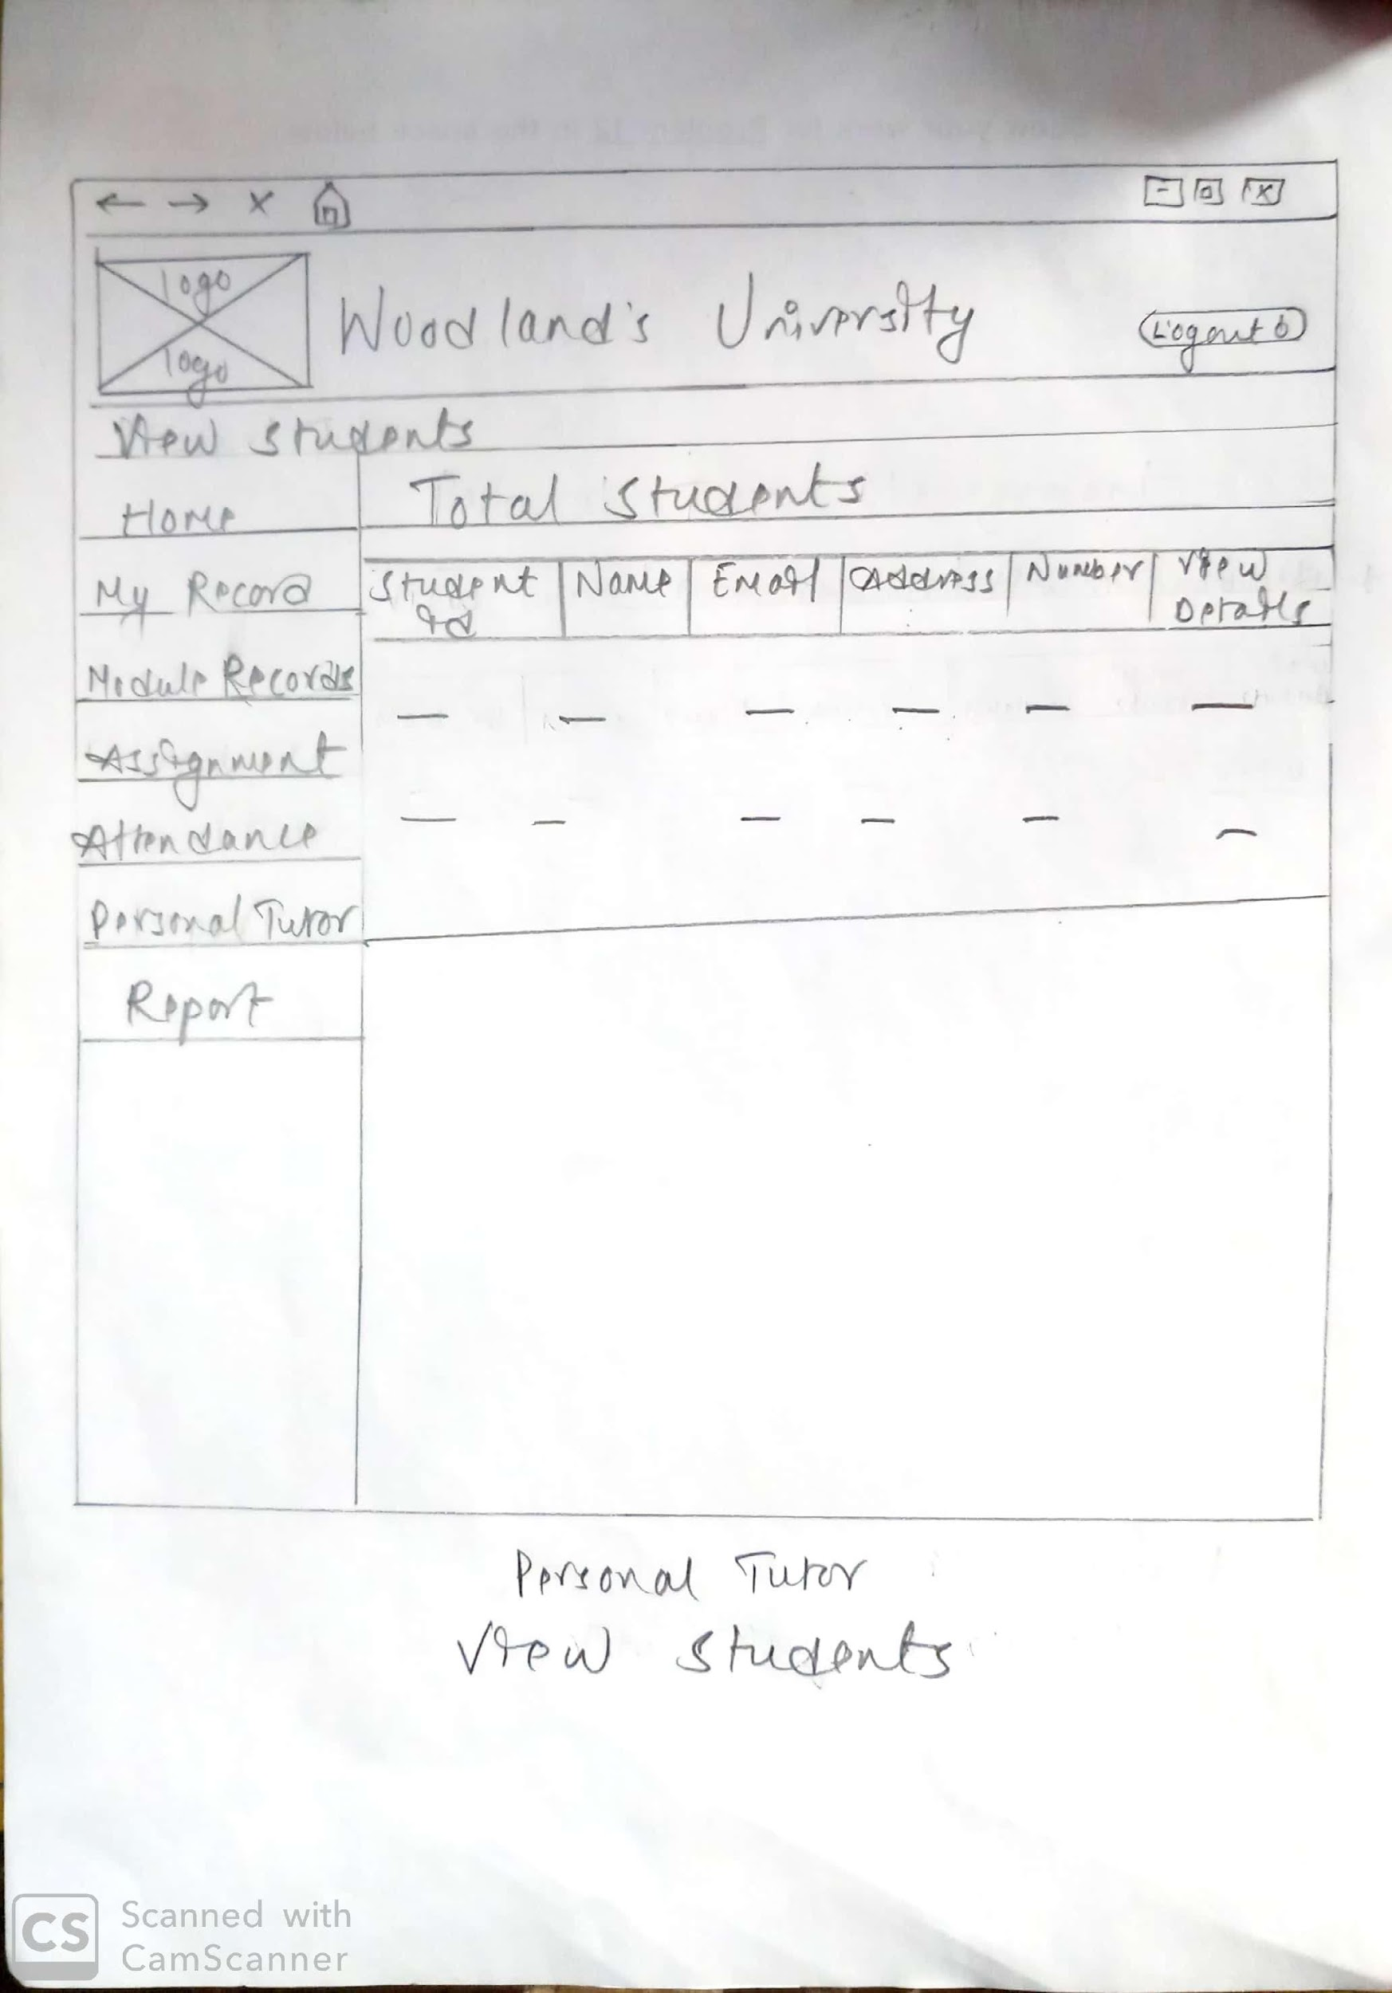

1. **Login Wireframe**

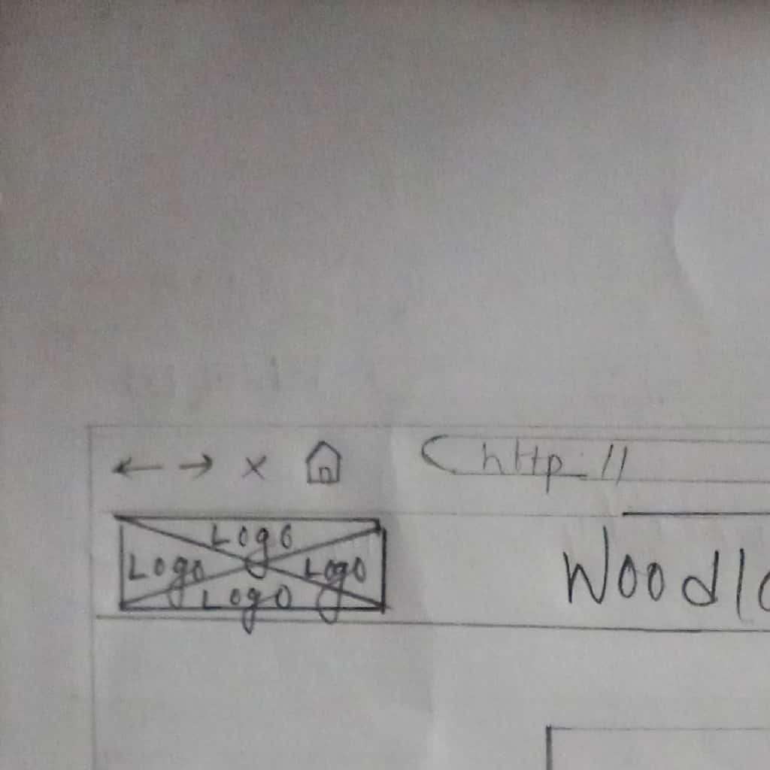

### 4.1.2 System Navigation Diagram

The system navigation diagram is used for the purpose to demonstrate the navigation of a website or a homepage. The system navigation diagram is a kind of documentation which helps other users/people to understand about the website. The system navigation diagram shows how the system works and makes things easier to understand. Therefore, our team made navigation diagram for admin, student and staffs. The navigation diagram is shown below in the figure:

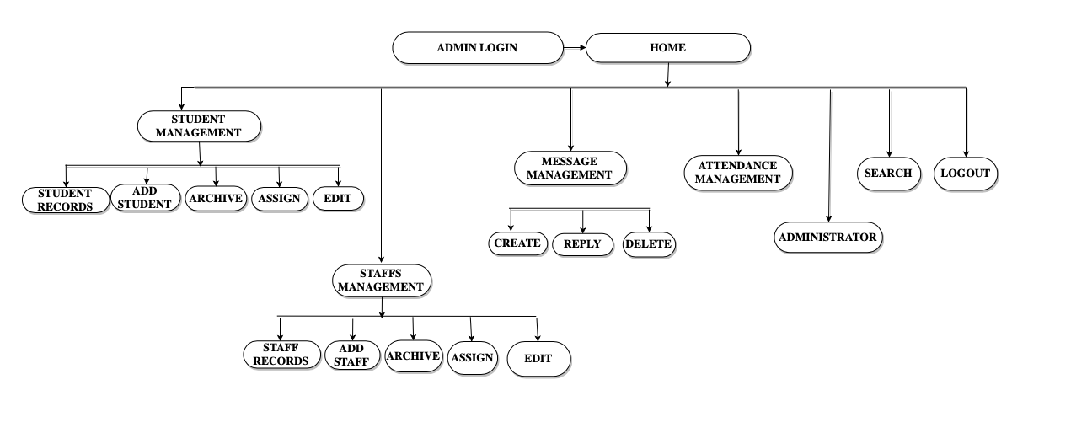

*Fig : 4.1.2.1 Admin Website Navigation Diagram*

The above picture represents the navigation diagram of the administration. In this system the admin can manage the students, staffs, student attendance and messages. The admin can view the details of both student and staff. He can edit, add, archive, assign both student and staff. The admin would be able to send messages to both students and staffs. He can also delete the messages.

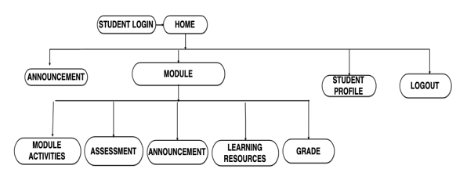

*Fig: 4.1.2.2 Student Website Navigation Diagram*

The above picture is the navigation diagram of the student website. When the student login into their system they would be able to access their profile. They can view the module activities. The can know any announcements provided by the admin or the module leader. The student would be able to view their grades. The student can download the assignment from the system and also upload the assignment when the work is done. The student can logout off the system when their work is done.

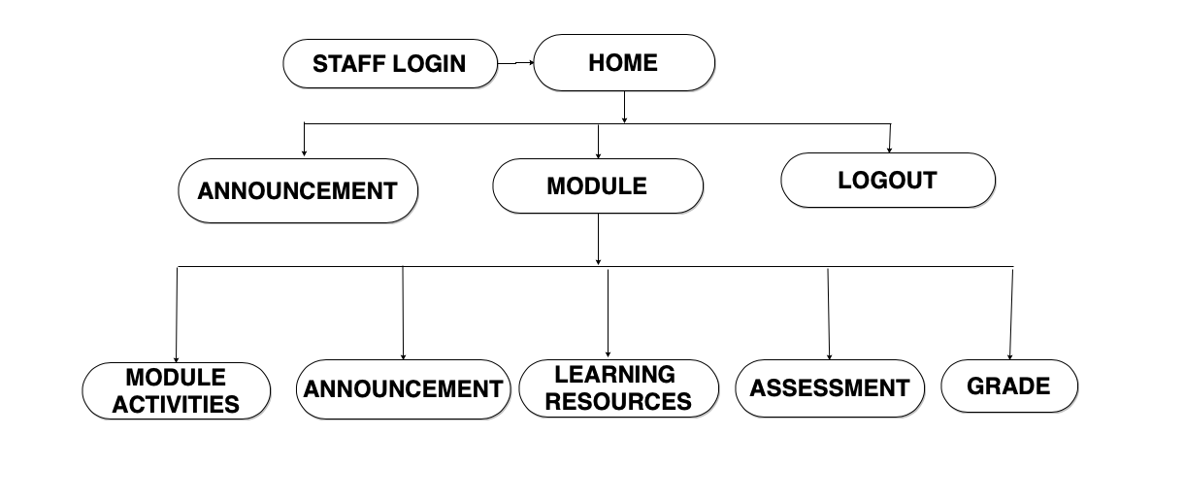

*Fig: 4.1.2.3 Staff Website Navigation Diagram*

The above picture is the navigation diagram of the staff website. When the staff login to their system then they would be able to manage the student’s module activities. The can be able to provide module contents to the students. They can give announcement to the students about upcoming events or notice. The staff would be able to provide assessment via their system to all the students who are enrolled to the model. The staff would be able to provide the grades to the students. The staff can sign off from the system when their work is done.

### 4.1.3 System Screen mock-ups

1. **Admin Mockups**

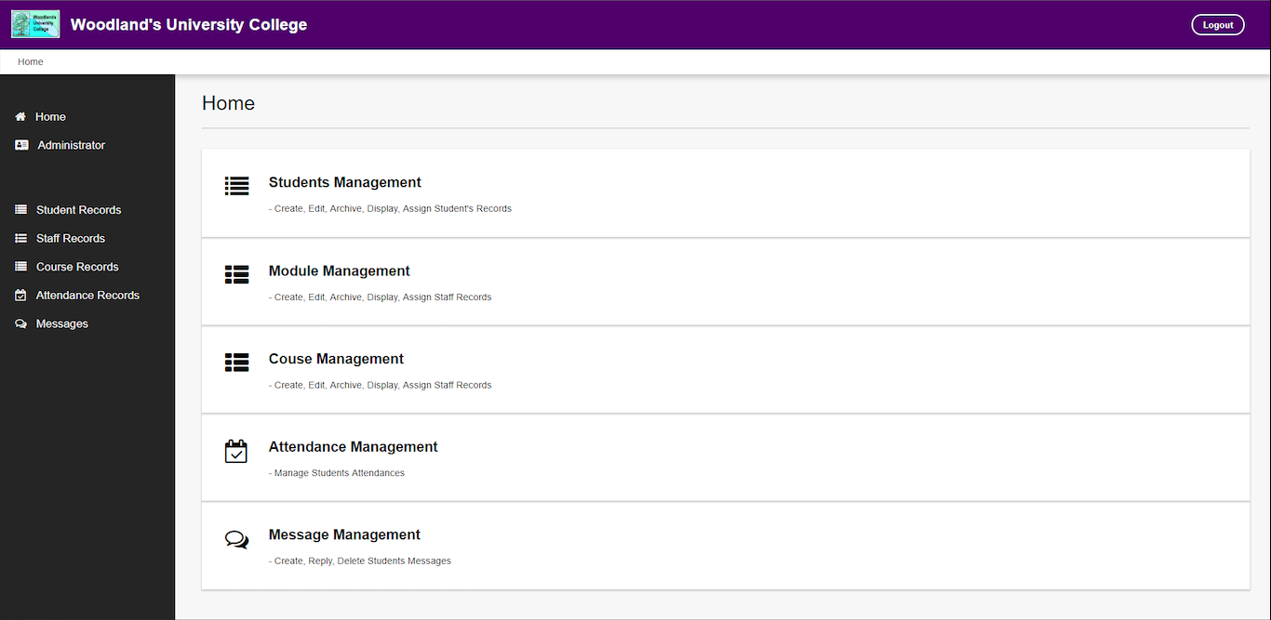

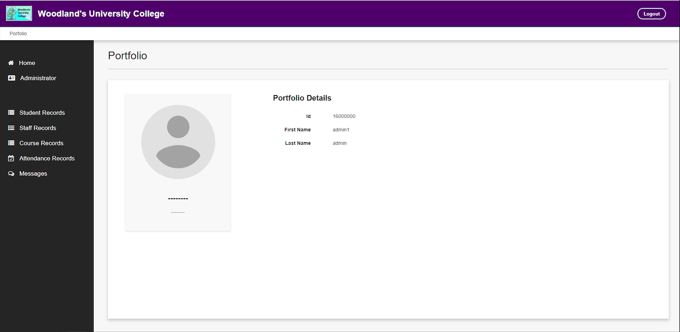

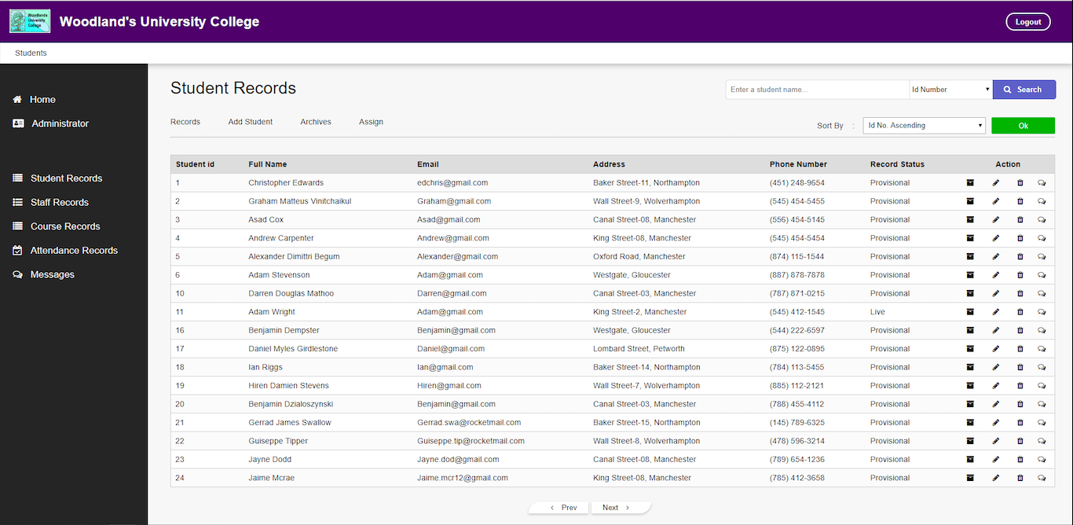

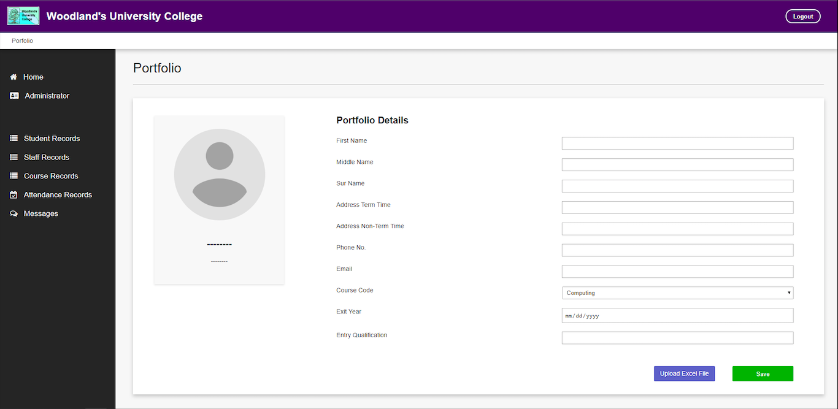

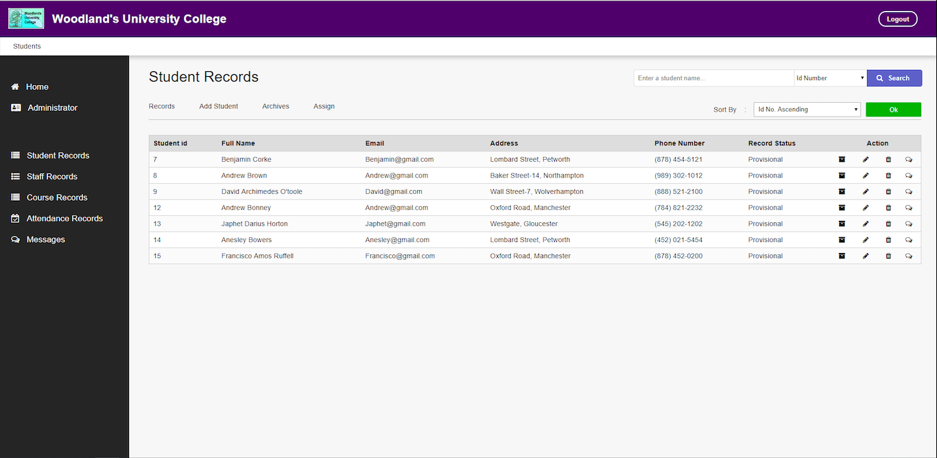

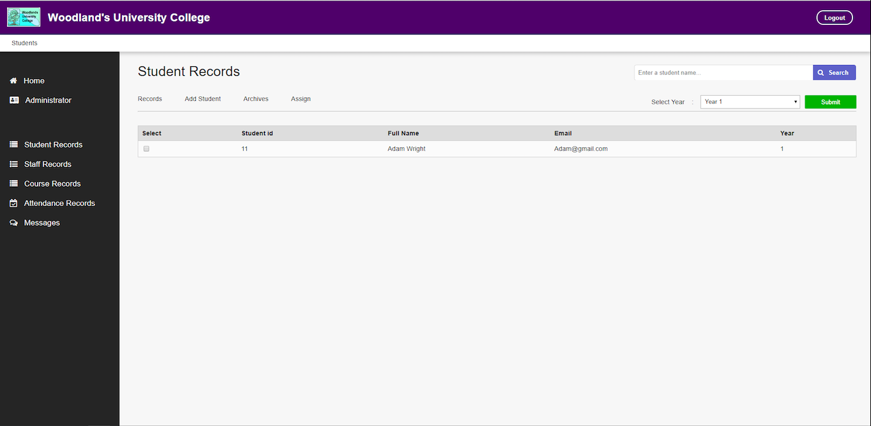

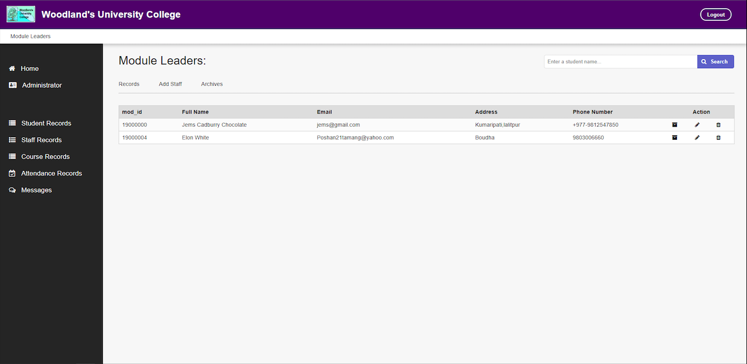

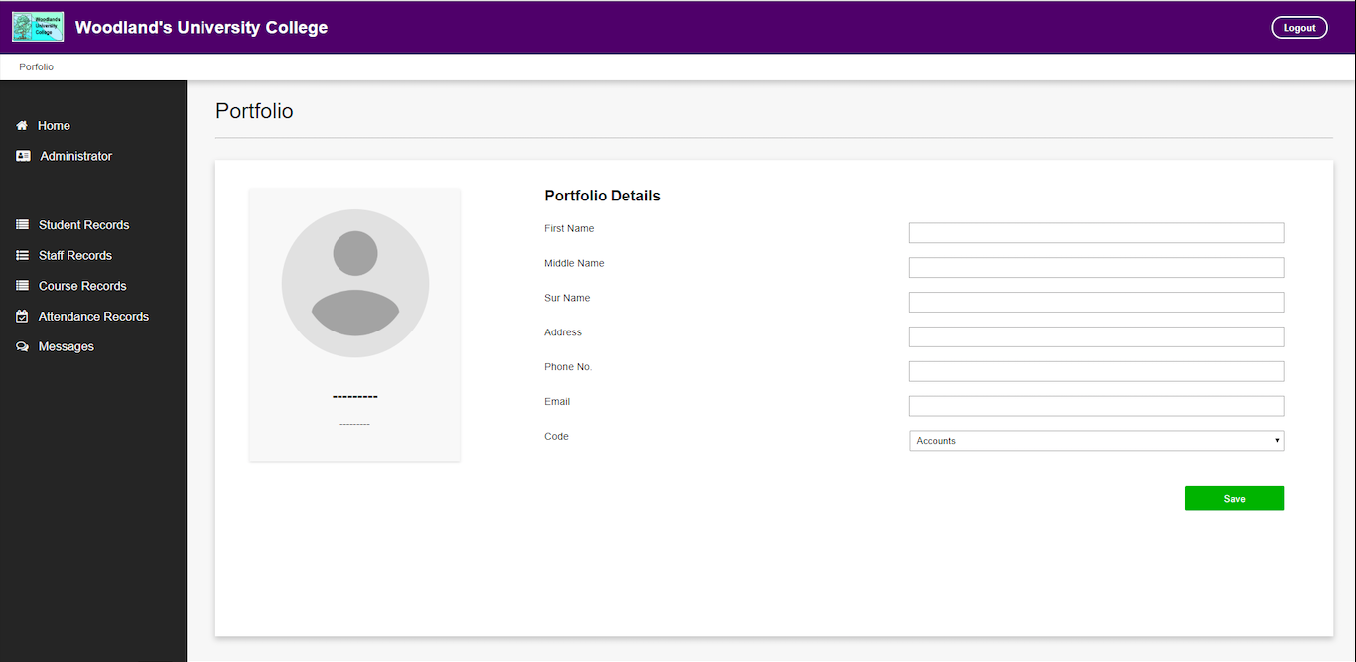

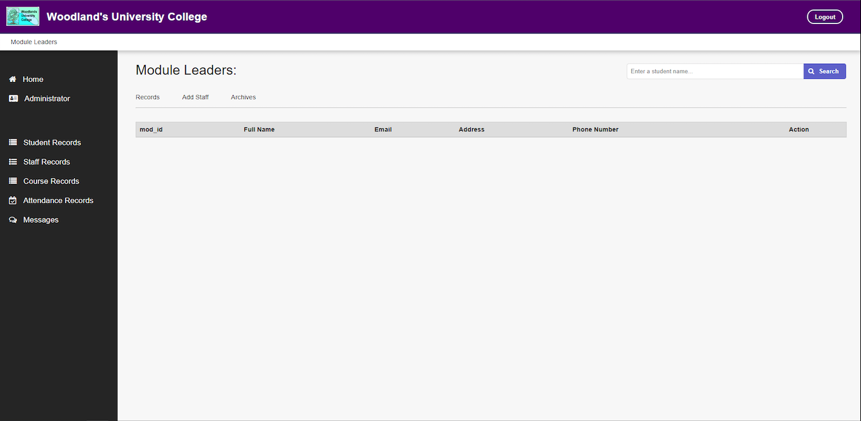

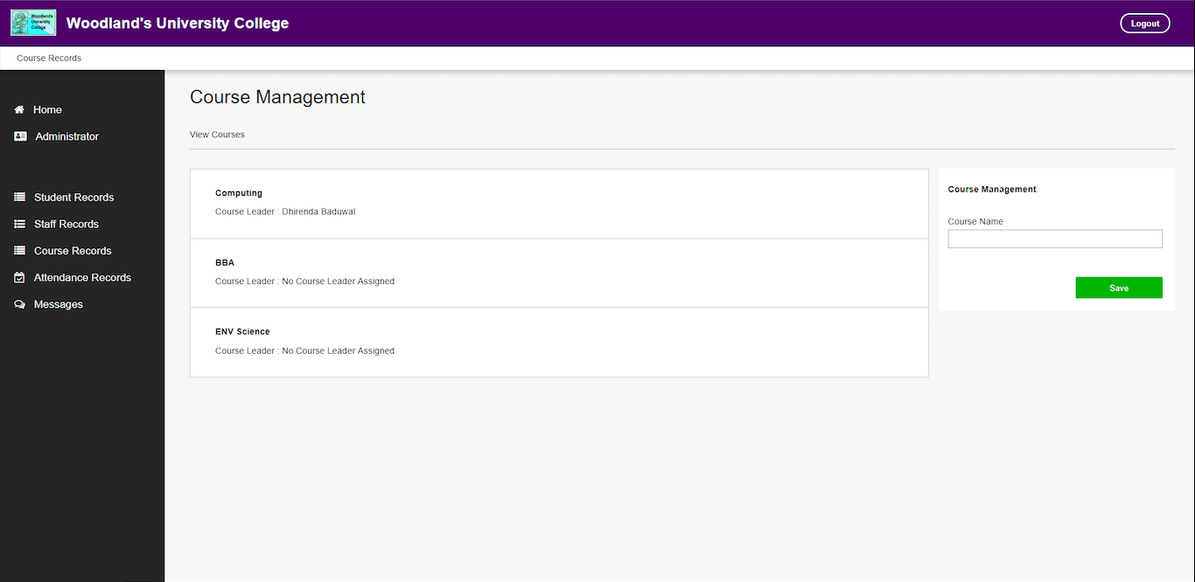

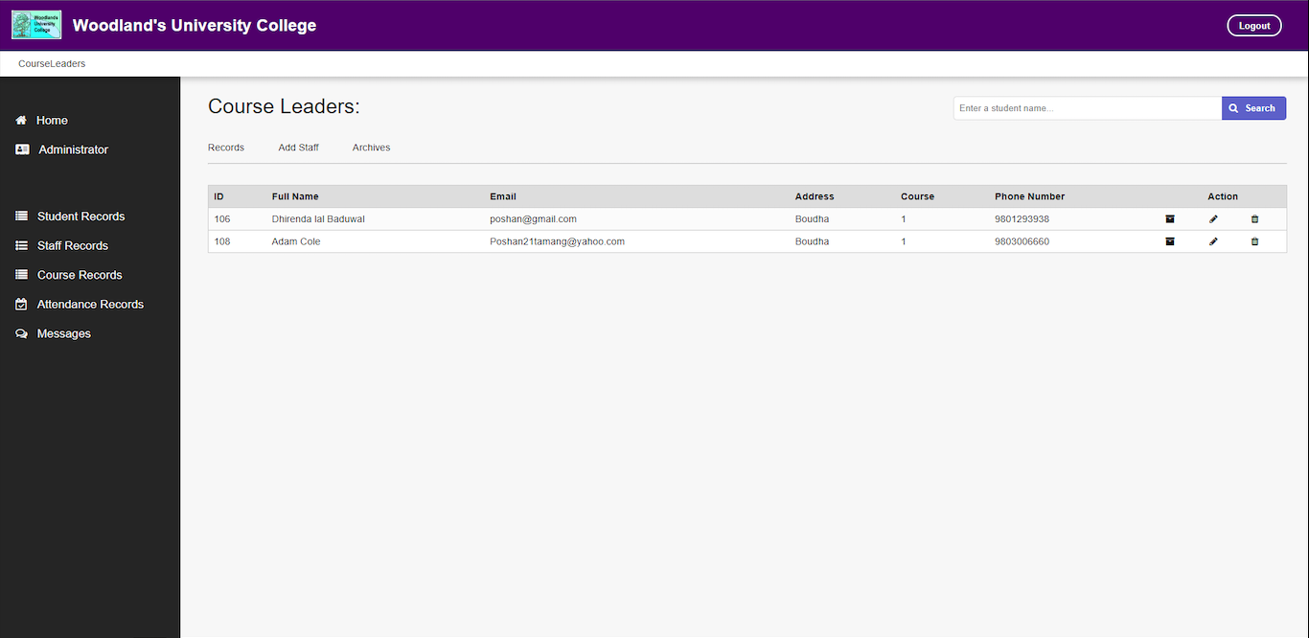

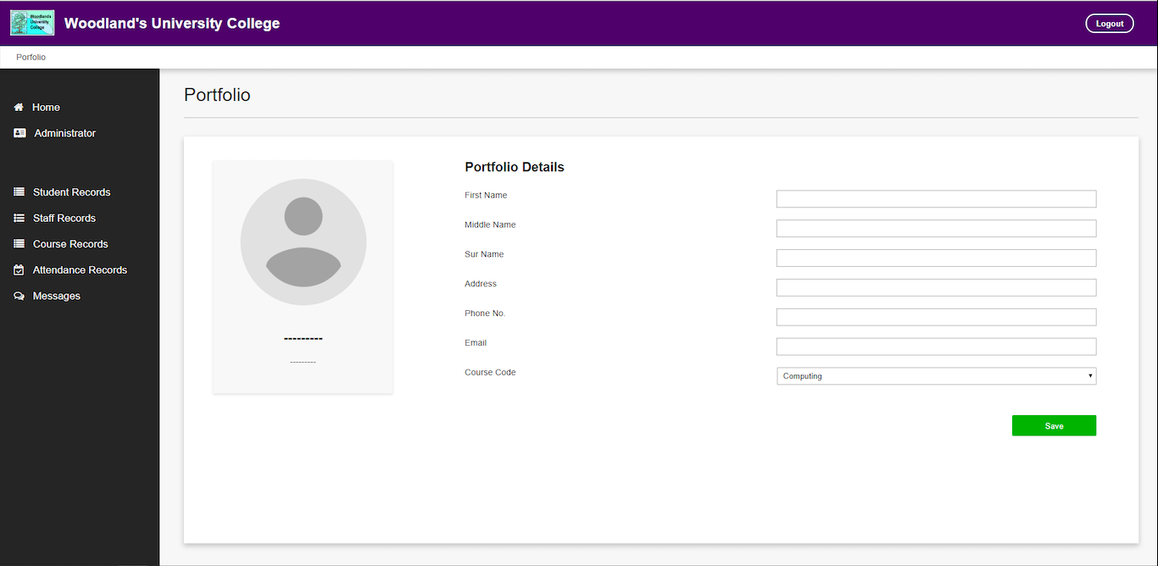

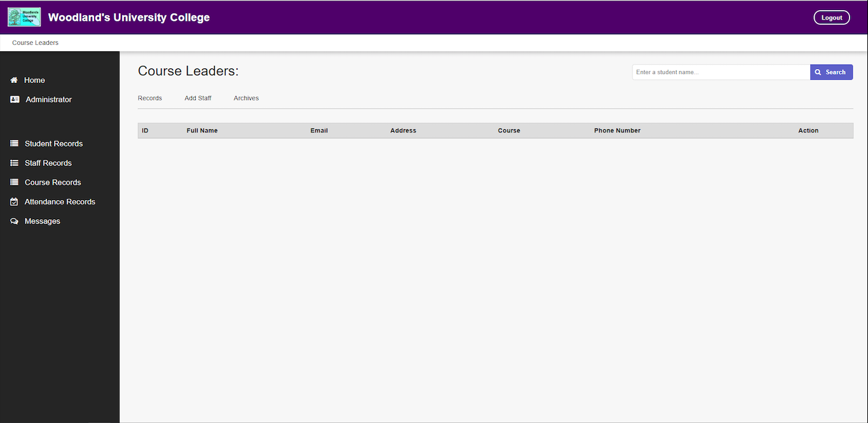

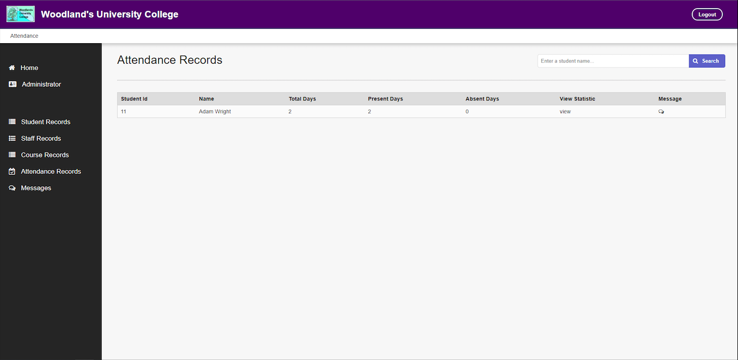

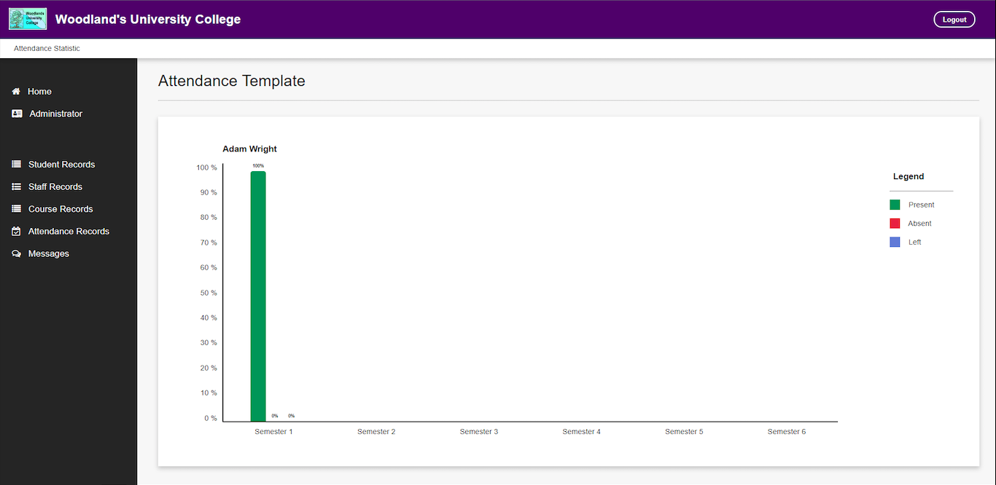

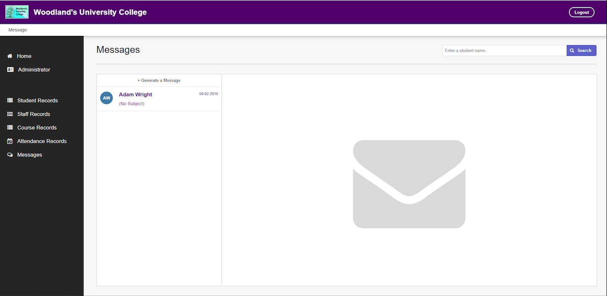

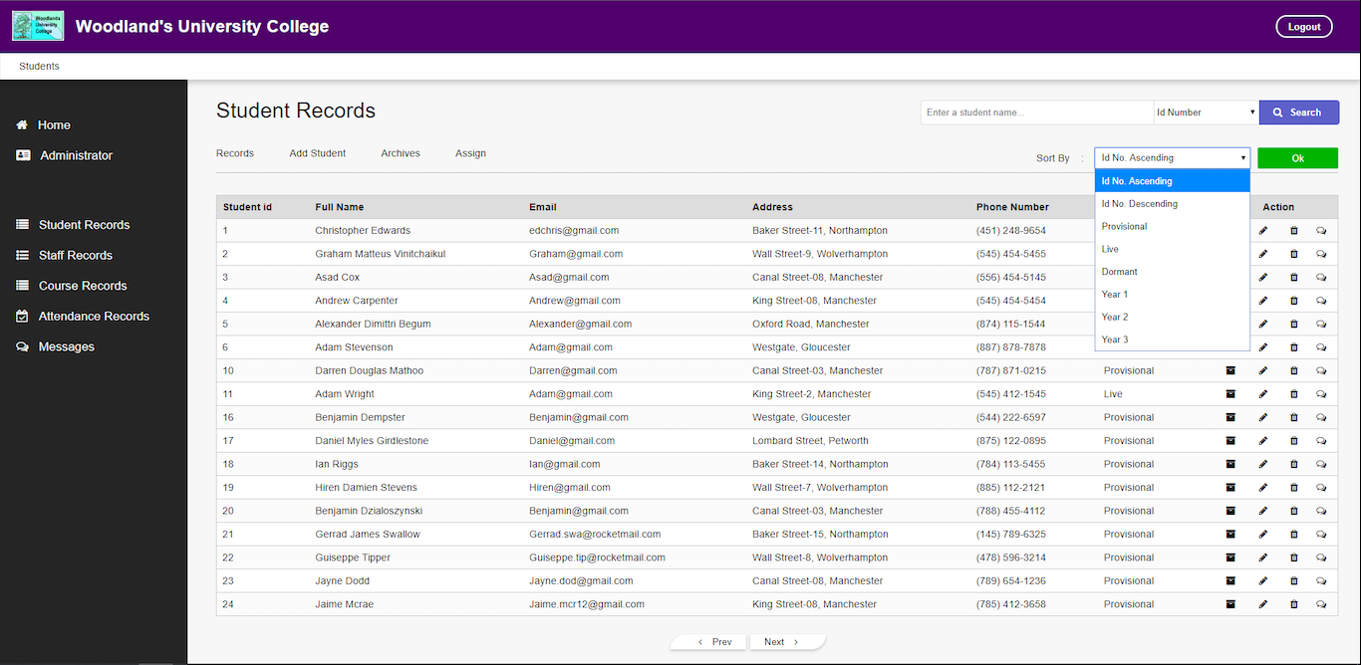

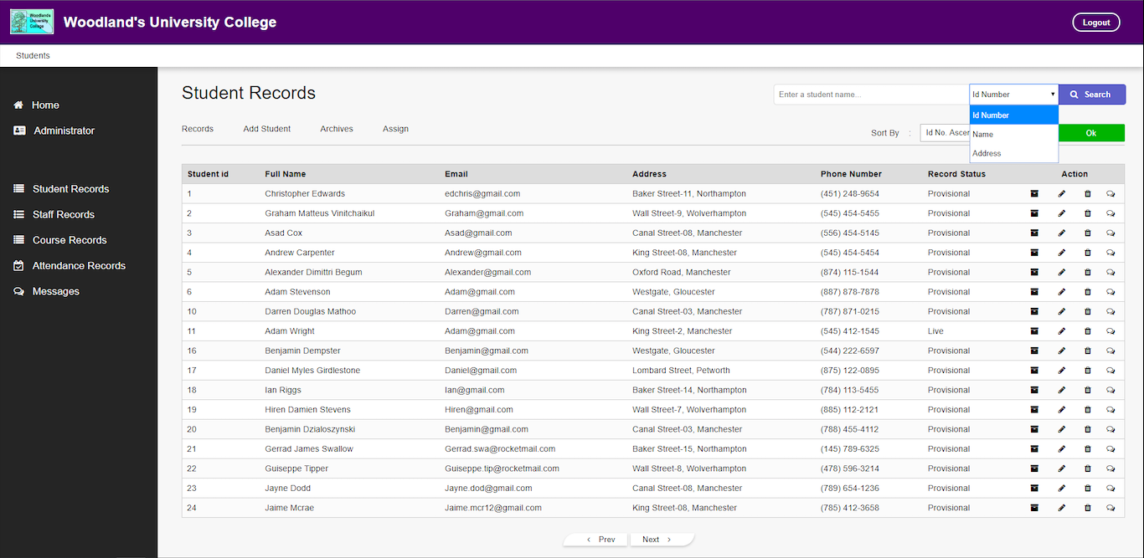

1. **Course Leader Mockups**

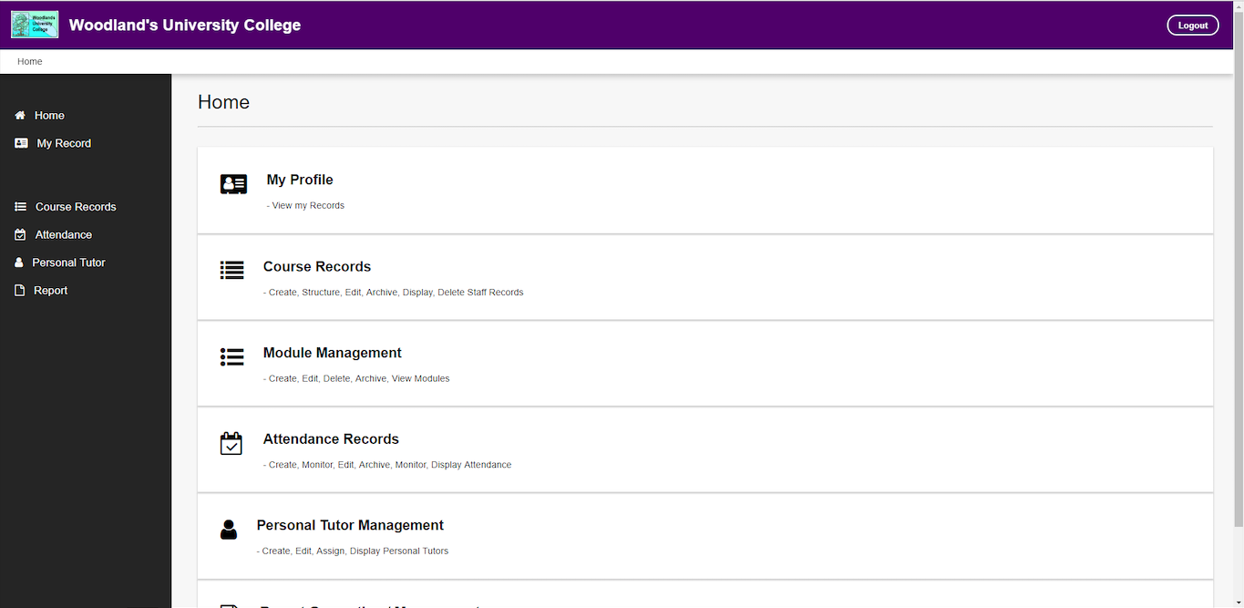

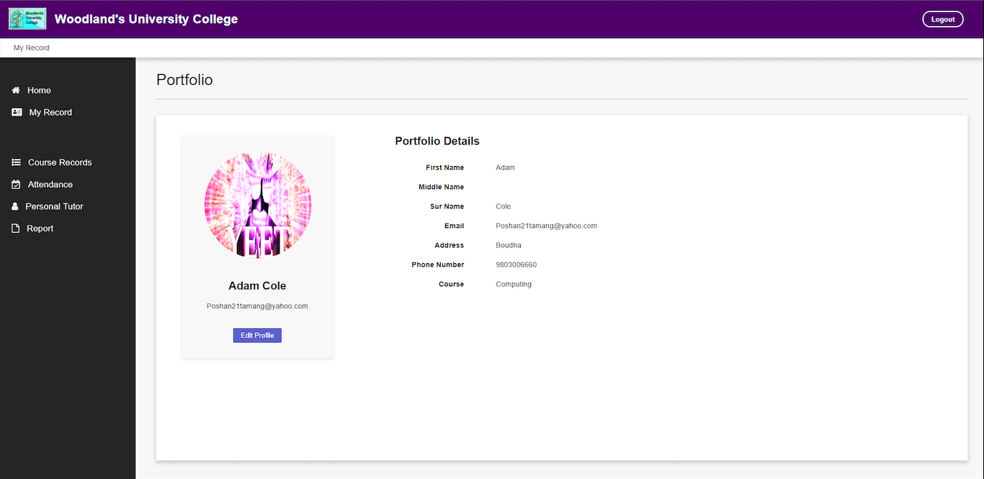

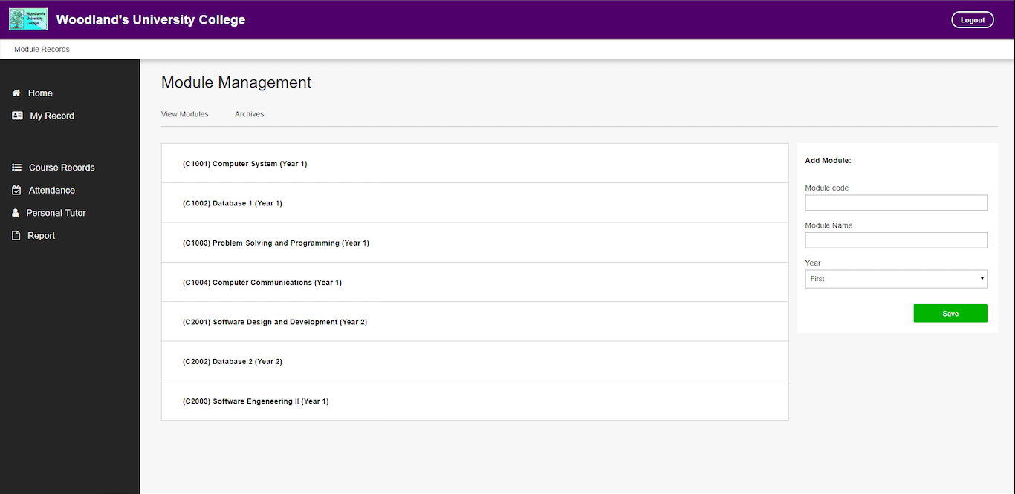

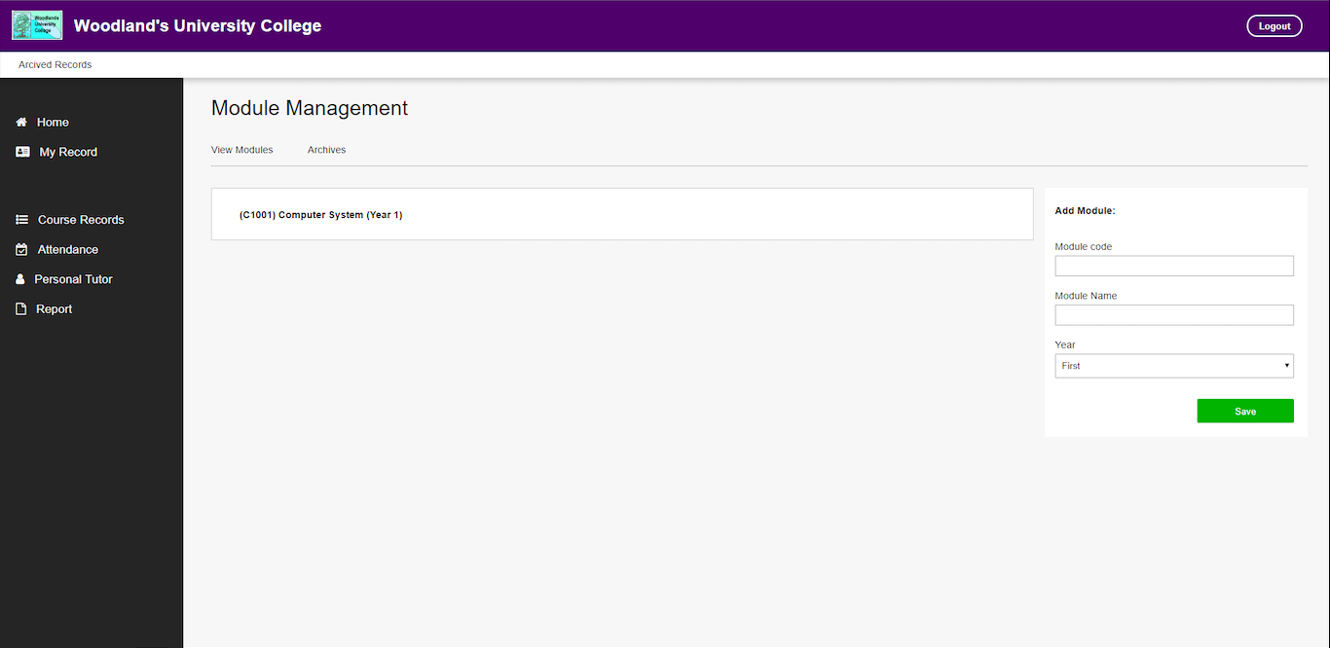

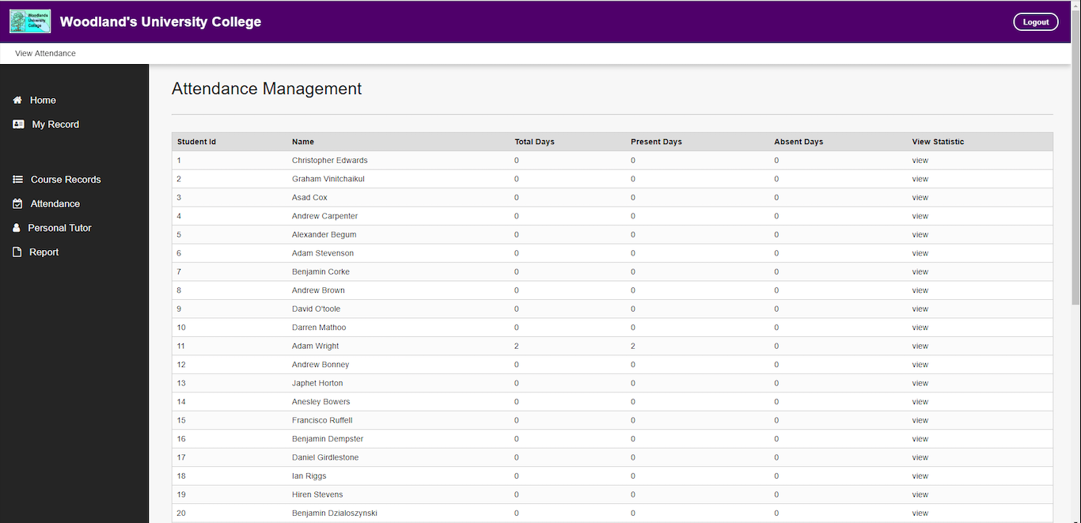

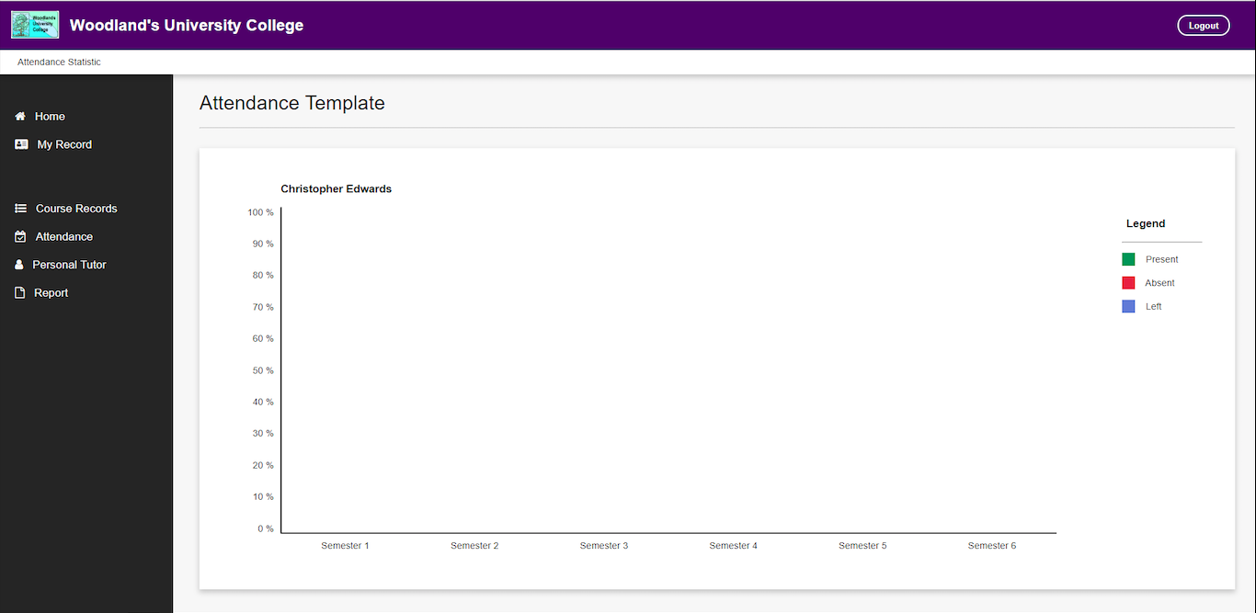

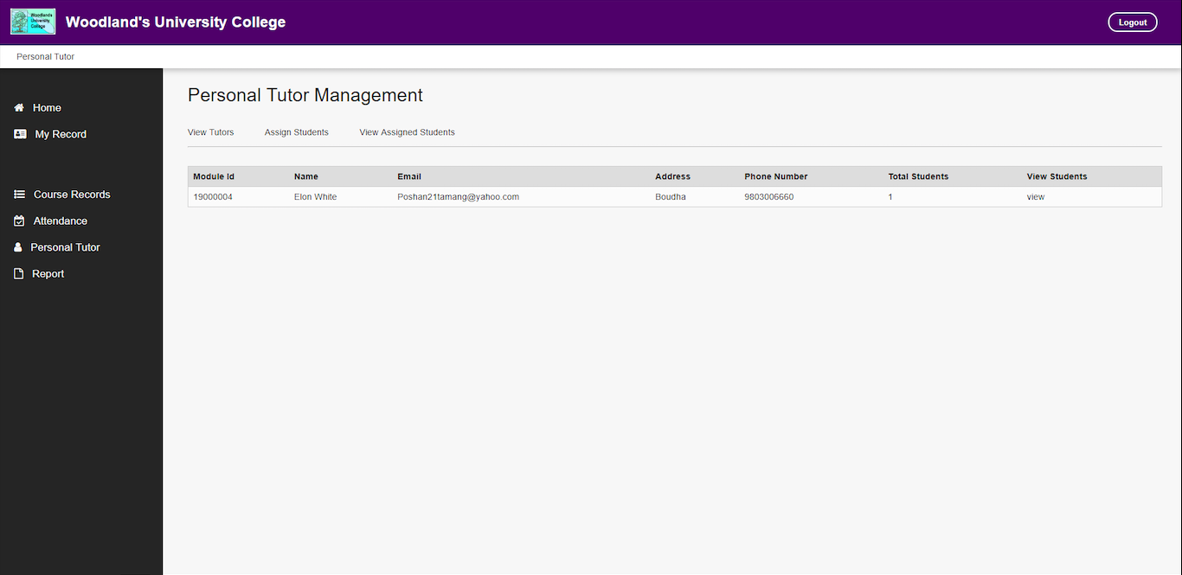

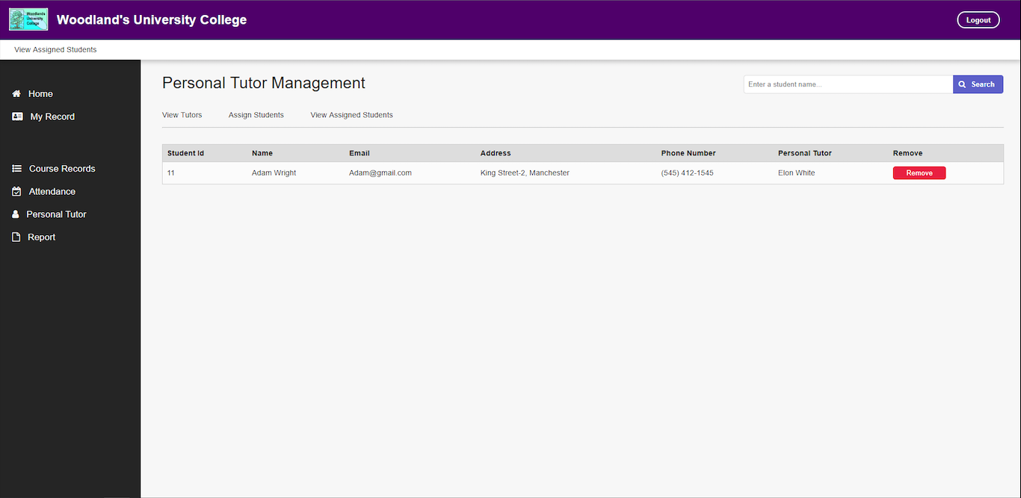

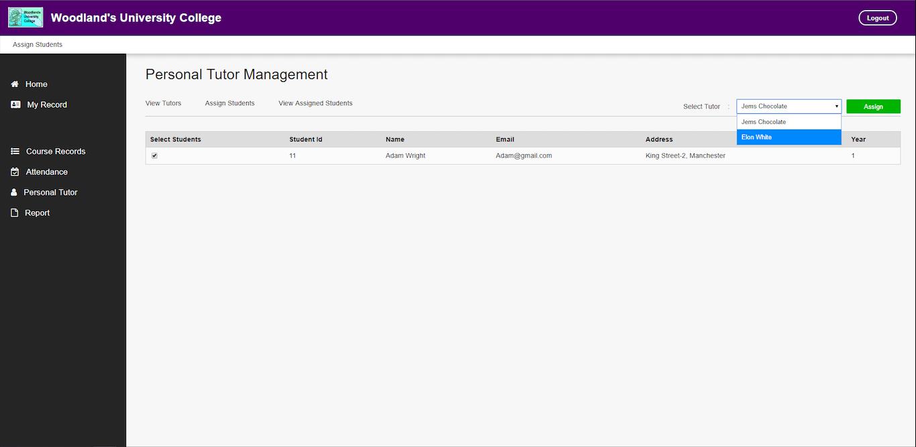



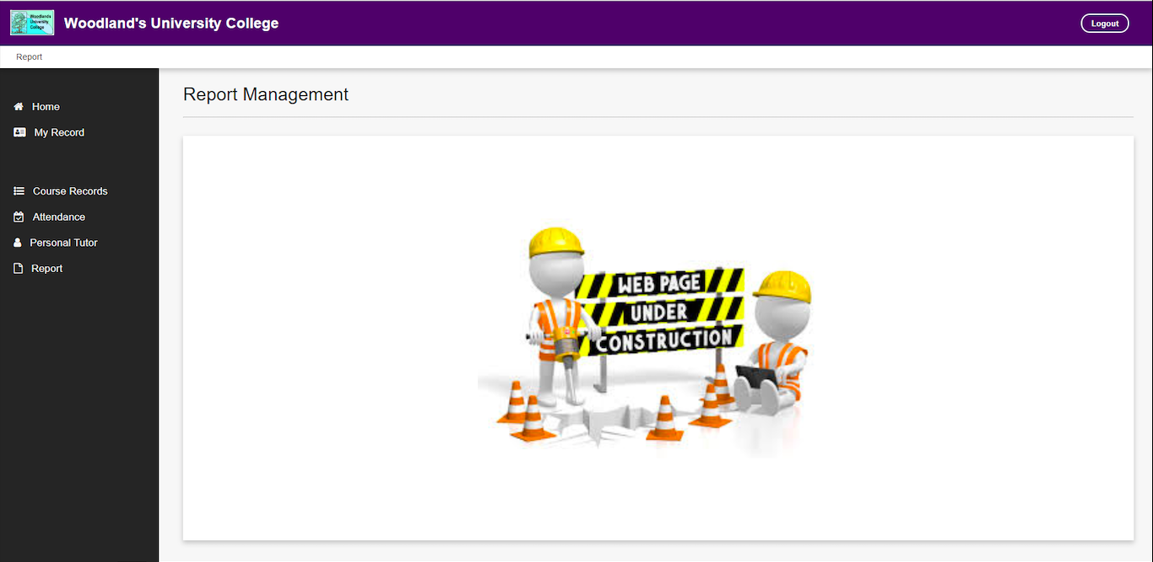

1. **Module Leader Mockups**

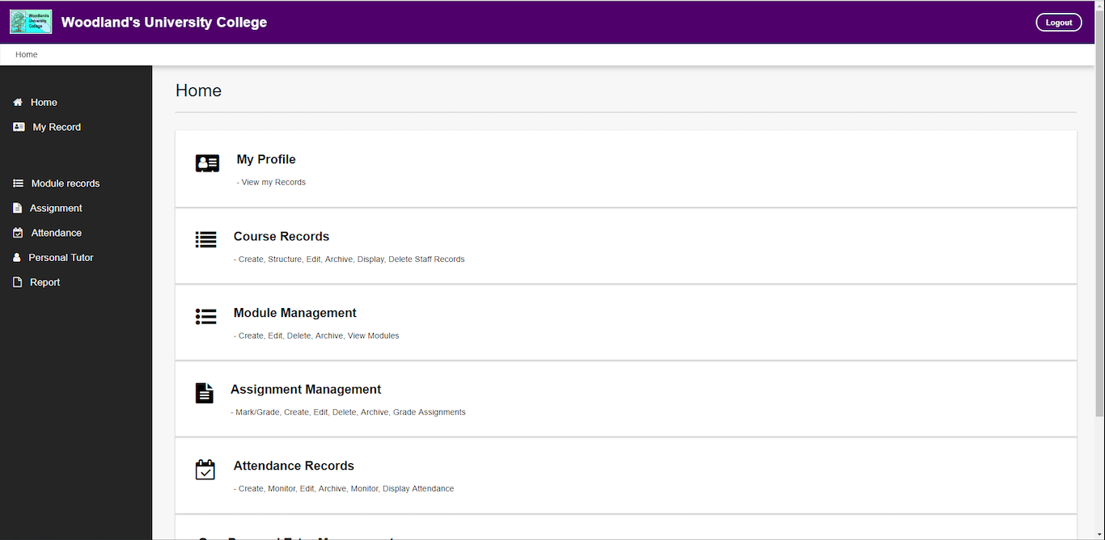

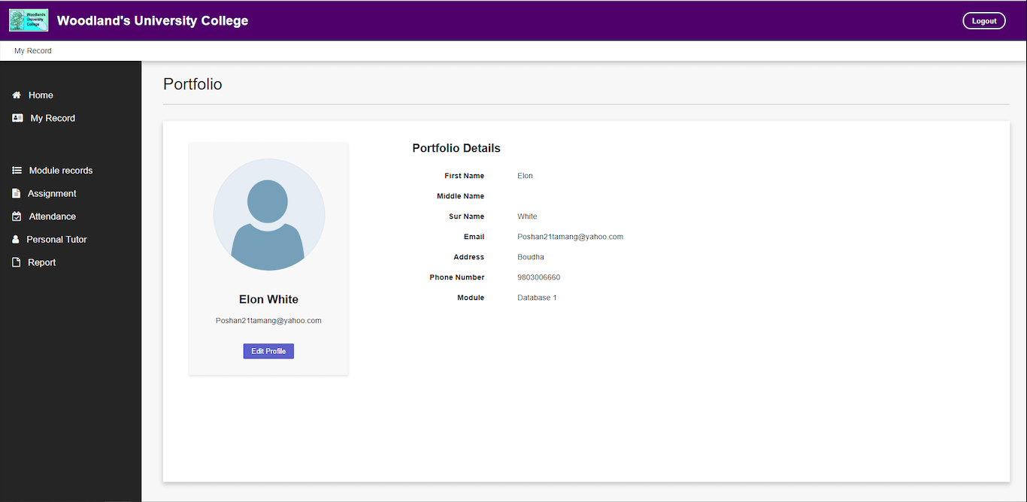

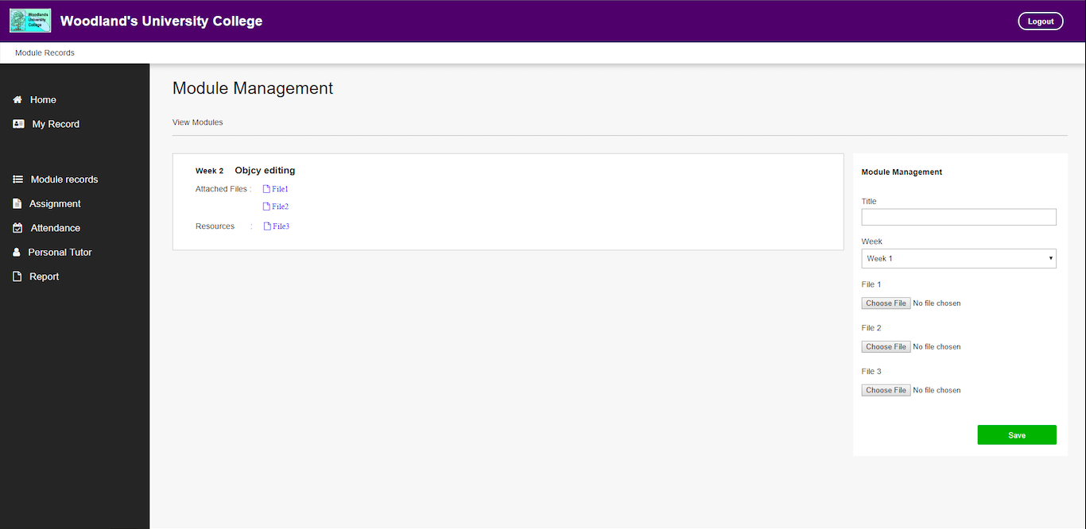

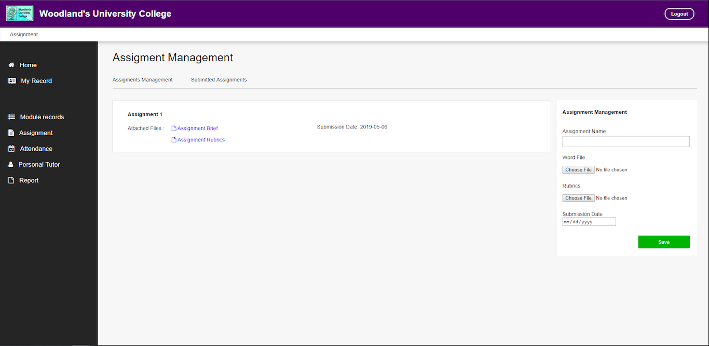

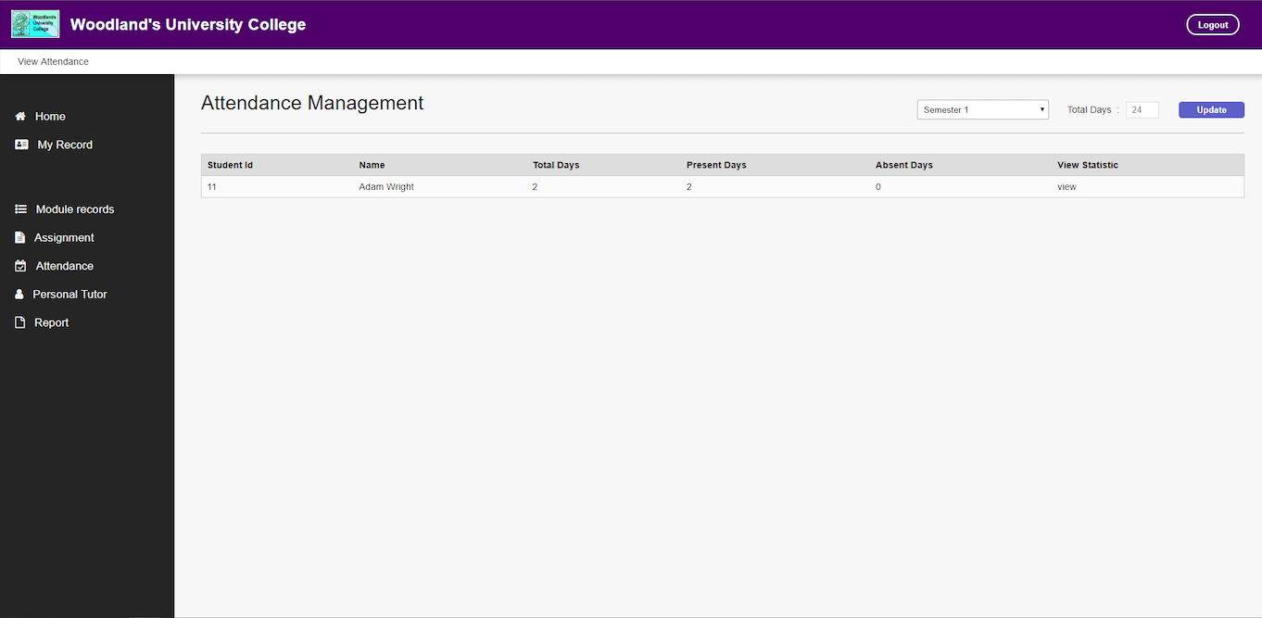

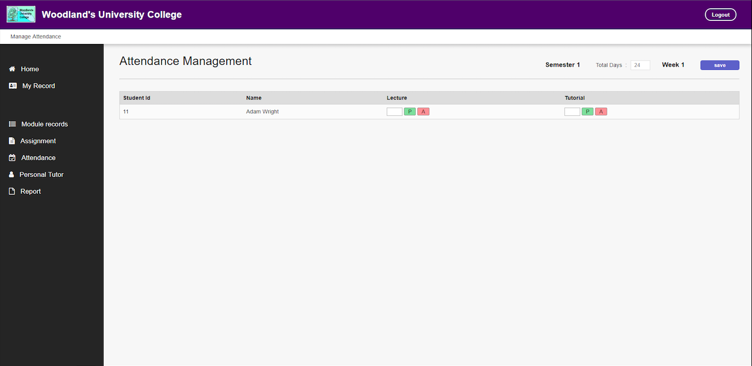

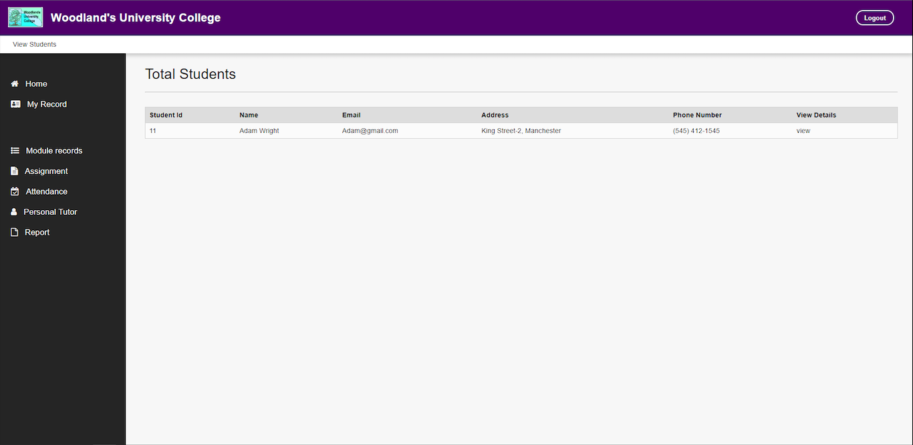

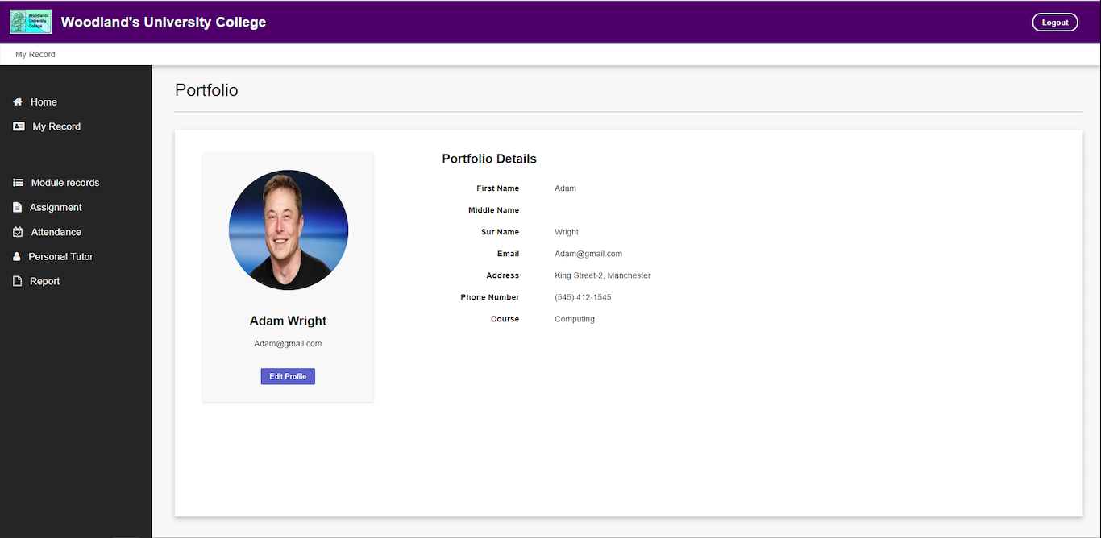

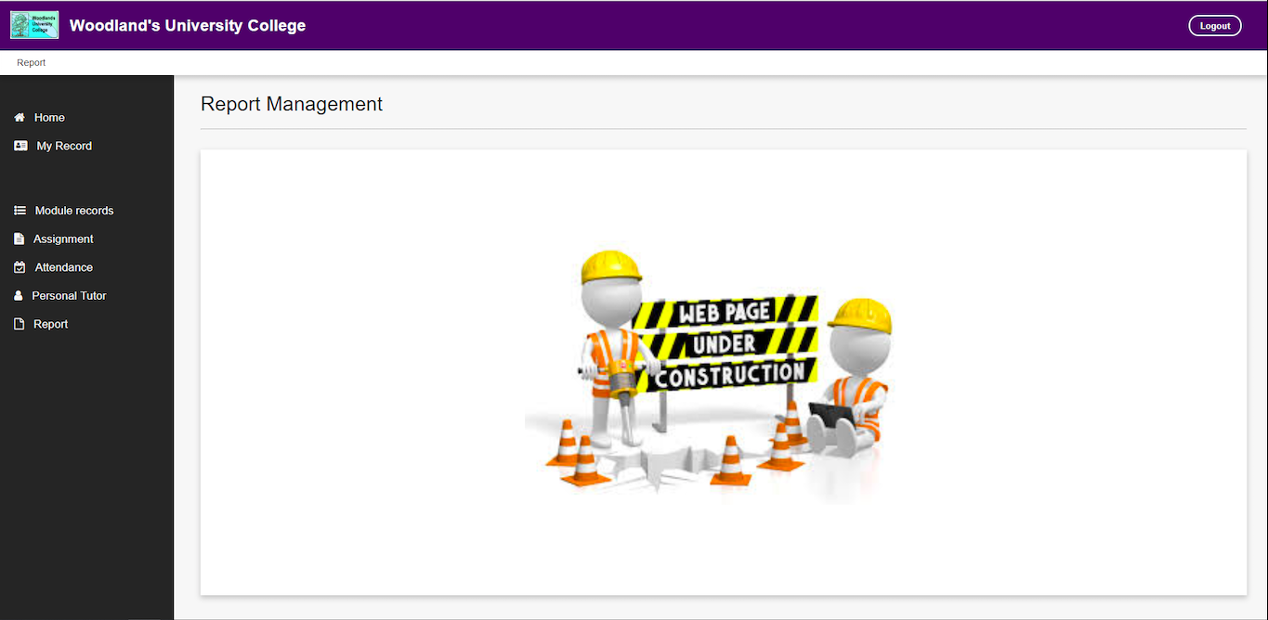

1. **Student Mockups**

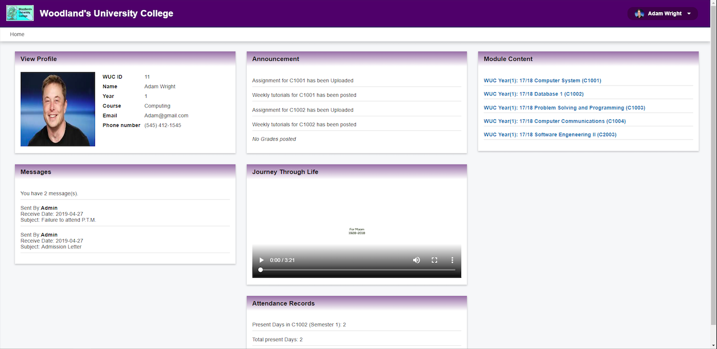

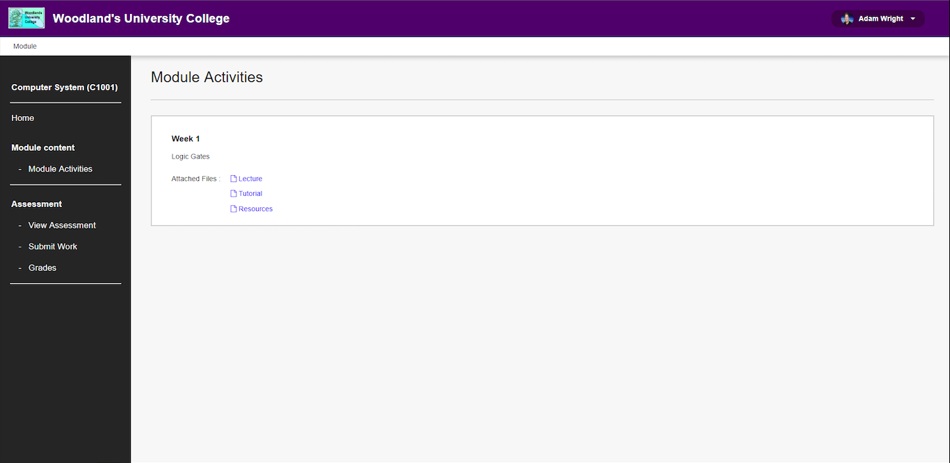

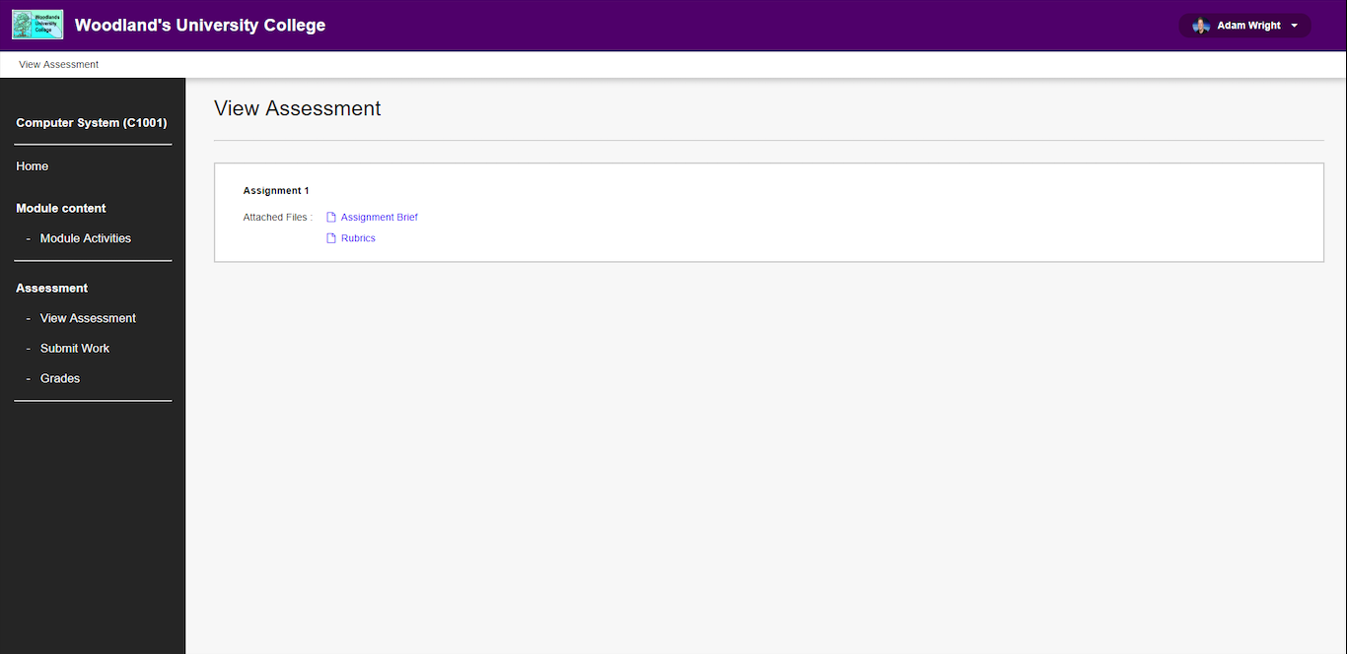

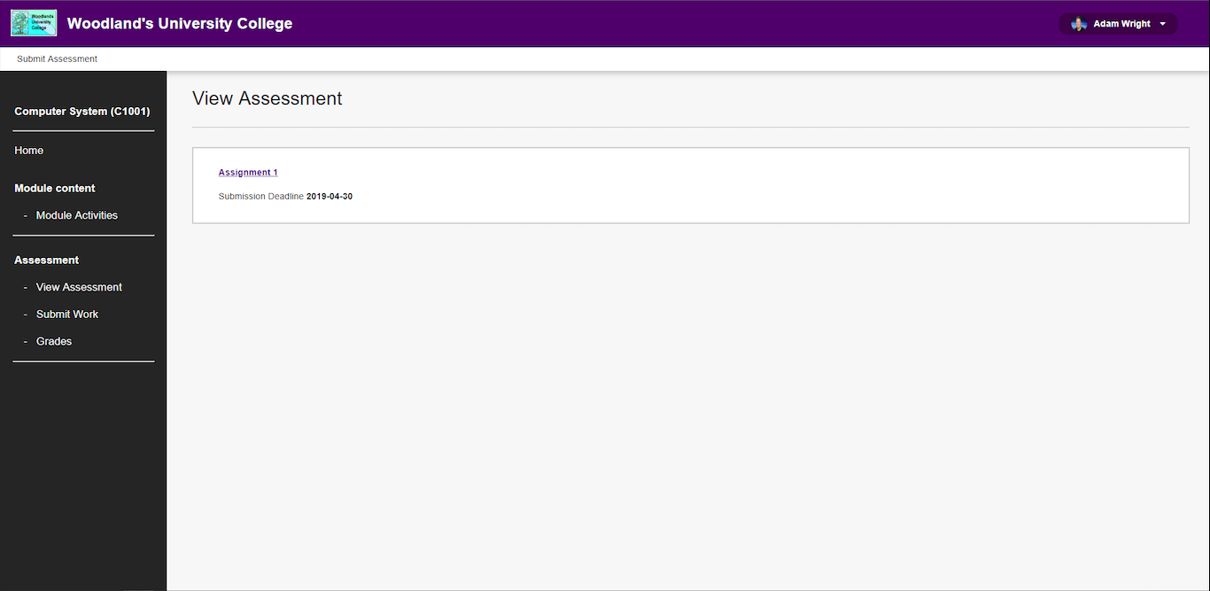

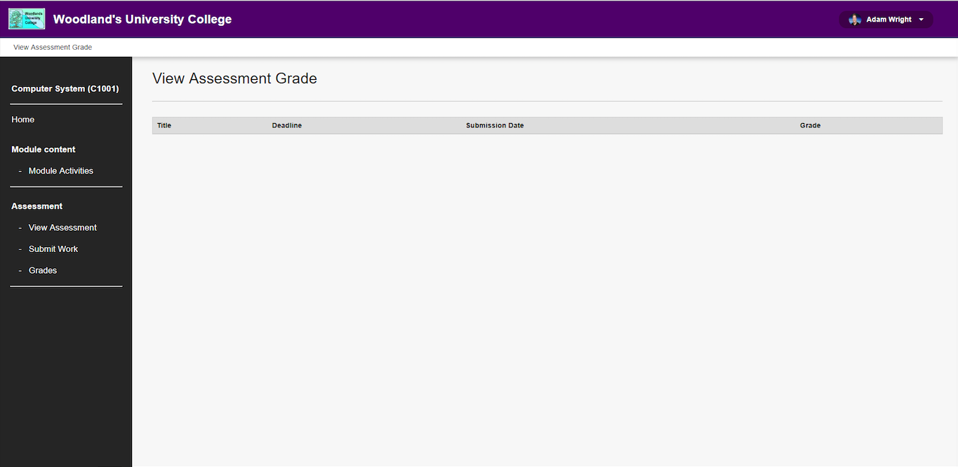

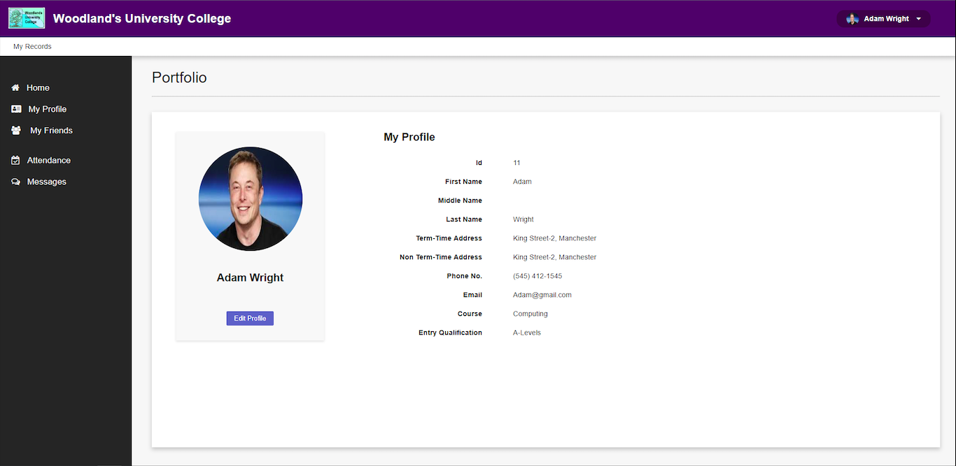

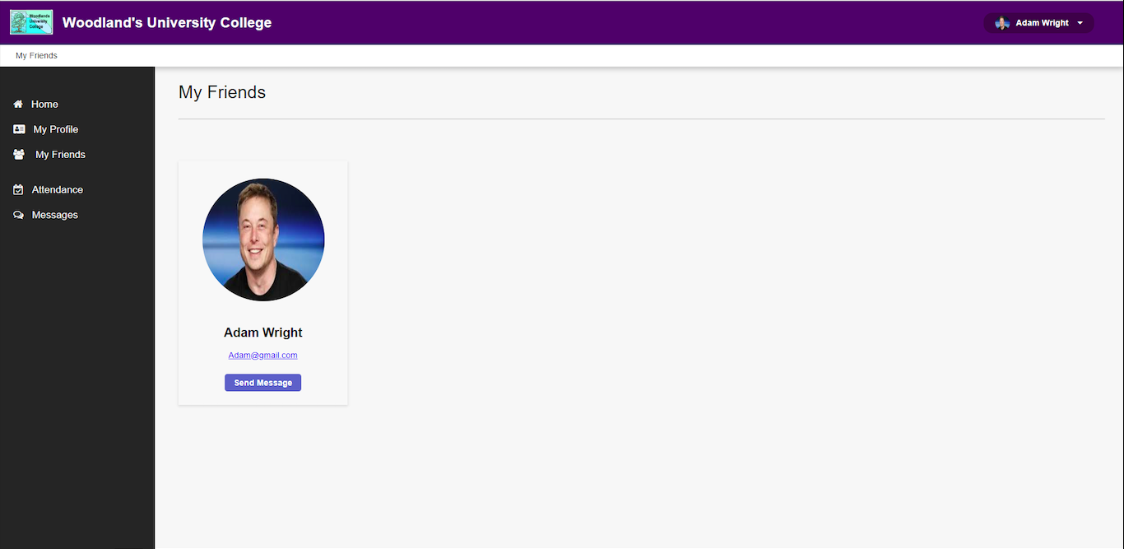

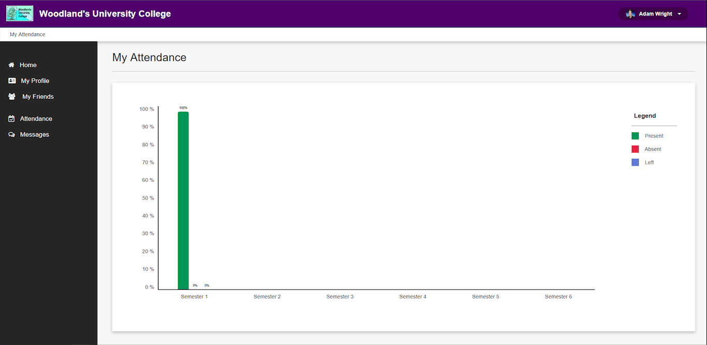

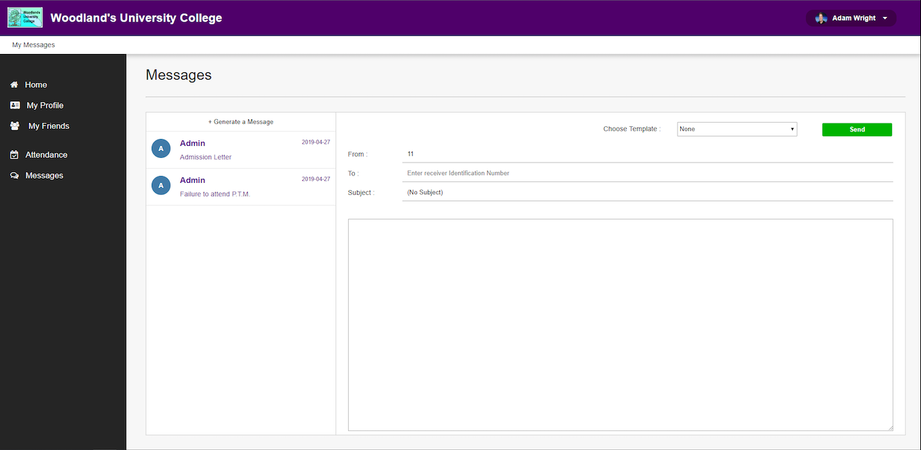

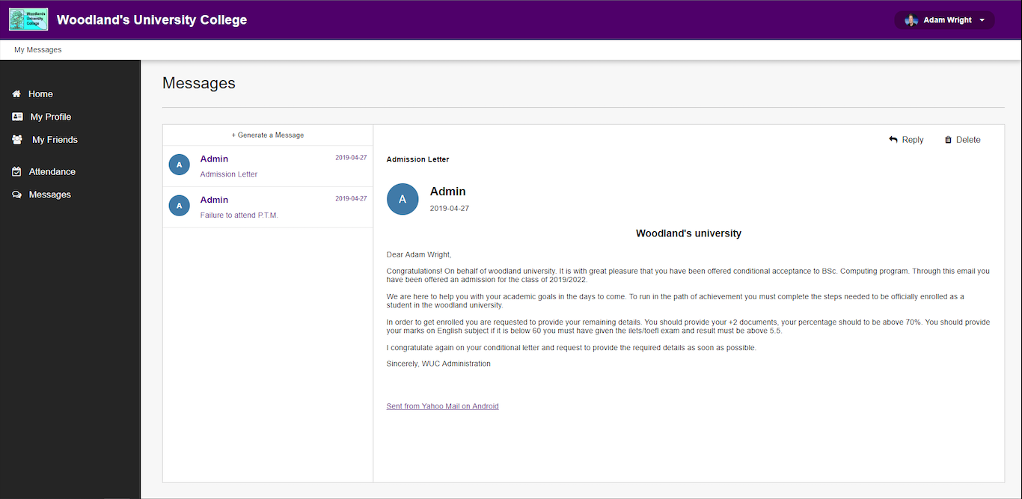

1. **Login Page Mockup**

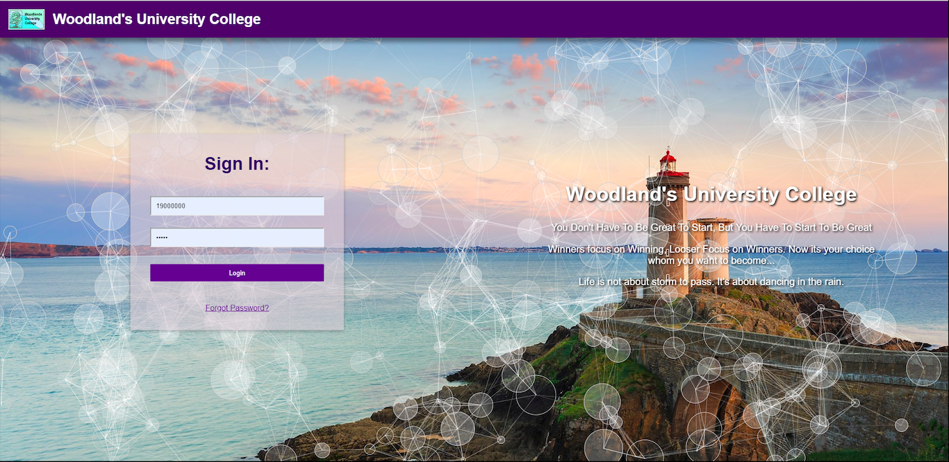

### 4.1.4 System Activity Event Diagrams

1. **Logging into the system.**

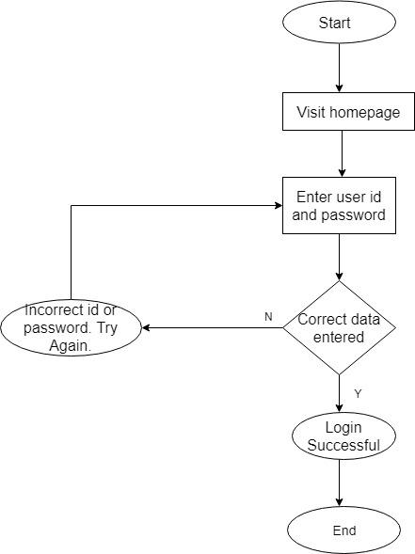

*Fig: logging into the system.*

1. **Assignment Submission.**

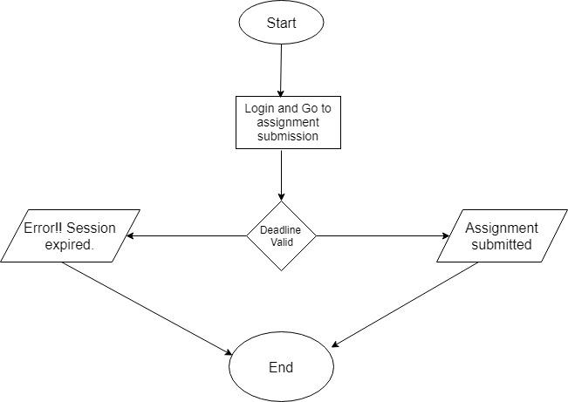

*Fig: assignment submission*

1. **Assigning module and course leaders**

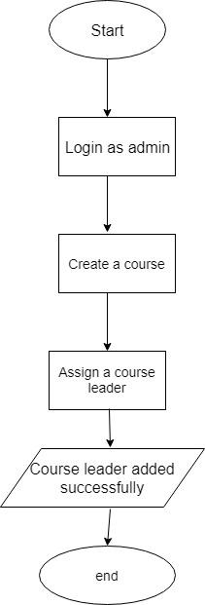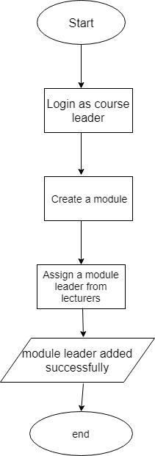

*Fig: assigning course and module leaders*

1. **Email regarding attendance**

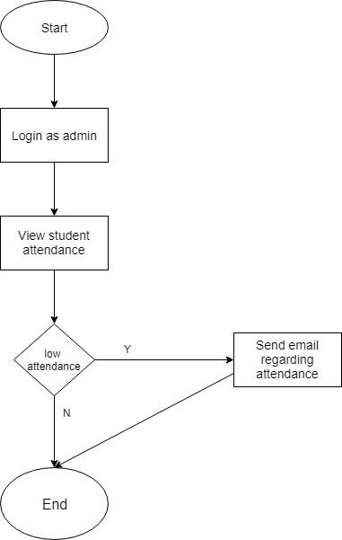

*Fig: Email regarding attendance*

1. **Changing student status into live**

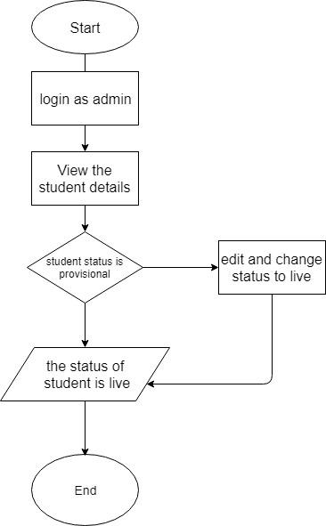

*Fig: Changing student status into live*

1. **Uploading weekly activities**

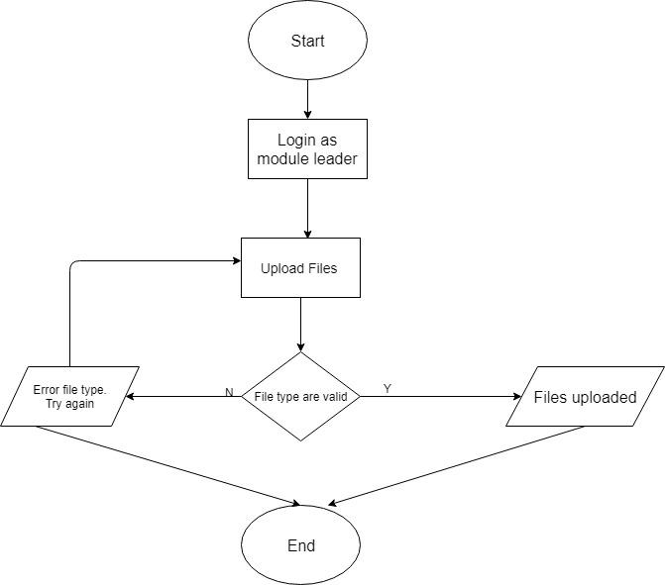

*Fig: Uploading weekly activities*

1. **Assigning personal tutor**

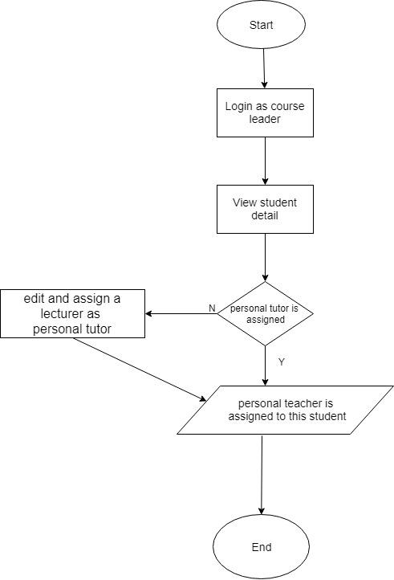

*Fig: Assigning personal tutor*

1. **Admission of a new student**

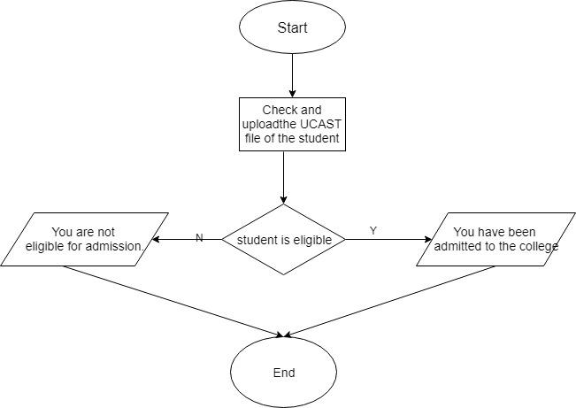

*Fig: admission of new student.*

## 4.2 Design Revisions

The design created for Woodland’s University was based on the interview and meetings. The team got suggestions and opinions from the students and staff of the university. There were many suggestions from student and staff about how the application should be. They told about their problems and the team manage to eradicate those problems by making this software. The team draw the wireframe and mockup for admin, staff and students. After completing the wireframes and mockups our work was then carried out.

At first, the team started to work in the backend i.e. the administration area. The color design used in the administration area is purple, dark black and white. The team use the purple color in the top where there is university logo and name. The team then used the dark black color in the left sidebar of website in which the button and icons are white in color so that the user can easily understand. The main section is in white color and the fonts used in the system is times new roman. The left sidebar contains the home, administrator, student records, staff records, attendance records and messages. The admin can manage both staffs and students. The admin can send messages to students and staffs. If the student wants to send the message to the admin regarding their problem then they can send message to the admin. In the clerical based system, the students were not able to check the address if the address is correct or not. In this system our team resolve this problem so the student would be able to check their address and inform the admin by sending message. The admin can be able to manage the student’s attendance. If the attendance is low than the admin can inform the individual student by sending them a message. The team decided to add a search button along with student id in the top right corner of the website so that it would be easier to search the records in no time. The admin can also select the year so that they would be able to point the specific records and reduce the search records.

After completing the administration area, the team started to work on the front end i.e. the staff area and student area. We use the same color design as we use in the administration area. However, in the home section of the student area the div boxes uses a light purple color which looks like the color is fading. The team consulted the university student about the design and color used in the mockup website and the student loved the design and framework of the system. After doing the designing of the website the team implemented the design. The student home section shows the module activities, their attendance record, video, announcement, messages and their profile. The student can check their profile and see if their personal information is correct. If the information is not correct then they can send message to the admin regarding their problems. Any announcement regarding their assignment or anything would be shown in the student website. The student would be able to submit their work by uploading it in the system and the staff would be able to view their work. The team decided to put the reading resources in the system as per the request in the interview. The student would be able to view their modules along with its resources. The team put the module activities according to the weekly basis so that it would be easier for student. All the implementation was complete and the team showed the final result to the student.

At last, talking about the login page the admin, staff and student would login from the same portal. The team made the login portal very attractive. Animation are used in the login panel. Overall the design of the web application is excellent.

## 4.3 Heuristic Evaluation

Heuristic evaluation is an inspection method for any software that helps to identify and solve different problems which are faced by the clients and users in the user design. Different topics determine the usability of the software. Some of the major subjects are:

1. **Visibility of system status:**

It is the evaluation that views the system status. The system should be very friendly and the working status of the system should be shown as well. All the functions should be usable and the status should be shown to the users.

1. **Match between system and real world:**

The system should be very realistic. The features that a real world can apply must be given more priority. Creativity and innovation are respected but the bad practices should not be added into the system which makes it fake and almost non-realistic.

1. **User control and freedom:**

For a software to get the best review, user must feel comfortable and easy to use that system. So, user must be given freedom to use the system freely. The system should be made simpler so that user can use it more efficiently. The design of the system should help the users to recognize, diagnose and recover from the errors.

1. **Consistency:**

The system should be consistent. Errors and bugs should be tackled with proper amendments I the system with updates. Essential backup plans should be used in order to make system consistent.

1. **Error prevention:**

The system should be made error free. For this proper testing and implementation should be done. System backups should also be kept handling the errors.

1. **Recognition over recall:**

The system should be made very simple. The user must be able to recognize the functionality in their very first use. Recalling a functionality over and over costs more time for both client and developer.

1. **Flexibility and efficient:**

The system should be flexible. Several users must be able to access the system at a time and proper plans for extending the system should also be covered for the future reference. The system should be efficient and should perform task without any blunder in a speedy ratio.

Hence if all of the above-mentioned functionality are covered then the system gets the best rating from the users.

# 5 System Build and Technical Notes

## 5.1 Technically Difficult Code Sections

During the creation of this project there were various sections of the project that the group had faced a series of tough situations where the functionality for the pilot system did not quite match up. The following table show all the difficult code sections for this pilot system.

|  |  |  |
| --- | --- | --- |
| Difficult Section | Difficulty Faced | Solution to the problem |
| Admission Process | The admission process for the university had to follow a certain criterion when adding new students. The student lists were first sent to the university in a huge bulk of a spreadsheet data. The first major task was to make a functionality that allowed the admin the upload all those data at once to the system while also following the university’s admission process.  The problem at hand was to make a system that could extract individual records from the spreadsheet and upload them to the database while correctly following the university’s admission process. | The group overcame this problem by using PHP’s built in functionality that allows the user to simply select a spread sheet file that can then be uploaded and sent to the function that then proceeds to add each individual record by following the university’s admission process. |
| Acceptance letter generation | As part of the admission process each student that was successfully admitted to the college would also be sent a. letter via email/system messages. These letters were proof about the admission of the student into the college. | The group created the two letters based on the conditions that the students were accepted in. The letters were automated and generated based on the student that was selected. The selected students detail would then be generated into the letter using SQL and PHP and the type of letter would be selected by the admin himself and sent to the student. |
| Management of online attendance | The attendance records of all the students were required to be managed in such a way that made paper based system seemingly useless. The attendance system was also monitored by the admins as well as the module and course leader. The module leader would upload all the attendance data of all the students that were present in the class and upload them to the database. These records would be further inspected by the admin and the course leader in the future. | The attendance was a quite tricky and a really difficult task that the group had to solve. The group ultimately decided to store every attendance record in the database allowing the module leaders to update the attendance records of the students one week at a time. As the weeks progressed the records of attendance for each student would pile up and the could be viewed by the admins and the course leader. |
| Profile management system for students and staffs | The students and staffs would each have a unique profile that could be edited however they wanted. The staff and students could only change their password and their profile picture. The profile of the students contained announcements for the students whenever a new weekly tutorial was posted. This system was a requirement that was suggested by one of the course leader. | The group made a profile that provided the students with all the details about that individual for them to view. When a module leader uploads any type of assessment or grade or lecture files it would immediately be posted onto the students dashboard with the help of a short SQL query and proper PHP handling. |

## 5.2 On-going Testing Methodology

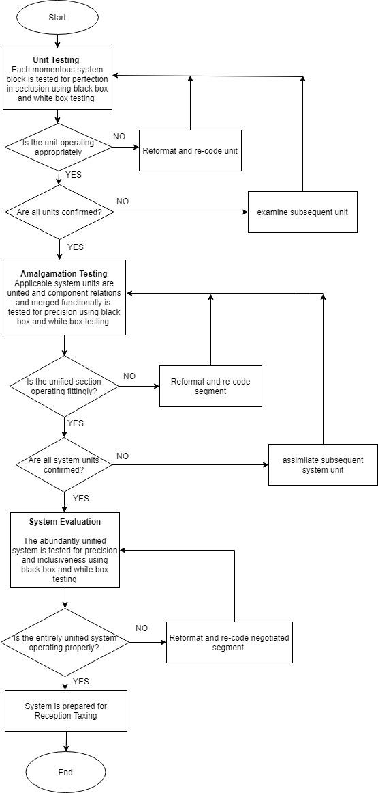

# 6 Test Strategy

## 6.1 Overview of Test Strategy

A test strategy/methodology is a blueprint or outline that depicts the testing approach of the software development cycle. The test system portrays the test level to be performed. There are fundamentally three levels of software testing: unit testing, integration testing, validation testing.

**Unit Testing:**

In the unit testing, each modules /component are tested individually based on implementation of the software. Each block of codes from the source code, internal structures of the software are tested individually in the unit testing. The testing involves sub-program units such as procedures and functions and different test cases are made to do so. It ensures complete coverage of a unit independently.

**Integration Testing**

In the integration testing, the architecture of the software is tested. It is usually accomplished on an incremental basis. It mainly focuses on the construction of software. Each unit tested on the unit testing are combined and integrate the tested unit into the system tested so-far with an integration test and test as a complete project.

**Validation Testing**

The validation testing also known as requirement testing is done after the unit testing and integration testing. The set of statements of *Systems Requirements Specification* (SRS) are tested here. In this testing, the actual software is tested and see if the actual software met criteria or to check if the expected/ required software is created or not. It mainly focuses on the requirement specifications of the software. It also consists of black-box testing, boundary value analysis, and white-box testing.

## 

## 6.2 Sample Test Results

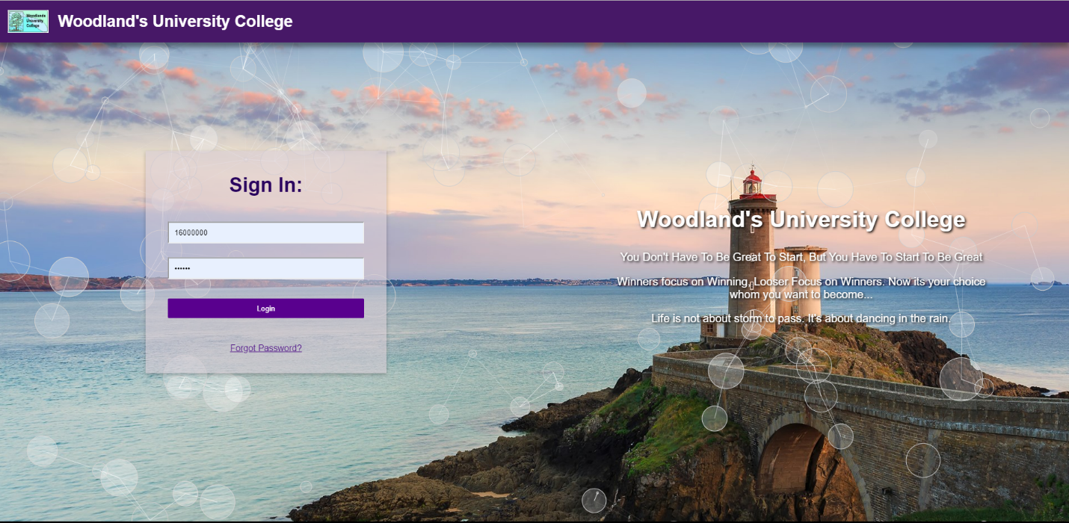

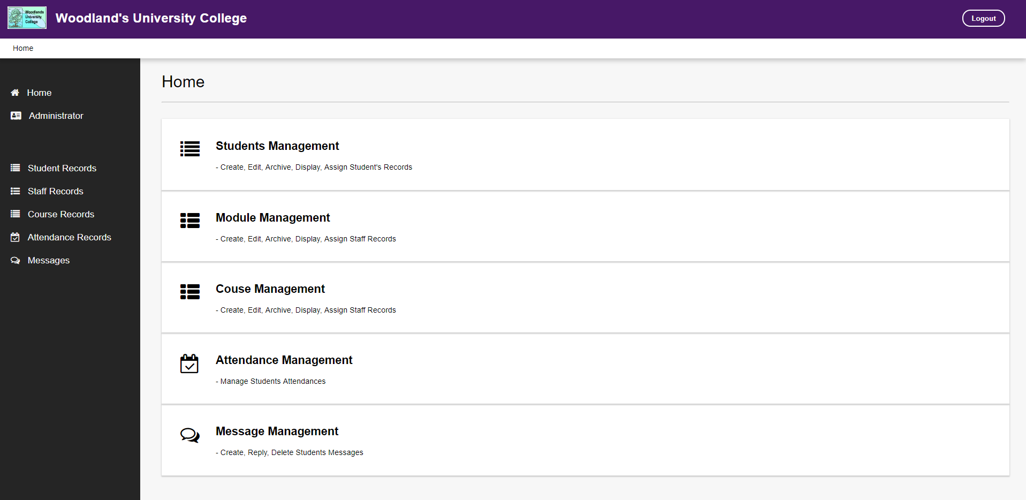

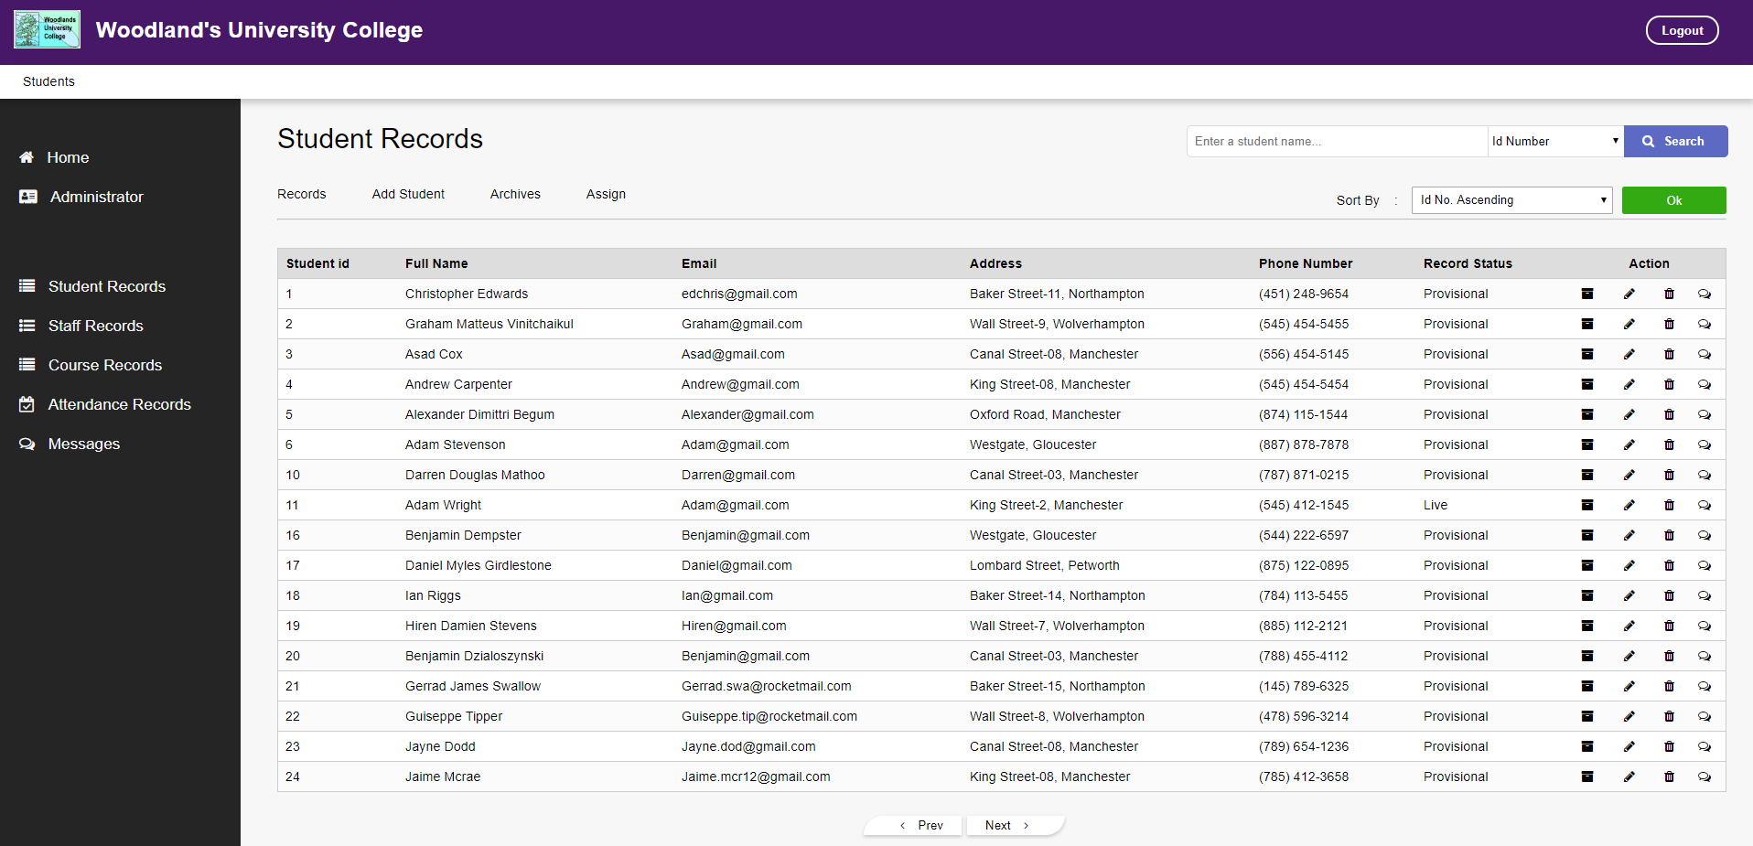

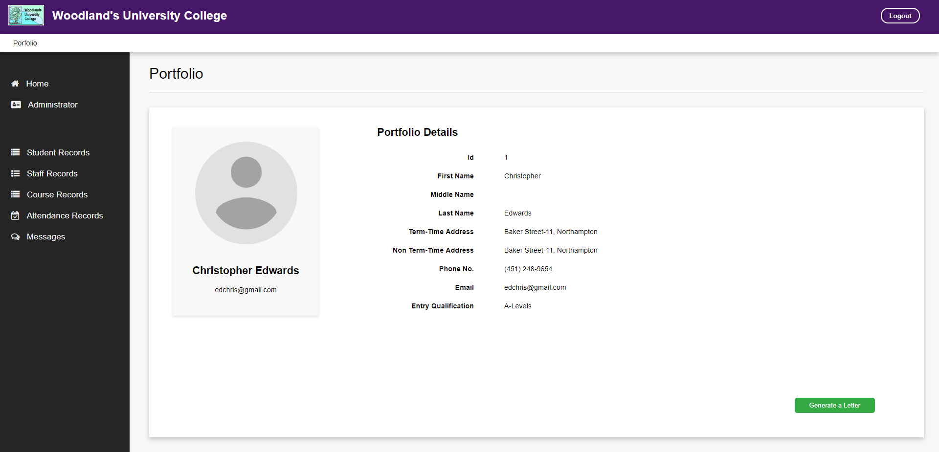

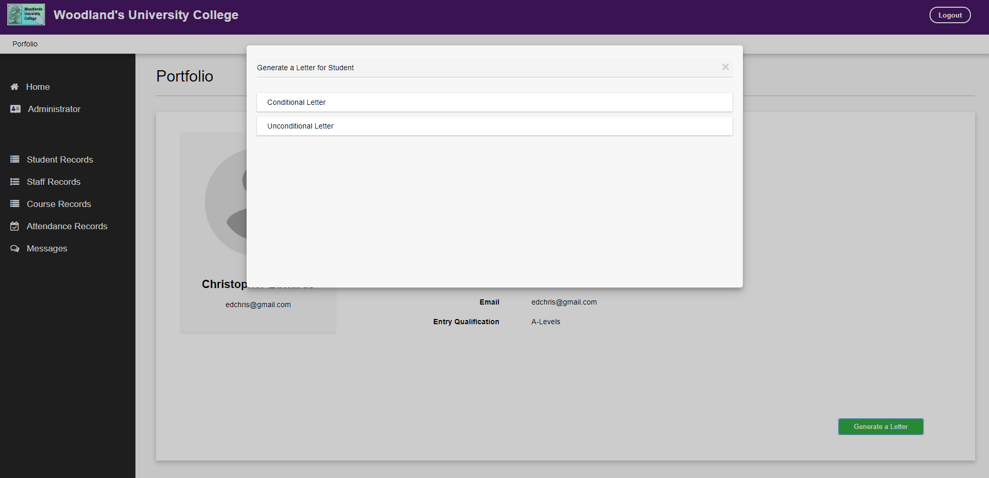

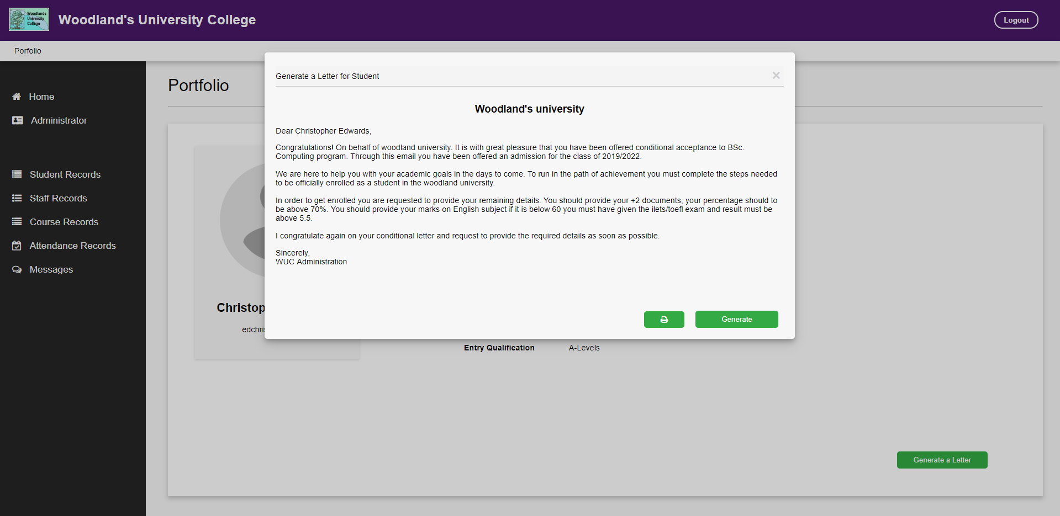

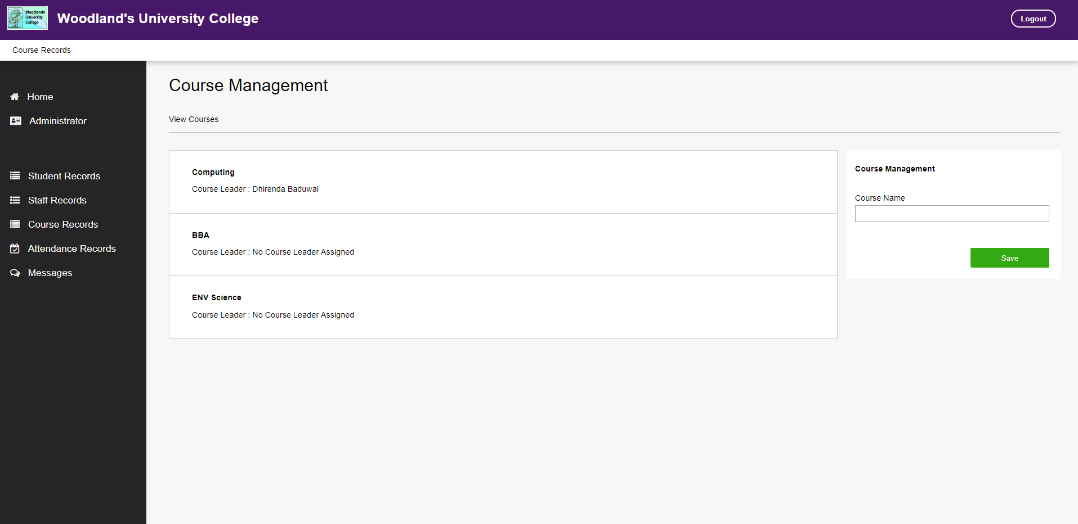

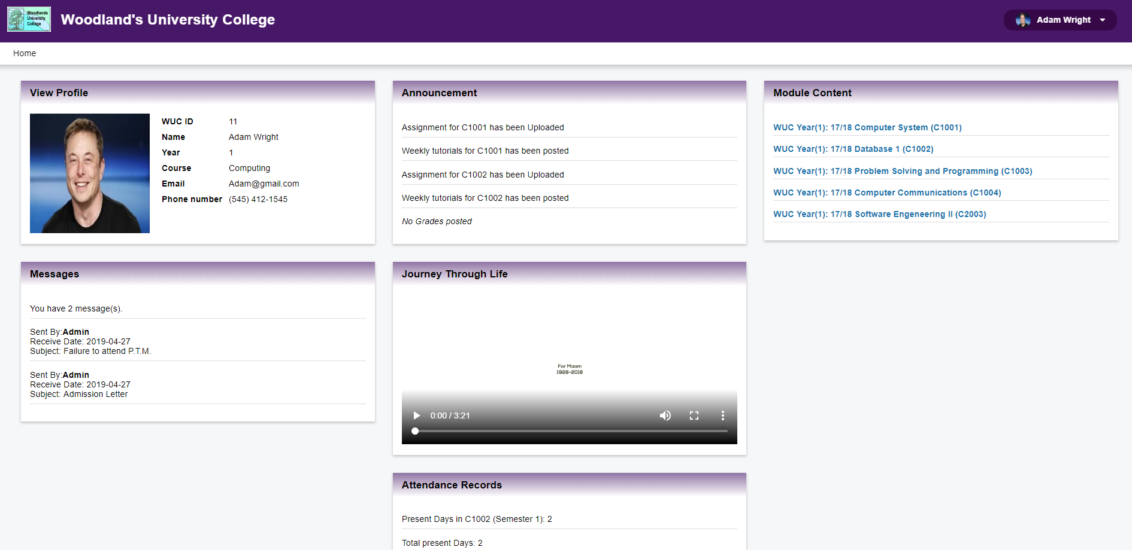

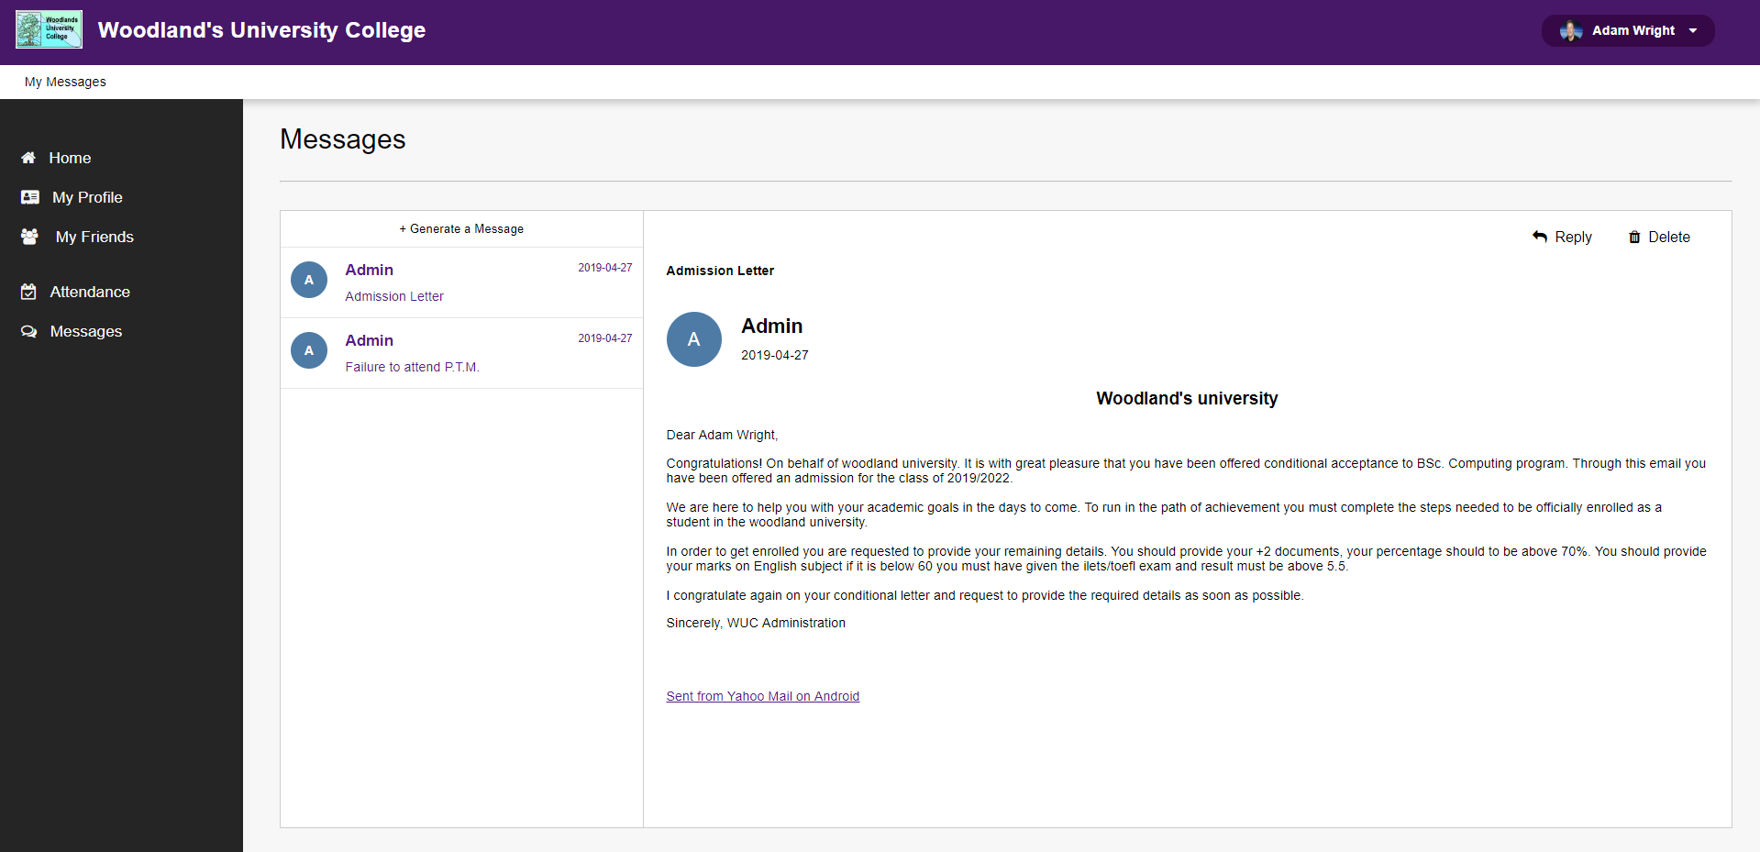

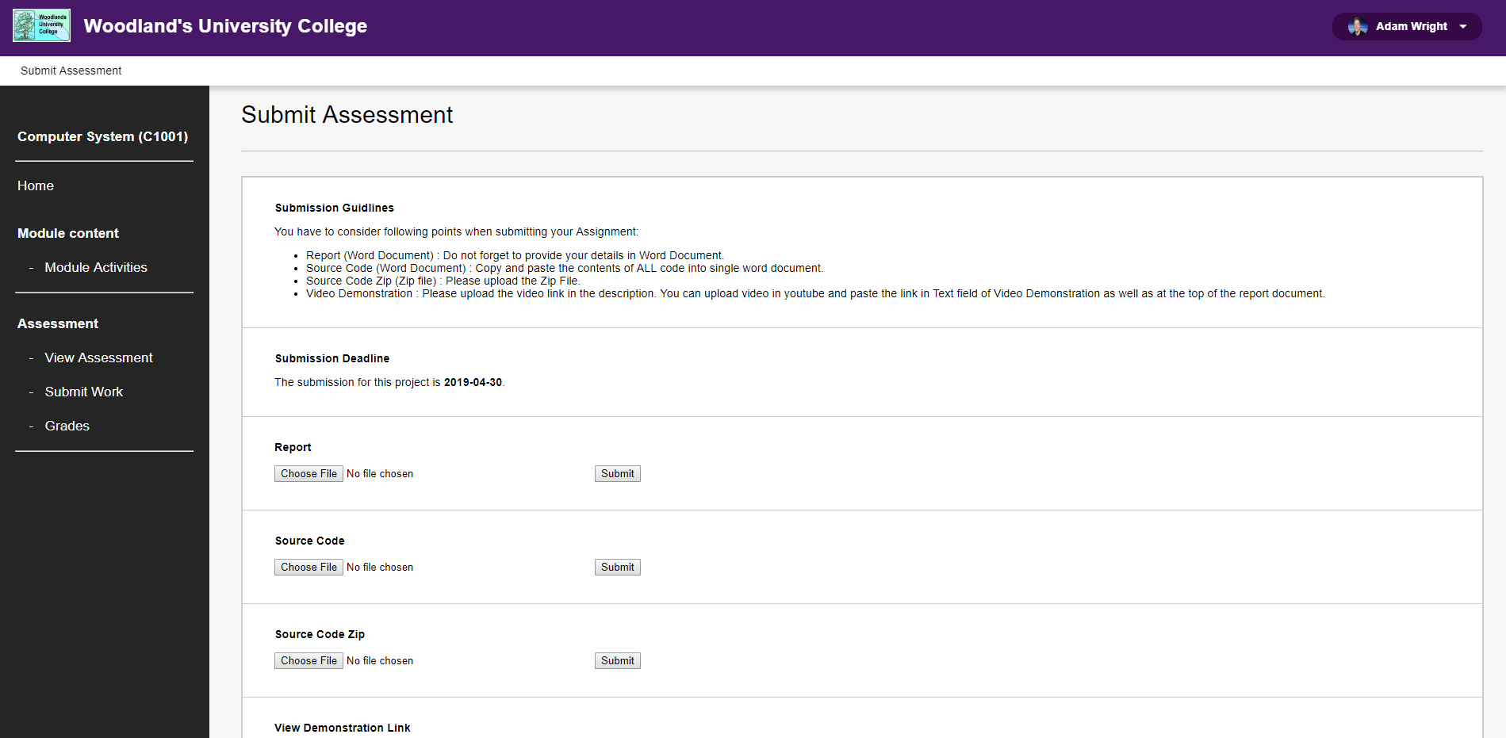

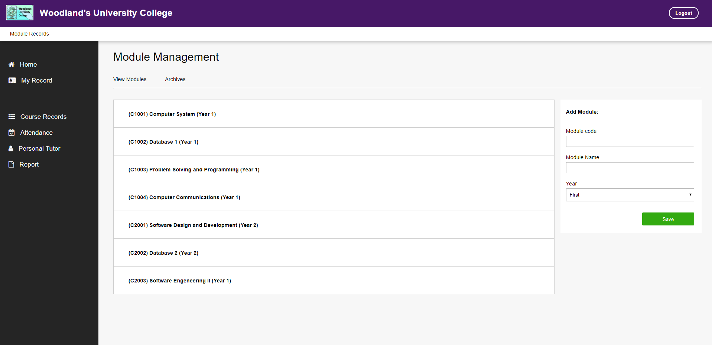

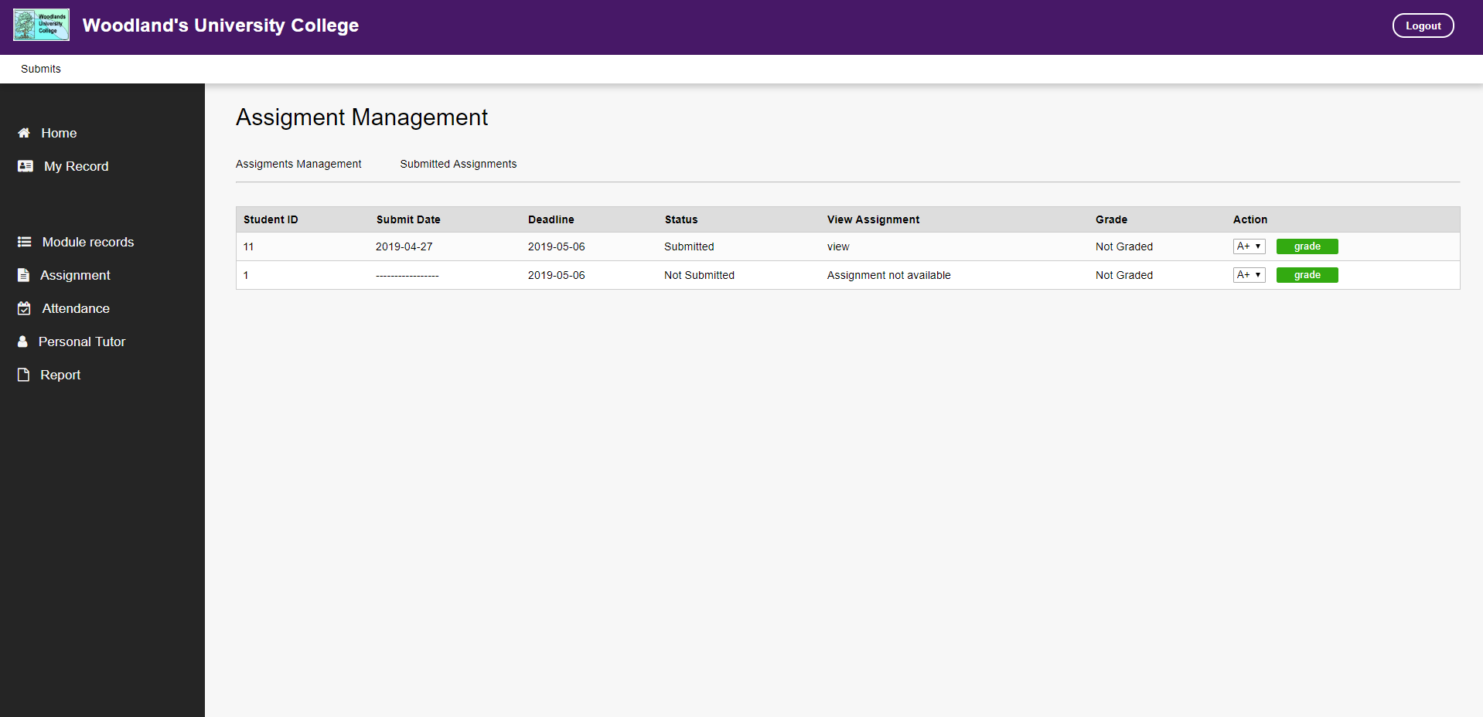

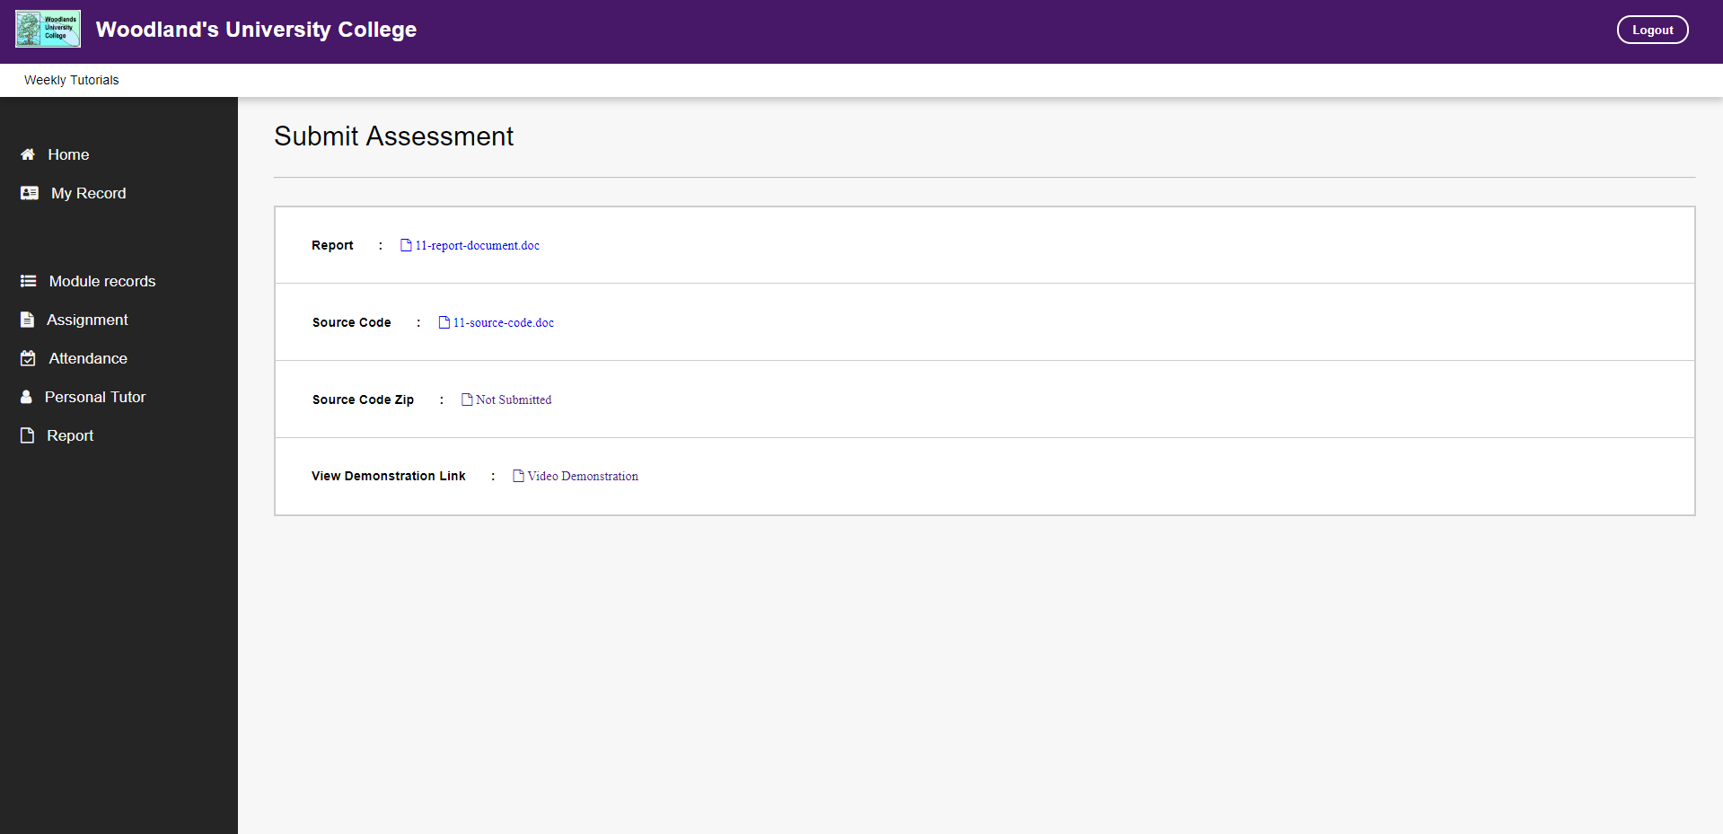

**Black Box Testing**

Black box testing is used to test that every aspect of the client’s requirement is handled correctly by an implementation. It sees the system through its specification and behavior. The behavior and specification define what the system should do and through black box testing the team made sure it does it. Hence black box testing is also known as behavioral testing. In the black box testing the team focuses on functional requirements of the website without going on its internal structures. We used the Equivalence Class Partitioning technique because it can be applied to all levels of testing such as unit testing, etc.

Equivalence and Boundary Value for Logging Into the system

1. If the username and password field is empty, then it is considered invalid
2. If the username is correct and password field is empty, then it is considered invalid
3. If the username is empty and password is correct, then it is considered invalid
4. If the username and password is filled but the username is incorrect whereas the password is correct, then it is considered invalid.
5. If the username and password is filled but the password is incorrect whereas the username is correct, then it is considered invalid.
6. If both username and password is incorrect, then it is considered invalid.
7. If the username and password both are correct, then it is considered valid.

|  |  |  |  |  |
| --- | --- | --- | --- | --- |
| **Test Scenario#** | **Test Scenario Description** | **Input/Test Data** | **Valid Equivalence Classes** | **Invalid Equivalence Classes** |
| 1 | To check that the login page accepts the correct username and password. | Username and Password | Username = correct  Password = correct | Username = empty  Password = empty  Username = correct  Password = empty  Username = empty  Password = correct  Username = incorrect  Password = correct  Username = correct  Password = incorrect  Username = incorrect  Password = incorrect |

Equivalence and Boundary Value for Admin to add a student and staff

1. Admin should be able to login to the website to add a student or staff is considered as valid.
2. If the admin is not being able to login to the website then it is considered as invalid to add student or staff.
3. A student with all the requirement’s is considered as valid.
4. A student without the requirement’s is considered as invalid.
5. If there is a seat to add a student, then it is considered as valid.
6. If there is no seat to add a student, then it is considered as invalid.
7. If the admin adds proper details of the student, then it is considered as valid.
8. If the admin does not add proper details of the staff, then it is considered as invalid.
9. If there is a position for a staff, then it is considered as valid.
10. If there is no position for a staff, then it is considered as invalid.
11. If the admin adds proper details of the staff, then it is considered as valid.
12. If the admin does not add proper details of the staff, then it is considered as invalid.

|  |  |  |  |  |
| --- | --- | --- | --- | --- |
| **Test Scenario#** | **Test Scenario Description** | **Input/Test Data** | **Expected Outcome** | **Actual Outcome** |
| 1 | To check that the admin adds a student and a staff in a valid way | Enter valid password and username | System should accept | System accepts |
| 2 |  | Enter invalid password and username | System should not accept | System rejects |
| 3 |  | Check all the student requirement | System should check the student requirement | System checks the student requirement |
| 4 |  | Doesn’t check all the student requirement | System should not accept | System rejects |
| 5 |  | Check number of available seats to add staff or student | System should check the number of available seats | System checks the number of available seats |
| 6 |  | Doesn’t check number of available seats to add staff or student | System should not add the student or staff without checking the available seats | System rejects to add the student or staff without checking the available seats |
| 7 |  | Fill the student or staff details in correct manner | System should accept if the student or staff details are in correct order | System accepts the student or staff |
| 8 |  | Doesn’t fill the student or staff details in correct manner | System should not accept | System Rejects |

Equivalence and Boundary Value For admin to message, edit, view, delete or archive the records of student and staffs

1. The admin should be able to login in to the website to view, edit, delete, message, manage attendance and archive the records of students and staffs.
2. If the admin is not able to login to the website then they cannot be able to view, edit, delete, message, manage attendance and archive the records of students and staffs.
3. The student and staff should be registered into the system so that the admin can view, edit, delete, message, manage attendance and archive their records.
4. If the student and staff are not registered into the system than the admin cannot be able to view, edit, delete, message, manage attendance and archive the records of the students and staffs.

|  |  |  |  |  |
| --- | --- | --- | --- | --- |
| **Test Scenario#** | **Test Scenario Description** | **Input/ Test Data** | **Expected Outcome** | **Actual Outcome** |
| 1 | To check that the admin can view records, edit, delete, archive, manage attendance and message the student or staff. | Enter valid username and password | System should accept | System accepts |
| 2 |  | Enter invalid username and password | System should not accept | System rejects |
| 3 |  | Check if the staff and students are in the system | System should check the records | System checks the records |
| 4 |  | View the record of staff and students | System should view the record of staff and students | System shows the records of staff or  students |
| 5 |  | Edit the record of staff or students | System should edit the record of student or staff | System edits the record of the student or staff |
| 6 |  | Delete the record of staff or students | System should delete the record of student or staff | System deletes the record of student or staff |
| 7 |  | Archive the record of staff or students | System should archive the record of student or staff | System archives the record of student or staff |
| 8 |  | Manage the courses | System should manage the courses | System manages the courses |
| 9 |  | Manage the modules | System should manage the modules | System manages the modules |
| 10 |  | Manage attendance of students | System should manage the student attendance | System manages the attendance of students |
| 11 |  | Send messages to student or staff | System should send messages to student or staff | System sends messages to staff or student |

Equivalence and boundary value for course leader to view module leaders, view student records, view module contents, view grades and announcements.

1. Course leader should provide valid username and password in order to login.
2. Course leader can view module leaders of their courses but cannot view module leaders of other courses.
3. Course leader can view the records of the students that are enrolled in their courses but cannot view student from other courses.
4. Course leader can view the module contents of their courses.
5. Course leader can view the grades of the students that are enrolled on their courses but cannot edit them.
6. Course leader can provide important information through announcements to students and module leaders that are in their courses.

|  |  |  |  |  |
| --- | --- | --- | --- | --- |
| **Test Scenario#** | **Test Scenario Description** | **Input/ Test Data** | **Expected Outcome** | **Actual Outcome** |
| 1 | To check that the course leader can view module leaders, student records, view module contents, view grades and announcements. | Enter valid username and password | System should accept | System accepts |
| 2 |  | Enter invalid username and password | System should not accept | System rejects |
| 3 |  | View the details of module leaders that are teaching in that course | System should view the details of module leaders that are teaching in that course. | System shows the details of the module leaders that are teaching in that course |
| 4 |  | View the student records that are currently studying in that course. | System should view the students records that are currently studying in that course. | System shows the student records that are currently studying in that course. |
| 5 |  | View the module contents of the module leaders that are in that course | System should view  the module contents of the module leaders that are in that course. | System shows the module contents of the module leaders that are in that course. |
| 6 |  | View the grades of the students that are studying in that course | System should view the grades of the students that are studying in that course. | System shows the grades of the students that are studying in that course. |
| 7 |  | Provide necessary information to students and module leader through announcements | System should provide the necessary information to students and module leaders through announcements. | System Provides necessary information to students and module leaders through announcements. |

Equivalence and Boundary Value For module leader to add lecture slides, upload assignment, provide grades, announcements.

1. Module leader should provide valid username and password in order to login.
2. Module leader can upload lecture slides to students who are enrolled in their module.
3. Module leader can provide grade to the students who are enrolled in their module.
4. Module leader can provide assignments to students who are enrolled in their module.
5. Module leader cannot provide lecture slides to students who are not enrolled in their module.
6. Module leader cannot provide grades to students who are not enrolled in their module.
7. Module leader cannot announce to students that are not enrolled in their module.

|  |  |  |  |  |
| --- | --- | --- | --- | --- |
| **Test Scenario#** | **Test Scenario Description** | **Input/ Test Data** | **Expected Outcome** | **Actual Outcome** |
| 1 | To check that the module leaders can provide lecture slides, assignment, grade, announcements to students. | Enter valid username and password | System should accept. | System accepts. |
| 2 |  | Enter invalid username and password | System should not accept. | System rejects. |
| 3 |  | Provide lecture slides to students who are enrolled on their modules. | System should provide lecture slides to students who are enrolled on their modules. | System provides lecture slides to students who are enrolled on their modules. |
| 4 |  | Provide assignments to students who are enrolled on their modules. | System should provide assignments to students who are enrolled on their modules. | System provides assignments to students who are enrolled on their modules. |
| 5 |  | Provide grades to students who are enrolled on their modules. | System should provide grades to students who are enrolled on their modules. | System provides grades to students who are enrolled on their modules. |
| 6 |  | Provide announcement to students who are enrolled on their modules. | System should provide announcement to students who are enrolled on their modules. | System provides announcements to students who are enrolled on their modules. |

Equivalence and boundary value for students to view lecture slides, view assignments, upload assignments, view grades, view and reply message to admin and view announcements.

1. Students should provide valid username and password.
2. Students can view lecture slides of their modules but cannot view lecture slides of other courses.
3. Students can view assignments of their modules.
4. Students can upload assignments of their modules.
5. Students can view grades of their modules.
6. Students can view message of the admin and reply if they are having problem with their account.
7. Student can view announcements from admin, course leader and module leaders.

|  |  |  |  |  |
| --- | --- | --- | --- | --- |
| **Test Scenario#** | **Test Scenario Description** | **Input/ Test Data** | **Expected Outcome** | **Actual Outcome** |
| 1 | To check that the students can view lecture slides, | Enter valid username and password | System should accept. | System accepts. |
| 2 |  | Enter invalid username and password | System should not accept. | System rejects. |
| 3 |  | View lecture slides of the modules | System should show the lecture slides of the modules | System shows the lecture slides of the modules |
| 4 |  | View assignments of the modules | System should show the assignments of the modules. | System shows the assignments of the modules. |
| 5 |  | Upload assignments of the modules | System should allow student to upload their modules. | System allows students to upload their modules. |
| 6 |  | View grades of the modules | System should show the grades of the modules. | System shows the grades of the modules. |
| 7 |  | View message from the admin | System should show the message from the admin. | System shows the message from the admin. |
| 8 |  | Reply message to the admin | System should allow the student to reply message to admin. | System allows the student to reply message to admin. |
| 9 |  | View announcements from admin, course leader and module leaders. | System should show the announcements from admin, course leader and module leaders. | System shows the announcements from admin, course leader and module leaders. |

# 7 System Evaluation

System evaluation is a task that results in more than one reported outcome. The main goal of the system evaluation is to check results of actions or interventions, in order to improve the quality of the actions or to choose the best action alternative. (citeseerx.ist.psu.edu, 2019)

## 7.1 Usability Evaluation Strategy

The main purpose of usability evaluation strategy is to take feedback to improve our designs, to achieve the user aims and objectives. The other main usability evaluation is to monitor long term use of the system in this case our web application. The user has to use our system in order to evaluate our web application. Our team had done all the testing and the software is ready to perform in the area. All of the functionality of the university has been tested and well implemented in our software.

Our team has selected appropriate usability evaluation strategy such as observation, interview with members of the university, questionnaire, heuristic methods and so on. We observe how the university runs in the clerical based system and analyze how to solve the problems that they were facing. We took interview with administration area, student, module leaders and course leaders to find out what they are dealing with the paper-based system. Our team took note of their problems and solve them one by one. There were a lot of problems with the clerical based system such as low security, loss of time, improper management of notice board system, grading of student’s papers and so many other problems. Our team eradicate all the above-mentioned problems and added additional functional requirements to the software. We added the messaging feature in the admin area and student are so that the admin and student can view their points through message. We added search icon in the admin area so that the admin can search the record that he wants in no time.

Our team evaluate this software through reliability, speed, capacity and usability. Our web application is very reliable since the user needs to provide username and password in order to login into the system. So, in terms of reliability our software is very secure and safe. It is very hard to be hackable. Talking about the speed, our web application is very fast and easy to operate. The user can find the necessary information or files in no time. In the old system, to find the particular file it would consume a lot of time. But in this system the admin can search through students and staff records and find the necessary file or information in very short period of time. Talking about the capacity, our team developed the web application to handle at least a thousand of users at a time. But this has not been tested yet. Our team thinks that our system is capable of handling a thousand of users at a time. Our system is very user friendly. Someone with less knowledge to use the application can use our software very easily.

## 7.2 System Pilot Trials

System pilot trial is one of the testing part where different functionality of the system is checked by letting the many users to run the system at the same time. This system is mostly used by the clients in order to check either their requirements are met or not in the system. They checks the whole of the system and checks functional requirements are met or not.

While they are checking a system they points out the weaknesses and these weakness are solved by the developer. Certain plans are made before conducting the pilot trial and proper training are given to the participants.

Pilots trial is one of the essential parts as it helps us to check whether the product is fully ready to be implement or not. As a developer also sometime we are unable to find some bugs in our program or sometimes it is seems to be there is no problems in the system so, pilots trials is one of the best solution for this.

In our system also pilot trial is performed by letting the users of about 20-25 people at a time and the clients are impressed by our products and also they found out some bugs in our system which we are able to solve this problems. As a result, we are able to deliver a fine a quality product to our clients.

# 8.Project Conclusions

To conclude this project that started off as a pilot system for a university that manages all the records of its staffs and students. This system that the group has created for the university to use turned out to be a really good system that could potentially serve as a standalone system that could manage the entire university on its own. This project has taught the group the importance of time management, the division of skill and problem assessment. This project also helped us learn about how a real life project works and each individual in the group plays an important role on creating solutions to the main problem. The group also learned various new skills while participating in this project that will definitely be of great help to each of the individuals of this group. Lastly the group would like to thank the University for providing them with this opportunity to learn and create something beneficial to all the members involved.

**END**

# 9. Project Management

## 9.1 Project Gantt Chat/WBDS/Activity List

|  |  |  |  |  |  |  |  |  |  |  |  |  |  |  |  |  |  |  |  |  |  |  |  |  |  |
| --- | --- | --- | --- | --- | --- | --- | --- | --- | --- | --- | --- | --- | --- | --- | --- | --- | --- | --- | --- | --- | --- | --- | --- | --- | --- |
| GANTT CHART | | | | | | | | | | | | | | | | | | | | | | | | | |
| Task | Description Week | 1 | 2 | 3 | 4 | 5 | 6 | 7 | 8 | 9 | 10 | 11 | 12 | 13 | 14 | 15 | 16 | 17 | 18 | 19 | 20 | 21 | 22 | 23 | 24 |
| 1 | Introduction |  |  |  |  |  |  |  |  |  |  |  |  |  |  |  |  |  |  |  |  |  |  |  |  |
| 1.1 | Project Background |  |  |  |  |  |  |  |  |  |  |  |  |  |  |  |  |  |  |  |  |  |  |  |  |
| 1.2 | Project Aims and Objectives |  |  |  |  |  |  |  |  |  |  |  |  |  |  |  |  |  |  |  |  |  |  |  |  |
| 1.3 | Project Development Methodology |  |  |  |  |  |  |  |  |  |  |  |  |  |  |  |  |  |  |  |  |  |  |  |  |
| 2 | Requirement Engineering |  |  |  |  |  |  |  |  |  |  |  |  |  |  |  |  |  |  |  |  |  |  |  |  |
| 2.1 | Elicitation Activities |  |  |  |  |  |  |  |  |  |  |  |  |  |  |  |  |  |  |  |  |  |  |  |  |
| 2.1.1 | Interview plans |  |  |  |  |  |  |  |  |  |  |  |  |  |  |  |  |  |  |  |  |  |  |  |  |
| 2.1.2 | Interview findings |  |  |  |  |  |  |  |  |  |  |  |  |  |  |  |  |  |  |  |  |  |  |  |  |
| 2.1.3 | Other problem domain research |  |  |  |  |  |  |  |  |  |  |  |  |  |  |  |  |  |  |  |  |  |  |  |  |
| 2.1.3.1 | Comparable domain research |  |  |  |  |  |  |  |  |  |  |  |  |  |  |  |  |  |  |  |  |  |  |  |  |
| 2.1.3.2 | Development Relevant Legislation |  |  |  |  |  |  |  |  |  |  |  |  |  |  |  |  |  |  |  |  |  |  |  |  |
| 2.1.3.3 | Academic Literature Review |  |  |  |  |  |  |  |  |  |  |  |  |  |  |  |  |  |  |  |  |  |  |  |  |
| 2.1.3.4 | Any other relevant problem domain investigation data |  |  |  |  |  |  |  |  |  |  |  |  |  |  |  |  |  |  |  |  |  |  |  |  |
| 2.2 | Requirement Specification |  |  |  |  |  |  |  |  |  |  |  |  |  |  |  |  |  |  |  |  |  |  |  |  |
| 2.2.1 | Problems Domain Description |  |  |  |  |  |  |  |  |  |  |  |  |  |  |  |  |  |  |  |  |  |  |  |  |
| 2.2.1.1 | Existing Business Operation |  |  |  |  |  |  |  |  |  |  |  |  |  |  |  |  |  |  |  |  |  |  |  |  |
| 2.2.1.2 | Summary of existing business limitations requiring resolution |  |  |  |  |  |  |  |  |  |  |  |  |  |  |  |  |  |  |  |  |  |  |  |  |
| 2.2.2 | Functional Requirement |  |  |  |  |  |  |  |  |  |  |  |  |  |  |  |  |  |  |  |  |  |  |  |  |
| 2.2.3 | Performance Requirement |  |  |  |  |  |  |  |  |  |  |  |  |  |  |  |  |  |  |  |  |  |  |  |  |
| 2.2.3.1 | Speed |  |  |  |  |  |  |  |  |  |  |  |  |  |  |  |  |  |  |  |  |  |  |  |  |
| 2.2.3.2 | Capacity |  |  |  |  |  |  |  |  |  |  |  |  |  |  |  |  |  |  |  |  |  |  |  |  |
| 2.2.3.3 | Reliability |  |  |  |  |  |  |  |  |  |  |  |  |  |  |  |  |  |  |  |  |  |  |  |  |
| 2.2.3.4 | Usability |  |  |  |  |  |  |  |  |  |  |  |  |  |  |  |  |  |  |  |  |  |  |  |  |
| 2.2.4 | Design Constraints |  |  |  |  |  |  |  |  |  |  |  |  |  |  |  |  |  |  |  |  |  |  |  |  |
| 2.2.5 | Commercial Constraints |  |  |  |  |  |  |  |  |  |  |  |  |  |  |  |  |  |  |  |  |  |  |  |  |
| 2.2.6 | Acceptance tests |  |  |  |  |  |  |  |  |  |  |  |  |  |  |  |  |  |  |  |  |  |  |  |  |
| 3 | System Analysis & Design |  |  |  |  |  |  |  |  |  |  |  |  |  |  |  |  |  |  |  |  |  |  |  |  |
| 3.1 | Preliminary Design |  |  |  |  |  |  |  |  |  |  |  |  |  |  |  |  |  |  |  |  |  |  |  |  |
| 3.1.1 | Textual Analysis |  |  |  |  |  |  |  |  |  |  |  |  |  |  |  |  |  |  |  |  |  |  |  |  |
| 3.1.2 | Significant Event Analysis |  |  |  |  |  |  |  |  |  |  |  |  |  |  |  |  |  |  |  |  |  |  |  |  |
| 3.1.3 | Commands Queries and Constraints |  |  |  |  |  |  |  |  |  |  |  |  |  |  |  |  |  |  |  |  |  |  |  |  |
| 3.2 | Detailed Static System Designs |  |  |  |  |  |  |  |  |  |  |  |  |  |  |  |  |  |  |  |  |  |  |  |  |
| 3.2.1 | First Draft BON System Architecture Diagram |  |  |  |  |  |  |  |  |  |  |  |  |  |  |  |  |  |  |  |  |  |  |  |  |
| 3.2.2 | BON System Chart |  |  |  |  |  |  |  |  |  |  |  |  |  |  |  |  |  |  |  |  |  |  |  |  |
| 3.2.3 | BON Cluster Charts |  |  |  |  |  |  |  |  |  |  |  |  |  |  |  |  |  |  |  |  |  |  |  |  |
| 3.2.4 | BON Class Charts |  |  |  |  |  |  |  |  |  |  |  |  |  |  |  |  |  |  |  |  |  |  |  |  |
| 3.3 | Detailed Dynamic System Designs |  |  |  |  |  |  |  |  |  |  |  |  |  |  |  |  |  |  |  |  |  |  |  |  |
| 3.3.1 | Events Charts |  |  |  |  |  |  |  |  |  |  |  |  |  |  |  |  |  |  |  |  |  |  |  |  |
| 3.3.2 | Object Creation Chart |  |  |  |  |  |  |  |  |  |  |  |  |  |  |  |  |  |  |  |  |  |  |  |  |
| 3.3.3 | System Scenario Chart |  |  |  |  |  |  |  |  |  |  |  |  |  |  |  |  |  |  |  |  |  |  |  |  |
| 3.3.4 | Dynamic Diagrams |  |  |  |  |  |  |  |  |  |  |  |  |  |  |  |  |  |  |  |  |  |  |  |  |
| 3.4 | System Database Design |  |  |  |  |  |  |  |  |  |  |  |  |  |  |  |  |  |  |  |  |  |  |  |  |
| 3.4.1 | E-R Model |  |  |  |  |  |  |  |  |  |  |  |  |  |  |  |  |  |  |  |  |  |  |  |  |
| 3.4.2 | Attribute Listings |  |  |  |  |  |  |  |  |  |  |  |  |  |  |  |  |  |  |  |  |  |  |  |  |
| 4 | System Interface Designs |  |  |  |  |  |  |  |  |  |  |  |  |  |  |  |  |  |  |  |  |  |  |  |  |
| 4.1 | Draft Interface Designs |  |  |  |  |  |  |  |  |  |  |  |  |  |  |  |  |  |  |  |  |  |  |  |  |
| 4.1.1 | Wireframes |  |  |  |  |  |  |  |  |  |  |  |  |  |  |  |  |  |  |  |  |  |  |  |  |
| 4.1.2 | System Navigation Diagram |  |  |  |  |  |  |  |  |  |  |  |  |  |  |  |  |  |  |  |  |  |  |  |  |
| 4.1.3 | System Screen mock-ups |  |  |  |  |  |  |  |  |  |  |  |  |  |  |  |  |  |  |  |  |  |  |  |  |
| 4.1.4 | System Activity Event Diagrams |  |  |  |  |  |  |  |  |  |  |  |  |  |  |  |  |  |  |  |  |  |  |  |  |
| 4.2 | Design Revisions |  |  |  |  |  |  |  |  |  |  |  |  |  |  |  |  |  |  |  |  |  |  |  |  |
| 4.3 | Heuristic Evaluator |  |  |  |  |  |  |  |  |  |  |  |  |  |  |  |  |  |  |  |  |  |  |  |  |
| 5 | System Build and Technical Notes |  |  |  |  |  |  |  |  |  |  |  |  |  |  |  |  |  |  |  |  |  |  |  |  |
| 5.1 | Technically Difficult Code Sections |  |  |  |  |  |  |  |  |  |  |  |  |  |  |  |  |  |  |  |  |  |  |  |  |
| 5.2 | On-going Testing Methodology |  |  |  |  |  |  |  |  |  |  |  |  |  |  |  |  |  |  |  |  |  |  |  |  |
| 5.3 | Final System Interface Displays |  |  |  |  |  |  |  |  |  |  |  |  |  |  |  |  |  |  |  |  |  |  |  |  |
| 6 | Test Strategy |  |  |  |  |  |  |  |  |  |  |  |  |  |  |  |  |  |  |  |  |  |  |  |  |
| 6.1 | Overview of Test Strategy |  |  |  |  |  |  |  |  |  |  |  |  |  |  |  |  |  |  |  |  |  |  |  |  |
| 6.2 | Sample Test Results |  |  |  |  |  |  |  |  |  |  |  |  |  |  |  |  |  |  |  |  |  |  |  |  |
| 7 | System Evaluation |  |  |  |  |  |  |  |  |  |  |  |  |  |  |  |  |  |  |  |  |  |  |  |  |
| 7.1 | Usability Evaluation Strategy |  |  |  |  |  |  |  |  |  |  |  |  |  |  |  |  |  |  |  |  |  |  |  |  |
| 7.2 | System Pilots Trials |  |  |  |  |  |  |  |  |  |  |  |  |  |  |  |  |  |  |  |  |  |  |  |  |
| 7.3 | Systems Trail Results |  |  |  |  |  |  |  |  |  |  |  |  |  |  |  |  |  |  |  |  |  |  |  |  |
| 8 | Project Conclusions |  |  |  |  |  |  |  |  |  |  |  |  |  |  |  |  |  |  |  |  |  |  |  |  |
| 9 | Project Management |  |  |  |  |  |  |  |  |  |  |  |  |  |  |  |  |  |  |  |  |  |  |  |  |
| 9.1 | Project Gantt Chat/WBDS/Activity List |  |  |  |  |  |  |  |  |  |  |  |  |  |  |  |  |  |  |  |  |  |  |  |  |
| 9.2 | Project Meeting Minutes |  |  |  |  |  |  |  |  |  |  |  |  |  |  |  |  |  |  |  |  |  |  |  |  |
| 9.3 | Project Quality Plan/Strategy |  |  |  |  |  |  |  |  |  |  |  |  |  |  |  |  |  |  |  |  |  |  |  |  |
| 9.4 | Project Work Log |  |  |  |  |  |  |  |  |  |  |  |  |  |  |  |  |  |  |  |  |  |  |  |  |
| 10 | References |  |  |  |  |  |  |  |  |  |  |  |  |  |  |  |  |  |  |  |  |  |  |  |  |
| 11 | Appendix |  |  |  |  |  |  |  |  |  |  |  |  |  |  |  |  |  |  |  |  |  |  |  |  |

## 9.2Project Meeting Minutes and Quality Plan/Strategy

Team Members: Rojen, Ayush, Sandesh, Roshan, Sushant, Shangbu, Prabin, Pragyan, Prajwal

On a weekly basis, the team members used to have a group meeting to discuss the problems, accomplishment of the work and the solution to the problem.

Week 1:

Time: 2-4 pm

The team was given a project to form a completely web-based system for a Woodland’s University. So, the team members gathered together in a room and discussed about the problem client were facing and made and interview plans. Then, they took an interview session with the former administrator, course leader, module leader and one of the students of the university. The specific problems were noted with the client’s suggestion for the system and again formed a meeting to discuss about the proper solutions for the project. The group leader then divided the work to the team members and the members were to research about the given work.

Week 2:

Time: 2:30-4:00

The team gathered after having a lunch in a college and discussed about the work completed. The divided work was discussed and compiled. The team decided to make some list of the functionality for the system and the designs were discussed. Different websites of colleges and schools were visited and the work on the design of the website was discussed. Finally, a week or a 2 week later, the wireframes of the website was finalized.

Week 4/5:

Time: 11pm

The team visited to the client to show the ideas we created and the wireframes of the website. After a meeting, the front end and back end coding and the further documentation part were divided and the work were started.

In the meantime, the team did not have a meeting but everyone was in a contact. We had a group chat in a Facebook Messenger and Discord to discuss about small details. Almost after a month, the team had another meeting to show the work done and discussed about it. Then, the code was compiled together and the work completed was shown to the clients and asked for a suggestions and a feedback. The feedback and suggestions given by the clients were noted down and done further coding. In this way, the team had a frequent conversation and meetings with the members during the given time period for this project and the final complete web based system was successfully made.

## 9.3 Project Work Log

|  |  |  |  |  |  |  |  |  |  |
| --- | --- | --- | --- | --- | --- | --- | --- | --- | --- |
| **TASK** | **INDIVIDUAL CONTRIBUTION** | | | | | | | | |
| **Introduction** | Rojen Tamang | Ayush Serpa | Prajwol Simkhada | Roshan Giri | Sushant Adhikari | Sandesh Bindukar | Prabin Shrestha | Shangbu Tamang | Pragyan Karki |
| Project Background | - | - | - | - | 100% | - | - | - | - |
| Project Aims and Objectives | - | - | - | - | 100% | - | - | - | - |
| Project Development Methodology | - | - | - | - | 100% | - | - | - | - |
| **Requirements Engineering** | Rojen Tamang | Ayush Serpa | Prajwol Simkhada | Roshan Giri | Sushant Adhikari | Sandesh Bindukar | Prabin Shrestha | Shangbu Tamang | Pragyan Karki |
| Interview plans |  | - | - | 100% | - | - | - | - |  |
| Interview Findings | - | - | - | 100% | - | - | - | - | - |
| Other problem domain research | - |  | 100% | - | - | - | - | - | - |
| Comparable Software System Review | - | - | 100% | - | - | - | - | - | - |
| Development Relevant Legislation | - | - | - | 100% | - | - | - | - | - |
| Academic Literature Review | - | - | - | - | - | 100% | - | - | - |
| Any Other Relevant Problem Domain Investigation Data | - | - | - | - | - | 100% | - | - | - |
| **Requirements Specification** | Rojen Tamang | Ayush Serpa | Prajwol Simkhada | Roshan Giri | Sushant Adhikari | Sandesh Bindukar | Prabin Shrestha | Shangbu Tamang | Pragyan Karki |
| Problem Domain Description | - | - | - | - | - | - | 100% | - | - |
| Existing Business Operation | - | - | - | - | - | - | 100% | - | - |
| Summary of existing business limitations requiring resolution | - | - | - | - | - | - | 100% | - | - |
| Functional Requirements | 50% | 50% | - | - | - | 100% |  | - | - |
| Performance Requirements | - | - | - | - | - | 100% | - | - | - |
| Design Constraints | - | - | - | - | - | - | - | - | 100% |
| Commercial Constraints | - | - | - | - | - | - | - | - | 100% |
| Acceptance Tests | - | - | - | - | - | - | 100% | - | - |
| **System Analysis and Design** | Rojen Tamang | Ayush Serpa | Prajwol Simkhada | Roshan Giri | Sushant Adhikari | Sandesh Bindukar | Prabin Shrestha | Shangbu Tamang | Pragyan Karki |
| Textual Analysis | - | - | - | - | - | - | - | - | 100% |
| Significant Event Analysis | - | - | - | - | - | - | - | - | 100% |
| Commands Queries and Constraints | - | - | - | - | - | - | - | - | 100% |
| First Draft BON System Architecture Diagram | - | - | - | - | - | - | - | 100% | - |
| BON System Charts | - | - | - | - | - | - | - | 100% | - |
| BON Cluster Charts | - | - | - | - | - | - | 100% | - | - |
| BON Class Charts | - | - | - | - | - | - | 100% | - | - |
| Events Charts | - | - | - | - | 100% | - | - | - | - |
| Object Creation Charts | - | - | - | - | 100% | - | - | - | - |
| System Scenario Charts | - | - | - | - | - | 100% | - | - | - |
| Dynamic Diagrams | - | - | - | - | - | 100% | - | - | - |
| E-R Model | - | 100% | - | - | - | - | - | - | - |
| Attribute Listings | 100% | - | - | - | - | - | - | - | - |
| **System Interface Designs** | Rojen Tamang | Ayush Serpa | Prajwol Simkhada | Roshan Giri | Sushant Adhikari | Sandesh Bindukar | Prabin Shrestha | Shangbu Tamang | Pragyan Karki |
| Wireframes | - | - | - | 100% | - | - | - | - | - |
| System Navigation Diagram | - | - | - | 100% | - | - | - | - | - |
| System Screen Mock-Ups | - | - | - | 100% | - | - | - | - | - |
| System Activity Event Diagrams | - | - | 100% | - | - | - | - | - | - |
| Design Revisions | - | - | - | 100% | - | - | - | - | - |
| Heuristic Evaluation | - | - | 100% | - | - | - | - | - | - |
| **System Build and Technical Notes** | Rojen Tamang | Ayush Serpa | Prajwol Simkhada | Roshan Giri | Sushant Adhikari | Sandesh Bindukar | Prabin Shrestha | Shangbu Tamang | Pragyan Karki |
| Technically Difficult Code Sections | - | 100% | - | - | - | - | - | - | - |
| On-going Testing Methodology | - | - | - | - | 50% | - | - | 50% | - |
| Final System Interface Displays | 100% | - | - | - | - | - | - | - | - |
| **Test Strategy** | Rojen Tamang | Ayush Serpa | Prajwol Simkhada | Roshan Giri | Sushant Adhikari | Sandesh Bindukar | Prabin Shrestha | Shangbu Tamang | Pragyan Karki |
| Overview of Test Strategy | - | - | - | - | - | 50% | 50% | - | - |
| Sample Test Results | - | - | - | 100% | - | - | - | - | - |
| **System Evaluation** | Rojen Tamang | Ayush Serpa | Prajwol Simkhada | Roshan Giri | Sushant Adhikari | Sandesh Bindukar | Prabin Shrestha | Shangbu Tamang | Pragyan Karki |
| Usability Evaluation Strategy | - | - | - | 100% | - | - | - | - | - |
| System Pilot Trials | - | - | - | - | - | - | 100% | - | - |
| System Trial Results | - | - | - | - | - | - | - | - | - |
| **Project Conclusions** | Rojen Tamang | Ayush Serpa | Prajwol Simkhada | Roshan Giri | Sushant Adhikari | Sandesh Bindukar | Prabin Shrestha | Shangbu Tamang | Pragyan Karki |
|  | - | 100% | - | - | - | - | - | - | - |
| **Project Management** | Rojen Tamang | Ayush Serpa | Prajwol Simkhada | Roshan Giri | Sushant Adhikari | Sandesh Bindukar | Prabin Shrestha | Shangbu Tamang | Pragyan Karki |
| Project Gantt Chat/WBDS/Activity List | - | - | - | 100% | - | - | - | - | - |
| Project Meeting Minutes | - | - | - | - | - | 100% | - | - | - |
| Project Quality Plan/Strategy | - | - | - | - | - | 100% | - | - | - |
| Project Work Log | 100% | - | - | - | - | - | - | - | - |
| **References** | Rojen Tamang | Ayush Serpa | Prajwol Simkhada | Roshan Giri | Sushant Adhikari | Sandesh Bindukar | Prabin Shrestha | Shangbu Tamang | Pragyan Karki |
|  | 100% | - | - | - | - | - | - | - | - |
| **Appendix** | Rojen Tamang | Ayush Serpa | Prajwol Simkhada | Roshan Giri | Sushant Adhikari | Sandesh Bindukar | Prabin Shrestha | Shangbu Tamang | Pragyan Karki |
|  | 100% | - | - | - | - | - | - | - | - |

|  |  |  |  |  |  |  |  |  |  |
| --- | --- | --- | --- | --- | --- | --- | --- | --- | --- |
| **Coding / Implementation** | Rojen Tamang | Ayush Serpa | Prajwol Simkhada | Roshan Giri | Sushant Adhikari | Sandesh Bindukar | Prabin Shrestha | Shangbu Tamang | Pragyan Karki |
|  | 50% | 50% | - | - | - | - | - | - | - |

|  |  |  |  |  |  |  |  |  |  |
| --- | --- | --- | --- | --- | --- | --- | --- | --- | --- |
| **Documentation** | Rojen Tamang | Ayush Serpa | Prajwol Simkhada | Roshan Giri | Sushant Adhikari | Sandesh Bindukar | Prabin Shrestha | Shangbu Tamang | Pragyan Karki |
|  | 50% | - | - | 50% | - | - | - | - | - |

# 10. References

* Legislation.gov.uk. (2018). *Data Protection Act 1998*. [online] Available at: <http://www.legislation.gov.uk/ukpga/1998/29> [Accessed 20 Dec. 2018].
* Council, F. (2018). *The eight data protection principles*. [online] Fareham.gov.uk. Available at: <https://www.fareham.gov.uk/about_the_council/data_protection/dataprotprin.aspx>

[Accessed 20 Dec. 2018].

* Legislation.gov.uk. (2018). *Computer Misuse Act 1990*. [online] Available at: <http://www.legislation.gov.uk/ukpga/1990/18> [Accessed 20 Dec. 2018].
* Legislation.gov.uk. (2018). *Equality Act 2010*. [online] Available at: <https://www.legislation.gov.uk/ukpga/2010/15> [Accessed 20 Dec. 2018].
* School Management System. 2019. School Management System. [ONLINE] Available at: <https://www.slideshare.net/aki_string/school-management-system-21413550>. [Accessed 27 January 2019].
* Techlead. 2019. eTechSchool | School Analytics . [ONLINE] Available at: <http://etechschoolonline.com>. [Accessed 27 January 2019].
* Moodle app features - MoodleDocs. 2019. Moodle app features - MoodleDocs. [ONLINE] Available at: <https://docs.moodle.org/36/en/Moodle_app_features>. [Accessed 27 January 2019].
* School Management System. 2019. *School Management System*. [ONLINE] Available at: <https://www.slideshare.net/aki_string/school-management-system-21413550>. [Accessed 10 April 2019].
* Techlead. 2019. *eTechSchool | School Analytics*. [ONLINE] Available at: [http://etechschoolonline.com](http://etechschoolonline.com/). [Accessed 10 April 2019].
* Citeseerx.ist.psu.edu. (2019). [online]

Available at: <http://citeseerx.ist.psu.edu/viewdoc/download?doi=10.1.1.87.8362&rep=rep1&type=pdf> [Accessed 4 May 2019].

# 11. Appendix

**Presentation Slides**



